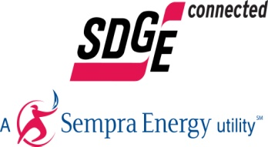

SDG&E ReMAT Queue Information: Program Period 16 (May – June 2016)

Baseload:
- Capacity available in Product Type
  - Remaining in Program: 10.88 MW
  - Program Period 16: 3.000 MW
- Complete PPRs in Product Type
  - There are fewer than 5 different Applicants in this Product Type

Peaking As-Available:
- Capacity available in Product Type
  - Remaining in Program: 7.80 MW
  - Program Period 16: 3.000 MW
- Complete PPRs in Product Type
  - There are fewer than 5 different Applicants in this Product Type

Non-Peaking As-Available:
- Capacity available in Product Type
  - Remaining in Program: 13.13 MW
  - Program Period 10: 3.000 MW
- Complete PPRs in Product Type
  - There are fewer than 5 different Applicants in this Product Type

