- Please provide the marginal costs for Schedule AL-TOU, without any percentage increase to recover embedded costs. Please separate these marginal costs by type of cost (e.g., distribution coincident, distribution-non-coincident, energy, generation capacity, transmission, customer), as well as by summer and voltage level, as appropriate. Please provide your response in Microsoft Excel format.

SDG&E Response: The only marginal costs included in the calculation of Schedule AL-TOU current rates are distribution and generation marginal costs. The attached file (NRDC DR-01_Q1) provides a breakdown of the marginal distribution and generation marginal costs used in the development of proposed EV-HP rates, which is the marginal costs from SDG&E’s 2016 General Rate Case (GRC) proceeding (Application [A.] 15-04-012).

- Please list the categories of costs (including FERC account numbers) that are included in the distribution cost categories and the types of costs (including FERC account numbers) that are included in the customer cost category.

SDG&E Response: Marginal distribution costs consist of customer and demand-related costs. The marginal distribution customer costs represent the cost of providing customers access to SDG&E electrical service, which are composed of two types of costs: (a) costs associated with the investment required to provide access (hook up) to a new customer, specifically final line transformer, service drop, and meter costs; and (b) ongoing costs of maintaining the new customer, which consists of customer related operation & maintenance (O&M) and customer service distribution costs. The marginal distribution demand costs represent the cost of providing distribution facilities from the substation to the customer access point in order to meet the customer’s individual demand. The marginal distribution demand costs are separated into two types of costs: (a) feeder and local distribution costs; and (b) substation costs. The marginal distribution cost categories are associated with FERC Distribution Plant Costs in FERC Accounts 360-374 and FERC Distribution O&M Costs in FERC Accounts 580-598.

- Please provide the Equal Percentage of Marginal Costs factor (or other appropriate factor) used to scale marginal costs to total revenue requirements.

SDG&E Response: SDG&E’s current electric rates are based on its 2016 GRC Phase 2 marginal distribution and generation costs. The table below (NRDC DR-01_Q3) provides the EPMC factors used to scale SDG&E’s 2016 GRC Phase 2 marginal distribution and generation costs to the total authorized distribution and generation revenue requirements that were currently being collected in SDG&E’s electric rates at that time.

- Please provide the billing determinants for Schedule AL-TOU as used to calculate rates in SDG&E’s most recent rate case.

SDG&E Response: The Schedule AL-TOU 2019 billing determinants used to calculate the proposed EV-HP rates can be found in the “EVHP Workpapers Chapter 2” file, tab “EV-HP Rate Design Modifications”, Column B. The only Schedule AL-TOU Secondary and Primary 2019 determinants for customers less than 500 kWh not used and thus not presented in that workpaper are the billing determinants for the Basic Service Fee and kWh on a System Net basis, which are presented in the table below:

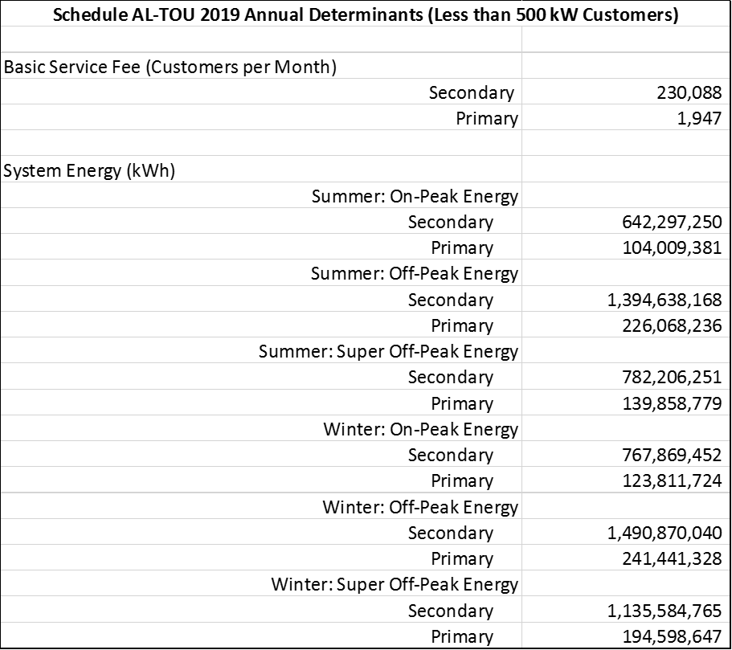

- Please provide the 8760 (12-month, hour-by-hour) load profiles for ten randomly chosen DCFC customers in SDG&E’s territory, excluding any identifying customer information. Please provide your response in Microsoft Excel format.

SDG&E Response: In accordance with Decision 16-08-024, the requested monthly meter data for existing DCFC charging stations is within the scope of data protected as confidential under applicable statutory provisions. DCFC meter data cannot be sufficiently anonymized to be publicly shared due to the low number of DCFC operators in SDG&E service territory.

- Please provide list the DCFC station interconnections in SDG&E’s territory for 2017 and 2018. For each interconnection, please provide:
  - The costs paid by the customer
  - The costs socialized to other customers
  - The major cost components and their dollar value (e.g., reconductoring, substation upgrades, etc.)

SDG&E Response: The proportion of a customer’s interconnection cost that are born by the customer and proportion that are socialized depend on that customer’s load, as do major cost components and their dollar values. Pursuant to Section 8380 of the California Public Utilities Code, SDG&E is prohibited from disclosing a customer’s electrical or gas consumption data except with the consent of the customer or in other limited circumstances that do not apply. As these chargers are owned by a discrete set of customers, aggregation or anonymization of the data would not suffice to comply with law.

- Please provide a description of the methodology used to classify transmission costs as either noncoincident or coincident. Please explain precisely how such determinations are made, particularly if certain cost categories are classified as a combination of both.

SDG&E Response: Transmission costs are not based on marginal costs. For the Medium/Large Commercial & Industrial (M/L C&I) class that pays transmission costs through either non-coincident or on-peak demand charges the transmission costs are simply allocated 90% to non-coincident and 10% to peak, an allocation approach adopted by the Federal Energy Regulatory Commission (FERC) in Docket No. ER09-295-000.

- Please provide a description of the methodology used to classify distribution system costs as either non coincident or coincident. Please explain precisely how such determinations are made, particularly if certain cost categories are classified as a combination of both.

SDG&E Response: In SDG&E’s 2016 GRC Phase 2 proceeding, SDG&E proposed that distribution demand costs should be assigned 100% to non-coincident demand. However, because customers that pay distribution demand charges such as M/L C&I customers were paying distribution demand costs through non-coincident and on-peak demand charges, SDG&E proposed a transition path to move towards 100% recovery of distribution demand costs through non-coincident demand charges from these customers starting with 65% allocated to non-coincident and 35% allocated to peak demand charges. In decision D.17-08-030, the Commission rejected SDG&E’s distribution allocation proposal and adopted the proposal of the Solar Energy Industries Association (SEIA) to allocate SDG&E’s distribution demand costs 39% to non-coincident and 61% to peak demand charges. The Commission also directed SDG&E to perform a distribution demand charge study in its next GRC Phase 2 proceeding to determine the appropriate allocation of distribution demand costs between non-coincident and peak demand charges. Per this requirement SDG&E performed a distribution demand charge study in its 2019 GRC Phase 2 proceeding (A.19-03-002) where it determined that its distribution demand costs should be allocated 94.8% to non-coincident and 5.2% to peak demand charges. The percentage of the costs that is peak related is based on evaluating the distribution costs that is capacity related, which for SDG&E was 5.2% of its total distribution demand costs.

Al-TOU rates effective June 1, 2019, per SDG&E Advice Letter 3377-E approved by Energy Division letter on June 21, 2019.
D.17-08-030, pp. 39-48.

