SUBJECT: “CONTRIBUTION TO MARGIN (CTM) ANALYSIS”

- In its response to Q1, SDG&E states that “NBCs are assessed as an energy charge,” which includes transmission charges. The workpaper shows a single NBC charge ($0.04273 on row 36 of tab “CTM Calc”). Is it standard practice for SDG&E to convert transmission charges into an energy rate for CTM analyses?

SDG&E Response: The Economic Development Rates (“EDR”) decisions adopted by the Commission have required the Contribution to Margin (“CTM”) calculations to determine the floor price, which consists of marginal distribution costs, marginal generation costs, and non-bypassable (“NBCs”) charges, including transmission charges. Because marginal costs are not calculated for transmission, the transmission charge used in the CTM calculation, like all NBCs, reflect the average $/kWh rate for the customer class. The $0.04273/kWh average NBC rate identified in your question represents the average NBC rate for the Medium/Large Commercial & Industrial (“M/L C&I”) customer class on January 1, 2018, with the average transmission rate being $0.01891/kWh.

- Total NBCs for the EV-HP rate schedule ($.05647/kWh) are significantly higher than in the port’s CTM analysis. Please explain the difference.

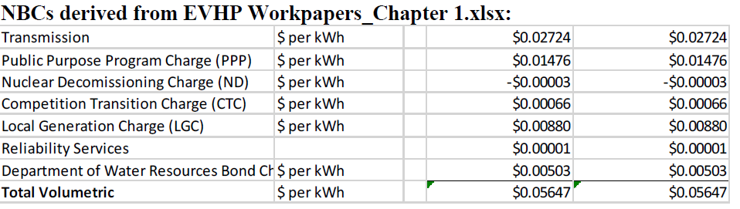

SDG&E Response: The difference between the EV-HP Total NBCs rate of $0.05647 and the EDR Total NBCs rate of $0.04273 presented in Question 1 is due to the fact that the rates shown for EV-HP are based on SDG&E’s electric rates effective June 1, 2019, and reflect rates specific for Schedule AL-TOU, a rate schedule in the M/L C&I customer class. Therefore, the rate differences are due to changes in SDG&E’s rates that occurred from January 1, 2018, to June 1, 2019, and differences between Schedule AL-TOU rates compared to M/L C&I class average rates.

- SDG&E assesses marginal distribution design demand costs as the marginal cost unit value (e.g. cell C23 of “CTM Calc” tab) times monthly non-coincident demand. However, SDG&E does not incorporate the effect of effective demand factors (EDFs), which it normally uses to calculate total marginal distribution design demand costs in the revenue allocation process.2 What is SDG&E’s rationale for not including the effect of EDFs in the port’s CTM analysis? Would it be appropriate to include the effect of EDFs for other medium and large commercial and industrial customers?

SDG&E Response: The monthly non-coincident demand rate in the CTM calculation you identify (Cell C23 of the “CTM Calc” tab) does reflect the effect of EDFs in the Port’s CTM analysis because the non-coincident demand rate reflects the Equal Percent Marginal Cost (“EPMC”) rate to recover the allocated distribution demand revenues based on the EDFs. Therefore, it would be appropriate to reflect the effect of EDFs for other M/L C&I customers, which SDG&E did by basing the EV-HP rates on Schedule AL-TOU’s current effective June 1, 2019, rates that include the effect of EDFs.

Decision 13-10-019, p. 17; and D.19-07-003, p. 7 and p. 8 (footnote 6).
SDG&E electric rates effective January 1, 2018, per SDG&E Advice Letter approved by Energy Division letter on April 30, 2018.
SDG&E electric rates effective January 1, 2018, per SDG&E Advice Letter approved by Energy Division letter on April 30, 2018.

