Question No. 1
In Exhibit SDGE-15, Chapter 1 Prepared Rebuttal Testimony of Jeff P. Stein (May 4, 2020), at page JPS-29, lines 8 through 10, Mr. Stein testifies: “SDG&E supports dynamic pricing and recognizes the importance of dynamic pricing in helping to shift the demand from peak to off-peak periods.” At lines 12 through 13 on the same page, Mr. Stein continues: “Currently, SDG&E has several dynamic rate schedules available to its customers such as Critical Peak Pricing (‘CPP’) rates and Schedules GIR and VGI.” Finally, at p. JPS-30, lines 1 through 3, Mr. Stein concludes that “any RTP [real time pricing] or dynamic pricing rates and tariffs should be developed within a pilot to ensure that all ratepayers will benefit from its implementation.”
- Is SDG&E specifically recommending a dynamic pricing or real time pricing (RTP) tariff or schedule for Commission adoption or approval in A.19-03-002 that is not currently in effect?
- Is SDG&E recommending that the Commission approve a pilot dynamic pricing or RTP program in A.19-03-002?
- If the Commission in its decision in A.19-03-002 were to direct that a dynamic pricing or RTP pilot program be initiated, does SDG&E have a recommendation for the goals and design of that pilot?
- If the Commission in its decision in A.19-03-002 were to authorize the development of a dynamic pricing or RTP pilot program, does SDG&E have a recommendation on the process and timeline for doing so, including an expected date for implementation?

SDG&E Response:

- No.
- No.
- As indicated in Jennifer Montanez’ prepared supplemental testimony, at page JM-3 lines 11-16, any new dynamic rate should have the following characteristics: “1) reduces the incremental system upgrade costs to ratepayers by utilizing current billing and meter capabilities; 2) will allow SDG&E, the Commission, and interested parties to gauge the level of interest in the type of dynamic rate; 3) encourages customer understanding by minimizing the complexity of the rate and targeted marketing, education and outreach (ME&O); and 4) ensures that this rate design does not create cost shifts from participants to non-participants.” If the Commission were to direct that a dynamic pricing or RTP pilot program be initiated, then such pilot should fully assess the goals outlined above.
- SDG&E should be given time to design and implement a pilot to assess customer interest with RTP and customer impacts. If the Commission were to authorize the development of an RTP pilot program, the timing of SDG&E’s new billing system should be considered. SDG&E has a planned “go live” date of April 2021 for its new billing system, followed by a 6-9 month stabilization period. After the stabilization period, SDG&E will need to implement all of the CPUC-adopted rate and system changes that have accumulated during the “freeze period”. Any new rate structure(s) would need to be added to the existing queue. The amount of time required to implement a dynamic pricing or RTP pilot program would also depend on the type and complexity of rate design approved.

Question No. 2
In Exhibit SDGE-22, the Prepared Supplemental Rebuttal Testimony of Jennifer Montanez, at page JM-14, lines 5 through 6, Ms. Montanez testifies that “SDG&E believes it is extremely unlikely that a CCA [Community Choice Aggregator] would willingly choose to provide an optional RTP rate,...”
- Has SDG&E confirmed with either San Diego Community Power or Solana Energy Alliance that either CCA would not offer an optional RTP rate to mirror the SDG&E RTP rate, if SDG&E were to offer such a rate?
- Please identify all documents on which Ms. Montanez relied to support her testimony that “it is extremely unlikely that a CCA would willingly choose to provide an optional RTP rate.” Please provide those documents or electronic links to those documents.

SDG&E Response:

- SDG&E has not confirmed with either San Diego Community Power or Solana Energy Alliance whether they would offer an optional RTP rate.
- Ms. Montanez relied on her professional opinion given the factual circumstances to provide the quoted testimony. As stated in the Supplemental Rebuttal Testimony of Jennifer Montanez, starting at page JM-13 line 23 through JM-14 line 2, Ms. Montanez testifies that “In order for a CCA to provide an RTP rate, it would have to choose to create it – and providing such a rate would require an investment, such as: rate design, development of pricing, ME&O and a platform to communicate price signals to customers.” Additionally, as of this testimony and proceeding San Diego Community Power (SDCP) is not yet serving load and the Solana Energy Alliance (SEA) has been serving a very small amount of load since June of 2018 and they currently do not offer their customers any dynamic rates options. For the reasons stated above, Ms. Montanez concluded that at this time it is “extremely unlikely that a CCA would willingly choose to provide an optional RTP rate.”

Question No. 3
In Exhibit SDGE-22, at page JM-6, lines 12 through 15, Ms. Montanez testifies that “...SDG&E’s residential meters measure data on an hourly interval. Sub-hourly or 15-minute interval pricing requires significant investments in advanced information technology and billing systems to accommodate the exponential increase in data collection, storage, billing, communication, and management.”
- Per SDG&E Electric Rule 32, which facilitates direct participation in demand response, SDG&E is obliged to reprogram the meter of any residential customer from 60-minute to 15-minute data resolution at the request of a demand response provider (DRP), until the approved funds for such reprogramming are exhausted. Therefore, SDG&E residential customers that are currently participating in demand response programs already have sub-hourly meters. How many SDG&E residential customers already have sub-hourly (i.e., 15-minute) metering?
- Please provide evidence that the cost of expanding the existing meter reprogramming regime to facilitate residential customers’ participation in an RTP rate would represent a “significant investment,” as claimed in the testimony of Ms. Montanez.
- Following on subpart b., please expand on why this would be the case even if the RTP rate were to be implemented as a relatively small pilot.

SDG&E Response:

- SDG&E currently has roughly 329,000 residential customer smart meters programmed at the standard 15-minute, 2-channel configuration.
- Ms. Montanez testified regarding the type of infrastructure investments needed to accommodate implementation and participation in an RTP rate. As stated in Ms. Montanez’ testimony, “JARP’s proposed rate would require significant investments in smart meter and IT infrastructure, in addition to CIS changes, to accommodate the exponential increase in communication, data collection, storage, system configurations, billing, and maintenance”. Ms. Montanez’ testimony also indicates that the standard smart meter configuration going from 60-minute, 1-channel meters (24 interval of data per day) to 15-minute, 2-channel meters (192 intervals per day) would create 168 more intervals per day per meter. SDG&E would need to increase the amount of Field Area Routers (FARs), data collection and storage, and require more recovery attempts to retrieve missing data, which will affect other business processes currently utilizing the Smart Meter network. For all the reasons stated, the type of required infrastructure needed would require a significant investment in comparison with a potentially low number of customers that might choose to select the proposed RTP rate.
- SDG&E objects to this question, as it assumes facts not within the scope of Ms. Montanez’ testimony. JARP/Enel’s testimony did not propose a relatively small RTP rate pilot, therefore, Ms. Montanez did not respond to such a proposal. As stated in JARP/Enel’s supplemental testimony dated 8/31/2020, page 9, the proposed RTP rate would be “. . . a flexible tariff for all customers . . .” In order to support a flexible rate available to all customers, SDG&E anticipates the need to reprogram all remaining hourly smart meters to operate at the proposed 15-minute interval. Furthermore, JARP’s testimony, at page 17, states “. . . the Joint Advanced Rate Parties do not believe a cap is necessary given the structure of the RTP rate we have proposed . . .” However, some types of investments listed above in answer (b) would be necessary to upgrade regardless the size of the program.

Question No. 4
In Exhibit SDGE-22, at page JM-9, lines 2 through 4, Ms. Montanez testifies that Day-Ahead Market (DAM) and the Real-Time Market (RTM) prices are not sufficiently different to warrant an RTM-based rate, noting that “the 2019 day-ahead prices and the real-time prices are very similar when taking the hourly average for the year.”
- Although the average hourly prices may be comparable, the RTM price often includes spikes and dips that are not reflected in the DAM rate. How does the standard deviation of the 2019 RTM prices compare to the standard deviation of the 2019 DAM prices?
- If the standard deviation for the 2019 RTM prices is higher than the standard deviation of the DAM prices, does SDG&E see this as evidence that customer load-shifting in response to a RTM-based dynamic rate could provide more grid and environmental value (both by reducing the need to run peaker plants and by reducing renewables curtailment) than a DAM-base dynamic rate?

SDG&E Response:

- The standard deviation for the 2019 DAM is 24 and RTM is 77.
- No, SDG&E does not agree that only analyzing the standard deviation between the RTM and DAM prices would be enough information to come to the conclusion “that customer load-shifting in response to RTM-based dynamic rate could provide more grid and environmental value than a DAM-base dynamic rate.” The RTM consists of many variables, as indicated in the diagram below, and can be very volatile from one interval to the next. SDG&E does not believe it is fair to assume that the standard deviation between the two pricing markets is evidence that customers will respond to RTM price signals more than the DAM. Further analysis would be needed to evaluate SDG&E’s specific factors, such as: gross load, net load, the relationship between RTM and DAM prices, and customers’ willingness to react to a price at the hourly versus sub-hourly interval.
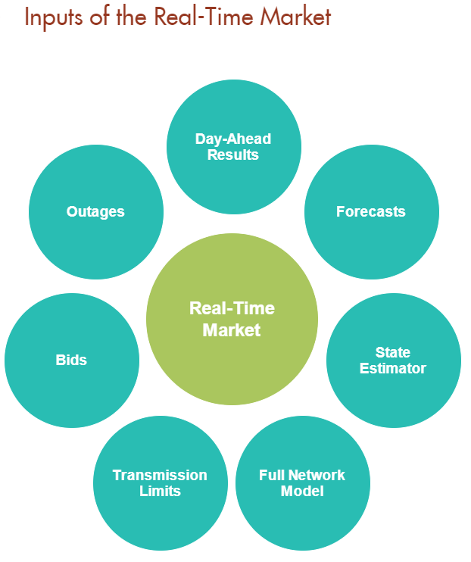

Question No. 5
In Exhibit SDGE-22, Ms. Montanez states at page JM-15, lines 1-3, “... JARP admits a similar type of rate proposal has never been adopted by any public utility commission and thus can provide no analogous support for its claims.” However, in Exhibit SDGE-15, at page JPS-29, lines 12 through 13, SDG&E witness Stein testifies: “Currently, SDG&E has several dynamic rate schedules available to its customers such as Critical Peak Pricing (‘CPP’) rates and Schedules GIR and VGI.”
- Is it SDG&E’s position that the rate schedules identified by Mr. Stein do not share any similarities with JARP-Enel’s proposed rate design?
- Does SDG&E agree that a rate design like that proposed by JARP-Enel is being offered to Direct Access customers and in regions with retail competition?

SDG&E Response:

- SDG&E does not believe that SDG&E’s current dynamic rates are similar to JARP/Enel’s proposed rate design. As stated in Ms. Montanez’ testimony, SDG&E currently does not have a dynamic rate with the complexities of a 15-minute interval configuration or pricing calculated using the RTM pricing (5-minute intervals).
- SDG&E objects to this request, as it assumes facts not within the scope of Ms. Montanez’ testimony. JARP-Enel did not submit evidence regarding Direct Access customers and regions with retail competition; therefore, Ms. Montanez did not respond to such evidence. SDG&E does not have sufficient knowledge of current rate options for Direct Access customers in other regions.

Question No. 6
In Exhibit SDGE-22, at page JM-25, lines 17-19, Ms. Montanez testifies: “From a billing perspective, SDG&E currently anticipates that the process of implementing an hourly RTP rate, billed on the CAISO day-ahead hourly prices, would not be able to begin until some point in 2022.” What aspect of “billing” causes a delay in implementation of an hourly RTP rate until “some point in 2022”, even if this rate would be based on the hourly day-ahead prices?

SDG&E Response:
SDG&E is in the midst of implementing a Customer Information System (CIS) Replacement Program that was approved by the Commission in D.18-08-008. D.18-08-008 approved an all-party settlement which included the CIS Replacement Program cost and the CIS Replacement Program’s projected timeline. The implementation timeline includes a “freeze period” on changes to SDG&E’s existing legacy CIS to reduce the overall risks and customer impact during the transition to the new CIS. The “freeze period” requires that any new structural rate changes or other similar initiatives be deferred until the new CIS goes live to permit transition from the legacy CIS to the new CIS. The “freeze period” began in January 2020 and continues until the new CIS goes live in April 2021. As a result of the current freeze on system changes, SDG&E cannot make any changes to its legacy CIS. SDG&E currently plans that it will need a 6-9 month system stabilization period after the April 2021 go-live date. The stabilization period after the new system goes live is to ensure that issues are resolved and customers are being billed correctly under the current framework before any new structural changes are implemented.

As stated in Ms. Montanez’ testimony, at page JM-22 lines 16-19, “The new CIS system is expected to go live in April 2021. The implementation timeline includes a “freeze period” on changes to SDG&E’s legacy CIS system during 2020 and 2021 to reduce the overall risks and customer impacts during the transition to the new system.” Since SDG&E’s CIS system currently has a “freeze period” through 2021 and SDG&E’s new CIS system will need a stabilization period of 6-9 months once it goes live, any new rate schedule(s) could not be implemented until “some point in 2022.”

https://www.sdcommunitypower.org/about-us
https://solanaenergyalliance.org/about/faqs/#toggle-id-5
https://solanaenergyalliance.org/billings-rates/sea-rate-schedule/

