1. Regarding SDG&E’s response to DR TURN-02, question 5 and BAM-1: Please
provide, in a readily workable Excel spreadsheet, the data for each of these charts:

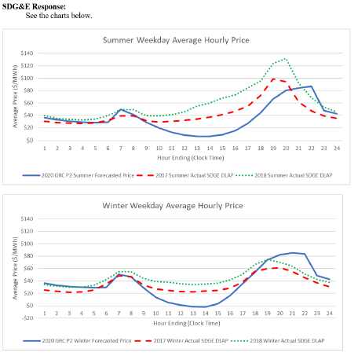

SDG&E Response:
Please see the attached spreadsheet.

2. Please confirm if SDG&E’s confidential response to DR TURN-01 Question 3b is
in fact average costs of generation. The numbers for the plants appear they may
be totals, undivided by MWs.

SDG&E Response:
No. They are in fact the costs invoiced in the respective years but were not divided by MWh’s. Please see the attached average costs by generator in $/MWh. This response has been redacted and excludes the confidential Excel File.

