DATA REQUEST & SDG&E Responses to Questions 1 – 14 & 29

1. Re - BAM 3 - 7 Marginal Energy Cost:

a. Is the Company a net purchaser for all 12 months? If not, please list the months that the Company is a net supplier.

SDG&E Response:
Yes, SDG&E is a net purchaser for each of the previous 12 months.

b. Please provide forecasted hourly profile based on net demand in the SP-15 market.

SDG&E Response:
SDG&E objects to this request to the extent it is not reasonably tailored to lead to the discovery of relevant, admissible evidence and/or seeks information that is not within SDG&E’s control and possession or otherwise would be unduly burdensome to produce. Subject to and without waiving this objection, SDG&E responds as follows:

SDG&E does not have the forecast data for all resources within the SP-15 zone to be able to calculate the net demand for the entire SP15 zone. SDG&E has calculated the net demand for SDG&E’s region, and it is shown in workpaper “Ch_6_WP#1_Marg Gen Comm Cost_Public.xlsx on tab “Net Load”

c. Please provide for the last 5 rate cases, forecasted hourly price shape and for the same time periods, actual SDG&E Default Load Aggregation Point (DLAP) akin to Chart BAM-1, but for matching time periods.

SDG&E Response:
SDG&E objects to this request to the extent it is not reasonably tailored to lead to the discovery of relevant, admissible evidence and/or seeks information that is not within SDG&E’s control and possession or otherwise would be unduly burdensome to produce. Subject to and without waiving this objection, SDG&E responds as follows:

SDG&E has the data provided for the 2016 General Rate Case Phase 2 (GRC). Shown below is a comparison of the forecasted 2016 net load shape as shown in RBA-1 in the testimony of Rob Anderson in the 2016 GRC Phase 2. This shape is compared with the corresponding actual DLAP price data for the same time period. 2016 data are more representative of current system conditions than data from the 4 additional rate cases prior to 2016, which are not available.

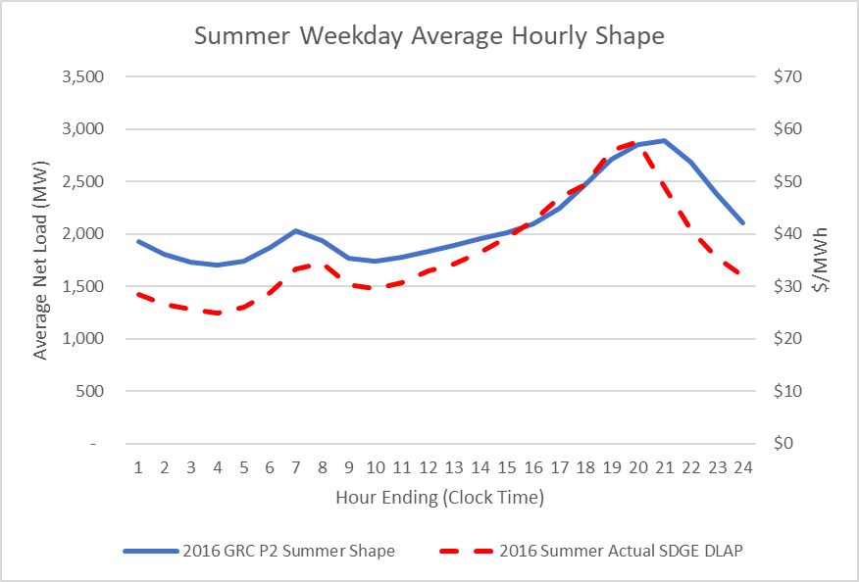

d. Please provide the actual 2018 hourly load profiles for each class of customer.

SDG&E Response:
See the attached spreadsheet. 2018 Actual Hourly Load Profiles are based on publicly available Dynamic Load Profiles.

e. Please provide average (monthly peak/customer) peak, in usage, for residential customer class for each month for the past 6 years.

SDG&E Response:
SDG&E objects to this request to the extent it is not reasonably tailored to lead to the discovery of relevant, admissible evidence and/or seeks information that is not within SDG&E’s control and possession or otherwise would be unduly burdensome to produce. Subject to and without waiving this objection, SDG&E responds as follows:

See the attached spreadsheet. Residential Average of Monthly Maximum Peaks are based on hourly kWh values, since most Residential Customers do not have 15-minute data available. The averages were calculated on all single meter customers and excludes multi metered customers on the following rate scheduled: DM, DS, DT and DTRV, which account for less than half (.5) a percent of the Residential class.

2. RE - BAM 1: Please explain in calculating marginal energy costs why the Company uses market prices. That is, why does the company not use marginal cost of service for its existing plants.

SDG&E Response:
Market prices represent the marginal price that the market will bear to serve our customers’ energy, whether it is provided by our existing plants or by power purchased from the broader market. The marginal cost of service for our existing plants is only a partial representation of the sources of energy our customers have access to.

3. RE: BAM 1: With the approach that the Company takes, in using market prices to proxy marginal energy costs:

a. Does the market price contain influence from, or account for, peak demand?

SDG&E Response:
Yes, the market price reflects the market’s expectation of marginal energy price due to generation supply as it relates to demand in every hour of the year, including the peak hours.

b. Please provide the average market price and the average marginal plant cost for each month for the past two years, for each of SDG&E’s generation resources (in $/MWh).

SDG&E Response:
See the embedded spreadsheet for the average market prices and average marginal plant costs for each of SDG&E’s conventional generation resources for each month of 2017 and 2018. Renewable generation was excluded, as the renewable marginal cost is functionally zero, since the contract cost of renewable generation is paid regardless of market conditions. This response contains Confidential Information and has been redacted.

4. RE - BAM 6 lines 1-3: Please provide the 2018 monthly average differential between renewable power market prices and non-renewable market prices for the SP-15 that the Company operates in.

SDG&E Response:
The differential between renewable power market prices and non-renewable market prices equals the Renewable Energy Credit (REC) price, since both renewable generation and non-renewable generation have an equivalent conventional market price component. The REC price that SDG&E used for its marginal price calculations is the market price benchmark calculated by the CPUC Energy Division using 2018 REC transactions for both WECC wide and IOU transactions. These values are typically provided on an annual basis and not on a monthly basis, so SDG&E is unable to provide a monthly variation of the REC value in 2018.

5. RE - BAM 4: Please provide graphs analogous to Chart BAM 1 and Chart BAM 2, but instead with $/MWh on the vertical axis.

SDG&E Response:
See the charts below.

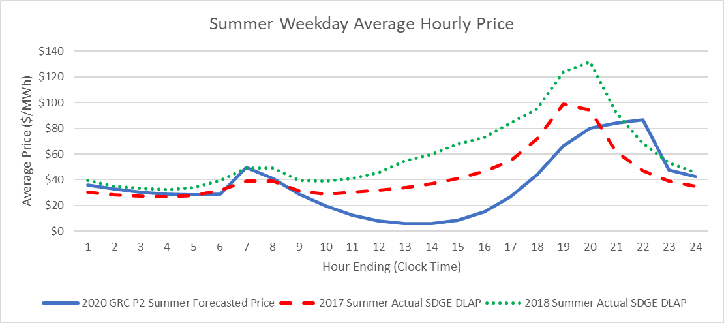

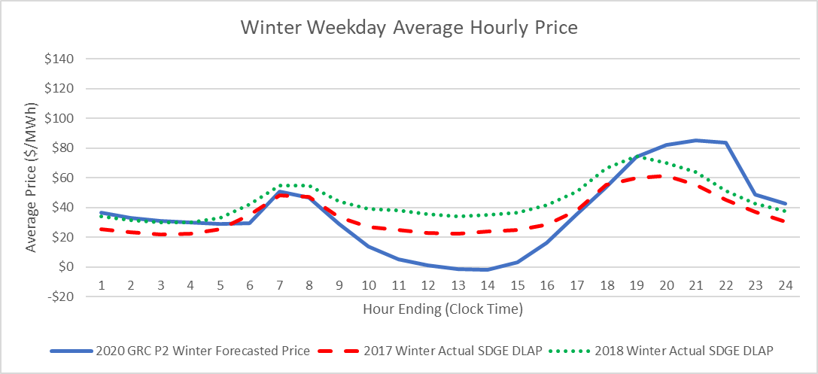

6. RE -BAM 4: Using the same methodology as described in BAM 4 line 6 – BAM5 line 6, please insert “monthly on peak and off peak DLAP prices” for “monthly CAISO on-peak and off-peak forward prices” and provide the results.

SDG&E Response:

SDG&E objects to this request to the extent it is not reasonably tailored to lead to the discovery of relevant, admissible evidence and/or seeks information that is not within SDG&E’s control and possession. Subject to and without waiving this objection, SDG&E responds as follows:

SDG&E is not able to respond to this request as there is not a forward price curve for DLAP prices. This is the reason SDG&E uses CAISO on and off-peak SP15 prices as a proxy for the DLAP price.

7. RE - BAM 4: For the time periods shown in Chart BAM 1 and Chart BAM 2, please provide for the Company’s own generation, the renewable percentage of its generation at the DLAP output, or if that data is not available, overall capacity.

SDG&E Response:
SDG&E interprets this request as seeking the percentage of SDG&E’s renewable generation to its total portfolio generation for each summer and winter weekday average hour. SDG&E used 2018 data to respond to this request. See the charts below.

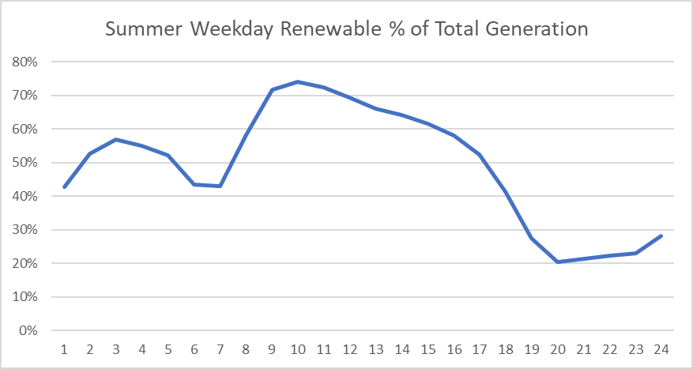

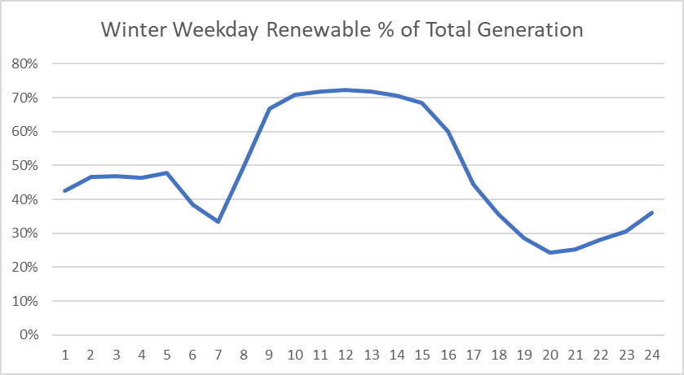

8. RE -BAM 4: For the time periods shown in Chart BAM 1 and Chart BAM 2, please provide the portion of energy that the Company (1) produces and (2) procures via CAISO.

SDG&E Response:
SDG&E interprets this request as seeking SDG&E’s total portfolio generation and CAISO market purchases as %’s of the sum of both for each summer and winter weekday average hour. SDG&E used 2018 data to respond to this request. See the charts below.

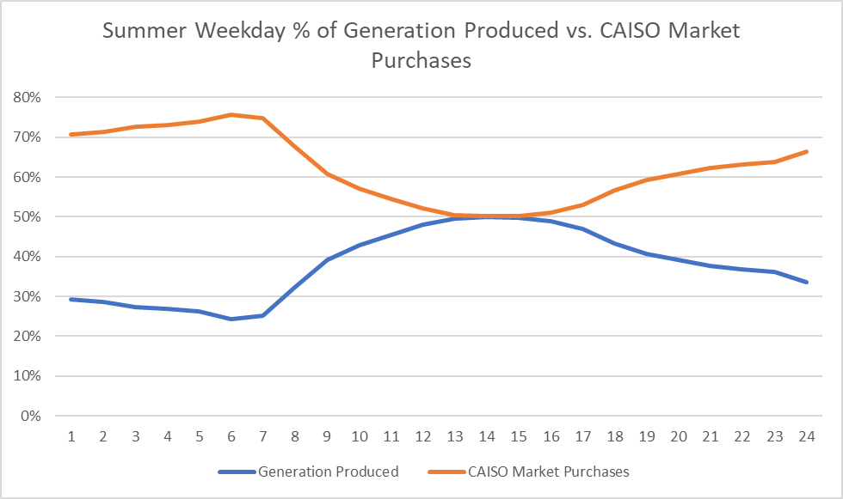

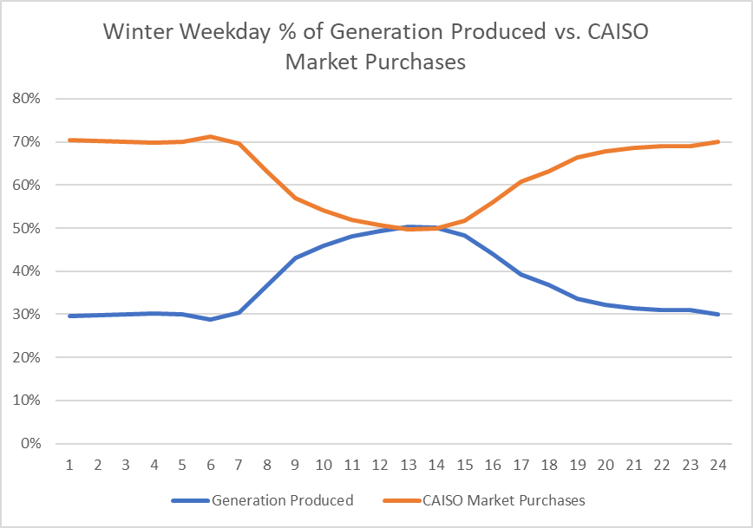

9. RE - BAM -5 Table BAM1 &BAM 4 Chart BAM2:

a. Given that for a large period of the day (10-16 hours) the 2020 GRC P2 winter shape (hourly price) Ratio with annual price is below .5 please explain why all the MEC factors are above .5 in Table BAM 1. Please provide the tables used to produce the MEC calculations or point to the location in the filing where they exist.

SDG&E Response:
The MEC Factor calculations are performed in workpaper “Ch_6_WP#1_Marg Gen Comm Cost.xlsx on tab “Prices Summary”. Hours 10-16 represent 7 of the 24 hours of the day so only less than 1/3 of the hours have factors that are less than 0.5. Also, the average factor for the day is greater than 1.0.

10. RE - BAM 4 line 6:

a. Given that SDG&E only operates in SP-15, are the “CAISO on peak and off-peak prices” referring to prices at the SP-15 node? If not, please explain why and what locational prices are used.

SDG&E Response:
Yes, SDG&E is referring to SP15 on- and off-peak prices.

11. RE - BAM 7 lines 3-8:

a. Please confirm whether, for the marginal generation capacity costs, whether these are applied only to the peak 100

SDG&E Response:
Yes, the marginal generation capacity costs are only applied to the top 100 hours.

12. RE - BAM 11 lines 13-19:

a. Given the Company’s LOLE approach, does LOLE imply that the resources do not meet demand (or would not meet demand) for the entire hour in the top 100 hours identified (TURN understands that this is not predicting unmet need, just simulating if there was unmet need, when it would occur). For instance, if an hour is identified, using LOLE analysis does the Company distinguish between an hour where 15 minutes of demand is unlikely to be met and an hour where 30 minutes of demand is unlikely to be met.

SDG&E Response:
Our methodology does not distinguish between sub-hourly vs. hourly outages for two reasons: the TOU periods do not distinguish time periods less than one hour and the LOLP analysis is only modeled on an hourly basis. LOLP measures the relative need between hours and treats each hour as a separate and equal time step for purposes of the analysis. Energy is either served or not served in a given hour.

b. For the last 5 years, for each outage related to insufficient resources,
please classify the outage as (1) 0-15 minutes (2) 15-30 minutes (3)
30-45 minutes or (4) 45-60 minutes.

SDG&E Response:
In the last 5 years, SDG&E has not experienced an outage that was caused by insufficient resources.

13. RE - BAM 12 lines 1-2: Does the Company use a moving average, or account for changes in usage and DG and renewable deployment?

SDG&E Response:
Referring to the LOLP analysis, SDG&E does not use a moving average. The model used for LOLP accounts for variations in load and renewable deployment by quantifying the historical relationship between load and renewables and then generating multiple future modeled results while maintaining these relationships. This produces a distribution of future results based on historical relationships.

14. RE - BAM 13 lines 11-13. Historically, when the Company has experienced a loss of load, please provide for the last 5 years, the number of hours that are due to insufficient distribution resources and the number of hours that are due to insufficient generation and lack of ability to make market purchases

SDG&E Response:
In the last 5 years, SDG&E has not experienced a loss of load (outage) which was caused by insufficient distribution resources, insufficient generation, or lack of ability to make market purchases.

29. RE JS 6-9 - On average, for each school in a distribution area, how many residences are located, and please provide the cumulative load profile for both.

SDG&E Response:
Please see the embedded Excel File named: TURN_DR_Q29

