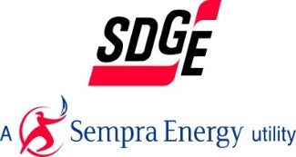
Supplier Quick Pay Program (SQPP) Enrollment Application
Email completed form to supplierdiversity@sempra.com, Attn: COVID-19 SQPP Enrollment
Company Name:
DBA:
Address:
City: State: Zip:
CPUC/Von # if applicable: SIC Code:_______________
Contact Person: Title:
Phone Number of Contact Person:
Email Address of Contact Person:
SDG&E Purchase Order Number(s):
Name of SDG&E Contracting Agent: ______________________________________________
SDG&E Purchase Order Start Date(s):
SDG&E Purchase Order End Date(s):
Annual Amount of SDG&E P.O.(s):
Total Annual Revenue of Your Company:
Total Number of Full Time Employees at Your Company:
Describe how COVID-19 has negatively impacted your business: ________________________
______________________________________________________________________________

For SDG&E Internal Use Only
Enrolled: _____ Date of Enrollment: __________ Date Payment Terms Modified:
Not Enrolled: _____ Reason If Not Enrolled:
SDG&E Reviewer: ______________________SDG&E Contract Agent_______________________

