Attachment C

San Diego Gas & Electric Company  
2020 Energy Efficiency Portfolio Analysis

2020 Energy Efficiency Portfolio Analysis

This section is intended to provide a discussion of the analysis SDG&E undertook to develop its 2020 Energy Efficiency Portfolio.

### A. Cost Effectiveness Assumptions

**Table 1: 2020 EE Portfolio Cost Effectiveness**

|  |  |  |  |
| --- | --- | --- | --- |
|  | TRC Ratio | PAC Ratio | RIM Ratio |
| Without Codes & Standards (C&S) | 1.26 | 1.49 | 0.61 |
| With Codes & Standards (C&S) | 1.47 | 4.12 | 0.56 |

SDG&E’s 2020 TRC and PAC results reflect the following inputs:

1. Updated 2020 avoided costs and greenhouse gas adder consistent with Resolution E-5014;
2. Excludes Emerging Technology, On-Bill Financing (OBF) revolving loan pool, and credit enhancements;
3. Excludes Market Effects (ME) based on D.19-08-034, which eliminated the 5% spillover for resource programs;
4. Uses workpapers that are approved by staff as of September 1, 2019;
5. D.19-08-034 provides the direction for forecasting for solicitations:

The IOUs shall align these Third Party program forecasts pending from solicitations as much as possible with the forecasting methods used for custom projects (in terms of measures and measure mix being “unknown” prior to a program year), as they develop PY 2020 third-party program savings forecasts.[1]

* 1. For local Third Party program forecasts pending from solicitations, SDG&E used the same forecasting methods used for custom projects (in terms of measures and measure mix being “unknown” prior to a program year). SDG&E provided its expected net benefits for proposed programs in the Request for Proposal (RFPs). To achieve the same RFP net benefits in its forecast, SDG&E selected “representative” custom end use measures whose savings would provide the same net benefits. In most cases, the Retrocommissioning (RCx) and “Whole Building” measure savings provide the expected result. It is important to note that these selections are not necessarily what bidders are expected to propose. Rather, SDG&E expects that after Third Party programs are selected with their own proposed measures, the resulting portfolio of programs for the market sector will result in the expected net benefits. SDG&E also expects that the selected programs will perform at least if not better that SDG&E’s current program implementations. This is consistent with the Commission’s expectation that Third Party programs can bring on more innovative and cost effective programs.
  2. For statewide Third Party programs, forecasted savings are based on the funding share method approved in the Joint IOUs Supplemental Advice Letter of the Shared Funding Mechanism Proposal submitted on November 15, 2018.[2] SDG&E’s portfolio, consistent with the other IOUs, only includes at this time Statewide Codes & Standards programs. The lead IOU, PG&E, provided SDG&E with its expected share of savings for the programs based on the agreed upon budget contribution.

1. Includes estimated Energy Savings Performance Incentive payments of $3.5 million; and
2. Includes indirect labor loaders adopted in SDG&E’s 2016 GRC D.16-06-054.

# B. Development of Portfolio Savings and Validation Against the 2019 Potential and Goals Study

1. SDG&E reviewed its 2019 portfolio of measures and as noted in the Advice Letter, reduced or eliminated non-cost-effective measures, measures that will be retired due to the updated Codes and Standards (Title 24 and Title 20), and/or measures with low customer demand.
2. SDG&E also updated all the savings assumptions based on SDG&E updated the measure savings assumptions based on DEER 2020, and all applicable deemed measure work paper dispositions.

The following table[3] summarizes the impacts of the above actions:

**Table 2: Major Portfolio Changes**

| **2020 Change** | **Portfolio Impact (+ or -)** | **Rationale** |
| --- | --- | --- |
| Removal of all screw-in lighting measures | Negative - - - - | Per CPUC memo June 14, 2019 - baseline for all screw-in lamps is considered 100% LED in upcoming DEER 2020 update. In 2019, the primary lighting program accounted for approximately 60 GWh of Net kWh at an approximate cost of $8million. |
| Smart Thermostat Savings Reduction | Negative - - | Per 4/5/19 CPUC Memo - savings reduced for smart thermostats by approximately 75% across all CZ's and residential building types. Reducing measure TRC from approximately 1.0 to about 0.35 which significantly impacted the Plug Load & Appliance net benefits |
| Commercial LED T8 Lamps | Negative - | Due to the statewide workpaper updates, these savings decreased by approximately 25% (39 kWh/unit to 29 kWh/unit) |
| Commercial LED Fixtures | Negative - | Due to the 2019 workpaper updates, these savings decreased by approximately 60%  (24kWh/unit to 9 kWh/unit) |
| Creation of Statewide Workpapers | Neutral | IOUs were ordered to create a single statewide workpaper for all 2020+ offerings instead of 4 individual IOU workpapers for the same measure. In their creation & measure update, some savings decrease while others increased. |
| Ramp Down of low TRC programs (<0.1) | Positive + | These programs (3212,3302, etc.) historically had very low (< 0.1) TRC's. Although their overall net impact was minimal, their removal is a positive net benefit |
| Multifamily LED T8 Lamps | Positive ++ | Resulting from updating the statewide T8 LED workpaper - the savings increased by 97% (45 kWh to 85 kWh) for multifamily measure install types which is the main positive measure for the multifamily program |
| Addition of new high TRC statewide measures | Positive ++ | Statewide workpaper updates increased savings significantly (2-4x) for low flow showerheads & faucet aerators in the residential sector which are higher TRC measures. Additionally, statewide workpaper creation for Steam/HW pipe & tank insulation measures which are high TRC measures (2.0+) in the commercial sector |

# B. 2019 Top Ten Portfolio End Uses or Measures

The following tables provides the list of top 10 electric measures and natural gas measures based on its savings contribution to the portfolio. SDG&E conducted an analysis of the SDG&E service territory data provided as part of the *2019 Energy Efficiency Potential and Goals Study* (P&G Study),[4] adopted by D.19-08-034. The focus of determining the viability of the SDG&E forecast is based on the P&G Study’s SDG&E market and economic potential. This is a reasonable basis for determining the feasibility of the forecast since both the P&G Study’s economic and market potential measures are selected based on a TRC of ≥ 1.00.

### 1. Electric Measures

The following Figure illustrates contribution of electric savings to the portfolio by sector:

**Figure 1: Electric Savings Contribution by Sector**

The following table shows the top 10 electric measures (GWH) of the portfolio and the forecasted savings.

**Table 3: Top 10 Electric End Uses/Measures**



As noted in the previous section, SDG&E provided its expected net benefits for proposed programs in the Request for Proposal (RFPs). To achieve the same RFP net benefits in its forecast, SDG&E selected “representative” custom end use measures whose savings would provide the same net benefits. In most cases, the Retrocommissioning (RCx) and “Whole Building” measure savings provide the expected result. It is important to note that these selections are not necessarily what bidders are expected to propose. Rather, SDG&E expects that after Third party programs are selected with their own proposed measures, the resulting portfolio of programs for the market sector will result in the expected net benefits. The new Commercial sector Third Party programs savings forecast reflect this assumption, Commercial Small Customer Services (<20KW) Program (4003) and Commercial large Customer Services (>20KW) Program (4004).

Table 4 below shows the comparison of the forecast with the identified economic potential for SDG&E in the 2019 Potential and Goals Study.[5]

**Table 4: Comparison of Electric (KWH) Forecast with Economic Potential**

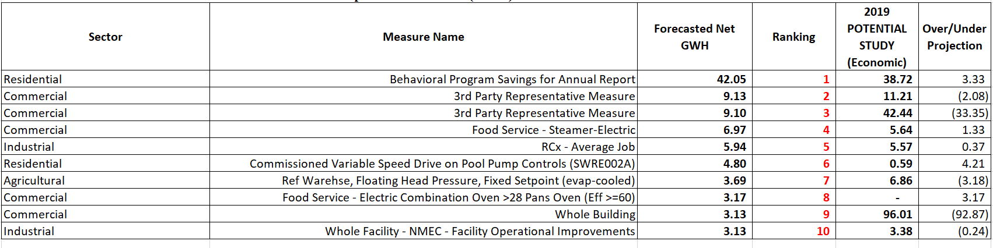

The following specific 2019 P&G Study measures were used to aggregate to match up with the forecasted measure.

**Table 5: Potential Study Electric Measures Used for the Electric Forecast**

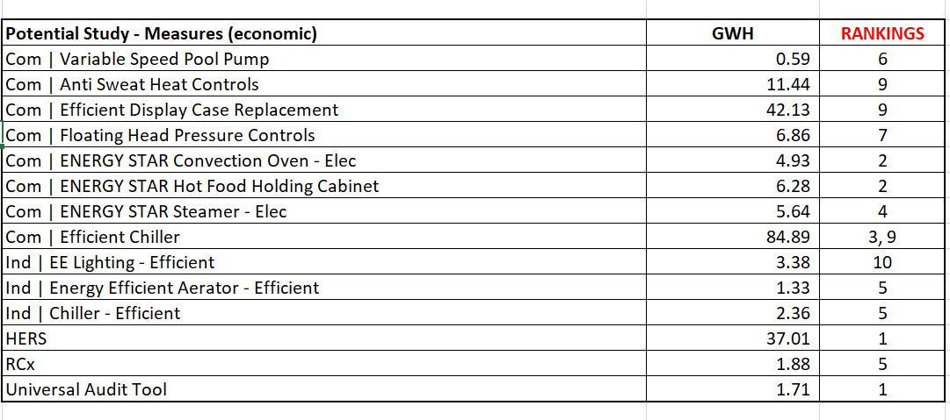

The rankings reference the rank of the forecasted measure in Table 4 above. To estimate the total potential savings for the forecasted measure, the associated Potential measure savings were summed. If the Potential measure is assigned several rankings, then the Potential Savings were equally divided between the forecasted measure to estimate the Potential Savings.

Three measures exceed the economic potential, RCx for Industrial, LED T8 lamp retrofits for Commercial and Residential pool pump controls. SDG&E believes that these are reasonable stretch goals. With the Retrocommissioning (RCx) program underway, SDG&E believes that additional customers could be added in the coming year. The LED T8 lamps are still available as viable measures such that both the Commercial Midstream Rebate and Direct Install programs would avail of this opportunity. With respect to residential pool pumps, with the continued roll out of the Time-of-Use rates, pool pump controls provide opportunities for savings to these customers. In addition to residential pools, San Diego’s Environmental Health department estimates that there are at approximately 4,000 public pools and spas under permit, including those located in apartments, hotels, parks, health clubs, bathhouses, and other health-regulated recreational establishments that can participate in SDG&E’s pool pump control rebate through its Plug Load and Appliance program.

Note that the Potential LED measures that are identified as “Low Income” are assumed to go to common areas that are serviced through the Commercial programs. The Potential measures associated with the Behavior program savings are measures that a customer can undertake if recommended in a HERS audit.

### 2. Natural Gas Measures

The following figure illustrates contribution of gas savings to the portfolio by sector:

**Figure 2: Natural Gas Savings Contribution by Sector**

The following table shows the top 10 natural gas measures (Millions of therms) of the portfolio and the forecasted savings.

**Table 6: Top 10 Natural Gas End Uses/Measures**



As noted in the previous section, SDG&E provided its expected net benefits for proposed programs in the Request for Proposal (RFPs). To achieve the same RFP net benefits in its forecast, SDG&E selected “representative” custom end use measures whose savings would provide the same net benefits. In most cases, the Retrocommissioning (RCx) and “Whole Building” measure savings provide the expected result. It is important to note that these selections are not necessarily what bidders are expected to propose. Rather, SDG&E expects that after Third Party programs are selected with their own proposed measures, the resulting portfolio of programs for the market sector will result in the expected net benefits. The new Commercial sector Third Party programs savings forecast reflect this assumption, Commercial Small Customer Services Program (4003) and Commercial large Customer Services Program (4004).

Table 7 below shows the comparison of the forecast with the identified economic potential for SDG&E in the 2019 Potential and Goals Study.

**Table 7: Comparison of Natural Gas (MMThm) Forecast with Economic Potential**

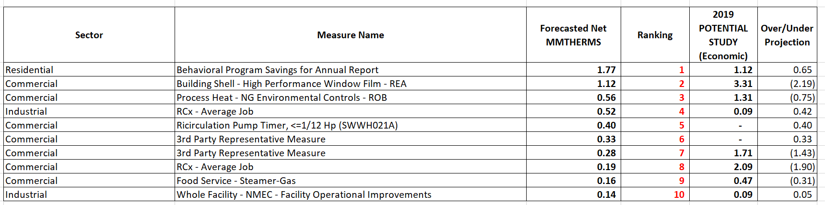

The following specific 2019 P&G Study measures were used to aggregate to match up with the forecasted measure.

**Table 8: Potential Study Natural Gas Measures Used for the Gas Forecast**

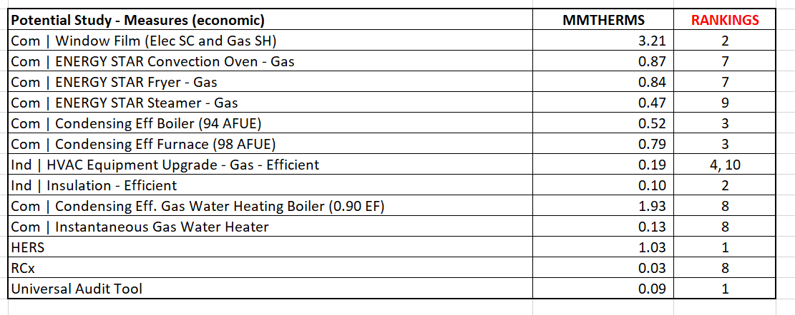

The rankings reference the rank of the forecasted measure in Table 7 above. To estimate the total potential savings for the forecasted measure, the associated Potential measure savings were summed. If the Potential measure is assigned several rankings, then the Potential Savings were equally divided between the forecasted measure to estimate the Potential Savings.

Three measures exceed the economic potential, Behavior Program, Recirculation Pump Timer (HVAC) for Commercial, and Process Heat for Industrial. SDG&E believes that these are reasonable stretch goals. With respect to the Behavior Program, SDG&E is expecting to be able to increase customer participation by working with Energy Division Staff to use alternative sampling methodologies to reduce the number of the control group so that more customers can receive HERs reports. With respect to the Process Heat for Industrial, the 2019 P&G Study shows the following measures that would count towards this measure end use.[6] The 2019 P&G Study further states, “Among end-use categories that capture potential from discrete measures that produce deemed savings, process heat dominates gas potential in the agriculture and industrial sectors, followed by HVAC across all scenarios.”[7] Although, SDG&E selected a representative measure from the 2019 P&G Study, SDG&E is anticipating that the potential exists in its service territory and that its SEM program[8] and new Third Party implementers will address this potential in the programs.

**Figure 3: Excerpt from 2019 P&G Study Regarding Industrial Measures Used in the Model[9]**

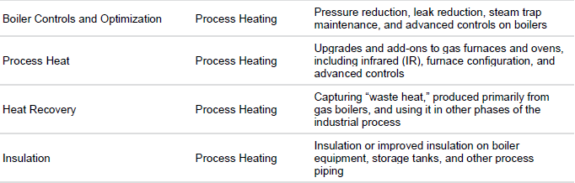

### 3. Net Benefits

The following are the top 10 End Uses/Measures based on their net benefits contribution to the portfolio.

**Table 15: Top 10 End Uses/Measures by Net Benefits**

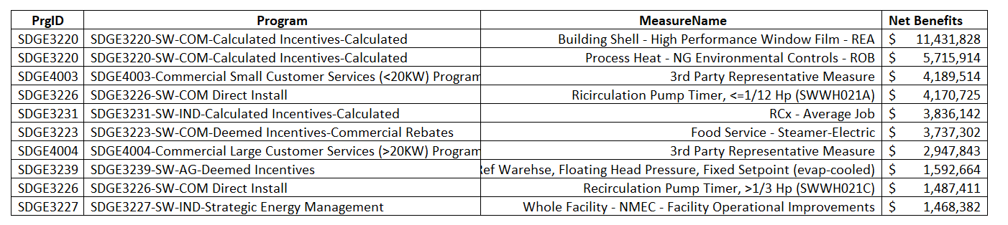

The top 10 forecasted measures that contribute to the majority of SDG&E’s Portfolio net benefits are combinations of the measures identified as either top 10 electric and/or natural gas measures. The 2019 P&G Study does not provide net benefits, therefore the reasonableness of the net benefits is a function of the reasonableness of the electric and gas measures identified as the leading portfolio measures.

1. D.19-09-034, p. 30.
2. San Diego Gas and Electric Company (SDG&E) Advice 3268-E-A/2701-G-A; Southern California Gas Company (SoCal Gas) Advice 5346-G-A; Southern California Edison Company (SCE) Advice 3861-E-A; and Pacific Gas and Electric Company (PG&E) Advice 5373-E-A/4009-G-A).
3. This is Table 12 in the Advice Letter.
4. 2019 Energy Efficiency Potential and Goals Study, Navigant Consulting, Inc., July 1, 2019.
5. 2019 Energy Efficiency Potential and Goals Study, Navigant Consulting, Inc., July 1, 2019.
6. 2019 Energy Efficiency Potential & Goals Study, p. D-2.
7. *Id*., p. 98.
8. *Id*., Table C-17, p. C-29.
9. *Id*., p. D-2.