Attachment B
San Diego Gas & Electric Company
Supplemental Budget Narrative

Table of Contents

Table of Contents 2
I. Introduction 1
II. Description of In-House organizational Structure and Associated Costs 1
A. Narrative Description of In-House Departments/Organizations Supporting the PA's EE Portfolio 1
B. Table Showing PA EE "Full Time Equivalent" Headcount by Department/Organization 4
SDG&E Response: 4
C. Table Showing Costs by Functional Area of Management Structure 4
D. Table Showing Cost Drivers Across the EE Organization 5
SDG&E Response: 5
E. Explanation of Allocation of Labor and O&M Costs Between EE-Functions and GRC- Functions or Other Non-EE Functions 5
III. BUDGET TABLES INCLUDING INFORMATION IDENTIFIED IN THE SCOPING MEMO 6
A. Attachment-A, Question C.8 6
B. Attachment-A, Question C.9 7
C. Attachment-A, Question C.10 7
Appendix A—2019 Energy Efficiency Management Organization Chart 8

Attachment B

San Diego Gas & Electric Company
Supplemental Budget Narrative

Introduction
This supplement is provided in compliance of D.18-05-041 Ordering Paragraph 44.
44. Beginning with the annual budget advice letters due on September 3, 2019, the program administrators must include updated budget estimates in the same format as the supplemental budget information filed in this proceeding on June 12, 2017.

Description of In-House organizational Structure and Associated Costs

A. Narrative Description of In-House Departments/Organizations Supporting the PA's EE Portfolio
1. Functions conducted by each department/organization
SDG&E Response:
Please refer to the definition of functions in the Attachment A Tab: Function Definitions.
- SDG&E's Customer Programs (CP) Department includes EE, Energy Savings Assistance (ESA), Demand Response and other non-EE customer programs; and Business Services. Managerial Areas under Customer Programs:
  - CP Energy Efficiency: manages all customer EE programs.
    - Residential programs: manages all residential programs
    - Nonresidential EE programs: manages all EE nonresidential programs.
    - Technology & Standards: manages Emerging Technology and Codes & Standard programs
    - Customer Resource Integration: manages Water Energy Nexus (WEN) and Integrated Demand Side Management (IDSM) programs and initiatives.
    - IDSM programs and activities
  - Residential Customer Programs: manages non-EE residential programs (including ESA, CARE); and WE&T
    - Energy Innovation Center (EIC): manages WE&T programs and education- related EE program initiatives in addition to managing SDG&E's EIC facility.
  - Business Analysis: manages finances and expenditures, including financial reporting, for the department.
  - Engineering Systems & Support: manages the engineering functions that support the programs (e.g., work papers, customer ex ante review process), EM&V, Inspections, Reporting and Processing.
  - Policy & Strategy: manages Customer Programs policy and strategy issues, including CPUC, CEC, legislative EE-related issues; and compliance and other and data request processes.
  - Product and Transition Management: manages development and management of potential customer-facing products and services, both EE and non-EE products.
    - Third Party Programs: manages all solicitations and EE third program management.
  - Business Services: manages all business customer services, including the promotion and support of EE programs and projects.
- Although an organization chart is not included, the following departments support EE programs.
  - IT department provides support for EE as required as it relates to EE systems support.
  - Marketing & Communications oversees the company's various marketing initiatives, research and analysis. It supports the EE Marketing Education & Outreach (ME&O) efforts.
  - Marketing Analytics may provide support for various customer surveys to support EE programs.
- Additional departments that support EE but do not bill to EE (not exhaustive) are Accounting (including Accounts Payable), Human Resources, Regulatory Case Management, Legal and Supply Management. These activities are covered through SDG&E's GRC.
2. Management structure and org chart SDG&E Response:
SDG&E Response:
See Exhibit A for the 2019 EE Management organization charts. This is the SDG&E EE organization as of this filing September 3, 2019.
3. Staffing needs by department/organization, including current and forecast for 2020, as well as a description of what changes are expected in the near term (2019-2020) or why it's impossible to predict beyond 2019, if that's the PA's position.
SDG&E Response:
As reflected in the Portfolio FTE Program Year 2020 forecast, there is natural attrition in FTEs, which continue to occur due to employee movements within the company, retirements and departures. In addition, program administration needs will change as new Third Party programs begin implementation. Their implementation may include program implementation support, e.g., processing, inspections, account representative services, etc. to which SDG&E will need to adjust its own in-house activities.
It should be noted that 2020 will be the first year of transitioning several programs to Third Party program implementation. In addition, PG&E anticipates that the Statewide Third Party Codes & Standards and New Construction programs will be in place. SDG&E anticipates that there will still be transitioning activities that will need to take place in the beginning of implementation that for the most part will not occur until Q3 2020 at the earliest. Clear staffing needs will not be final until the full deployment of solicitations and completion of outsourcing the portfolio in 2022.
4. Non-program functions currently performed by contractors (e.g. advisory consultants), as well as a description of what changes are expected in the near term (2019-2020) or why it's impossible to predict beyond 2018, if that's the PA's position.
SDG&E Response:
SDG&E continues to contract with various consultants who provide a variety of EE support services, including, but not limited to, engineering, reporting, portfolio analytics and forecasting, IT, rebate processing support, marketing, EM&V (e.g., process evaluations, customer surveys, etc.), and EE employee development.
5. Anticipated drivers of in-house cost changes by department/organization.
SDG&E Response:
Please refer to response to Question 3 above.
6. Explanation of method for forecasting costs
SDG&E Response:
SDG&E provided the various assumptions it used for its 2020 forecast in the section “2020 PORTFOLIO AND BUSINESS SECTOR CHANGES” in the Advice Letter. The following illustration summarizes the various planning steps SDG&E undertook to develop its proposed 2020 portfolio.
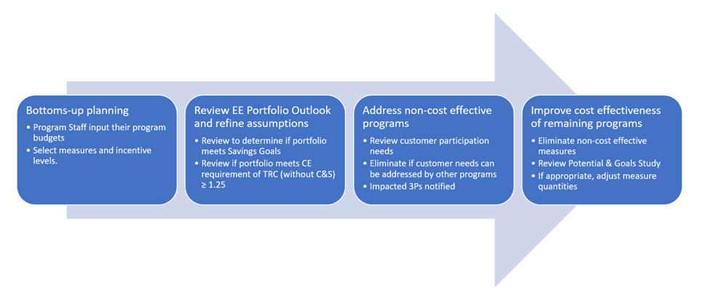

B. Table Showing PA EE "Full Time Equivalent" Headcount by Department/Organization
- TURN and ORA like this example, taken from testimony PG&E's 2017 GRC addressing its Energy Procurement department. We would be looking for 2016 or 2017 "recorded" positions, depending on what's most appropriate for the PA, or both, if that provides the most clarity. For forecast years, we'd want at least 2018. Note, if PA’s FTE needs change, these changes can be made without reporting or seeking CPUC approval.
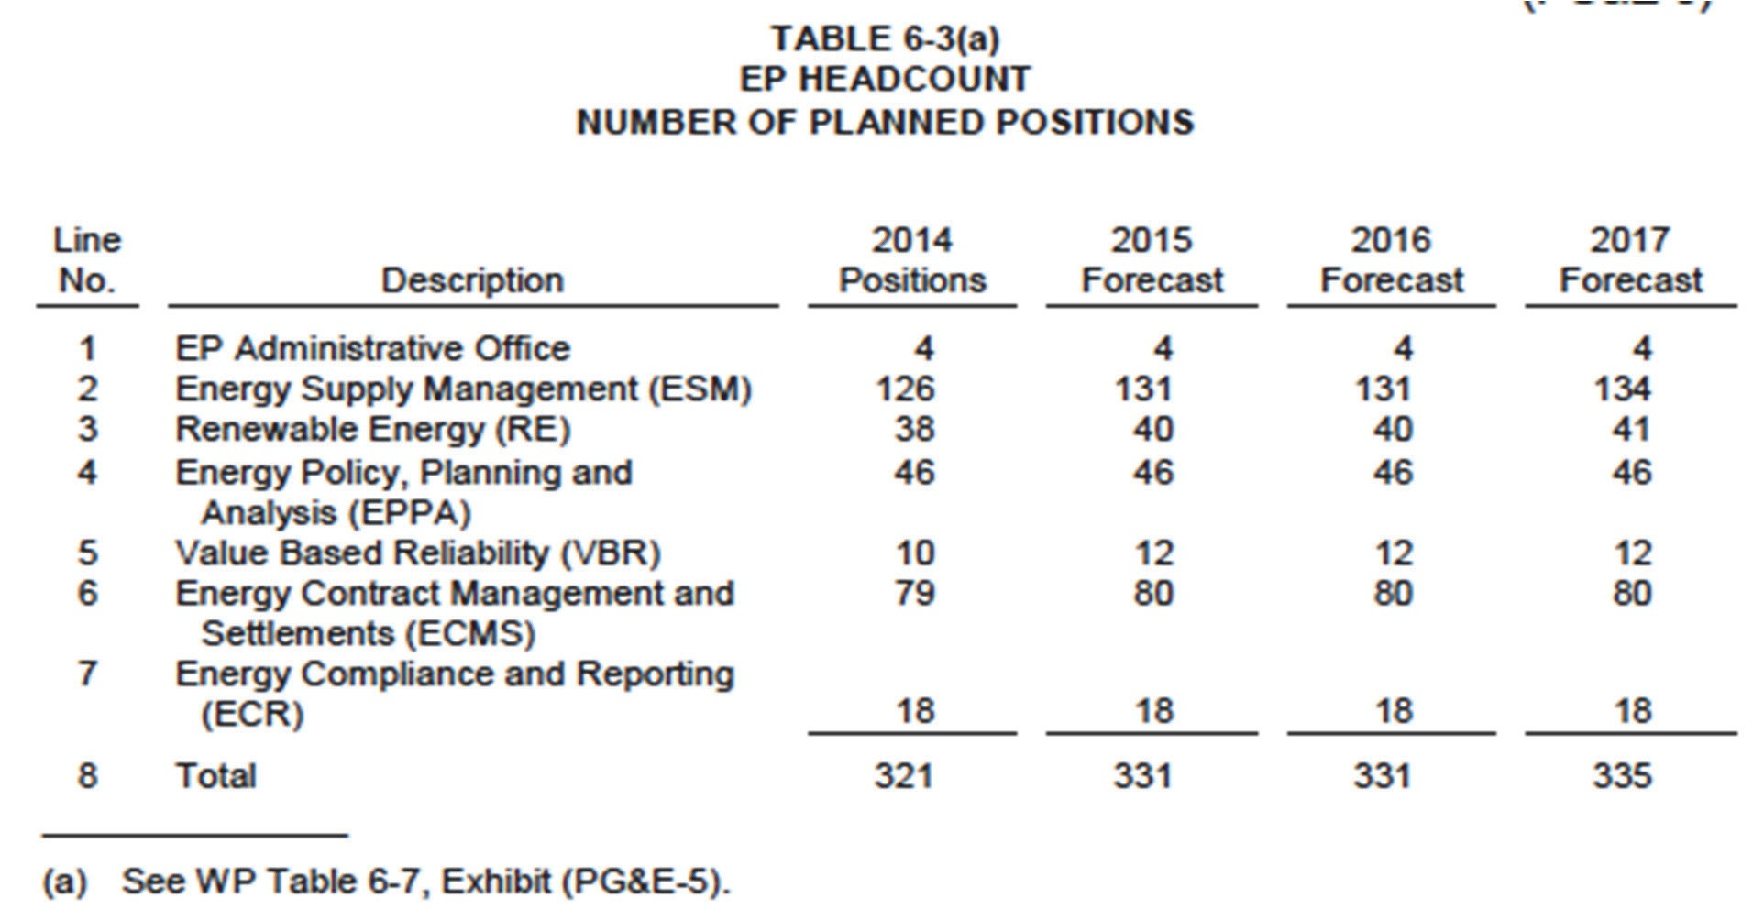

SDG&E Response:
Please refer to Attachment A for the following worksheets: Function Definitions and Table 10 Portfolio FTE. This table provides the full-time equivalents (FTEs) for 2018 and 2020. SDG&E calculated only productive hours, since the Vacation & Sick Leave (V&S) is covered separately but will be represented in the fully loaded value of the various FTEs. SDG&E calculated an FTE as follows:
The productive hours would not include:
- vacation (2.5 weeks = 100 hours);
- holidays/floaters (14 days = 112 hours); and/or
- sick leave (10 days = 80 hours).
Therefore, the annual hours for an FTE would be approximately 1788 (2080 - 292) or 149 hours a month.

C. Table Showing Costs by Functional Area of Management Structure
- Expenses broken out into labor, non-labor O&M (with contract labor identified).
SDG&E Response:
Please refer to Attachment A worksheet: Table 9 Portfolio Summary.
- Identify any capital costs.
SDG&E Response:
SDG&E did not identify any capital costs in its forecast.

D. Table Showing Cost Drivers Across the EE Organization
- TURN and ORA like this example, taken from testimony PG&E's 2017 GRC addressing its Energy Procurement department. While this example pertains to departmental cost increases, in our case, cost increases or decreases would be attributed to major cost drivers.
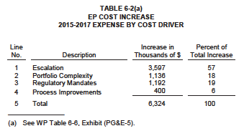

SDG&E Response:
SDG&E does not have data comparable to the data illustrated in the sample table above.

E. Explanation of Allocation of Labor and O&M Costs Between EE-Functions and GRC- Functions or Other Non-EE Functions
11. When an employee spends less than 100% of her/his time on EE, how are costs tracked and recovered (e.g., on a pro rata basis between EE rates and GRC rates; when time exceeds a certain threshold, all to EE; etc.).
SDG&E Response:
SDG&E tracks each employee's time through cost centers and internal orders. For its EE programs, SDG&E has an extensive set of internal orders and cost centers to track programs and cost categories (Administration, Marketing, Direct Implementation). Similarly, non-EE GRC work hours are charged to appropriate cost centers and internal orders.
All labor hours, which are tracked in SDG&E's My Time system, are approved on a bi-weekly basis by the employees' respective supervisors. Costs recorded in EE internal orders are tracked in the various EE balancing accounts for appropriate cost recovery.
12. Describe the method used to determine the proportion charged to EE balancing accounts for all employees who also do non-EE work.
SDG&E Response:
Each employee works with their respective supervisor to determine the appropriate hours or percentage of their time to be charged to various activities. This time allocation is reviewed periodically by the supervisor with their respective employees. Reorganizations are triggers for review of time allocations.
13. Identify the EE functions that are most likely to be performed by employees who also do non-EE work (e.g. Customer Account Representatives?)
SDG&E Response:
Please refer to the definition of functions in Attachment A: Function Definitions worksheet response to Question 1 above.
14. Are labor costs charged to EE fully loaded?
SDG&E Response:
No, SDG&E only charges vacation and sick leave and payroll taxes loaders to EE for EE FTEs. Pensions & Benefits (P&B) are part of GRC.
15. How are burden benefit-related administrative and general (A&G) expenses for employees who work on EE programs recovered (EE rates or GRC rates)?
SDG&E Response:
Please refer to response to Question 14 above.
16. When EE and non-EE activities are supported by the same non-labor resources, how are the costs of those resources or systems allocated to EE and non-EE activities?
SDG&E Response:
SDG&E charges and recovers non-labor costs as described in response to Question 11 above.
17. Identify the EE O&M costs that are most likely to be spread to non-EE functions as well as EE, if any.
SDG&E Response:
Not applicable.

BUDGET TABLES INCLUDING INFORMATION IDENTIFIED IN THE SCOPING MEMO

A. Attachment-A, Question C.8
"Present a single table summarizing energy savings targets, and expenditures by sector (for the six specified sectors). This table should enable / facilitate assessment of relative contributions of the sectors to savings targets, and relative cost-effectiveness."
18. TURN and ORA invite the PAs to propose a common table format for this information. We don't have anything specific in mind. Additionally, include a brief description of the method used by the PA to estimate the costs presented in the C.8 Table.
SDG&E Response:
Please refer to Attachment A: Table 9 Portfolio Summary worksheet.

B. Attachment-A, Question C.9
"Using a common budget template developed in consultation with interested stakeholders (hopefully agreed upon at a "meet and confer" session), display how much of each year's budget each PA anticipates spending "in-house" (e.g., for administration, non-outsourced direct implementation, other non-incentive costs, marketing), by sector and by cross-cutting program."
19. TURN and ORA invite the PAs to propose a common table format for this information. We don't have anything specific in mind.
SDG&E Response:
Please refer to Attachment A: Table 11 Residential, Table 12 Commercial, Table 13 Industrial, Table 14 Agricultural, Table 15 Public Sector, Table 16 Cross Cutting worksheets.
20. Additionally, include a brief description of the method used by the PA to estimate the costs presented in the C.9 Table.
SDG&E Response:
Labor costs by function use the standard SDG&E labor cost assumptions. Program Advisors, who plan the program budgets, determine the various functions required to support their programs. Non-labor costs are based on experience from previous program years and any updated activities. Managers review and approve the forecast.

C. Attachment-A, Question C.10
"Present a table akin to PG&E's Figure 1.9 (Portfolio Overview, p 37) or SDG&E's Figure 1.10 (p. 23) that not only shows anticipated solicitation schedule of "statewide programs" by calendar year and quarter, but also expected solicitation schedule of local third-party solicitations, by sector, and program area (latter to extent known, and/or by intervention strategy if that is more applicable). For both tables, and for each program entry on the calendar, give an approximate size of budget likely to be available for each solicitation (can be a range)."
21. TURN and ORA invite the PAs to propose a common table format for this information. We don't have anything specific in mind. Additionally, include a brief description of the method used by the PA to estimate the costs presented in the C.10 Table.
SDG&E Response:
The current Statewide Solicitation schedule is available at SDG&E’s Energy Efficiency Third Party Solicitation webpage https://www.sdge.com/more-information/doing-business-with-us/energy-efficiency-third-party-solicitations.

Appendix A—2019 Energy Efficiency Management Organization Chart

Customer Programs Department
(as of September 3, 2019)

