NOTIFICATION

San Diego Gas & Electric Company Energy Savings Assistance Program Pilot Plus/Pilot Deep Request for Proposal 2.0

Introduction
As part of San Diego Gas & Electric Company’s (SDG&E) solicitation schedule, and to comply with Decision (D.) 21-06-015, SDG&E will be requesting proposals within its service territory for the Energy Savings Assistance (ESA) Pilot Plus/Pilot Deep (Pilot) segment. SDG&E will serve as the Program Administrator for the Pilot. The Request for Proposal (RFP) Solicitation will consist of a single-stage, followed by a two-step selection process, beginning in November 2022.
SDG&E Service Territory:
San Diego Gas & Electric Company provides safe and reliable energy service to 3.6 million people through 1.4 million electric meters and 873,000 natural gas meters in San Diego and southern Orange counties. Their service territory covers an area of 4,100 square-miles and spans 2 counties and 25 communities. San Diego, California has a diversity of climates not seen in other states, and the statewide provisions adopted into the California Energy Code accounts for these variations using a set of sixteen climate zones. SDG&E’s service territory has several different climate zones where energy efficient Pilot measures may be based on climate zones to achieve the most energy savings in a home.

Pilot Vision:

The goal of the Pilot is to create deeper energy savings through greater investments per household by utilizing various measure packages. The expectation is that the investment will yield deeper energy savings through a comprehensive and innovative program approach. Pilot results will assist SDG&E to evaluate the potential for broader implementation. The Pilot Plus measure packages should yield between 5 – 15% energy savings, while the Pilot Deep packages should go beyond that and yield between 15 – 50% energy savings.

In addition to the Pilot vision, the following section summarizes additional pilot guidelines, and associated objectives, to be included in proposals for implementation of the Pilot.

Deep Energy Savings:
- The proposed implementation plan should include a Whole-House approach and utilize Building Performance Institute (BPI) certified contractors to conduct upfront audits and determine potential savings.
- The proposed implementation plan should include efforts to track implementation activities in such a way as to enable data collection and analysis of the measure delivery approach, the level of investment required to perform deeper retrofits in both Pilot treatment packages, and the actions taken to achieve savings, all of which is intended to support Pilot evaluation.
Equity
- The proposed implementation model should include opportunities for participation in the Pilot by both homeowners and renters.
Quality:
- The proposed implementation plan should include the process for determining the Whole-House energy savings potential and how to address a negative-savings situation.
- The proposed implementation plan should include efforts to track implementation activities in such a way as to enable data collection and analysis of long-term benefits of the treatments to the household.
Customer-centric:
- The successful bid will present innovative and cost-effective approaches to deliver a seamless, low-income, deep energy saving program for the recipient with as many services provided in as few visits as possible and improve on current ESA Program delivery.
- The proposed program implementation plan should include a process for installing all feasible, direct-install measures in as few visits as possible to discourage multiple treatments by different installers scoped to install different measure packages (i.e., the main ESA program measures, and the Pilot Plus or Pilot Deep measure packages).
- The successful bid will describe how the program will be delivered to participating households in a manner that minimizes disruption and adds to an expedient treatment timeline.
- The proposed implementation plan will address how specifications and warranties will be administered, including ESA warranty requirements. .
Optimization
- The successful bid will present innovative and cost-effective approaches to achieve program objectives while minimizing program administration, and duplicative costs.
- SDG&E will evaluate proposals based in part on the total funding requested for implementer administration versus measure installation as a proportion of overall proposed costs.

Pilot Market Segment:

The Pilot market segment, at a minimum, will be comprised of low-income qualified customers. Eligible ESA program customers are defined as customers with annual household incomes at or below 250% of Federal Poverty Levels. Additionally, other strategies, including specifying customers who may be in multiple “needs state” as outlined in the table below and identified in Attachment 3, Section 3 of D.21-06-015, will be considered.
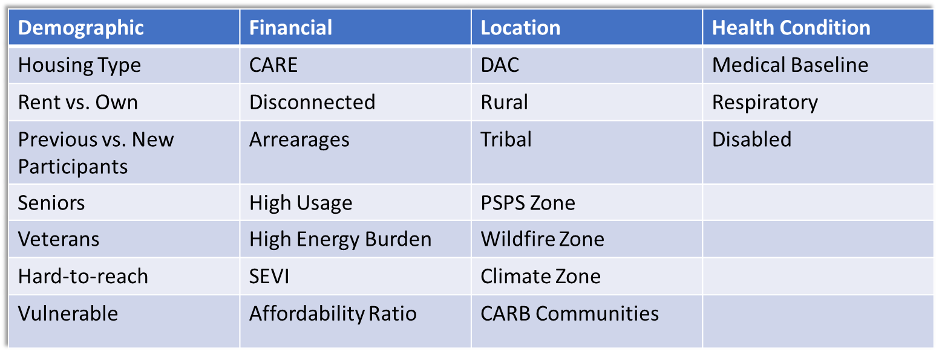

At a minimum, the ESA Pilot Plus/Pilot Deep solicitation seeks the following from its third-party providers:
- Incorporate all Pilot guidelines within their proposed implementation plans;
- Describe the outreach and installation process including the tools that will be utilized to treat households and achieve the savings goals;
- Provide a detailed budget breakdown; and
- Incorporate best practices from previous pilots, as applicable.

The single-stage RFP will include instructions with a sample version of the contract documents to be negotiated and executed by successful participants in the solicitation process. SDG&E’s typical contract contains Standard Contract Terms and Conditions, as requires by D.21-06-015, and General Terms and Conditions, both of which consist of regulatory and commercial terms that are required for ESA Pilot Plus/Pilot Deep. Other information may be included depending on the program requirements.

Purpose and Objectives
The purpose of this RFP is to evaluate proposals for program implementation services for the ESA Pilot Plus/Pilot Deep. Key elements to consider when bidding on this RFP:
- Pilot Opportunity (vision, delivery, intervention strategies, energy savings goals, customer-centric, optimization, quality, treatment levels)
- Pilot Overview
- Pilot Compliance
- Statement of Work
- Pilot Tracking
- Terms and Conditions
- Technical Requirements
- Diversity, Equity, and Inclusion
- Pilot Goals
- Safety
- Adherence to Requirements

If the proposal is successful, the bidder will be invited to answer specific questions and provide a presentation during interviews. This presentation would need to include additional information to further validate the bidder’s proposal.

PowerAdvocate Registration

SDG&E will manage this event through PowerAdvocate’s sourcing platform. Interested bidders will be required to register in PowerAdvocate to access all future communications and, upon its release, the RFP for ESA Pilot Plus/Pilot Deep.

All Bidders are required to register in Power Advocate to access the RFP documents, submit questions, and submit an ESA Pilot Plus/Pilot Deep 2.0 proposal. Bidders can register in Power Advocate using the following URL: (https://www.poweradvocate.com).

Apply to the ESA Pilot Plus/Pilot Deep 2.0 event through the Power Advocate “Opportunities” portal, search for the SDG&E event, and then click the key to request access to the event. The following is the procedure for applying to the ESA Pilot Plus/Pilot Deep 2.0 event.

- Are you registering for a specific event? * Click the ‘Yes’ button Who referred you to this event? * PEPMA Announcement
- Name of that individual’s company:* San Diego Gas & Electric Company
- Name or description of the Event: PA event #135733 SDGE Pilot Plus Pilot Deep Request for Proposal 2.0
- Click “Continue”

If you require assistance, please contact PowerAdvocate Support at the following:

PowerAdvocate Support
Support@poweradvocate.com
(857) 453-5800 M-F 8:00 AM to 8:00 PM Eastern Time

Interested Organizations Form
To encourage participation by Diverse Business Enterprises (DBEs) and Small Business Enterprises (SBEs) in the RFP solicitation, whether bidding as prime contractors or subcontractors, and to support the formation of diverse teams and new entrants, the RFP will provide a voluntary RFP participation contact list for those who provide consent. This RFP contact list enables interested DBEs, SBEs, prime contractors, and subcontractors to circulate their information (i.e., names, core capabilities, and certification statuses) and be contacted, if desired, in connection with this RFA.

Those interested in having their information on the RFP contact list must complete and submit the “Pilot Plus and Pilot Deep 2.0 - Interested Organizations Form" linked form here. This form will remain open until January 6, 2023.

D.21-06-015 at 355 and Attachment 4, Section 1.
See Senate Bill 756, Stats. 2021-2022, Ch. 248 (Cal. 2021), "On and after July 1, 2022, the bill would define ‘low- income customers’ for those purposes as persons and families whose household income is at or below 250% of the federal poverty level.”
D.21-06-015 at 498, Ordering Paragraph 110.

