To all Parties on the Service Lists for A.19-11-003 et al, R.13-11-005, R.15-03-010, R.18-07-006, R.12-11-005, R.19-01-011:

The Supplier Diversity teams from San Diego Gas & Electric Company (SDG&E), Pacific Gas and Electric Company (PG&E), Southern California Edison Company (SCE), and Southern California Gas Company (SoCalGas) (collectively the investor-owned utilities or Joint IOUs) are rescheduling the Contractor Symposium webinar from Monday, December 13, 2021, to Wednesday, January 12, 2022 from 1 pm to 3:30 pm PST. The primary objective of this event is to create visibility and accessibility between interested third party vendors and contractors to facilitate networking and business relationships that may lead to potential business opportunities for qualified, diverse, and/or small businesses who may be interested in submitting bids to any upcoming Energy Savings Assistance (ESA) and/or Energy Efficiency (EE) solicitations. Webinar call-in information will only be provided to those who register for this event.

Registration for this event has been extended and will close on Friday, December 3, 2021. Organizations who registered by the original November 19, 2021, deadline are not required to register a second time.

Once the Registration deadline closes, all registered participants will receive additional instructions.

Please register via the link or QR code provided below.

For questions regarding the Contractor Symposium please contact: Meredith Garcia (SDG&E) at MGarciaO@sdge.com and David Pell (PG&E) at DRPR@pge.com

Register via the Registration Form Link: https://forms.office.com/r/GHb7ZCxME4​
Or via the QR Code Below:

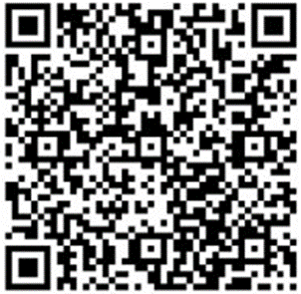

ESA and EE solicitation information for the IOUs is available on PEPMA using the following link: https://www.pepma-ca.com/Public/Default.aspx

