QUESTION 1:

Please provide copies of FERC Form 2 for SoCalGas and SDG&E for 2013 and 2014.

RESPONSE 1:

Due to their size, the requested FERC Forms have been provided separately.

QUESTION 2:

Please provide additional information regarding the gas summary of earnings table included as page 335 of the SDG&E settlement comparison exhibit for Test Year 2016 in A.14-11-003/-004.

  - If an alignment of settlement expenses by FERC account has been prepared, please provide it. If not, answer parts c, d, e and f.
  - Divide O&M expenses by function into labor and non-labor costs.
  - Divide Support Services and Information Technology expenses by function (transmission, storage, distribution, customer, A&G).
  - Divide shared services adjustments by function.
  - Divide reassignments by function.
  - Divide A&G expenses into insurance, pensions and benefits, and other A&G expenses separately stated by function (e.g., transmission, distribution, customer accounts, customer service, A&G), and into labor and non-labor.
  - Divide depreciation expenses by function (transmission, storage, distribution, and common and general plant).
  - Divide taxes other than income into property-related taxes and labor-related taxes.
- Provide the components of rate base. Separately provide gross plant, depreciation reserve and net plant, divided into transmission, storage, distribution, and common and general plant, as well as other components of rate base not differentiated by function (materials and supplies, customer advances for construction, accumulated deferred income taxes, cash working capital).

RESPONSE 2:

Because O&M functional labor costs for Test Year 2016 are not shown in the above referenced exhibit, the corresponding functional allocation factors are not available to calculate responses to this request.

QUESTION 3:

Please provide additional information regarding the summary of earnings table included as page 283 of the SoCalGas settlement comparison exhibit for Test Year 2016 in A.14-11-003/-004.

a) If an alignment of settlement expenses by FERC account has been prepared, please provide it. If not, answer parts c, d, e and f.
b) Divide O&M expenses by function into labor and non-labor costs.
c) Divide Support Services and Information Technology expenses by function (transmission, storage, distribution, customer, A&G).
d) Divide shared services adjustments by function.
e) Divide reassignments by function.
f) Divide A&G expenses into insurance, pensions and benefits, and other A&G expenses separately stated by function (e.g., transmission, distribution, customer accounts, customer service, A&G), and into labor and non-labor.
g) Divide depreciation expenses by function (transmission, storage, distribution, and common and general plant).
h) Divide taxes other than income into property-related taxes and labor-related taxes.
i) Provide the components of rate base. Separately provide gross plant, depreciation reserve and net plant, divided into transmission, storage, distribution, and common and general plant, as well as other components of rate base not differentiated by function (materials and supplies, customer advances for construction, accumulated deferred income taxes, cash working capital).

RESPONSE 3:

See Response 2 above.

QUESTION 4:

Please provide a workpaper showing the source of the current base margin and deriving the $1,668,970 in scaled LRMC revenues from Table 14 of Mr. Chaudhury’s testimony. Specifically explain whether the transmission and storage figures are SoCalGas’s embedded costs for 2013, and identify the date when total base margin was developed in this testimony.

RESPONSE 4:

The derivation of base margin of $1,987,220 is shown in the first attached Excel file (workpaper of Mr. Bonnett: 2017TCAP SCG RD Model.xlsm, Revenue Check tab, cell F18). Cell F22 of the same tab shows adjusted base margin of $1,975,458, adjusted for AB32 Fees and Core Brokerage Fees. This adjusted base margin is then linked to the second attached excel file (workpaper of Mr. Chaudhury: SoCalGas Cost Allocation mdodel.xlsx, Cost Allocation tab, cell E29). Starting at cell E29, column E of the Cost Allocation tab shows how the $1,668,970 in scaled LRMC revenues is derived on cell E38. The transmission and storage figures are SoCalGas’ embedded costs for 2013 as discussed in the prepared direct testimony of Ms. Fung. The attached workpapers to the Revised Testimony of Jason Bonnett and Sharim Chaudhury were developed for the Revised Prepared Direct Testimony submitted in November 2015.

QUESTION 5:

Would setting transmission costs at 2013 embedded cost levels mean that all increases in revenue requirements from 2013 until the next TCAP (other than PSEP costs) would be assigned to distribution rates and thereby assigned over 95% to core customers? If so, please explain why this treatment is reasonable. Also, please explain in detail how increases to the transmission revenue requirement from 2013 until the next TCAP (other than PSEP costs) would be allocated under each utility’s proposal in this TCAP.

RESPONSE 5:

The costs would be allocated through scalar.

This treatment facilitates rate stability during the triennial open season for all BTS customers, allowing them to lock in baseload contracts at specific receipt points for at least three years.

For determining the allocation of base margin, please refer to Response 4.

QUESTION 6:

Please provide estimates of the increases in gas transmission net plant and operations and maintenance expenses that SoCalGas and SDG&E forecast from this 2013 embedded cost study to 2016 in the utilities’ direct testimony in the general rate case, A14-11-003 and A14-11-004.

RESPONSE 6:

These estimates are not available for the following reasons:

These 2013 recorded costs are based on the FERC Uniform System of Accounts (USOA) shown in SoCalGas’ Annual Report to the CPUC (also known as the FERC Form 2), which is the primary source used for allocating costs since this report is publicly available to all interested parties.

SoCalGas does not use the FERC-USOA to manage and control operations – instead there is a cost control system based on areas of responsibility and function described internally as “cost centers.” Historically, it had been necessary to translate these operating cost center control accounts into FERC-USOA for the GRC application. This often led to significant adjustments. Even though the accounting system was able to generate a conversion, SoCalGas made numerous adjustments to “manually” reallocate many overhead accounts or activities to the FERC-USOA accounts for GRC presentation. Past experience showed that using the FERC-USOA format added an unnecessary level of complexity in the GRC that required conversion from the in-house accounting and management control system used in utility operations. As a result, D. 08-07-046, Ordering Paragraph 22, authorized SoCalGas to file the next GRC using the then-current “cost center” system of internal accounting and control rather than convert and allocate the data to approximate the FERC-USOA.

QUESTION 7:

Please provide estimates of the increase in gas transmission net plant and operations and maintenance expenses that SoCalGas and SDG&E forecast from this 2013 embedded cost study to the settlement comparison exhibit for 2016 in the general rate case, A14-11-003 and A14-11-004.

RESPONSE 7:

See Response 6.

QUESTION 8:

Please confirm that the net plant figures used by Ms. Fung in the embedded cost study to allocate rate base include Asset Retirement Obligations (FERC Accounts 358 (storage), 372 (transmission), and 388 (distribution) for both SoCalGas (12th unnumbered page) and SDG&E (17th unnumbered page).

RESPONSE 8:

Yes.

QUESTION 9:

Please confirm that Asset Retirement Obligations are not included in rate base and do not earn a return.

RESPONSE 9:

Yes.

QUESTION 10:

Is it the position of either SoCalGas or SDG&E that it is reasonable to include costs that are not included in rate base as part of an allocator to allocate the return on costs that are included in rate base? If the answer is anything but an unequivocal “no” please provide a detailed explanation.

RESPONSE 10:

Yes.

It is reasonable to include Asset Retirement Obligation (ARO) in determining functional cost allocation factors because ARO’s are capitalized costs of a company’s legal obligations resulting from the retirement of tangible long-lived assets. For fiscal years beginning after June 15, 2002, the Financial Accounting Standards Board (FASB) issued Statement 143 to provide a mechanism to improve companies’ balance sheets to more clearly reflect the economic realities of the retirement obligations associated with long-lived assets. The changes are particularly significant for capital-intensive companies such as SoCalGas and SDG&E. With the long-term business trend toward a more balance-sheet-oriented focus in accounting, FASB has fixed its attention on how entities account for obligations associated with the retirement of tangible long-lived assets. SDG&E and SoCalGas have complied with this accounting requirement in their FERC Forms 1 and 2, respectively. Therefore, the allocation factors used by SoCalGas and SDG&E are consistent with their annual reports filed with the CPUC.

QUESTION 11:

For each utility, please identify the amount of customer advances for construction that are related to (a) transmission and (b) distribution.

RESPONSE 11:

As of December 31, 2013 customer advances for construction were:

SoCalGas’ Transmission = $ 8,421,213

SoCalGas’ Distribution = $ 110,535,869

SDG&E’s Transmission = $ 0

SSDG&E’s Distribution = $1,726,914

QUESTION 12:

Please confirm that the income taxes included in the embedded cost study for SoCalGas are only current income taxes and do not include deferred income taxes that are also part of a utility’s revenue requirement.

RESPONSE 12:

See Response 15.

QUESTION 13:

Please provide deferred income tax expenses in 2013.

RESPONSE 13:

Total deferred income tax expense recorded in 2013 is $116,940,231.

QUESTION 14:

Please confirm that by not including deferred income taxes in the transmission revenue requirement, those deferred income taxes will be collected as part of the revenue requirement in distribution rates. If this is incorrect, please identify the amount of deferred income taxes that are in the transmission revenue requirement, and explain in detail how this amount was calculated.

RESPONSE 14:

Corrected Response March 10, 2016

They would be allocated through scalar. For informational purposes only, the attached table includes deferred income taxes in the transmission revenue requirement.

QUESTION 15:

Please reconcile the FERC Form 2 income tax expenses for SoCalGas (Fung Workpaper 13th unnumbered pages) of negative $31,888,000 with the 2013 recorded data shown in the Testimony of Ragan Reeves in A. 14-11-003 (Exhibit SCG-28 page RGR-15) of positive $28,164,000. Is Mr. Reeves’ calculation of recorded income taxes for SoCal what is referred to as “income taxes for ratemaking” in Ms. Fung’s workpaper for SDG&E (16th unnumbered page). If not, please provide the calculation and identify the source for that calculation.

RESPONSE 15:

The $31,888,000 mentioned in question 15 is made up of federal and state income tax cash refunds received during 2013 and is not related to income tax expenses accrued during the year. The $28,164,000 referred to above in Mr. Reeves’ testimony relates to the 2013 federal income tax expense accrued during the year. The two amounts are unrelated and thus cannot be compared. In addition, the $28,164,000 is being pulled from Mr. Reeves’ original superseded Application and therefore does not reflect the updated federal income tax expense amount for 2013 that is shown in Mr. Reeves’ testimony from the revised Application.

QUESTION 16:

Please confirm that Mr. Reeves originally forecast an increase in federal income tax to $98,667,000 by 2016 on page RGR-15 of Exhibit SCG-28, and confirm that under SoCal’s TCAP methodology, 100% of the difference between negative $31,888,000 and positive $98,667,000 would be assigned to distribution rates. If this is incorrect, please explain how the difference would be treated under the utilities’ proposal

RESPONSE 16:

See Response 14.

QUESTION 17:

Are there differences in the source of data used to derive “income taxes for ratemaking” included for SDG&E on the 16th unnumbered page and the income taxes used for SoCalGas on the 13th unnumbered page? If so, please identify and describe in detail each difference

RESPONSE 17:

See Response 14.

QUESTION 18:

Please explain why the SDG&E “income tax used for ratemaking” used by Ms. Fung ($14,223,000 on the 16th unnumbered page) is only $339,000 different from Mr. Reeves’ 2013 recorded figure for gas distribution ($14,662,000 on SDG&E-29, page RGR-19), while there is a difference of approximately $60 million for SoCalGas between Ms. Fung and Mr. Reeves.

RESPONSE 18:

See Response 14

QUESTION 19:

- Please respond to the following questions regarding the 50% functionalized A&G percentage for both SoCalGas and SDG&E in the embedded cost study:
  - Referring to the Testimony of Ms. Fung at page 5, which shows the labor factors used for transmission and storage, please explain why SoCalGas did not simply assign 12.5% of A&G and general plant costs to transmission and storage but instead allocated only half that amount (- 6.24%) of marginal A&G and general plant costs to transmission and storage.
  - Provide specific documentation supporting the 50% reduction factor for functionalized A&G.
  - Does that factor effectively assign 50% of A&G costs that would otherwise be allocated to transmission and storage to gas distribution? If not, please explain where the 50% of A&G costs not allocated to transmission and storage are effectively assigned under SoCalGas’ approach.
  - Does SoCalGas contend that it is reasonable for SoCalGas to assign 50% of the employee-related pensions, benefits, payroll taxes, and workers compensation expenses for employees who are working directly on gas transmission and storage issues as distribution-related costs? If the response is anything other than an unqualified negative, please provide a detailed explanation of why such an assignment is consistent with cost causation.
  - If the answer to any of the four preceding questions is in any way different for SDG&E as to the basis for the 50% reduction or any other related issues in A&G allocation, please explain why SDG&E is in a different position from SoCal.

RESPONSE 19:
- This is consistent with D.09-11-006, 2009 BCAP Phase 2, Appendix A, Settlement Agreement, Section II.B.2.A. and D.14-06-007.
- See Response 19(a).
- They would be allocated through scalar.
- Yes. See Response 19(a).
- Not applicable.

QUESTION 20:

Do the capital costs and/or installation costs of meters for SoCalGas presented in the marginal cost study include the costs of Automatic Meter Infrastructure (AMI)? If so, what are those costs?

RESPONSE 20:

No.

QUESTION 21:

Provide the following information monthly from 2012 through the latest available month in 2015 for SoCalGas:
- Number of meters read manually
- Number of meter readers (full-time equivalent)
- Costs booked to FERC Account 902, divided into labor and non-labor, and divided into the FERC sub-accounts used by SoCalGas.
- A definition of each FERC sub-account used by SoCalGas (e.g., 902, 902.2, 902,125, 902.5 and any other sub-accounts used by SoCalGas).

RESPONSE 21:

- The total number of meters for which we completed a manual meter read from 2012 through 2015 by month can be found in the attached excel spreadsheet.
- The total number of full-time equivalent meter readers from 2012 through 2015 by month can be found in the attached Excel spreadsheet in Response 21(a).
- and d) See the attached Excel spreadsheet.

QUESTION 22:

Please provide the following statistics on gas distribution mains and services for SoCalGas at the end of the latest available year:
  - Number of miles of steel distribution mains by size of pipe.
  - Number of miles of steel services by size of pipe.
  - Number of steel services by size of pipe.
  - Number of miles of plastic distribution mains by size of pipe.
  - Number of miles of plastic services by size of pipe.
  - Number of plastic services by size of pipe.
  - Number of miles of other distribution mains (e.g., cast iron) by size of pipe.
  - Number of miles of other services by size of pipe.
  - Number of other services by size of pipe.
  - How many miles of gas main, divided into steel and plastic, are high pressure mains and how many are medium pressure mains?
  - Please provide relevant Handy-Whitman price escalators for gas mains.
  - If available, please provide a data base showing the number of miles and cost of gas distribution mains currently in service by size and type of pipe installed in each year.

RESPONSE 22:
- - j) The attached file contains the requested information at the end of Year 2014.
k) The relevant Handy-Whitman price escalators for gas mains are attached here.

l) Please see the attached file.

QUESTION 23:

Please provide the following information on main and service replacement for SoCalGas:
  - Number of miles of gas distribution mains that have been replaced in each year from 2010-2014, that have been replaced in 2015 through the latest available month, and that are projected to be replaced in each year from 2015 to the end of the TY 2016 GRC cycle. Divide by type of pipe.
  - Total cost of main replacement in each year from 2010-2017, divided into O&M and capital using recorded and projected data from above.
  - Number (or number of miles) of gas services that have been replaced in each year from 2006-2014, that have been replaced in 2015 through the latest available month, and that are projected to be replaced in each year from 2015 to the end of the TY 2016 GRC cycle. Divide by size of pipe and pipe material to the extent that data are available.
  - Total cost of service replacement in each year from 2010-2017, divided into O&M and capital using recorded and projected data from above.

RESPONSE 23:

- The number of miles of replaced gas distribution mains by pipe size and material for the years 2010 to 2014 is presented in the attached excel file below. The data for 2015 is still being validated and is not available. Replacement distribution mains lengths are not projected for future years separately and, therefore, are not available.

- The table below contains the capital costs for gas distribution mains replacement for the years 2010 through 2014.
The distribution mains replacement O&M expenses are collected together with other distribution mains maintenance expenses, such as mains repairs, and are recorded in various O&M accounts. In addition, these expenses are not separated by pipeline size or material. Because of the manner in which these expenses are accounted for, replacement expenses alone separated by size and material cannot be accurately determined.
Distribution mains replacement costs are not projected separately for future years; therefore, they are not available.
 | Distribution Mains Replacement Capital Cost by Year
Year | 2010 | 2011 | 2012 | 2013 | 2014
Capital Cost | $ 108,119,150 | $ 109,103,418 | $ 120,099,842 | $ 118,714,151 | $ 113,244,206

- The number of miles of replaced gas service lines by pipe size and material for the years 2006 to 2015 is presented in the attached excel file below. Replacement service lengths are not projected for future years separately and therefore, are not available.

- The table below contains the capital costs for service line replacement for the years 2010 through 2015.
The service line replacement O&M expenses are collected together with other service maintenance expenses, such as service repairs, and are recorded in various O&M accounts. In addition, these expenses are not separated by pipeline size or material. Because of the manner in which these expenses are accounted for, replacement expenses alone separated by size and material cannot be accurately determined.
Service line replacement costs are not projected separately for future years; therefore, they are not available.

 | Service Replacement Capital Cost by Year
Year | 2010 | 2011 | 2012 | 2013 | 2014 | 2015
Capital Cost | $ 24,716,229 | $ 27,478,234 | $ 27,145,837 | $ 31,764,496 | $ 37,852,531 | $ 36,470,535

QUESTION 24:

Please provide the following information on cathodic protection for SoCal:
  - Identify costs of cathodic protection separately from other costs in Accounts 874 and 887.
  - Identify the number of miles of mains and services under cathodic protection at the end of 2014. To the extent possible divide the estimate between mains and services, between high pressure and low-pressure mains, and by the size of pipe.

RESPONSE 24:

- The excel file below provides the 2014 historical expenditures for Cathodic Protection for Account 887. Please note that there is no Cathodic Protection expenditure recorded in FERC Account 874.
- The attached file contains the information on the number of miles of mains and services under cathodic protection at the end of 2014.

QUESTION 25:

Please identify the total number of meters replaced by SoCalGas in each year from 2006 to 2015, the number of meters required to be replaced in order to install AMI, and the number of other meters replaced.

RESPONSE 25:

QUESTION 26:

Regarding the replacement and new business costs associated with services:
  - Please provide documentation supporting the replacement and new business costs per foot of services.
  - Please provide documentation supporting the average length of service drops by type.
  - For multi-family services, please provide more detail on individual jobs showing the cost and number of customers of each individual job included in the analysis.
  - Please provide documentation confirming that the number of customers associated with larger multifamily services (sizes of 2P or 2S and above) are not the number of buildings being connected but the number of metered apartments that will ultimately be built in those buildings (e.g, show material confirming that SoCal believes that a 3 inch plastic service of 299 feet is actually required to serve a single multi-family customer, not to serve an entire whole apartment building). If you cannot confirm that you correctly estimated the number of customers served by these service lines, please provide a corrected analysis.

RESPONSE 26:

a) The attached file shows the derivation of the replacement and new business costs per foot of services. Distribution service unit costs in this TCAP were derived by escalating unit costs from the last TCAP as the 2011- 2013 unit cost data generally appeared high and did not seem reasonable compared to prior TCAP filings.

b) New service line activity for 2009-2013 was used at the premise level by pipe type and size. The new service line footage by premise was merged with new 2009-2013 customer information that included rate group. New service line footage was then aggregated by rate group, line type and line size. Average new service line footage by rate group, line type, and size was then derived by dividing the aggregated service line footage by the number of service lines.

- [Pending]
- [Pending]

QUESTION 27:

With regard to residential services of each type identified on the service cost detail workpaper, please identify the portion of the cost of each type of line that would be paid for by the applicant through customer advances for construction or contributions in aid of construction. Specifically identify the conditions under which ratepayers could be responsible for the entire cost of a line serving a single residential customer with a cost in excess of $5,000 per customer.

RESPONSE 27:

For most residential new business jobs, ratepayers cover $1,398 of the estimated line extension. Thus, for a $5,000 single residential customer line extension, regardless of the pipe diameter size, ratepayers will pay $1,398 or 28% of the $5,000 job. For replacements, if an applicant requests an alteration, relocations, or replacements, then ratepayers do not assume any costs. The customer pays for the costs per Rule 21. For service replacements for leakage, main replacement, or company replacement, there is no customer advance, and therefore associated costs are borne by the ratepayers.

QUESTION 28:

Following up on ORA-TCAP-2-SCG-08 FERC Account worksheets, please provide data by FERC Account and sub-account for 2012, 2013, and 2014 and provide a definition of subaccounts for all of Customer Services O&M Costs 870.65, 878, 879, 880, Customer Accounting O&M Costs 901, 902, 903, and 905, and meter and regulator O&M accounts in Accounts 878 and 893. Provide for each individual sub-account in each account, even if aggregated in the response to ORA.

RESPONSE 28:

Attached are the meter and regulator O&M accounts in Accounts 878 and 893.

Attached are the Customer Services O&M Costs 870.65, 878, 879, 880 and the Customer Accounting O&M Costs 901, 902, 903, and 905.

QUESTION 29:

Please respond to the following questions related to SoCalGas’s treatment of A&G and general plant loading factors for marginal cost:
  - In the calculations that assume all Employee Pensions and Benefits are Marginal Costs, did SoCalGas inadvertently include pensions and benefits from non-marginal A&G labor costs in Account 920 as marginal costs? If so, please estimate non-marginal labor in Account 920 as a percentage of total labor for SoCalGas.
  - In calculating the tax that funds EE, LIEE, CARE and other gas public goods programs, does SoCalGas include pensions, benefits, workers compensation, and other specific labor-related overhead costs for its employees in these programs in that calculation? If not why not? If so, please provide that figure consistent with the 2013 recorded figures used in this marginal cost filing.
  - If SoCalGas includes pensions, benefits, workers compensation, and other specific labor-related overhead costs for its employees working under programs funded by the state public goods tax, did SoCalGas remove costs included in that tax from its A&G loader analysis in this marginal cost study? If not, (a) explain why not; and (b) recalculate the A&G loader analysis excluding the labor-related overhead costs recovered in the tax.
  - If SoCalGas does not include labor-related overheads for employees working in public goods programs funded by the state public goods tax in the costs recovered by the state public goods tax, please answer the following questions.
    - Please provide labor expenses associated with (a) energy efficiency (b) Low Income Energy Efficiency, and (c) the CARE program.
    - Please explain why pensions, benefits, and workers compensation expenses for public goods workers should not be considered non-marginal costs in the LRMC study, given that these costs are not affected by changes in labor associated with costs of transmission, storage, distribution, and customer functions.

RESPONSE 29:

  - No.
  - Vacation and sick and payroll tax are the only labor-related overhead costs included in the Public Purpose Program (PPP) surcharge that funds LIEE, EE, and CARE programs. All other labor-related overhead costs are excluded from the calculation of the PPP surcharge because those costs are funded through SoCalGas’ GRC. 2013 costs for vacation & sick and payroll taxes for each of the programs are:
 | LIEE | EE | CARE
Vacation & Sick | $ 543,653 | $ 2,030,717 | $ 337,656
Payroll Tax | $ 334,562 | $ 1,240,765 | $ 208,316

  - As explained in b) above, vacation and sick and payroll tax are the only labor-related overhead costs included in the Public Purpose Program (PPP) surcharge that funds LIEE, EE, and CARE programs. All other labor-related overhead costs, including pensions, benefits, workers compensation, are excluded from the calculation of the PPP surcharge because those costs are funded through SoCalGas’ GRC.
  - i) 2013 recorded labor expenses for LIEE, EE, and CARE are:
 | LIEE | EE | CARE
2013 Labor Expenses | $ 3,453,336 | $ 12,731,556 | $ 2,152,783

Vacation and sick and payroll tax costs were provided in response 29b) above.
- Pensions, benefits, and workers compensation expenses for public goods workers are marginal costs, given that these costs are affected by changes in labor associated with the public goods programs. The marginal cost of direct labor, vacation and sick, and payroll taxes for the public goods workers are included in the PPP surcharge and, therefore, are not included in the LRMC study. Because pensions, benefits, and workers compensation expenses for public goods workers are not included in the PPP surcharge, they are included in the LRMC study.

QUESTION 30:

Do the capital costs and/or installation costs of meters for SDG&E presented in the marginal cost study include the costs of Automatic Meter Infrastructure (AMI)? If so, what are those costs?

RESPONSE 30:

No. The meter costs presented do include the costs of the AMR modules purchased with the meter, but they do not include any costs or allocation of costs for the AMI infrastructure (system-wide equipment and operating costs for operating the AMR modules).

QUESTION 31:

Provide the following information monthly from 2012 through the latest available month in 2015 for SDG&E:
  - Number of gas meters read manually.
  - Number of meter readers (full-time equivalent – gas and electric).
  - Costs booked to FERC Account 902, divided into electric and gas and further divided into labor and non-labor.

RESPONSE 31:

    - and b) See attachment

    - See attachment

QUESTION 32:

Please provide the following statistics on gas distribution mains and services for SDG&E at the end of the latest available year:
  - Number of miles of steel distribution mains by size of pipe.
  - Number of miles of steel services by size of pipe.
  - Number of steel services by size of pipe.
  - Number of miles of plastic distribution mains by size of pipe.
  - Number of miles of plastic services by size of pipe.
  - Number of plastic services by size of pipe.
  - Number of miles of other distribution mains (e.g., cast iron) by size of pipe.
  - Number of miles of other services by size of pipe.
  - Number of other services by size of pipe.
  - How many miles of gas main, divided into steel and plastic, are high pressure mains and how many are medium pressure mains?
  - Please provide relevant Handy-Whitman price escalators for gas mains.
  - If available, please provide a data base showing the number of miles and cost of gas distribution mains currently in service by size and type of pipe installed in each year.

RESPONSE 32:

Responses to a) – f) and l) are drawn from the Annual Report for Calendar Year 2014 – Gas Distribution System, Form PHMSA F 7100.1-1 (rev 01-2011) submitted by SDG&E to the Department of Transportation (DOT):
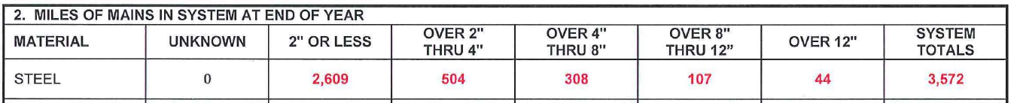
- Number of miles of steel distribution mains by size of pipe.

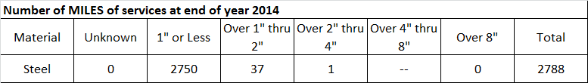
b) Number of miles of steel services by size of pipe.

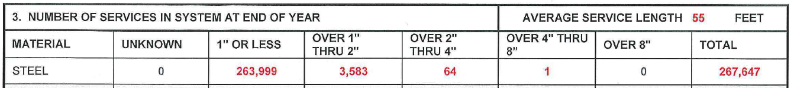
c) Number of steel services by size of pipe.

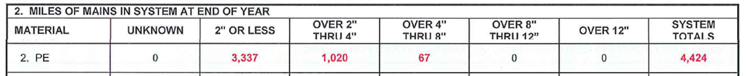
d) Number of miles of plastic distribution mains by size of pipe.

e) Number of miles of plastic services by size of pipe.
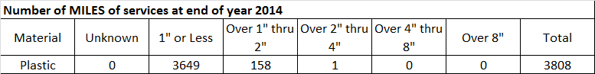
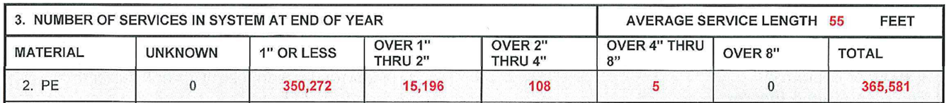
f) Number of plastic services by size of pipe.

g) Number of miles of other distribution mains (e.g., cast iron) by size of pipe.
None
h) Number of miles of other services by size of pipe.
None
i) Number of other services by size of pipe.
None
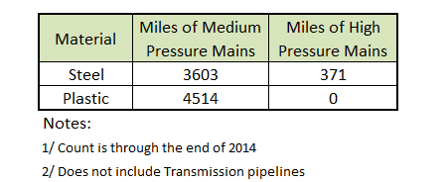
j) The number of miles of gas main, divided into steel and plastic and separated by high pressure mains and medium pressure mains are presented below: (This data was derived from SDG&E’ GIS Mapping database).

k) The relevant Handy-Whitman price escalators for gas mains are attached here.

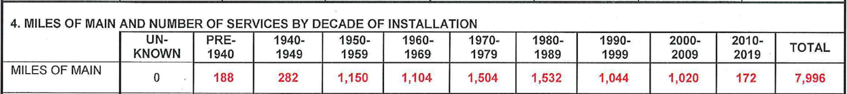
l) The total number (all sizes) of miles of mains by decade is available, but totals by size and associated costs for these totals by decade are not available.

QUESTION 33:

Please provide the following information on main and service replacement for SDG&E:
  - Number of miles of gas distribution mains that have been replaced in each year from 2010-2014, that have been replaced in 2015 through the latest available month, and that are projected to be replaced in each year from 2015 to the end of the TY 2016 GRC cycle. Divide by size of pipe and pipe material to the extent that data are available.
  - Total cost of main replacement in each year from 2010-2017, divided into O&M and capital using recorded and projected data from above.
  - Number (or number of miles) of gas services that have been replaced in each year from 2006-2014, that have been replaced in 2015 through the latest available month, and that are projected to be replaced in each year from 2015 to the end of the TY 2016 GRC cycle. Divide by size of pipe and pipe material to the extent that data are available.
  - Total cost of service replacement in each year from 2010-2017, divided into O&M and capital using recorded and projected data from above.
RESPONSE 33:
- The number of feet of replaced mains by size and material for the years 2010 to 2014 is presented in Table 1 below. Mapping for the year 2015 is still being completed and therefore totals for 2015 could not be presented in a complete listing. Lengths of replacement main are not projected for future years separately or in this format and therefore are not available.
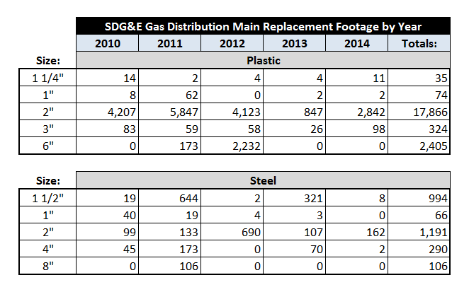
Table 1

- The main replacement expenses are collected together with other main maintenance expenses, such as, main repairs, and are found in various O&M and Capital accounts. In addition, these expenses are not separated by pipeline size or material. Because of the manner in which these expenses are accounted for, replacement expenses alone separated by size and material cannot be accurately determined. In addition, replacement main costs are not projected for future years separately or in this format and are therefore also not available.

- The number of feet of replaced gas services by size and material for the years 2010 to 2014 is presented in Table 2 below. The lengths of services prior to 2010 cannot be accurately presented because it was prior to SDG&E’s implementing its GIS mapping system. Gas pipeline mapping for the year 2015 is still being completed, and therefore totals for 2015 could not be presented in a complete listing. Replacement service lengths are not projected for future years separately or in this format and are therefore not available.

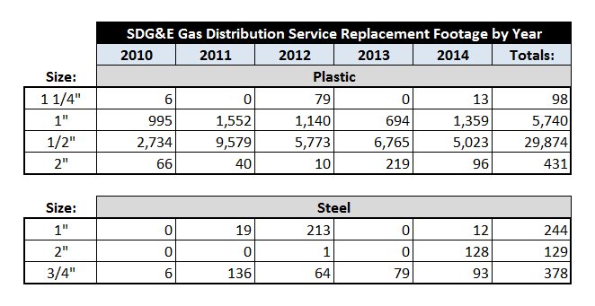
Table 2

d) The service replacement expenses are collected together with other service maintenance expenses, such as service repairs, and are found in various O&M and Capital accounts. In addition, these expenses are not separated by pipeline size or material. Because of the manner in which these expenses are accounted for, replacement expenses alone separated by size and material cannot be accurately determined. In addition, replacement service costs are not projected for future years separately or in this format; therefore, they are also not available.

QUESTION 34:

Please provide the following information on cathodic protection for SDG&E:
  - Identify costs of cathodic protection separately from other costs in Accounts 874 and 887.
  - Identify the number of miles of mains and services under cathodic protection at the end of 2014. To the extent possible divide the estimate between mains and services, between high pressure and low-pressure mains, and by the size of pipe.

RESPONSE 34:

a) Total costs for cathodic protection separate from all other costs for the year of 2014 was $1,148,000. That represents direct labor and non-labor charges.
b) The number of miles of mains and services under cathodic protection at the end of 2014 is presented below. The division by total number of miles of pipe between high pressure and medium-pressure mains is presented in the response for Question 32(j) in the first line of that Table (for steel pipe).
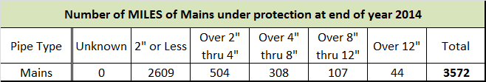

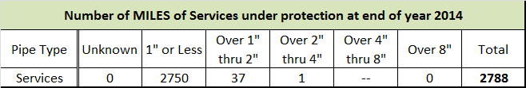

QUESTION 35:

Please identify the total number of gas meters replaced by SDG&E in each year from 2006 to 2015, the number of meters required to be replaced in order to install AMI, and the number of other meters replaced.

RESPONSE 35:

The gas meters replaced in each year from 2006 to 2015, separated by meter replacements to accommodate an AMI installation and all other replacements are presented here:
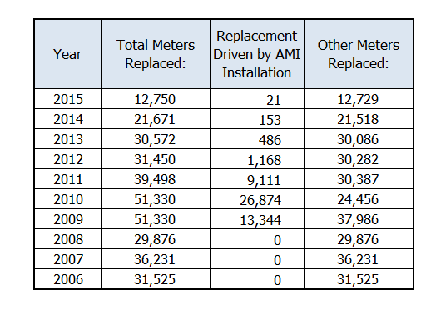

QUESTION 36:

Please respond to the following questions related to SDG&E’s treatment of A&G and general plant loading factors for marginal cost:
  - In the calculations that assume all Employee Pensions and Benefits are Marginal Costs, did SDG&E inadvertently include pensions and benefits from non-marginal A&G labor costs in Account 920 and other A&G accounts as marginal costs? If so, please estimate non-marginal labor in A&G accounts as a percentage of total labor for SDG&E.
  - In calculating the tax that funds EE, LIEE, CARE and other gas public goods programs, does SDG&E include pensions, benefits, workers compensation, and other specific labor-related overhead costs for its employees in these programs in that calculation? If not why not? If so, please provide that figure consistent with the 2013 recorded figures used in this marginal cost filing.
  - If SDG&E includes pensions, benefits, workers compensation, and other specific labor-related overhead costs for its employees working under programs funded by the state public goods tax, did SDG&E remove costs included in that tax from its A&G loader analysis in this marginal cost study? If not, (a) explain why not; and (b) recalculate the A&G loader analysis excluding the labor-related overhead costs recovered in the tax.
  - If SDG&E does not include labor-related overheads for employees working in public goods programs funded by the state public goods tax in the costs recovered by the state public goods tax, please answer the following questions.
    - Please provide labor expenses associated with (a) energy efficiency (b) Low Income Energy Efficiency, and (c) the CARE program.
    - Please explain why pensions, benefits, and workers compensation expenses for public goods workers should not be considered non-marginal costs in the LRMC study, given that these costs are not affected by changes in labor associated with costs of transmission, storage, distribution, and customer functions.

RESPONSE 36:
    - No.
    - Vacation & sick and payroll tax are the only labor-related overhead costs included in the Public Purpose Program (PPP) surcharge that funds LIEE, EE, and CARE programs. All other labor-related overhead costs are excluded from the calculation of the PPP surcharge because those costs are funded through SDG&E’s GRC. 2013 costs for vacation & sick and payroll taxes for each of the programs are:

 | LIEE | EE | CARE
Vacation & Sick | $ 84,058 | $ 143,210 | $ 25,163
Payroll Tax | $ 46,175 | $ 77,332 | $ 13,775

c) As explained in b) above, only vacation and sick, and payroll tax are the only labor-related overhead costs included in the Public Purpose Program (PPP) surcharge that funds LIEE, EE, and CARE programs. All other labor-related overhead costs, including pensions, benefits, workers compensation, are excluded from the calculation of the PPP surcharge because those costs are funded through SDGE’s GRC.
d i) 2013 recorded labor expenses for LIEE, EE, and CARE are:
 | LIEE | EE | CARE
2013 Labor Expenses | $ 573,336 | $ 960,866 | $ 172,470

Vacation & sick and payroll tax costs were provided in response 36b) above.
    - Pensions, benefits, and workers compensation expenses for public goods workers are marginal costs, given that these costs are affected by changes in labor associated with the public goods programs. The marginal costs of direct labor, vacation and sick, and payroll taxes for the public goods workers are included in the PPP surcharge and, therefore, are not included in the LRMC study. Because pensions, benefits, and workers compensation expenses for public goods workers are not included in the PPP surcharge, they are included in the LRMC study.

QUESTION 37:

Please provide annual bill frequency distributions for residential customers, divided into single-family and multi-family for calendar years 2013, 2014, and 2015 for SoCalGas. For each annual bill frequency bin, please provide average monthly usage for that stratum.

RESPONSE 37:
Single Family - Avg Monthly Use per Customer
Bill Quantile | 2013 | 2014 | 2015
0%-10% | 12.1 | 10.5 | 10.3
10%-20% | 23.7 | 19.9 | 19.9
20%-30% | 32.2 | 26.4 | 26.3
30%-40% | 42.0 | 32.8 | 33.2
40%-50% | 55.5 | 40.2 | 42.1
50%-60% | 71.1 | 49.5 | 53.5
60%-70% | 89.1 | 62.3 | 68.2
70%-80% | 112.9 | 80.1 | 88.4
80%-90% | 149.6 | 110.7 | 121.9
90%-100% | 274.5 | 231.7 | 248.0

Multi Family - Avg Monthly Use per Customer
Bill Quantile | 2013 | 2014 | 2015
0%-10% | 5.4 | 5.0 | 4.9
10%-20% | 12.9 | 11.4 | 11.4
20%-30% | 17.9 | 15.0 | 15.5
30%-40% | 22.4 | 18.4 | 19.0
40%-50% | 26.8 | 22.4 | 22.4
50%-60% | 32.7 | 26.4 | 26.8
60%-70% | 41.0 | 31.2 | 32.3
70%-80% | 52.7 | 38.8 | 40.2
80%-90% | 70.8 | 51.4 | 54.6
90%-100% | 118.8 | 87.4 | 95.8

QUESTION 38:

Please provide the latest RASS study data for SoCalGas customers including customer weights, climate zones, etc.; include at least 12 months of gas billing data for each sampled customer.

RESPONSE 38:

Please see the attached file for SoCalGas.

QUESTION 39:

Please provide all information in the possession of the Sempra utilities relating gas usage by customers of SoCalGas to any of the following characteristics: dwelling type, dwelling size, household size, or income.

RESPONSE 39:

Please see the file attached in response to Question 38.

QUESTION 40:

Please provide all information in the possession of the Sempra utilities relating saturation of different types of gas appliances by customers of SoCalGas to any of the following characteristics: dwelling type, dwelling size, household size, or income.

RESPONSE 40:

Please see the file attached in response to Question 38.

Please note that “climate zone” corresponds to SoCalGas’ climate zones/temperature zones. For more detail, please see the Workpapers to the Prepared Direct Testimony of Gregory Teplow for this TCAP, page 5. The “weight” is the number of customers represented by the particular survey respondent. “people” is the number of individuals in the household (i.e. household size).

Dwelling Types are as below:
1 | Single-Family Detached House
2 | Townhouse
3 | 2-4 Unit Apartment/Condominium
4 | 5+ Unit Apartment/Condominium
5 | Mobile Home
6 | Other
97 | No Response/Missing Data

End-use data indicate whether the respondent possesses a gas appliance of that type. The types of appliances in the data are presented below:
“g_sh” | Gas Space Heating
“g_wh” | Gas Water Heating
“g_ck” | Gas Cooking
“g_dry” | Gas Drying
“gas_pool” | Gas Pool Heating
“gas_spa” | Gas Spa Heating

Saturations can be calculated for any desired combination of survey characteristics by dividing the sum of the end-use indicators by the total number of respondents with the desired combination of characteristics.

QUESTION 41:

Please provide annual bill frequency distributions for residential customers, divided into single-family and multi-family for calendar years 2013, 2014, and 2015 for SDG&E. For each annual bill frequency bin, please provide average monthly usage for that stratum.

RESPONSE 41:
Single Family - Avg Monthly Use per Customer
Quantile | 2013 | 2014 | 2015
0%-10% | 9.5 | 8.2 | 7.6
10%-20% | 17.3 | 14.9 | 14.1
20%-30% | 23.9 | 19.5 | 18.9
30%-40% | 31.2 | 23.4 | 23.8
40%-50% | 40.1 | 28.3 | 28.8
50%-60% | 51.0 | 34.7 | 35.2
60%-70% | 64.4 | 42.6 | 44.6
70%-80% | 81.4 | 54.1 | 57.8
80%-90% | 107.2 | 74.0 | 79.6
90%-100% | 200.1 | 151.6 | 160.6

Multi Family - Avg Monthly Use per Customer
Quantile | 2013 | 2014 | 2015
0%-10% | 5.4 | 4.9 | 4.3
10%-20% | 11.0 | 10.0 | 9.0
20%-30% | 14.0 | 12.5 | 11.9
30%-40% | 16.9 | 14.9 | 15.1
40%-50% | 20.8 | 18.5 | 17.9
50%-60% | 25.9 | 21.9 | 21.3
60%-70% | 31.6 | 26.2 | 26.2
70%-80% | 40.6 | 33.6 | 34.3
80%-90% | 58.4 | 52.2 | 54.5
90%-100% | 156.8 | 226.3 | 223.4

QUESTION 42:

Please provide the latest RASS study data for SDG&E customers including customer weights, climate zones, etc.; include at least 12 months of gas billing data for each sampled customer.

RESPONSE 42:

Please see the attached file for SDG&E.

QUESTION 43:

Please provide all information in the possession of the Sempra utilities relating gas usage by customers of SDG&E to any of the following characteristics: dwelling type, dwelling size, household size, or income.

RESPONSE 43:

Please see the file attached in response to Question 42.

QUESTION 44:

Please provide all information in the possession of the Sempra utilities relating saturation of different types of gas appliances by customers of SDG&E to any of the following characteristics: dwelling type, dwelling size, household size, or income.

RESPONSE 44:
Please see the file attached in response to Question 42.

Please note that “weight” is the number of customers represented by the particular survey respondent. “people” is the number of individuals in the household (i.e. household size).

The “climate zone” corresponds to SDG&E’s climate zones/temperature zones. For more detail, please see page 90 of the Workpapers to the Prepared Direct Testimony of Gregory Teplow for this TCAP as well as the below table.
Coastal | Lindberg Field
Maritime | Miramar Naval Station
Transition | El Cajon

Dwelling Types are as below:
1 | Single-Family Detached House
2 | Townhouse
3 | 2-4 Unit Apartment/Condominium
4 | 5+ Unit Apartment/Condominium
5 | Mobile Home
6 | Other
97 | No Response/Missing Data

End-use data indicate whether the respondent possesses a gas appliance of that type. The types of appliances in the data are presented below:
“g_sh” | Gas Space Heating
“g_wh” | Gas Water Heating
“g_ck” | Gas Cooking
“g_dry” | Gas Drying
“gas_pool” | Gas Pool Heating
“gas_spa” | Gas Spa Heating

Saturations can be calculated for any desired combination of survey characteristics by dividing the sum of the end-use indicators by the total number of respondents with the desired combination of characteristics.

A.14-12-017 SoCalGas’ Response to Ruling Requesting Information (RRI), 4/3/15, at 8, 2nd paragraph.
Id. at 9, last paragraph.
http://www.journalofaccountancy.com/issues/2001/dec/accountingforassetretirementobligations.html

