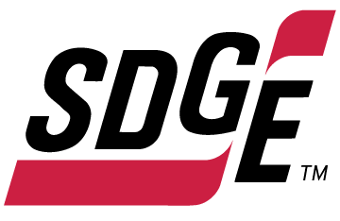

SDG&E RESIDENTIAL AND SMALL BUSINESS CONTENT PACKAGE | SEPTEMBER 2022
As a trusted community partner, we thank you for sharing our content and digital assets with your audiences – including residents, customers and employees – to help amplify our key messages in your email communications, websites or newsletters.
Best practices for using our content, social media posts and images
- Images
Please choose images that are relevant for your audience and feel free to mix and match what we provide. For alternate images, Unsplash.com and Canva.com offer free images that you can download.
- SDG&E logo
You’re welcome to mention our name but, due to legal requirements, please do not use our logo in any marketing materials that you create. Please only use the SDG&E logo if we provide it to you in this package or it’s publicly available online like a social post or video. You can also retweet our public posts which you’ll find on twitter.com/sdge.
- Videos
We have a library of videos you can share in your communications and social posts when you visit youtube.com/c/SanDiegoGasElectric/videos. If you’d like to sort our videos by topic, visit youtube.com/c/SanDiegoGasElectric. Some videos are in Spanish. Our newest videos discuss the path to net zero, fire hardening and safety, public safety power shutoffs, 811 Dig Alert and more. You’ll see some on TV, too!
This month’s topics: Energy-saving tips for home and work, customer assistance programs, free energy-related webinars

Follow us
You can find us on Facebook, Instagram, Twitter, YouTube and LinkedIn. When sharing these digital assets and content, feel free to tag SDG&E’s social media accounts and direct your audience to sdge.com.
Article: SIMPLE TIPS TO REDUCE ENERGY USE AT HOME
Want to stay cool and reduce your energy use at the same time? Check out these helpful tips from San Diego Gas & Electric.
- Pre-cool your home. Take advantage of lower-priced energy by using your A/C to cool your home before 4 p.m. During on-peak hours of 4 p.m. to 9 p.m., adjust your thermostat to 78 degrees or higher, health permitting.
- Cool down with a fan. Turn off fans when you leave a room as fans cool people, not rooms. During warmer months, using your ceiling fan while your A/C is on allows you to raise your thermostat around 4 degrees and maintain the same level of comfort. Run ceiling fans counterclockwise to push cool air down. In cooler months, run your fans clockwise at a low speed to draw room air up and force warm air down.
- Block the sun. During the hottest part of the day, cover windows to block the sun’s heat. If you can, open windows at night and early mornings to let the cool air in.
- Use small appliances. Instead of the oven, use small appliances such as a microwave, toaster oven or slow cooker. They use less energy and won’t add much heat to your home.
- Power down. Switch off your electronic devices, such as computers and coffee pots, when not in use. Keep in mind, electronics in standby mode still draw power. Use a smart power strip to power down devices and appliances at one time.
- Shift use. Shift some energy use, such as running a dishwasher or clothes washer, to outside of the on-peak hours of 4 p.m. to 9 p.m. Demand on the electric grid is typically highest during these hours and the cost of electricity is the highest.
- Get paid to conserve energy. It pays to be flexible! Enroll in SDG&E’s Power Saver Rewards program at sdge.com/PSR. Receive a bill credit when you lower your electricity use when energy is most in demand.
- Sign up for Flex Alert Notifications. These are voluntary calls for conservation when the power grid is stressed. This usually happens in the evening when solar generation is reduced and people are coming home from work and turning on air conditioners, lights and appliances. Do your part and sign up for notifications at FlexAlert.org.
- Wash clothes in cold water. Did you know around 90% of the energy used in a clothes washer goes to heating the water? To save even more energy, consider hanging towels and sheets outdoors to dry.
- Lights out. Turn off all unnecessary lights and use task or desktop lamps with LEDs instead of overhead lights.
Social posts: SIMPLE TIPS TO REDUCE ENERGY USE AT HOME
use any of the tips above and add: #sdge #SDGEAssist
Images: SIMPLE TIPS TO REDUCE ENERGY USE AT HOME
Twitter:
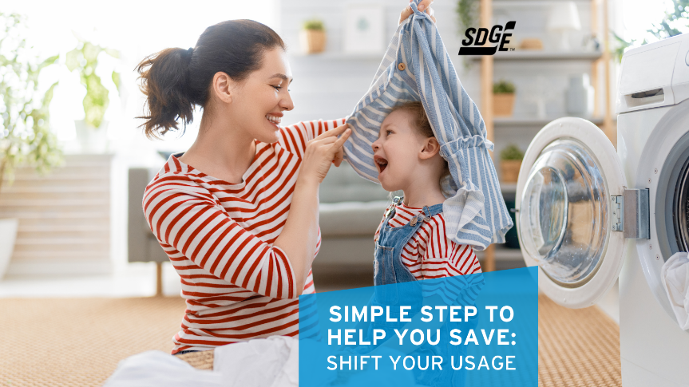
Facebook/Instagram:
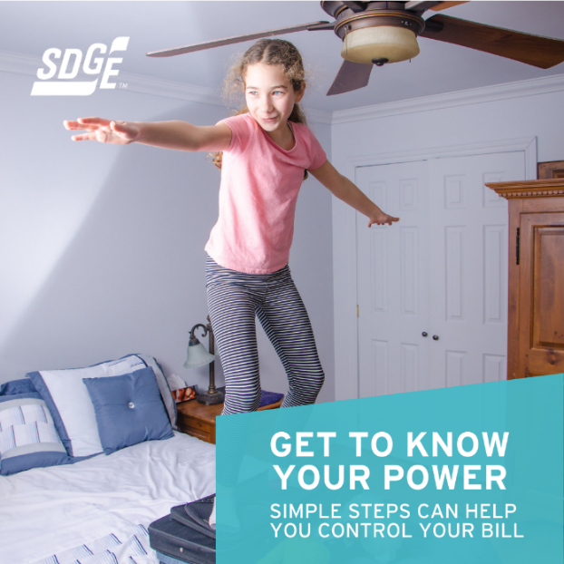

Article AND OR SOCIAL POST: Save 18% on your monthly electric bill with FERA
SDG&E recognizes this is still a challenging time for many customers. Even if you have never qualified for assistance before, you may be eligible now. If you have three or more people in your household and are having a hard time paying your electric bill, you may be eligible for an 18% discount on your electric bill. To apply, visit sdge.com/FERA.
images: Save 18% on your monthly electric bill with FERA
Twitter:
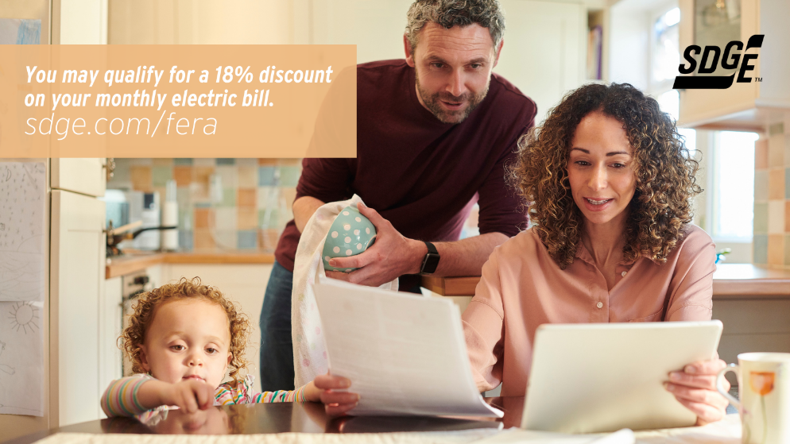

Instagram/Facebook:
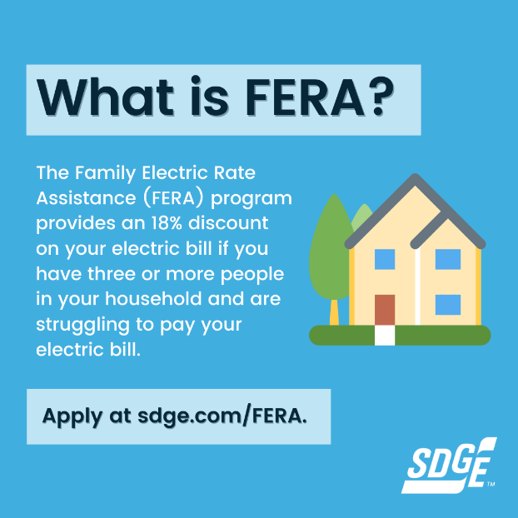
Article: NEED HELP WITH YOUR ENERGY BILL?
SDG&E recognizes that this can be a challenging time for many customers and may be able to help if you are having trouble paying your bill. You may be eligible for programs and services that can provide immediate financial assistance and help you avoid interruptions in your service. Flexible payment arrangements are available to help you pay down past due balances. Learn more at sdge.com/Payment-Arrangements.

Check out these energy assistance programs:
- California Alternate Rates for Energy (CARE) Program: Save 30% or more every month on your bill. Find out if you qualify at sdge.com/CARE.
- Family Electric Rate Assistance (FERA) Program: If you don’t qualify for CARE and your household has 3 or more people, you may qualify for FERA. You could receive an 18% discount on your electric bill. Visit sdge.com/FERA to learn more.
- Energy Savings Assistance (ESA) Program: You may qualify to receive free energy-saving improvements for your home, such as new appliances, lighting, insulation and more. Find details at sdge.com/ESA.
- Arrearage Management Plan (AMP): If you have outstanding bills and you are a CARE or FERA customer, you may be eligible for debt forgiveness. See if you qualify at sdge.com/AMP.
- Low-income Home Energy Assistance Program (LIHEAP): This program offers up to $1,000 towards your energy bill. This Federal assistance program also provides support for energy-related home improvements. Learn more at sdge.com/LIHEAP.
Even if you made a recent payment or set up a flexible payment plan with SDG&E, there may still be assistance programs available to help you. For a complete list of available offerings, visit sdge.com/assistance.

Social posts: NEED HELP WITH YOUR ENERGY BILL?
- If you’re behind on your energy bill, you may qualify for financial assistance. Learn more at sdge.com/assistance. #sdge #SDGEAssist
- Hardship is everywhere right now – the last thing you need to worry about is your energy bill. Get help with your bill at sdge.com/assistance. #sdge #SDGEAssist
- SDG&E provides assistance programs to help you with your monthly bill which can include up to a 30% discount. Find out if you qualify at sdge.com/assistance. #sdge #SDGEAssist
- Whether you rent or own, you could be eligible to receive no-cost, energy-efficient home improvements that can make your home more comfortable and help reduce your energy bill. Find out if you qualify at sdge.com/ESA. #sdge #SDGEAssist
Article (translated): ¿NECESITA AYUDA CON SU FACTURA DE ENERGÍA?
Usted puede calificar para un descuento en su factura o mejoras en el hogar. Los programas de asistencia de SDG&E ayudan a reducir su factura mensual de energía mientras mantiene su hogar cómodo.
- Programa de Tarifas Alternativas de Energía de California (CARE, por sus siglas en inglés): Ahorre un 30% o más cada mes en su factura. Averigüe si califica en sdge.com/CARE.
- Tarifa Eléctrica Familiar (FERA, por sus siglas en inglés): Si no califica para CARE y su hogar tiene 3 o más personas, puede calificar para FERA. Podría recibir un 18% de descuento en su factura de electricidad. Visite sdge.com/FERA para obtener más información.
- Programa de Asistencia para el Ahorro de Energía (ESA, por sus siglas en inglés): Puede calificar para recibir mejoras gratuitas para el ahorro de energía en su hogar, tales como electrodomésticos nuevos, iluminación, aislamiento y más. Encuentre los detalles en sdge.com/ESAP.
- Arrearage Management Plan (AMP): Si tiene facturas pendientes y es participante en el programa de CARE o FERA, puede ser elegible para la condonación de deudas. Averigüe si califica en sdge.com/AMP.
- Clientes comerciales: Configure un plan de pago flexible, para que pueda estar tranquilo sabiendo que está cubierto. Visite sdge.com/recovery para obtener más información.
Las aplicaciones en línea son fáciles, rápidas y convenientes. Para obtener más información, visite sdge.com/asistencia.
Postas sociales: ¿NECESITA AYUDA CON SU FACTURA DE ENERGÍA?
- Si está atrasado en su factura de energía, puede calificar para asistencia financiera. Obtenga más información en sdge.com/asistencia. #sdge #SDGEAssist
- En este momento, las dificultades se encuentran en todas partes - lo último que necesita es preocuparse por su factura de energía. Obtenga ayuda con su factura en sdge.com/asistencia. #sdge #SDGEAssist
- SDG&E ofrece programas de asistencia para ayudarle con su factura mensual que puede incluir hasta un 30% de descuento. Descubra si califica en sdge.com/asistencia. #sdge #SDGEAssist
- Si alquile o es propietario, podría ser elegible para recibir mejoras de eficiencia energética en su hogar, sin costo, que pueden hacer que su hogar sea más cómodo y ayuden reducir su factura de energía. Descubra si califica en sdge.com/ESA. #sdge #SDGEAssist

Images: NEED HELP WITH YOUR ENERGY BILL?
Twitter:
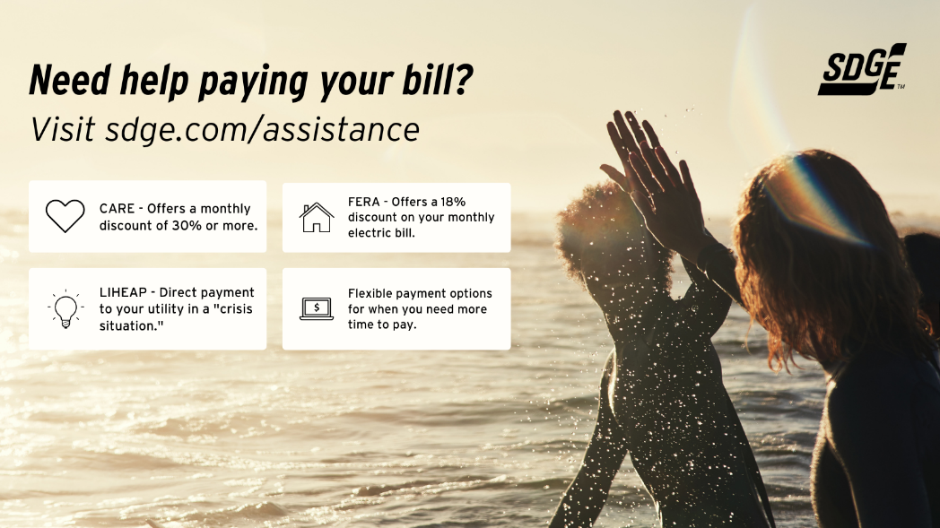

Instagram/Facebook:
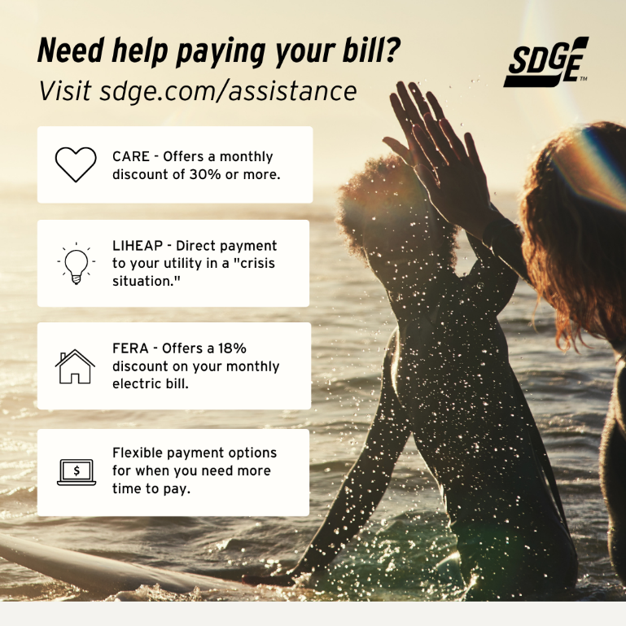

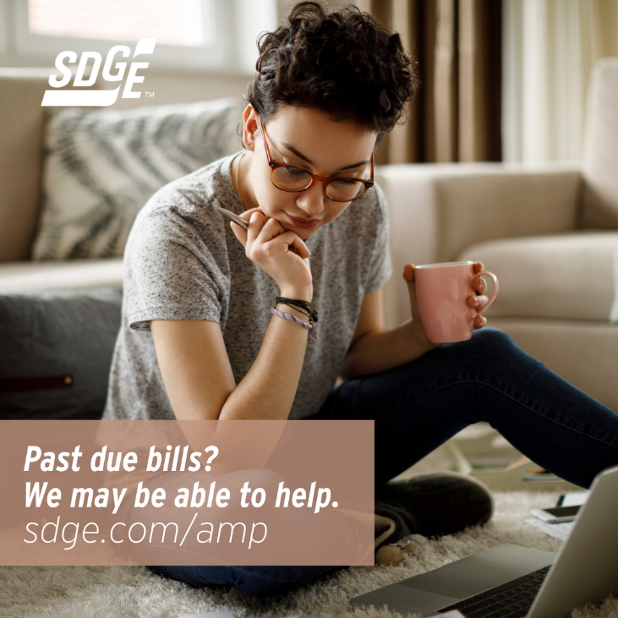

Business Article: save on energy costs at the office
Looking for ways to save on your SDD&E bill at your office? Here are some helpful business energy-saving tips leaving you with more budget for other expenses or to improve occupant comfort.
- Raise your thermostat a few degrees. Did you know office building HVAC systems consume up to 40 percent of energy bills? Turn temperatures up during unoccupied hours using smart programmable thermostats. You can also set back temperatures a few degrees without occupants noticing. Running ceiling fans with your A/C allows you to raise the thermostat 4 degrees without any change in comfort.
- Use daylighting controls. These systems use sensors to adjust lighting levels in response to available daylight and can reduce your lighting energy use up to 80 percent. If you have areas where natural daylight is prevalent, consider installing daylighting controls. If you already have daylighting controls installed, check them to make sure they are properly calibrated and working as expected.
- Pre-cool in the evening. If your business has a building automation system, consider cooling the building at night with outside air. This lowers the temperature of the building which helps reduce your cooling needs during the day between 5 and 20 percent. It can also result in improved occupant comfort by improving air quality.
- Clean the condenser coils. When the condenser coils in your air-conditioning equipment become dirty, the ability to effectively transfer heat lessens. Check your condenser coils for natural or artificial debris that has accumulated to make sure they’re working as efficiently as possible. Thoroughly wash the coils twice a year for preventive maintenance.
- Change the filters. Particularly during warmer months, filters should be changed regularly to make sure the air-conditioner fan isn’t using more energy to push air through clogged filters. If your building is located next to a highway, construction site or other location where the air isn’t as clean, consider changing filters as often as several times a month.
- Check the economizer. Many air-conditioning systems use a dampered vent, called an economizer, that draws in cool outside air to reduce the need for mechanically cooled air. Regularly check that the linkage that opens and shuts the damper is working properly to prevent large energy waste.
- Use fans. Fans can help your business maintain a comfortable temperature. Moving air can make higher temperatures and humidity feel more comfortable and reduce the need for air conditioning. When the temperature outside feels more comfortable than inside, use a box fan in the window or a whole facility fan in the attic to pull in the comfortable air.
- Ward off “vampire” equipment. Monitors and computers are two culprits that continue to draw power even when they are switched off. Prevent “phantom” loads by using a smart power strip to cut power.
- Enroll in SDG&E business programs. If you’re a small or medium business and an SDG&E customer, you may qualify for customized business solutions that can help you reduce your energy costs and save money. Find out more at sdge.com/mybusiness.
- Want to connect with an energy specialist and learn how you can save? Take a quick survey at sdge.com/business/save-energy-and-money.

Social posts: save on energy costs at the office
Use any of the above tips and add at end, “For more business energy-saving tips, visit sdge.com/mybusiness. #sdge #SDGEAssist”

Images: save on energy costs at the office

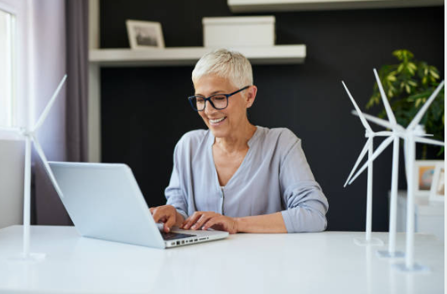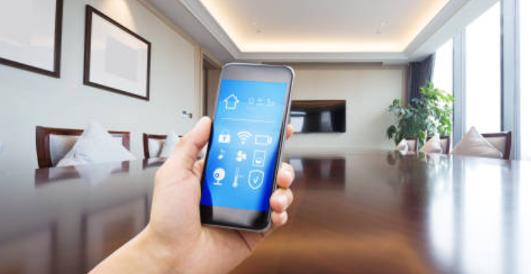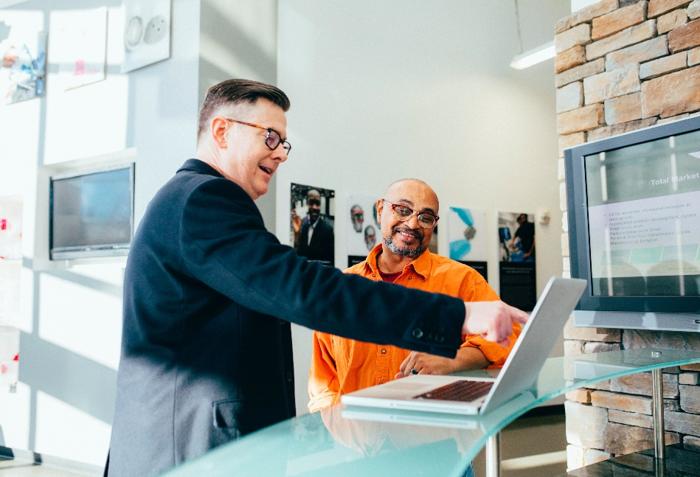

Article: TAKE ADVANTAGE OF NO-COST TRAINING FROM ENERGY EXPERTS
Did you know that SDG&E provides webinars for business owners and trade professionals, so you can learn new skills at your own pace? And most are at no cost. You or your employees can learn about the latest in green building practices, technology and energy-saving solutions from industry experts. Certifications and continuing education units are available for many classes. Check out the class listing at sdge.com/EnergyClasses.
Are you a Trade Professional? Join SDG&E’s Trade Professional Alliance at sdge.com/TradePro.
Some of September’s topics include:
- Various Title 24 classes
- Introduction to Commercial Heat Pump Water Heaters
- Photovoltaic (PV) and Energy Storage Systems (ESS) Site Analysis and Installation
- Energy Auding Techniques for Small and Medium Commercial Facilities
- Indoor Air Quality: How to Prepare Your Commercial HVAC for Pandemics and Wildfires
- Practical Green Buildings
- Electric Induction Kitchens
- Smart Building Technologies

Social posts: TAKE ADVANTAGE OF NO-COST TRAININGS FROM ENERGY EXPERTS
- Did you know SDG&E provides energy education and training webinars at no cost? These on-demand webinars are offered at introductory, intermediate and advanced levels. See the webinar list at sdge.com/EnergyClasses. #sdge #SDGEAssist
- Learn the latest in green building design, operations, maintenance and technology at no-cost energy webinars led by industry experts. See the on-demand webinar list at sdge.com/EnergyClasses. #sdge #SDGEAssist
- Enroll in a no-cost, on-demand energy topic webinar. Energy education and training can give you and your employees the knowledge and skills that customers value. Check out the webinar list at sdge.com/EnergyClasses. #sdge #SDGEAssist
Images: TAKE ADVANTAGE OF NO-COST TRAININGS FROM ENERGY EXPERTS
Twitter:

Instagram/Facebook:

