

SDG&E® RESIDENTIAL AND SMALL BUSINESS CONTENT PACKAGE | SEPTEMBER 2023
As a trusted community partner, we thank you for sharing our content and digital assets with your audiences – including residents, customers and employees – to help amplify our key messages in your email communications, websites or newsletters.
Best practices for using our content, social media posts and images
- IMAGES
Choose IMAGES that are relevant for your audience and feel free to mix and match what we provide. For alternate IMAGES, Unsplash.com and Canva.com offer free IMAGES that you can download.
- SDG&E logo
You’re welcome to mention our name but, due to legal requirements, please do not use our logo in any marketing materials that you create. Please only use the SDG&E logo if we provide it to you in this package or it’s publicly available online like a social post or video. You can also retweet our public posts which you’ll find on twitter.com/sdge.
- Videos
We have a library of videos you can share in your communications and SOCIAL POSTS when you visit youtube.com/c/SanDiegoGasElectric/videos. If you’d like to sort our videos by topic, visit youtube.com/c/SanDiegoGasElectric. Some videos are in Spanish. You’ll see some on TV, too!
Follow us
Find us on Facebook, Instagram, Twitter, YouTube and LinkedIn. When sharing our digital assets and content, feel free to tag SDG&E’s social media and direct your audience to sdge.com.

This month’s topics: Energy-saving tips for residential and business customers, customer assistance, wildfire safety, EV Day, start/stop/move SDG&E service, energy webinars. Articles and social posts translated in Spanish are in blue font.

ARTICLE: CUT COSTS ON YOUR SUMMER ENERGY BILL
Are you looking for ways to reduce your energy bill? Use major appliances when energy is less expensive, before 4 p.m. or after 9 p.m., Monday – Sunday. Here are more ways to save energy and money while staying cool.
First, let’s talk about appliances. They tend to use a lot of energy and heat up your home so, with that in mind, consider the following:
- Change the way you cook
Turn off the oven and stovetop as much as possible. These appliances can give off lots of heat and warm up your home. Instead, use microwaves, air fryers, slow cookers, backyard grills or eat foods that don’t need to be cooked. If you’re going to use your oven, do it sparingly and during the coolest part of the day.
- Change how you wash your clothes
Use cold water to wash your clothes so you don’t have to pay to heat the water. Cold water helps reduce wrinkles and remove stains. Washing in cold can help your clothes last longer, prolong vibrancy and maintain their shape and size. Always aim for full loads of laundry and consider line drying clothes.
- Don’t “heat dry” your dishes
When running your dishwasher, turn off the “heat dry” cycle and let dishes air dry instead.
- Use smart plugs for appliances
One of the best smart plug uses is to connect appliances to them. Smart plugs allow you to schedule when your appliances are on or off – even remotely. They also help reduce “vampire draw” because appliances still use energy when they’re off but still plugged in.
Beyond appliances, here are other great ways to stay cool and save big:
- Check out SDG&E’s new RES program
Do you rent or own a single-family home? Eligible customers may receive free products such as smart thermostats, low-flow showerheads, brushless fan motors, HVAC services like air duct testing and sealing – and more. SDG&E has contracted with Synergy Companies to provide customers with energy efficiency audits from their experts. Customers can request a home visit at SynergyCompanies.com or by calling 1-888-272-8394. Learn more at sdge.com/RES.
- Save with Golden State rebates
Receive rebates toward the purchase of energy-efficient products like smart thermostats, water heaters and room air conditioners. Get details at sdge.com/rebates. Visit GoldenStateRebates.com for the product list.
- Sign up for SDG&E’s Power Saver Rewards
Earn a bill credit of $2 per kilowatt hour when you reduce your energy use when the grid needs it the most. Get details at sdge.com/PowerSaver.
- Use ceiling fans instead of the A/C
Ceiling fans can save up to 25 percent on cooling costs and reduces your home’s temperature up to ten degrees. In warmer temps, fans should be set counterclockwise for the best cooling effect.
For more ideas on how to save energy, visit sdge.com/MyEnergy.
SOCIAL POSTS: CUT COSTS ON YOUR SUMMER ENERGY BILL
Use any bullet above and then add: #sdge #SDGEassist
IMAGES: CUT COSTS ON YOUR SUMMER ENERGY BILL


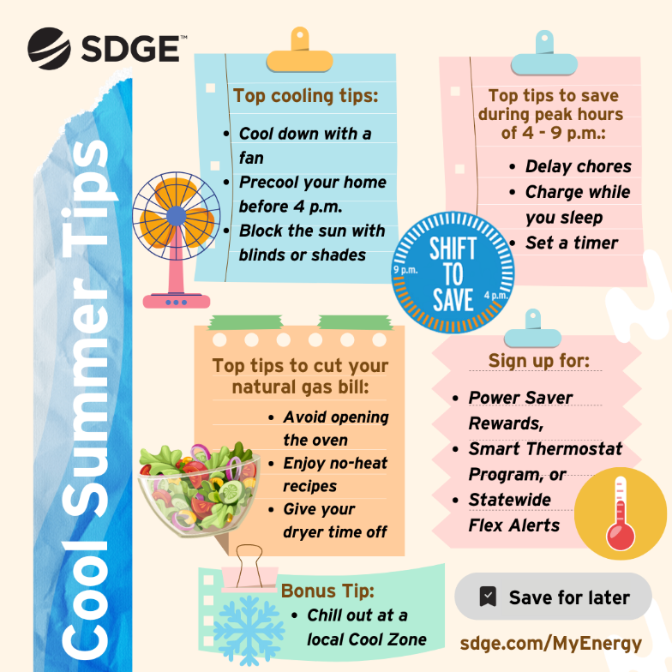
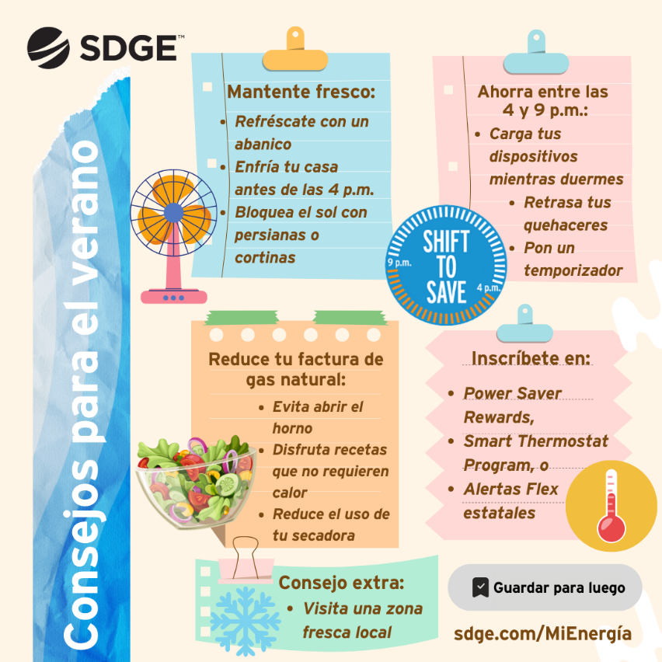

ARTICLE: NEED HELP WITH YOUR ENERGY BILL?

SDG&E recognizes that this can be a challenging time for many customers and may be able to help if you are having trouble paying your bill. You might be eligible for programs and services that can provide immediate financial assistance and help you avoid interruptions in your service. Flexible payment arrangements are also available to help you pay down past due balances. Learn more at sdge.com/Payment-Arrangements.
Check out these energy assistance programs:
- California Alternate Rates for Energy (CARE) Program: Save 30% or more every month on your bill. Find out if you qualify at sdge.com/CARE.
- Family Electric Rate Assistance (FERA) Program: If you don’t qualify for CARE and your household has 3 or more people, you may qualify for FERA. You could receive an 18% discount on your electric bill. Visit sdge.com/FERA to learn more.
- Energy Savings Assistance (ESA) Program: You may qualify to receive free energy-saving improvements for your home, like new appliances, lighting, insulation and more. Find details at sdge.com/ESA.
- Arrearage Management Plan (AMP): If you have outstanding bills and you are a CARE or FERA customer, you may be eligible for debt forgiveness. See if you qualify at sdge.com/AMP.
Even if you made a recent payment or set up a flexible payment plan with SDG&E, there may still be assistance programs available to help you. For a complete list of available offerings, visit sdge.com/assistance.

SOCIAL POSTS: NEED HELP WITH YOUR ENERGY BILL?
- If you’re behind on your energy bill, you may qualify for financial assistance. Learn more at sdge.com/assistance. #sdge #SDGEAssist
- Hardship is everywhere right now – the last thing you need to worry about is your energy bill. Get help with your bill at sdge.com/assistance. #sdge #SDGEAssist
- SDG&E provides assistance programs to help you with your monthly energy bill which can include up to a 30% discount. Find out if you qualify at sdge.com/assistance. #sdge #SDGEAssist
- Whether you rent or own, you could be eligible to receive no-cost, energy-efficient home improvements that can make your home more comfortable and help reduce your energy bill. Find out if you qualify at sdge.com/ESA. #sdge #SDGEAssist

ARTICLE (translated): ¿NECESITA AYUDA CON SU FACTURA DE ENERGÍA?
Usted puede calificar para un descuento en su factura o mejoras en el hogar. Los programas de asistencia de SDG&E ayudan a reducir su factura mensual de energía mientras mantiene su hogar cómodo.
- Programa de Tarifas Alternativas de Energía de California (CARE, por sus siglas en inglés): Ahorre un 30% o más cada mes en su factura. Averigüe si califica en sdge.com/CAREesp.
- Tarifa Eléctrica Familiar (FERA, por sus siglas en inglés): Si no califica para CARE y su hogar tiene 3 o más personas, puede calificar para FERA. Podría recibir un 18% de descuento en su factura de electricidad. Visite sdge.com/FERAesp para obtener más información.
- Programa de Asistencia para el Ahorro de Energía (ESA, por sus siglas en inglés): Puede calificar para recibir mejoras gratuitas para el ahorro de energía en su hogar, tales como electrodomésticos nuevos, iluminación, aislamiento y más. Encuentre los detalles en sdge.com/ESAPesp.
- Arrearage Management Plan (AMP): Si tiene facturas pendientes y es participante en el programa de CARE o FERA, puede ser elegible para la condonación de deudas. Averigüe si califica en sdge.com/AMPesp.

Las aplicaciones en línea son fáciles, rápidas y convenientes. Para obtener más información, visite sdge.com/asistencia.

POSTAS SOCIALES: ¿NECESITA AYUDA CON SU FACTURA DE ENERGÍA?
- Si está atrasado en su factura de energía, puede calificar para asistencia financiera. Obtenga más información en sdge.com/asistencia. #sdge #SDGEAssist
- En este momento, las dificultades se encuentran en todas partes - lo último que necesita es preocuparse por su factura de energía. Obtenga ayuda con su factura en sdge.com/asistencia. #sdge #SDGEAssist
- SDG&E ofrece programas de asistencia para ayudarle con su factura mensual que puede incluir hasta un 30% de descuento. Descubra si califica en sdge.com/asistencia. #sdge #SDGEAssist
- Si alquile o es propietario, podría ser elegible para recibir mejoras de eficiencia energética en su hogar, sin costo, que pueden hacer que su hogar sea más cómodo y ayuden reducir su factura de energía. Descubra si califica en sdge.com/ESAesp. #sdge #SDGEAssist

IMAGES: NEED HELP WITH YOUR ENERGY BILL?


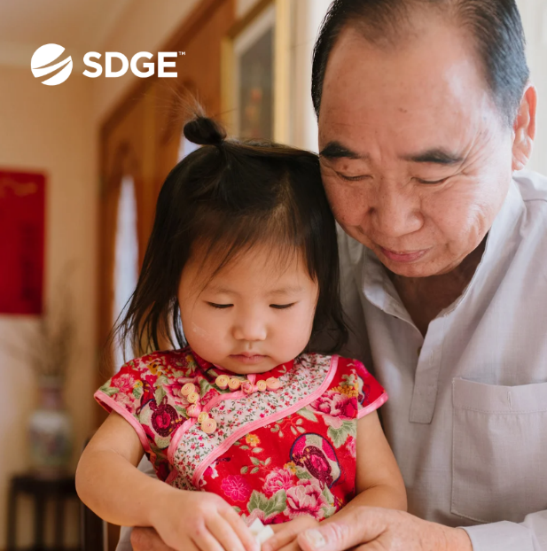
article: WILDFIRE ALERT: IS YOUR HOME PREPARED?
Despite record-breaking rainfall this year, the risk of wildfires persists. To increase your property's chances of surviving a wildfire, it's essential to create a defensible space around your property and reinforce your home or business with fire-resistant materials.
- Create a defensible space. Minimize your home’s exposure to risk by modifying the vegetation space around it to help resist a wildfire. California requires 100 feet of defensible space around your property.
- Increase your home’s defenses.
- Consider building your roof or re-roof with materials such as stone, slate, metal, clay tiles or asphalt shingles, which offer the highest resistance to fire.
- Cover all vent openings with 1/16-inch to 1/8-inch metal screening, as flying embers can enter your house through vents.
- If possible, windows should be double-paned with one pane of tempered glass; it’s recommended to help reduce the chance of breakage in a fire, especially if facing large areas of vegetation.
- Keep rain gutters clear or enclose rain gutters to prevent the accumulation of plant debris.
- Cover your chimney and stovepipe outlets with a non-flammable screen. Use metal screen material with openings no smaller than 3/8-inch and no larger than 1/2-inch to prevent embers from escaping and igniting a fire.
- Additional things to consider:
- Have a fire extinguisher and tools such as a shovel, rake, bucket and hose for fire emergencies.
- Store all combustible and flammable liquids away from ignition sources.
- Make sure your address is clearly visible from the road.
- Consider having multiple garden hoses that are long enough to reach all areas of your home and other structures on your property.
For more information on wildfire safety, visit sdge.com/Wildfire-Safety.
social posts: WILDFIRE ALERT: IS YOUR HOME PREPARED?
Use any of the bullets above then add: For more information on wildfire safety, visit sdge.com/Wildfire-Safety. #sdge #SDGEassist

IMAGES: WILDFIRE ALERT: IS YOUR HOME PREPARED?
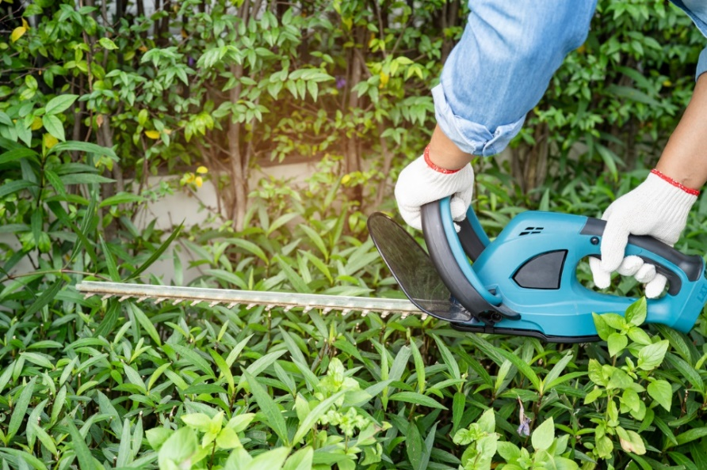

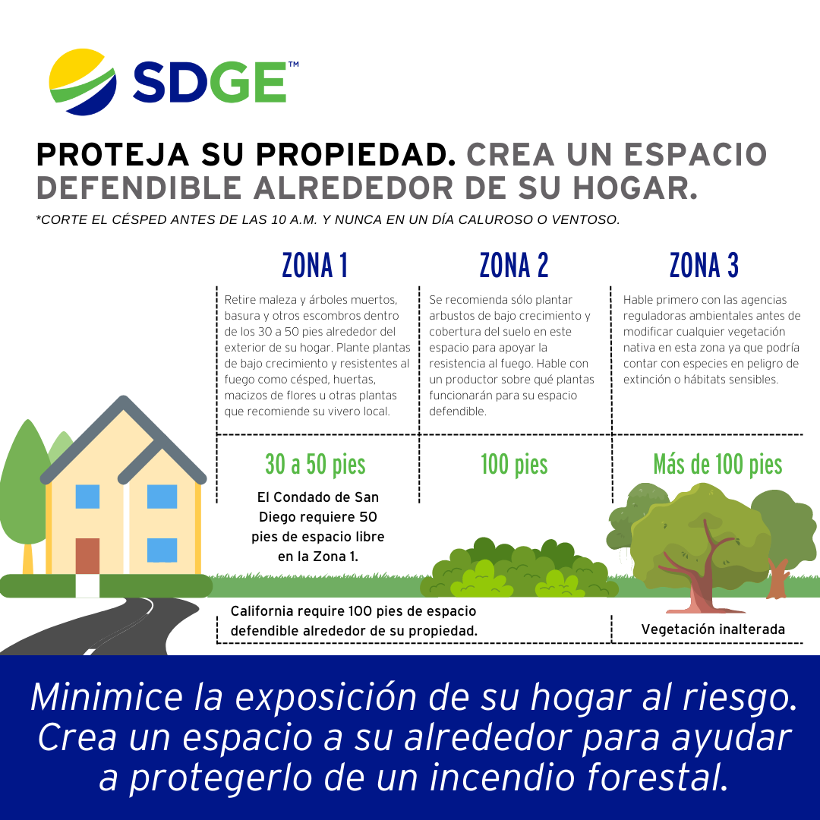
ARTICLE: Rev Up Your Curiosity at THE San Diego Electric Vehicle Day EVENT
Are you eager to explore the latest electric vehicle (EV) models and their impressive features? The 11th annual San Diego Electric Vehicle Day event features test drives of the newest EVs, a showcase of electric vehicles, good food and family entertainment. Get ready for an electrifying experience!
This year's event is set to make history as the largest of its kind in the region, offering a lineup of over 50 EVs for test drives and exhibition. The new venue at Snapdragon Stadium provides significantly more space than the previous location ensuring ample room for test drives, vehicle displays and a host of family-friendly activities. Join us for an unforgettable day of EV exploration.
Date and Time: Saturday, October 14th, from 10 a.m. to 3 p.m.
Location: Snapdragon Stadium, 2101 Stadium Way, San Diego, CA 92108
Admission: Free
SOCIAL POSTS: Rev Up Your Curiosity at THE San Diego Electric Vehicle Day EVENT
- Join @SDGE at the 11th annual San Diego EV Day on Oct. 14th! At this free event located at @SnapDragonStadium, you'll be able to test drive the latest EV models, learn about charging options and enjoy a day of family fun. Learn more at sdge.com/EVday. #LOVELECTRIC #sdge #SDGEassist
- Discover the world of electric vehicles at EV Day on Oct. 14th at @SnapDragonStadium. This no-cost event sponsored by @SDGE invites you to drive the latest EV models, chat with local EV owners and learn about EV incentives. Let's drive change together! Learn more at sdge.com/EVday. #LOVELECTRIC #sdge #SDGEassist
- Embrace the power of electric vehicles with @SDGE at @SnapdragonStadium on Oct. 14th! From test drives to eco-friendly vendors, San Diego's EV Day is a free event that has it all. Learn more at sdge.com/EVday. #LOVELECTRIC #sdge #SDGEassist

IMAGES: Rev Up Your Curiosity at THE San Diego Electric Vehicle Day EVENT
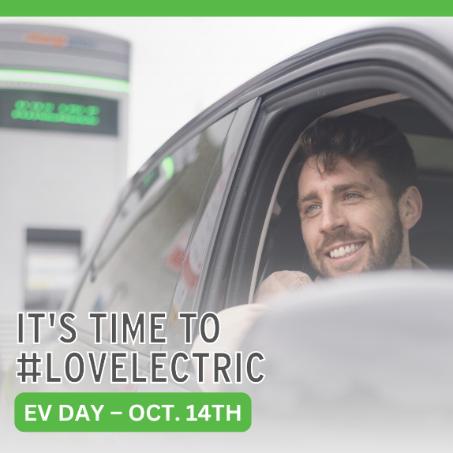
ARTICLE: MOVING? SCHEDULE YOUR SDG&E SERVICE REQUEST ONLINE
Take a little stress out of your move when you schedule your SDG&E service request online. Use SDG&E’s My Account to start, transfer or stop your service. It’s easy and only takes a minute. No need to call and no need to wait on the phone. Online scheduling shows you available dates that you can choose. If your plans change, simply update your request online. Get more information at sdge.com/move.
SOCIAL POSTS: MOVING? SCHEDULE YOUR SDG&E SERVICE REQUEST ONLINE
- Moving? Make moving easier with online scheduling tools. Visit sdge.com/move to start, transfer or stop your SDG&E service. #sdge #SDGEassist
- Moving made easy. Start, transfer or stop your SDG&E service online. Easy, convenient – no calls, no waiting. Get more information at sdge.com/move. #sdge #SDGEassist

IMAGES: MOVING? SCHEDULE YOUR SDG&E SERVICE REQUEST ONLINE


BUSINESS SECTION:
ARTICLE: WAYS YOUR BUSINESS CAN KEEP COOL AND CUT COSTS
As temperatures rise, so do energy bills for small businesses. But don't sweat it! There are plenty of ways for small businesses to keep cool and save energy—and money—during the scorching summer months. Here are some tips to help you beat the heat while keeping your energy costs in check:
1. Schedule a no-cost energy assessment: One of SDG&E’s authorized contractors will come to your business, identify energy efficiency upgrades and install new equipment. There are over 100 measures including energy-efficient lighting, water heaters and refrigeration controls – many provided at no cost! For more information, visit sdge.com/BES.
2. Proper insulation and sealing: Ensure your business space is well-insulated and properly sealed. This keeps the cool air in and the hot air out. Inspect doors and windows for drafts and seal any gaps with weatherstripping or caulk.
3. Maintain your HVAC system: Regular maintenance of your heating, ventilation and air conditioning (HVAC) system is essential. Clean or replace filters, check for leaks and schedule professional maintenance to ensure your system operates efficiently.
5. Use natural ventilation: Take advantage of cooler morning and evening temperatures by opening windows and using fans to circulate air. Ceiling fans can make you feel cooler, allowing you to set the thermostat a bit higher.
6. Reduce heat from appliances: Electronics and appliances generate heat, adding to the cooling load. Turn off equipment when not in use and consider using power strips to completely cut power to devices that continue to draw energy in standby mode.
By implementing these energy-saving strategies, your small business can stay comfortable during the summer heat while lowering energy costs. Remember, every dollar saved on energy bills goes straight to your bottom line. So, beat the heat and boost your business's sustainability by becoming more energy efficient.
Social posts: WAYS YOUR BUSINESS CAN KEEP COOL AND CUT COSTS
Use any of the above bullets and add: Get more tips at sdge.com/MyBusiness. #sdge #SDGEassist

images: WAYS YOUR BUSINESS CAN KEEP COOL AND CUT COSTS


ARTICLE: TAKE ADVANTAGE OF NO-COST TRAINING FROM ENERGY EXPERTS
Did you know that SDG&E provides webinars for business owners and trade professionals, so you can learn new skills at your own pace? And most are at no cost. You or your employees can learn about the latest in green building practices, technology and energy-saving solutions from industry experts. Certifications and continuing education units are available for many classes. Check out the class listing at sdge.com/EnergyClasses.
SOCIAL POSTS: TAKE ADVANTAGE OF NO-COST TRAININGS FROM ENERGY EXPERTS
- Did you know SDG&E provides energy education and training webinars at no cost? These on-demand webinars are offered at introductory, intermediate and advanced levels. See the webinar list at sdge.com/EnergyClasses. #sdge #SDGEassist
- Learn the latest in green building design, operations, maintenance and technology at no-cost energy webinars led by industry experts. See the on-demand webinar list at sdge.com/EnergyClasses. #sdge #SDGEassist
- Enroll in a no-cost, on-demand energy topic webinar. Energy education and training can give you and your employees the knowledge and skills that customers value. Check out the webinar list at sdge.com/EnergyClasses. #sdge #SDGEassist

imageS: TAKE ADVANTAGE OF NO-COST TRAININGS FROM ENERGY EXPERTS


NEW SECTION!
JUST POSTS – Residential
- A piggy bank on wheels. Driving an electric vehicle can save you up to $1,350 a year on fuel and up to $4,600 a year on maintenance costs. Plus, you may qualify for thousands in rebates and tax incentives. It’s easy to LOVELECTRIC! Learn more at sdge.com/lovelectric. #sdge #SDGEassist
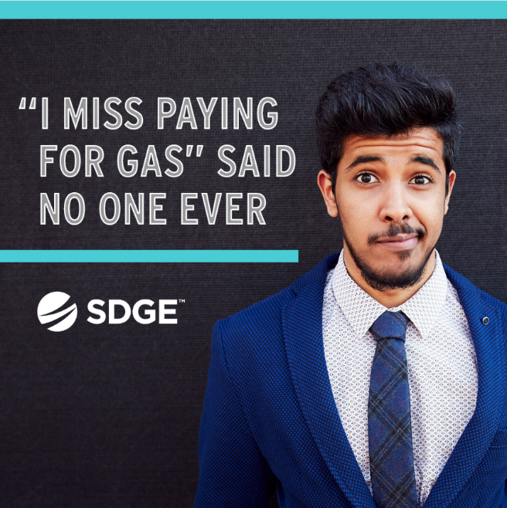
- Did you know whole house fans can help beat the heat? Whole house fans can quickly cool a home. Compared to traditional air conditioning systems, whole house fans consume less energy and maintain a more natural indoor climate. Get more tips at sdge.com/MyEnergy. #sdge #SDGEassist
- Use a moisture sensor on your dryer to avoid over-drying. Hang drying is the most energy-efficient and low-cost way to dry clothes. If you do need to use a clothes dryer, make sure to run only full loads and remove lint from the filter after each cycle. Get more tips at sdge.com/MyEnergy. #sdge #SDGEassist
- Tips on how to stay cool while keeping energy costs down are available at sdge.com/MyEnergy. You’ll also find tools for managing your energy use and bill. #sdge #SDGEassist
- Use a small air conditioner for smaller spaces. Correctly sizing the air conditioner for your home can result in energy savings. Get more tips at sdge.com/MyEnergy. #sdge #SDGEassist
- Download SDG&E’s mobile app at sdge.com/MobileApp. You can set energy use and cost alerts, pay your bill, track power outages and restoration times and update your emergency contact information. #sdge #SDGEassist
- Qualifying SDG&E customers can receive rebates toward the purchase of energy-efficient products for the home. Learn more about the Golden State Rebates program at sdge.com/rebates. #sdge #SDGEassist
- Manage your energy bill when you sign up for energy use alerts. Receive a text or email notification when your energy usage reaches a dollar amount that you set. Get more info at sdge.com/alerts. #sdge #SDGEassist
- The Neighbor-to-Neighbor program provides eligible SDG&E customers with up to $600 to offset their outstanding energy bills. SDG&E customers may apply if they are experiencing serious illness, temporary unemployment, disability or unusual hardship. Learn more at sdge.com/NTN. #sdge #SDGEassist
- A new no-cost energy efficiency upgrade program for renters and owners of single-family homes is now available. Residential Energy Solutions has no income restrictions and has the potential to help local families achieve long-term savings on their energy bills. Get details at sdge.com/RES. #sdge #SDGEassist
- Visit a Cool Zone which is a network of free, air-conditioned facilities across San Diego County like libraries and community centers. If you’re unable to get to a Cool Zone, call 2-1-1 to be connected to a transportation service at no cost. Visiting Cool Zones is also a way to use less energy at home and help reduce your energy costs. Find a Cool Zone near you at sdge.com/Cool-Zones or bit.ly/43EdfKw.

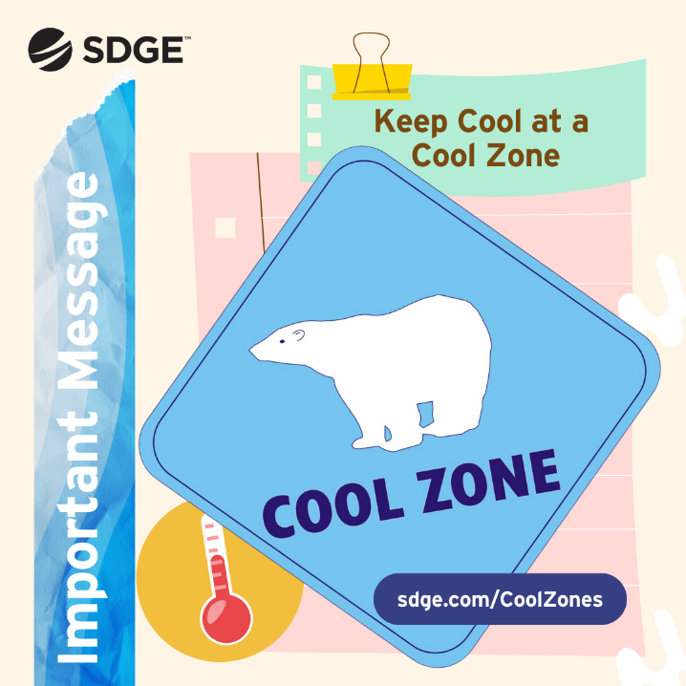

JUST POSTS – Business
- Do you own a small business? Receive energy-efficient upgrades like lighting, water heaters and refrigeration controls when you sign up for a no-cost energy assessment. One of SDG&E’s contractors will come to your business, make recommendations on where to save energy and install new equipment – many items at no cost! For more information, visit sdge.com/BES. #sdge #SDGEassist
- When your business participates in SDG&E’s ELRP program, you can earn financial incentives of $2 per kilowatt-hour when your business reduces energy during a grid emergency. Get more information at sdge.com/ELRP. #sdge #SDGEassist
- Looking for ways to save energy at your business or office? Check out sdge.com/MyBusiness for energy-saving tips. #sdge #SDGEassist
- Ward off “vampire” equipment at work. Monitors and computers are two culprits that continue to draw power even when they are switched off. Prevent “phantom” loads by using a smart power strip to cut power. Get more energy-saving tips at sdge.com/MyBusiness. #sdge #SDGEassist
- The Emergency Load Reduction Program is a flexible way your business can get incentives for using less energy. Learn more at sdge.com/ELRP. #sdge #SDGEassist

