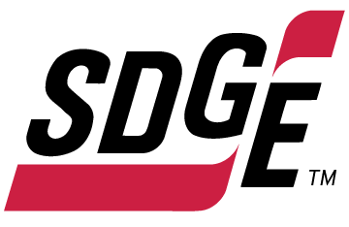

SDG&E RESIDENTIAL CONTENT PACKAGE | SEPTEMBER 2021
As a trusted community partner, we thank you in advance for sharing these digital assets with your audiences, including residents, customers and employees to help amplify our monthly messages. Here are social media posts, articles and photos you are welcome to use in email communications, websites or newsletters. There are several images with each posting. Please choose images that fit your audience and feel free to mix and match.

Follow Us
You can find us on Facebook, Instagram, Twitter, YouTube and LinkedIn. When sharing these messages in your social posts, feel free to tag SDG&E’s social media accounts and direct your audience to sdge.com.

This month’s topics: Energy-saving tips, Medical Baseline Program, emergency preparedness, customer assistance programs

Article 1: WAYS TO SAVE ON YOUR ENERGY BILL
Temperatures are still rising, but your energy bills shouldn’t. Here are a few tips to help reduce your energy use, stay cool and lower your utility bill.

- Are you on the right pricing plan for your lifestyle? Being on the best pricing plan can add up to real savings on your energy bill, especially if you can shift your energy use to before 4 p.m. or after 9 p.m. Learn more at sdge.com/pricing.
- Turn off fans when you leave the room. Remember that fans cool people, not rooms.
- While the air conditioning is on, run a ceiling fan too. You can raise the thermostat 4°F while maintaining the same comfort level.
- When it cools off at night, turn off your A/C and open your windows. In the morning, shut the windows and blinds to capture the cool air.
- Place lamps or TV sets away from your air-conditioning thermostat. It senses heat from these appliances, which can cause the air conditioner to run longer than necessary.
- One way to avoid using energy at home is to enjoy being out in the community. On hot afternoons, consider going someplace cooler like the beach, an indoor shopping mall, movie theater or library. Find a Cool Zone near you at sdge.com/CoolZones.
- Wash with cold water. Using warm water instead of hot can cut a load’s energy use in half; using cold water will save even more. As an added bonus, cold water helps your clothes last longer.
- Save energy while you sleep. Recharge your electronic devices while you do the same so your devices will be fully charged when you wake up.
- There's nothing better than walking into a chilled home. Keep it cool by turning your A/C on in the morning and turning it off at 4 p.m. to take advantage of off-peak pricing.
- By setting your thermostat to 78° or higher (health permitting) between 4 p.m. – 9 p.m., you’ll join fellow Californians in saving money and reducing greenhouse gas emissions.
For more home energy-saving tips, visit sdge.com/tips.

Social posts: WAYS TO SAVE ON YOUR ENERGY BILL
- Avoid using energy at home by enjoying your community. On hot afternoons, consider going someplace cooler like the beach, an indoor shopping mall, movie theater or library. Find a Cool Zone near you at sdge.com/CoolZones. #sdge #SDGEassist
- Are you on the right pricing plan for your lifestyle? Being on the best pricing plan can add up to real savings on your energy bill, especially if you can shift your energy use to before 4 p.m. or after 9 p.m. Learn more at sdge.com/pricing. #sdge #SDGEassist
- Turn off fans when you leave the room. Remember that fans cool people, not rooms. #sdge #SDGEassist
- Keep tabs on your energy use and costs. Get customized SDG&E alerts by email, text or both. Learn more at sdge.com/alerts. #sdge #SDGEassist

Images: WAYS TO SAVE ON YOUR ENERGY BILL

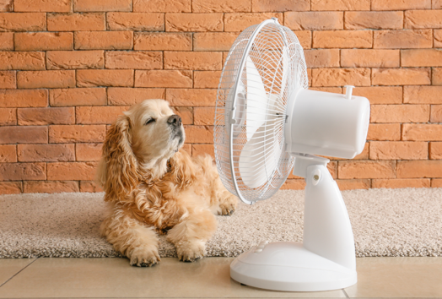

Article 2: Medical needs? Here’s your prescription for savings.
Certain medical needs may qualify you or someone in your home for savings every month on your gas and electric bill. Apply for the Medical Baseline Allowance program if you need to use more energy due to a qualifying medical condition or to prevent an existing condition from getting worse. Examples include:
A requirement for permanent space heating or cooling due to paraplegia, quadriplegia, hemiplegia, multiple sclerosis, scleroderma, a compromised immune system or a life-threatening illness.
Required use of a life-support device, such as an aerosol tent, apnea monitor, kidney dialysis machine, motorized wheelchair or respirator (devices used for therapy don’t qualify; only medical devices that sustain life or are needed for mobility).
To get a Medical Baseline Allowance application and more information, visit sdge.com/medical. Eligibility requirements include having a physician sign your application to certify the medical need.
Social posts: Medical needs? Here’s your prescription for savings.
- If you or someone in your household has a qualifying medical condition or a need for certain medical devices that require electricity, you may qualify for SDG&E’s Medical Baseline Allowance Program. Apply at sdge.com/medical. #sdge #SDGEassist
- SDG&E’s Medical Baseline Allowance Program provides an additional amount of gas and electricity at the lowest energy rates. Get details at sdge.com/medical. #sdge #SDGEassist
- Anyone who uses certain medical devices or needs space heating or air conditioning because of a medical condition may qualify for SDG&E’s Medical Baseline Allowance Program. Learn more at sdge.com/medical. #sdge #SDGEassist

Article 2 translated: ¿Hay necesidades médicas? Obtenga esta receta para ahorrar.
Ciertas necesidades médicas pueden hacer que usted o alguien que vive en su casa cumpla con los requisitos para ahorrar cada mes en su factura de gas y electricidad. Solicite el programa de Asignación Médica Inicial si necesita consumir más energía debido a una enfermedad que cumpla con las condiciones o para evitar que una condición existente empeore. Por ejemplo:
Requerir calefacción o aire acondicionado ambiental permanente debido a paraplejia, tetraplejia, hemiplejia, esclerosis múltiple, esclerodermia, un sistema inmunitario afectado o una enfermedad potencialmente mortal.
Requerir el uso de un dispositivo de soporte vital, como una tienda de nebulización, monitor de apnea, máquina para diálisis del riñón, silla de ruedas motorizada o respirador (los dispositivos usados para terapia no cumplen con los requisitos; únicamente dispositivos médicos que sustenten la vida o se necesiten para movilidad).
Para obtener un formulario de solicitud para el programa de Asignación Médica Inicial y más información, visite sdge.com/programa-medico. Los requisitos para tener derecho a participar incluyen el que un médico firme su solicitud para certificar la necesidad médica.
Postas sociales: ¿Hay necesidades médicas? Obtenga esta receta para ahorrar.
- Si usted o alguien en su hogar tiene una condición médica calificada o una necesidad de ciertos dispositivos médicos, puede calificar para el Programa de Asignación Médica Inicial de SDG&E. Solicite en sdge.com/programa-medico. #sdge #SDGEassist
- El Programa de Asignación Médica Inicial de SDG&E proporciona una cantidad adicional de gas y electricidad a las tarifas de energía más bajas. Obtenga detalles en sdge.com/programa-medico. #sdge #SDGEassist
- Cualquier persona que use ciertos dispositivos médicos o necesite calefacción o aire acondicionado debido a una afección médica puede calificar para el Programa de Asignación Médica Inicial de SDG&E. Obtenga más información en sdge.com/programa-medico. #sdge #SDGEassist

Images: Medical needs? Here’s your prescription for savings.
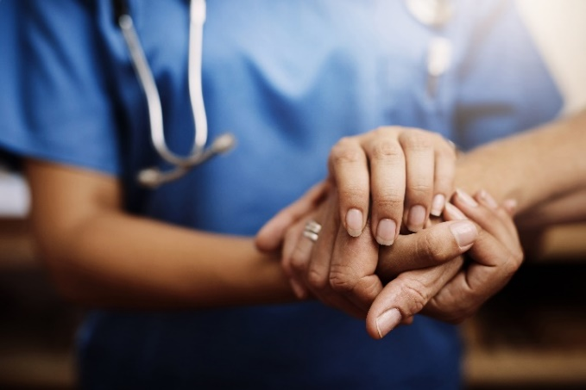
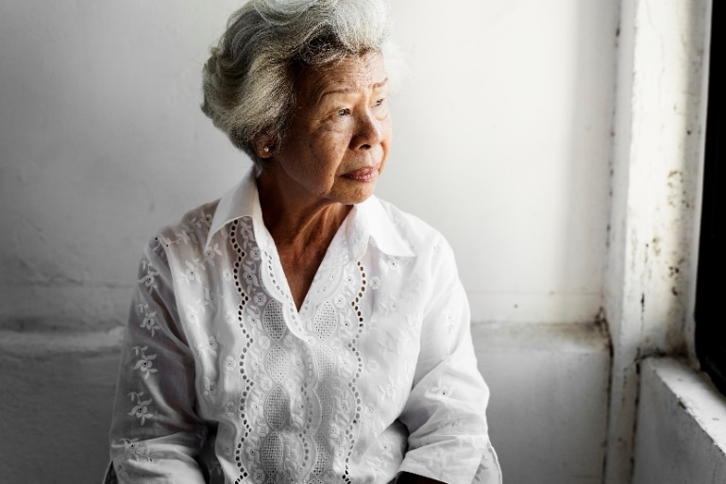
Article 3: PREPARE NOW FOR AN EMERGENCY LATER
Emergencies come in many forms such as wildfires, storms, earthquakes or floods. There’s no better time to prepare for an emergency than right now. Every family is different, but here are some tips and resources to help you plan and stay safe should an emergency happen.
- Develop an emergency plan. Identify a place to meet with family, safe routes and shelters, as well as what actions you will take. Discuss and practice the plan with your family, including your children and pets.
- Prepare an emergency kit for at least three days. Keep essentials on hand like water (one gallon per person per day), a first aid kit, flashlight, canned goods, medicine, clothes and cash. Stock your kit with items you and your family need, including those with a disability, seniors and your pets. Store supplies in easy-to-carry containers such as backpacks or plastic crates. For ideas, visit these checklists at sdge.com/checklists.
- Help your neighbors. Being a good neighbor takes more than sharing the occasional cup of sugar or hosting a potluck. It’s important to help our neighbors during emergencies, especially those who are vulnerable, elderly or disabled.
For more emergency checklists and evacuation plans, visit sdge.com/emergency.
Update your SDG&E contact information
Whatever the circumstances, SDG&E will make every effort to communicate with you during emergencies. Go to sdge.com/MyAccount to sign in. From the My Account homepage, click on your profile name in the top right-hand corner, then select “My Profile.”
Sign-up for outage notifications
Get notified when there is an outage in your area. Sign into sdge.com/MyAccount. From the My Account Home Page, click on your profile name in the top right-hand corner, then select “Notification Settings.”

Social posts: PREPARE NOW FOR AN EMERGENCY LATER
- It’s important to be prepared for emergencies like wildfires. Use our checklist and stock up on staples to remain prepared for the unexpected. Learn more at sdge.com/emergency. #sdge #SDGEassist
- Are you, your family and pets ready in case of an emergency? Visit sdge.com/checklists to learn which items you should have on hand in a pinch. #sdge #SDGEassist
- Stay safe this wildfire season by updating your contact info on SDG&Es website so they can notify you of power outages. Visit sdge.com/MyAccount. #sdge #SDGEassist
- Help your neighbors during emergencies, especially those who are vulnerable or elderly. Find safety tips at sdge.com/Wildfire-Safety. #sdge #SDGEassist
- Think smart and don’t leave your safety to chance. Visit sdge.com/Wildfire-Safety for steps to prepare now for an emergency later. #sdge #SDGEassist
- Does SDG&E have your current contact information in case of a Public Safety Power Shutoff? Visit sdge.com/PSPS for details. #sdge #SDGEassist
- Stay informed during a Public Safety Power Shutoff event by downloading SDG&E’s Alerts app at sdge.com/notifications. #sdge #SDGEassist

Images: PREPARE NOW FOR AN EMERGENCY LATER
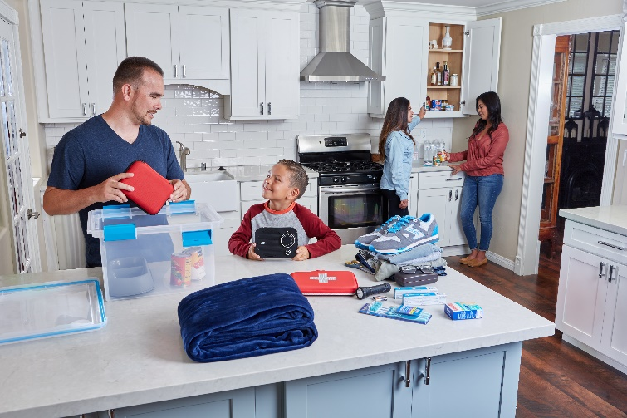
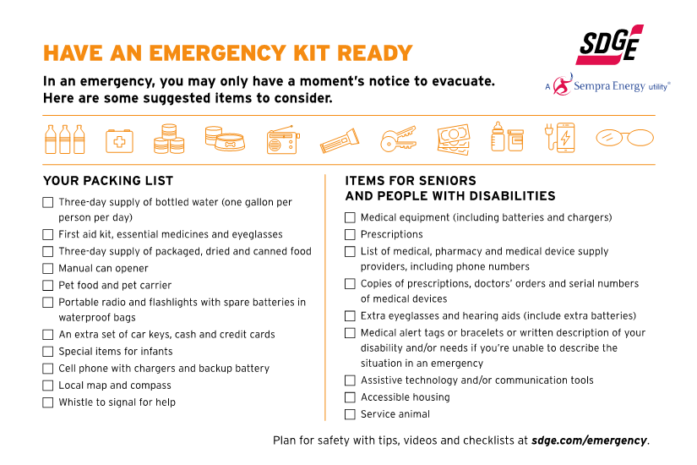
Article 4: NEED HELP WITH YOUR ENERGY BILL?
You may qualify for a bill discount or home improvements. SDG&E’s assistance programs can help you lower your energy use and/or monthly energy bill while keeping your home comfortable.
California Alternate Rates for Energy (CARE) Program: Save 30% or more every month on your energy bill. Find out if you qualify at sdge.com/CARE.
Family Electric Rate Assistance (FERA) Program: If you don’t qualify for CARE and your household has 3 or more people, you may qualify for FERA. You could receive an 18% discount on your electric bill. Visit sdge.com/FERA for more information.
Energy Savings Assistance (ESA) Program: You may qualify to receive no-cost, energy-saving improvements for your home, such as new appliances, furnace repair, lighting, insulation and more. Find details at sdge.com/ESAP.
Online applications are easy, fast and convenient. To learn more about SDG&E’s assistance programs, visit sdge.com/assistance.
Social posts: NEED HELP WITH YOUR ENERGY BILL?
- If you’re behind on your energy bill, you may qualify for financial assistance. Learn more at sdge.com/assistance. #sdge #SDGEassist
- Hardship is everywhere right now – the last thing you need is to worry about your energy bill. Get help with your bill at sdge.com/assistance. #sdge #SDGEassist
- SDG&E provides assistance programs to help you with your monthly bill which can include up to a 30% discount. Find out if you qualify at sdge.com/assistance. #sdge #SDGEassist
- Whether you rent or own, you could be eligible to receive no-cost, energy-efficient home improvements that can make your home more comfortable and reduce your energy bill. Find out if you qualify at sdge.com/ESAP. #sdge #SDGEassist

Article 4 (translated): ¿Necesita ayuda con su FACTURA de energía?
Usted puede calificar para un descuento en su factura o mejoras en el hogar. Los programas de asistencia de SDG&E ayudan a reducir su factura mensual de energía mientras mantiene su hogar cómodo.
Programa de Tarifas Alternativas de Energía de California (CARE, por sus siglas en inglés): Ahorre un 30% o más cada mes en su factura. Averigüe si califica en sdge.com/CARE.
Programa de Asistencia de Tarifa Eléctrica Familiar (FERA, por sus siglas en inglés): Si no califica para el programa de CARE y su hogar tiene 3 o más personas, puede calificar para FERA. Podría recibir un 18% de descuento en su factura de electricidad. Visite sdge.com/FERA para obtener más información.
Programa de Asistencia para el Ahorro de Energía (ESA, por sus siglas en inglés): Puede calificar para recibir mejoras gratuitas para el ahorro de energía en su hogar, tales como electrodomésticos nuevos, reparación de hornos, iluminación, aislamiento y más. Encuentre los detalles en sdge.com/ESAP.
Las aplicaciones en línea son fáciles, rápidas y convenientes. Para obtener más información, visite sdge.com/asistencia.
Postas sociales: ¿Necesita ayuda con su FACTURA de energía?
- Si está atrasado en su factura de energía, puede calificar para asistencia financiera. Obtenga más información en sdge.com/asistencia. #sdge #SDGEassist
- En este momento, las dificultades se encuentran en todas partes - lo último que necesita es preocuparse por su factura de energía. Obtenga ayuda con su factura en sdge.com/asistencia. #sdge #SDGEassist
- SDG&E ofrece programas de asistencia para ayudarle con su factura mensual que puede incluir hasta un 30% de descuento. Descubra si califica en sdge.com/asistencia. #sdge #SDGEassist
- Ya sea que alquile o sea propietario, podría ser elegible para recibir mejoras de eficiencia energética en su hogar, sin costo, que pueden hacer que su hogar sea más cómodo y reducir su factura de energía. Descubra si califica en sdge.com/ESAP. #sdge #SDGEassist
Images: NEED HELP WITH YOUR SDG&E BILL?

