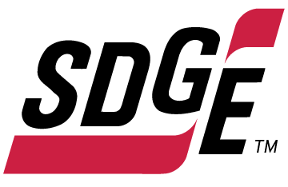
SDG&E BUSINESS CONTENT PACKAGE | SEPTEMBER 2021
As a trusted community partner, we thank you in advance for sharing these digital assets with your audiences, including residents, customers and employees to help amplify our monthly messages. Here are social media posts, articles and photos you are welcome to use in email communications, websites or newsletters. There are several images with each posting. Please choose images that fit your audience and feel free to mix and match.

Follow Us
You can find us on Facebook, Instagram, Twitter, YouTube and LinkedIn. When sharing these messages in your social posts, feel free to tag SDG&E’s social media accounts and direct your audience to sdge.com.

This month’s topics: electrical and power tool safety, energy-saving tips at work, on-demand energy webinars

Article 1: Power Tool and ELECTRICAL Equipment Safety
Chances are, you use power tools for projects at work and home. Working with power tools requires skilled instruction and training and can be deadly if not properly used or maintained.

The National Fire Protection Association (NFPA) provides these power tool safety tips:
- Use ground fault circuit interrupters (GFCIs) with every power tool to protect against electric shocks.
- Do not use power tools with an extension cord that exceeds 100 feet in length.
- Never use power tools near live electrical wires or water pipes.
- Use extreme caution when cutting or drilling into walls where electrical wires or water pipes could be accidentally touched or penetrated.
- If a power tool trips a safety device while in use, take the tool to a manufacturer-authorized repair center for service.
- When working with electricity, use tools with insulated grips.
- Appropriate protective gear should be worn when using power tools like safety goggles, dust masks and gloves as recommended for each tool.
- Do not use power tools without the proper guards.
- When using a wet-dry vacuum cleaner or a pressure washer, be sure to follow the manufacturer’s instructions to avoid electric shock.
- Safeguards on outdoor electric tools are there for a reason. Make sure that they are always in place before operating.
For more electrical safety tips, visit sdge.com/safety.

Social posts: Power Tool and ELECTRICAL Equipment Safety
Any of the bullets above. Please add #sdge #SDGEassist

Images: Power Tool and ELECTRICAL Equipment Safety
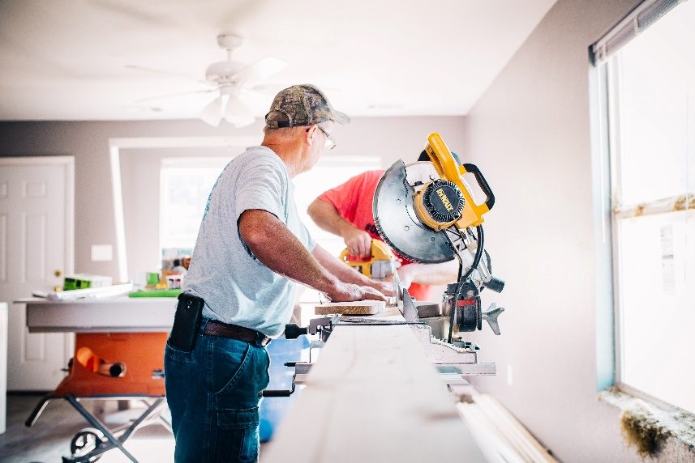

Article 2: no-cost and low-cost energy tips for the office
When you run a business, controlling your costs is a priority. Here are some easy tips to help reduce your energy use and bills.
- Power down your office equipment (monitors, printers, lights) when not in use to reduce unnecessary power drain.
- Close curtains, shades and blinds, particularly during unoccupied times. Too much sun exposure inside can put a strain on your HVAC equipment – making it work harder than necessary.
- Keep your HVAC equipment running efficiently. Clean condenser coils, replace air filters and check ducts and pipe insulation for damage.
- Clean diffusers and lamps once or twice a year. Did you know dust can add to your energy bills? It can build up on lighting diffusers and lamps which reduces the lumen output of your business’s lighting. Don’t forget to replace incandescent lighting with CFLs or, better yet, LED bulbs.
- Add weatherstripping around doors and windows to reduce drafts. Use caulking to seal ducts, plumbing openings, recessed lighting or any other openings that allow air leaks in walls, floors and ceilings.
- Keep your vents clear of furniture and equipment. Blocked vents require up to 25% more energy to distribute air.
- Check your central heating and cooling duct systems for leaks. They can be big energy wasters if they aren’t sealed properly or insulated well.
Visit sdge.com/business-summer for more ways to save energy.

Social posts: no-cost and low-cost energy tips for the office
Any of the bullets above. Please add #sdge #SDGEassist
- Is your business on the best SDG&E pricing plan? It can make a big difference to your bottom line. Visit sdge.com/business-summer to compare pricing plans. #sdge #SDGEassist
Images: no-cost and low-cost energy tips for the office

Article 3: TAKE ADVANTAGE OF SDG&E’S NO-COST TRAINING FROM ENERGY EXPERTS
Did you know that SDG&E provides webinars for business owners and trade professionals, and most are at no cost? You or your employees can learn about the latest in green building practices, technology and energy-saving solutions from industry experts. Some of September’s topics include indoor lighting controls, commercial chillers, luminaires, commercial refrigeration, air sealing and insulating homes, facility management and how to properly install flowmeters.
Certifications and continuing education units are available for many of the classes. Check out the class listing at sdge.com/EIC.
Social posts: TAKE ADVANTAGE OF SDG&E’S NO-COST TRAININGS FROM ENERGY EXPERTS
- Did you know SDG&E provides energy education and training webinars at no cost? These on-demand webinars are offered at introductory, intermediate and advanced levels. See the webinar list at sdge.com/EIC. #sdge #SDGEassist
- Learn the latest in green building design, operations, maintenance and technology at no-cost energy webinars led by industry experts. See the on-demand webinar list at sdge.com/EIC. #sdge #SDGEassist
- Enroll in a no-cost, on-demand energy topic webinar. Energy education and training can give you and your employees the knowledge and skills that customers value. Check out the webinar list at sdge.com/EIC. #sdge #SDGEassist
Images: TAKE ADVANTAGE OF SDG&E’S NO-COST TRAININGS FROM ENERGY EXPERTS

