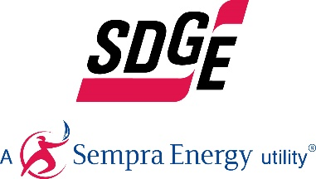
SDG&E BUSINESS CONTENT PACKAGE | MARCH 2021
Here are social posts, articles and photos you’re welcome to use in email communications, websites or newsletters. Thank you for sharing this with your residents, customers & employees. There are several images with each posting. Feel free to mix and match the images or use your own. You can find free images at unsplash.com.
This month’s topics: Energy-saving tips, commercial electric vehicles, energy webinars
Article 1: ENERGY-SAVING TIPS FOR SMALL BUSINESSES
There are a variety of ways you can reduce costs in your business when it comes to energy. By assessing the needs of your employees and customers, you’ll be able to make a plan that helps you cut costs where you need it the most.
- Don’t heat or cool what you don’t use. This may seem obvious but it’s easy to oversee. Only heat or cool the rooms and areas of the building which are in use every day, not hallways since they aren’t occupied for more than a few minutes. Rooms with low usage should have their thermostats turned down in winter and up in summer or off until they are in use.
- Get employees invested. Saving energy is a team sport, not the sole responsibility of the business owner. Encourage staff to share innovative ideas on how to cut down energy costs – creating an energy efficient work culture.
- Plug leaks with weather stripping and caulking. It's important to locate any leaks in your business to prevent costly heating and cooling loss. You can easily plug leaks with weather stripping and caulking to efficiently manage your ventilation.
- Install occupancy sensors. Install dimmers and occupancy sensors in proper locations to automatically turn off lighting. It's important to ensure that the sensors are properly installed. Even good equipment can be installed incorrectly, like in an obstructed location (e.g. behind a coat rack, door, bookcase or other furniture).
- Turn off unused equipment. Office computer monitors are an easy way to save on your business's energy bill as they use a lot of energy. Ensure that monitors are set on automatic sleep mode during non-working hours or are manually turned off when not in use. Screen savers do not reduce energy use by monitors.
- Reduce paper usage. Paper and printing can be costly for your business. Print only when necessary and double-sided when you do. This will reduce paper waste and help cut the energy required to run your printer, which reduces your energy costs and may extend the life of your printer.
- Install hand dryers. Install hand dryers instead of using paper towels. As paper towel dispensers need to be refilled, they are a constant, recurring cost and more expensive than automatic hand dryers in the long run. It’s also less mess.
- Insulate your water heater. If your business's water heater is older than seven years, be sure to wrap it in insulation to retain water heat. Regardless of whether your water heater is old or new, insulate the first three feet of the heated water out pipe.
By considering these steps, you may see changes in your energy bill. People often underestimate the little things they do at work, so promoting awareness about energy issues is important. Not only will you be lowering your energy bill, you’ll also be promoting a healthy environment within your own workplace. For more ideas on how to save energy in your business, visit sdge.com/business.
Social posts: ENERGY-SAVING TIPS FOR SMALL BUSINESS
- If you’re a small or medium business, you may qualify for customized energy solutions to help reduce costs and save energy. Learn more at sdge.com/SCP. #sdge #energytips4u
- Need to trim energy costs at your business? Performing a simple, top-level energy assessment can help you lower your carbon footprint and energy expenses by recognizing inefficient systems and equipment and making changes. #sdge #energytips4u
- Use any of the 1 – 9 bullets above for a social post. Just add #sdge #energytips4u
Images: ENERGY-SAVING TIPS FOR SMALL BUSINESS

Article 2: INNOVATIVE NEW ELECTRIC VEHICLE-HIGH POWER PLAN OFFERS BILL STABILITY
Businesses, transit agencies and school districts in the region that are considering making a switch to commercial electric vehicles are now able to take advantage of an innovative pricing plan that makes it possible to reap both financial and environmental benefits by powering their fleet with electricity. The optional subscription pricing plan, called the Electric Vehicle-High Power (EV-HP) rate, was recently approved unanimously by the California Public Utilities Commission (CPUC). Those who sign up for the plan can choose the level of power to subscribe to for their charging needs and pay for it with a fixed monthly subscription fee.

The EV-HP pricing plan also enables customers to save by charging during times of the day when demand for electricity is low or renewable energy generation is high. Encouraging customers to charge during grid-friendly hours with the proper price signals ensures that the growing adoption of electricity-powered equipment doesn’t strain the grid during peak periods and require costly grid enhancements that must be borne by all customers.

The adoption of the EV-HP rate complements SDG&E’s Power Your Drive for Fleets Program, approved in 2019 by the CPUC to build charging infrastructure for a minimum of 3,000 plug-in medium-duty and heavy-duty electric vehicles and equipment, including transit buses, school buses, delivery trucks and forklifts. This initiative also supports the electrification of refrigerated semi-truck trailers, which are vital for transporting perishable goods. For more information, visit sdge.com/EVfleets.

Social Posts: INNOVATIVE NEW ELECTRIC VEHICLE-HIGH POWER PLAN OFFERS BILL STABILITY
- SDG&E’s Power Your Drive for Fleets helps fleet owners and operators reduce operating costs, eliminate emissions and simplify vehicle maintenance by transitioning to electric vehicles. Visit sdge.com/EVfleets for more information. #sdge #energytips4u
- The SDG&E Power Your Drive for Fleets program connects fleets with resources, fleet-friendly charging rates and financial incentives to easily and cost-effectively design and install the charging infrastructure that is needed to power medium- and heavy-duty electric fleets. Visit sdge.com/EVfleets to learn more. #sdge #energytips4u

Images: INNOVATIVE NEW ELECTRICVEHICLE-HIGH POWER PLAN OFFERS BILL STABILITY
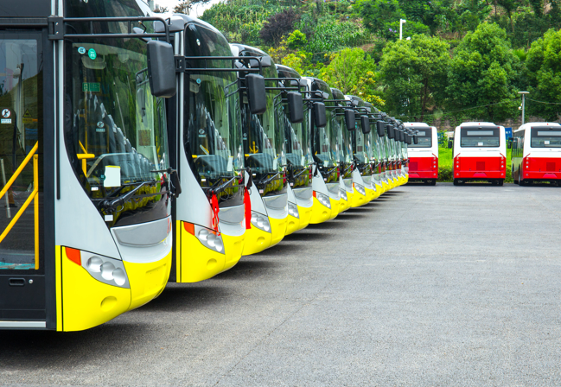

Article 3: TAKE ADVANTAGE OF SDG&E’S NO-COST TRAININGS FROM ENERGY EXPERTS
Did you know that SDG&E provides webinars for business owners and trade professionals, and most are at no cost? You or your employees can learn about the latest in green building practices, technology and energy-saving solutions from experts in the industry. Topics in March include:
- Photovoltaic (PV) & energy storage systems (ESS)
- Identifying existing lighting technologies
- HVAC advanced unitary air conditioning
- Title 24 – residential and nonresidential standards
- Project management for energy efficiency
- Pathways to a zero net energy home
- Electric heat pumps for space heating and cooling
- Energy savings through process improvement and optimization
Certifications and continuing education units are available for many of the classes. Check out the class listing at seminars.sdge.com.
Social posts: TAKE ADVANTAGE OF SDG&E’S NO-COST TRAININGS FROM ENERGY EXPERTS
- Did you know SDG&E provides energy education and training webinars at no cost? These webinars are offered at introductory, intermediate and advanced levels. See the webinar list at seminars.sdge.com. #sdge #energytips4u
- Learn the latest in green building design, operations, maintenance and technology at no-cost energy webinars led by industry experts. See the webinar list at seminars.sdge.com. #sdge #energytips4u
- Enroll in a no-cost energy topic webinar. Energy education and training can give you and your employees the knowledge and skills that customers value. Check out the webinar list at seminars.sdge.com. #sdge #energytips4u

Images: TAKE ADVANTAGE OF SDG&E’S NO-COST TRAININGS FROM ENERGY EXPERTS
