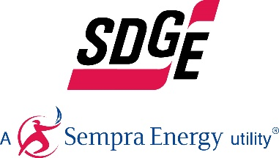
SDG&E BUSINESS CONTENT PACKAGE | DECEMBER 2020
Here are social posts, articles and photos you’re welcome to use in email communications, websites or newsletters. Thank you for sharing this with your residents, customers & employees. There are several images with each posting. Feel free to mix and match the images or use your own. You can find free images at unsplash.com.
This month’s topics: Safe and energy-efficient holiday lighting tips, winter energy-saving information, energy webinars
Article 1: Keep holiday light decorating safe, ENERGY-efficient, festive and fun
Businesses enjoy lighting up their stores for the holidays to add a festive spirit but they don’t enjoy the increase in their electricity bill after all the holiday cheer and lights are gone.
Here are some ways to be energy-efficient this holiday season:
- Make smart lighting choices. LED holiday lights are the way to go! They use up to 80% less energy and are brighter and safer since they are much cooler than incandescent lights. They’re easier to install—up to 24 strings of LEDs can be connected end-to-end without overloading a wall socket. They last 10x longer and have no filaments or glass to break.
- Limit energy use. Set timers for lights to automatically turn on when it gets dark and off in the middle of the night. You can save more by keeping light displays on only 8 hours of the evening.
- Get reflective. Shiny ornaments, tinsel and mirrors can multiply the effects of your lighting without using more energy. Reflective ornaments and tinsel are just as bright at night, so getting creative with your lighting display can multiply your resources for shine. Don't forget the ribbons, wreaths, garland, and reflective menorahs for electricity- free, age-old traditions that bring holiday cheer.
Be sure to stay safe over the holidays. Here are some great tips to keep you and your customers and patrons safe.
- Limit the connection of light strands. Avoid overloading extension cords and wall sockets by following the manufacturer’s limits for the number of light strings that can be safely connected.
- Hang lighting safely. Make sure that no cords will be pinched by furniture or placed under rugs, furniture or other appliances. If covered, cords can overheat or become frayed, increasing the risk of fire. Replace faulty lights instead of trying to repair them.
- Avoid electric hazards outdoors. Before climbing ladders to string outdoor lights, check for overhead power lines on your roof or attached to your storefront. Always keep at least 10 feet away from overhead lines. Never place yourself or any object, such as a string of lights, in a position that risks contact with a power line—the result can be fatal.
- Use GFCI outlets. Outdoor electric lights and decorations should be plugged into circuits protected by ground fault circuit interrupters (GFCIs). How do you know if it’s a GFCI? Look for the “test” and “reset” buttons. If circuits are not GFCI-protected, portable outdoor GFCIs can be purchased.
- Check your environment outdoors. Before stringing lights on outdoor trees, make sure tree limbs haven’t grown into or near power lines. Branches, entire trees and even the ground adjacent to a tree can become energized when trees contact power lines.
- Put your tree in a safe location. Keep your holiday tree away from heat sources such as heat vents. The heat will dry out the tree, making it more susceptible to fires caused by heat, flame or sparks.
- Check condition of lights. Inspect light strands for cracked or broken plugs, frayed insulation or bare wires. Worn cords can cause fires, so discard damaged sets of lights.
- Read the labels. Be sure to check each product label to see whether the lights are intended for indoor or outdoor use. Make sure lights have a tag indicating they have been evaluated by a recognized testing laboratory.

For more winter energy-saving and safety tips, visit sdge.com/business-winter.

Social posts: Keep holiday light decorating safe, ENERGY-efficient, festive and fun
- LED holiday lights are the way to go! They use up to 80% less energy and are brighter, safer, more durable and last longer than traditional light strings. They’re easier to install too – up to 24 strings of LEDs can be connected end-to-end without overloading a wall socket. #sdge #energysavings4u
- Before climbing ladders to string outdoor lights, check for overhead power lines on your roof. Always keep at least 10 feet away from overhead lines. Never place yourself or any object, such as a string of lights, in a position that risks contact with a power line—the result can be fatal. #sdge #energysavings4u
- Set timers for holiday lights to turn on and off automatically. Keep light displays on during the evening and turn them off overnight while your business is closed. #sdge #energysavings4u
- Before stringing lights on outdoor trees, make sure tree limbs haven’t grown into or near power lines. Branches, entire trees and even the ground adjacent to a tree can become energized when trees contact power lines. #sdge #energysavings4u
- Get more helpful winter energy-saving and safety tips at sdge.com/business-winter. #sdge #energytips4u

Images: Keep holiday light decorating safe, ENERGY-efficient, festive and fun

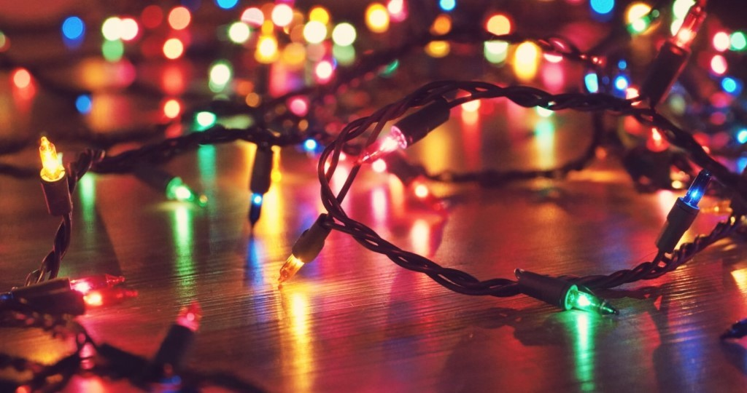

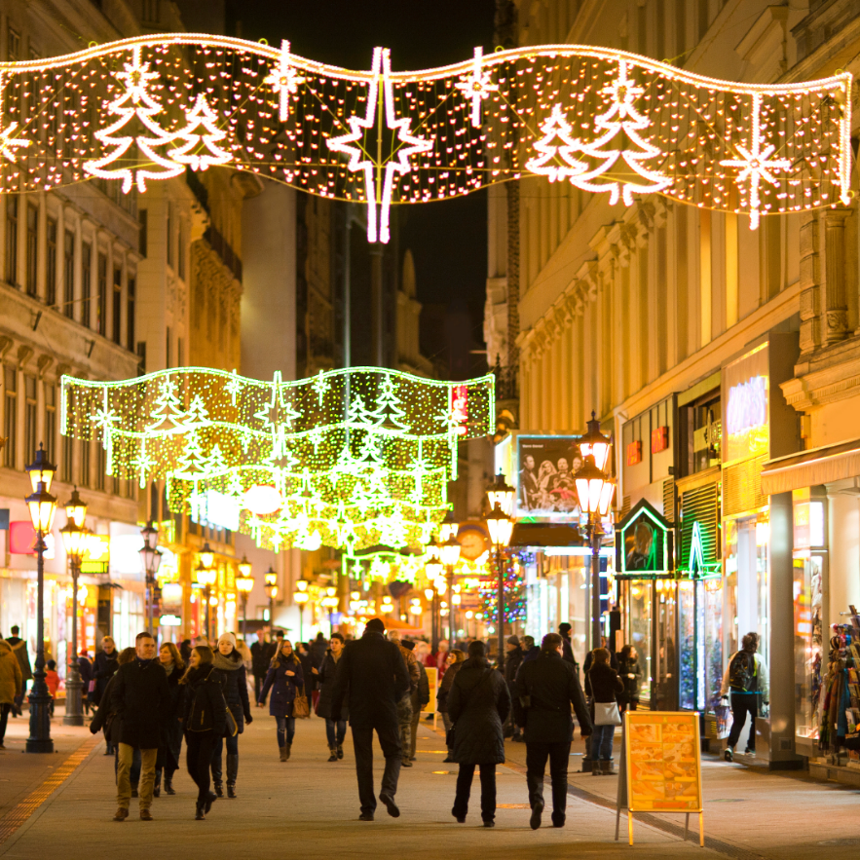

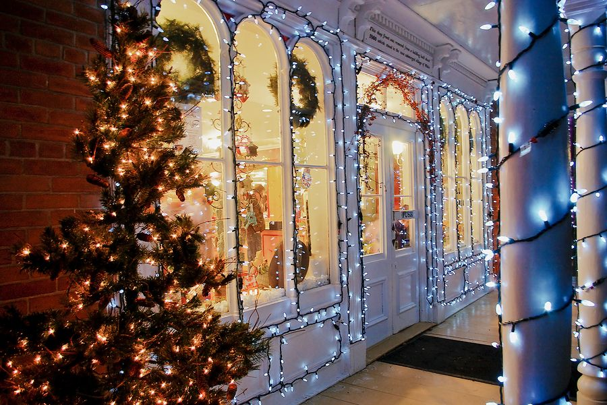

Article 2: WINTER SAVINGS TIPS FOR YOUR BUSINESS
There are a variety of ways to save money when it comes to your business’s energy use. Try these tips to help trim your winter energy bills.
- Adjust your thermostat. When you’re in your office or workplace, set your thermostat as low as is comfortable. At night or when you’re out of the office or workplace, turn it back 10 – 15 degrees to save around 10% a year. Invest in a smart thermostat and get a smart deal of $75 off your purchase, now through 12/31/20. Learn more at sdge.com/instant.
- Tune your HVAC. Just as a tune-up for your car can improve gas mileage, an annual tune-up of your heating and cooling system can improve efficiency and comfort. Schedule a no-cost energy audit at sdge.com/BES. You may also receive installed energy-efficient products at no cost or a discount!
- Weatherize your business. Insulate your facility and caulk drafty doors and windows to help prevent heat from escaping. Insulating your business also helps keep the cool air in during the warmer months.
- Upgrade your lighting. Using LED lighting could help your business save year-round, especially if you’re decorating the office for the holidays. Another bonus, LEDs are sturdier and safer.
- Switch off or power down your electronic devices on unused equipment when not in use. Turning off one computer and monitor nightly and on weekends can save up to $80 a year – savings like those can really add up! Also, use smart power strips.
Get more helpful winter energy-saving and safety tips at sdge.com/business-winter.

Social posts: WINTER SAVINGS TIPS FOR YOUR BUSINESS
- Adjust your thermostat. When you’re in your workplace, set your thermostat as low as is comfortable. At night or when you’re out of your workplace, turn it back 10 – 15 degrees to save around 10% a year. Invest in a smart thermostat and get a smart deal of $75 off your purchase, now through 12/31/20. Learn more at sdge.com/instant. #sdge #energytips4u
- Tune your HVAC. Just as a tune-up for your car can improve gas mileage, an annual tune-up of your heating and cooling system can improve efficiency and comfort. Schedule a no-cost energy audit at sdge.com/BES. You may also receive installed energy-efficient products at no cost or a discount! #sdge #energytips4u
- Plug leaks in your store or facility with weatherstripping and caulking. Locating leaks helps prevent costly heating loss. Weatherizing your business allows you to more efficiently manage your property’s ventilation. #sdge #energytips4u
- Install occupancy sensors to automatically turn off lighting when not in use. Be careful not to install the sensor in an obstructed location, like behind a coat rack, so that it can properly detect motion. #sdge #energytips4u
- Switch from a desktop to a laptop computer. Laptops use around 80% less energy! To maximize savings with a laptop, put the AC adapter in a smart power strip that can be turned off. The transformer in the adapter draws power even when the laptop isn’t plugged in. #sdge #energytips4u

Images: WINTER SAVINGS TIPS FOR YOUR BUSINESS

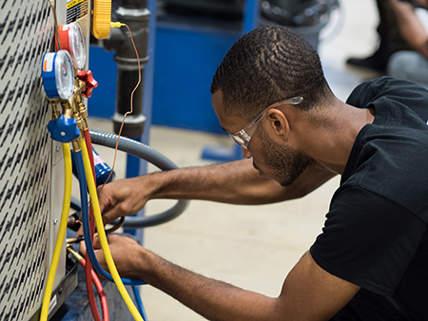

Article 3: TAKE ADVANTAGE OF SDG&E’S NO-COST TRAININGS FROM ENERGY EXPERTS
Did you know that SDG&E provides webinars for business owners and trade professionals, and most are at no cost? Learn about the latest in green building practices, technology and energy-saving solutions from experts in the industry. Upcoming topics include Title 24 – nonresidential standards for building inspectors, HVAC field performance, NCI airflow testing and diagnostics, and energy and the circular economy. Certifications and continuing education units are available for many of the classes. Check out the class listing at seminars.sdge.com.
Social posts: TAKE ADVANTAGE OF SDG&E’S NO-COST TRAININGS FROM ENERGY EXPERTS
- Did you know SDG&E provides energy education and training webinars at no cost? These webinars are offered at introductory, intermediate and advanced levels. See the webinar list at seminars.sdge.com. #sdge #energytips4u
- Enroll in a no-cost energy topic webinar. Energy education and training can give you the knowledge and skills that customers value. Check out the webinar list at seminars.sdge.com. #sdge #energytips4u
Images: TAKE ADVANTAGE OF SDG&E’S NO-COST TRAININGS FROM ENERGY EXPERTS

