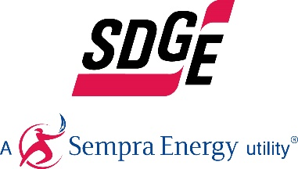
SDG&E BUSINESS CONTENT PACKAGE | OCTOBER 5, 2020
Here are social posts, articles and photos you’re welcome to use in email communications, websites or newsletters. Thank you for sharing this with your residents, customers & employees. There are several images with each posting. Feel free to mix and match the images or use your own. You can find free images at unsplash.com.
This month’s topics: Business rebates, On-Bill Financing, emergency preparedness, energy saving tips, energy webinars
Article 1: NEW SDG&E HVAC REBATES ARE NOW AVAILABLE
Does your business need to upgrade its HVAC? SDG&E offers rebates on many types of energy-efficient equipment for businesses – which can help save energy and lower bills. Now, there are more ways you can save energy and earn rebates on your HVAC unit. Upgrading your HVAC components can help lower your monthly energy bill and save energy.
Newly added rebates include:
- Variable frequency drives – rebates range from $55 - $131 per cap-ton
- Package terminal AC or heat pump – rebates range from $24 - $38 per cap-ton
- Water cooled chillers – rebates ranging from $39 - $148 per cap-ton
Visit sdge.com/NLrebates to see SDG&E’s current product catalog for a full list of their business rebates.
You can also visit sdge.com/BES to schedule a complimentary energy assessment to find out if your business qualifies for no- or low-cost energy efficiency upgrades.

Social posts: NEW SDG&E HVAC REBATES ARE NOW AVAILABLE
- You can track and monitor your business’s energy usage by signing up for SDG&E’s My Account at sdge.com/myaccount. Take advantage of SDG&E’s new HVAC rebates to help your business save energy and money. Learn about business rebates and incentives at sdge.com/EEBR. #sdge #energysavings4u
- SDG&E has new HVAC rebates for businesses to help lower your energy bill. Get details at sdge.com/EEBR. #sdge #energysavings4u
- Check out SDG&E’s current product catalog for a full list of business rebates including new rebates for HVAC at sdge.com/NLrebates. #sdge #energysavings4u
- Visit sdge.com/BES to schedule a complimentary energy assessment to find out if your business qualifies for no- or low-cost energy efficiency upgrades. #sdge #energytips4u
Images: NEW SDG&E HVAC REBATES ARE NOW AVAILABLE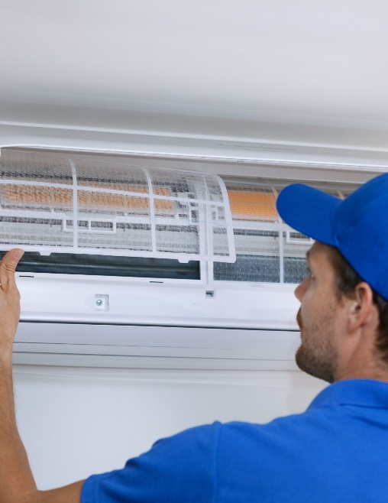
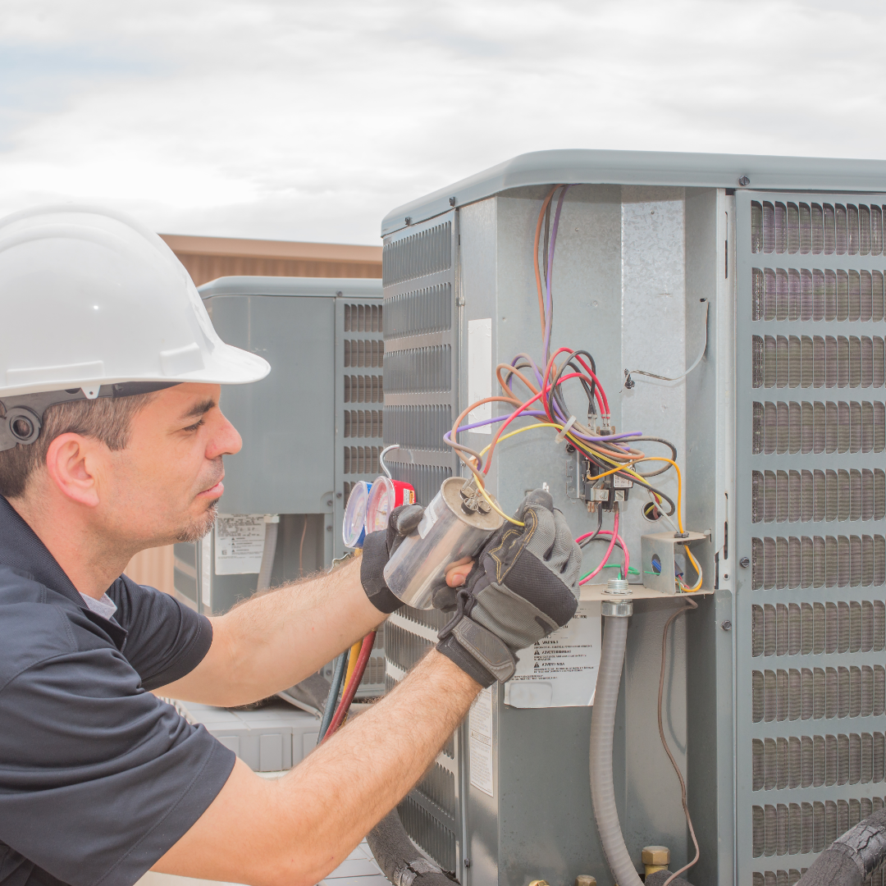

Article 2: 5 TIPS TO HELP YOU SAVE ON YOUR BUSINESS ENERGY COSTS (FROM SDGE NEWSCENTER)
Summer might have officially ended, but in San Diego it’s the time of year when the heat really picks up – and so can cooling costs for your business. Coupled with the impacts of COVID-19, it’s even more important to familiarize yourself with your available SDG&E pricing plans, programs and tips to help you manage your energy costs the best way for your unique business.
Tip #1: Know your energy pricing plan.
Energy costs are determined by how much energy your business uses and when. If you’re on a plan that participates in event days, your business could be called to conserve energy between 2 to 6 p.m. when there is high demand on the power grid. If you’re unable to conserve, this could add considerable energy costs, which means this may not be the right plan for you. Make sure your business is on the right plan by visiting sdge.com/bizplans.
Tip #2: Ensure efficient cooling.
Cooling costs may account for 40% of energy costs for commercial buildings. This means ensuring your HVAC system is maintained according to manufacturer’s instructions can make a big difference. Make sure condenser coils are cleaned, change filters and regularly check ducts and pipe insulation for damage. Check out SDG&E’s current business rebates at sdge.com/NLrebates.
Tip #3: Save on lighting.
Install energy-efficient lighting equipment like LED bulbs, and keep them on a motion sensor so they turn off automatically when not in use. Try not to over-light your facility. It costs more and can cause eye strain, headaches and glare.
Tip #4: Shut down equipment when not in use.
Power down computers, monitors, printers and other equipment when not in use. Upgrading to models that shut down or hibernate after some time of inactivity can also help you save on your energy bill.
Tip #5: Sign up for alerts.
You can sign up for SDG&E energy use alerts to help you track your energy usage at sdge.com/alerts. SDG&E also has a new app that notifies you in the event of a power outage due to a Public Safety Power Shutoff. Learn more at sdge.com/pspsapp.
Remember, you’re not in this alone. If you have questions about your SDG&E business account or are having trouble paying your bill, you can call SDG&E’s Business Care Center at 1-800-336-7343 or visit sdge.com/assistance.
Social posts: 5 TIPS TO HELP YOU SAVE ON YOUR BUSINESS ENERGY COSTS
- SDG&E’s Business Care Center can help business customers set up payment arrangements if they’re having difficulty paying their bill because of COVID-19. Call 1-800-336-7343 for help. #sdge #energytips4u
- Being on the right SDG&E pricing plan can make a big difference in a business’s bottom line. Visit sdge.com/bizplans to choose a pricing plan that best meets your needs while keeping business energy costs under control. #sdge #energytips4u
- SDG&E has a webpage dedicated to COVID-19 resources for business customers at sdge.com/recovery. Links to local, state and federal financial assistance program are available on this site. #sdge #energytips4u
- Do you have a business and want to learn how you can save on your energy bill? Get energy-saving tips at sdge.com/business-tips. #sdge #energytips4u
- Visit sdge.com/BES to schedule a complimentary energy assessment to find out if your business qualifies for no- or low-cost energy efficiency upgrades. #sdge #energytips4u

Images: 5 TIPS TO HELP YOU SAVE ON YOUR BUSINESS ENERGY COSTS
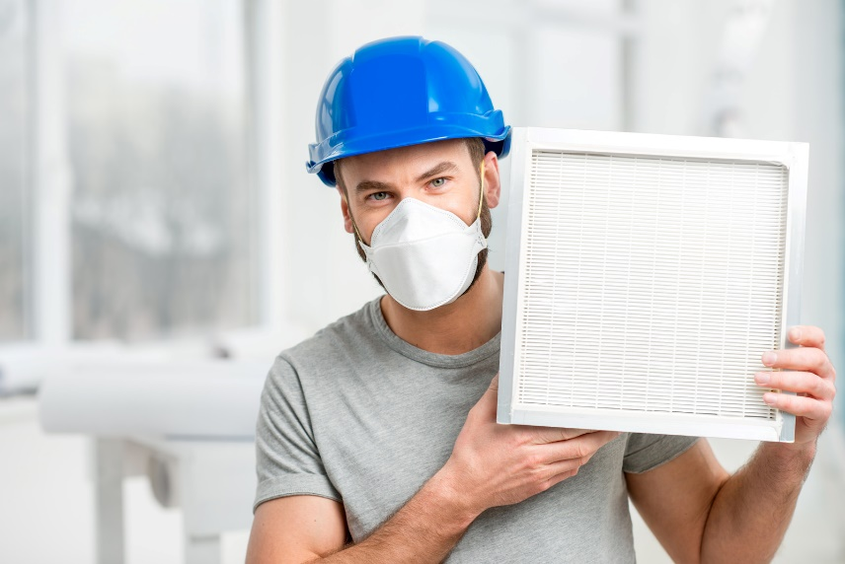
Article 3: UPGRADE YOUR EQUIPMENT WITH SDG&E 0% FINANCING (FROM MAILER)
Is your business equipment in need of an upgrade? SDG&E is offering 0% On-Bill Financing with no payments for six months! APPLICATIONS MUST BE RECEIVED BY 11/1/20. Energy efficiency upgrades are a great way to lower your energy use, reduce monthly bills and help reduce Green House Gas Emissions (GHGs).
How much is your inefficient equipment costing you? SDG&E lends money for qualified upgrades and your business can repay the loan ― interest-free ― on your monthly utility bill. You’ll get new equipment without upending your budget. When your loan is paid off, you’ll see even more savings. It’s a win-win!
Financing is available to fund upgrades like LED lighting, refrigeration, HVAC products, food service equipment, laundry systems and water heaters. Find out if you qualify at sdge.com/OBF. Act now ― applications are due November 1, 2020!
Social posts: UPGRADE YOUR EQUIPMENT WITH SDG&E 0% FINANCING
- Find out if you qualify for SDG&E’s 0% on-bill financing on energy efficiency upgrades at sdge.com/OBF. #sdge #energytips4u
- SDG&E’s on-bill financing offers 0% financing to help fund the purchase of new, qualifying energy-efficient business equipment. Get details at sdge.com/OBF. #sdge #energytips4u
- SDG&E’s on-bill financing offers eligible business customers 0% financing on qualifying energy-efficient business equipment. Learn more at sdge.com/OBF. #sdge #energytips4u

Images: UPGRADE YOUR EQUIPMENT WITH SDG&E 0% FINANCING

Article 4: DISASTERS DON’T PLAN AHEAD. YOU CAN.
An estimated 25 percent of businesses don’t open again after a major disaster, according to the Institute for Business and Home Safety. Protect your business by identifying the risks relevant to your location, both natural and man-made. Then, keep your plan of action updated.
Preserve your equipment and business records by referencing this IRS guide on how to protect your information before an emergency strikes. The Federal Emergency Management Agency (FEMA) also offers an emergency preparedness checklist and toolkit.
Here are helpful preparedness tips to learn before an emergency strikes not during.
- Train your employees in general fire safety, especially for tasks with a high-fire risk, such as welding and cutting, fueling vehicles, working with flammable liquids, etc.
- If your office roof is accessible by ladder, prop it against the building so you and firefighters have access to the roof.
- Establish an evacuation plan and keep it current. Plan primary and secondary exits from your buildings. Consider how employees will escape if doors or windows are blocked by an exterior fire.
- Build a personal “go bag” for your cubicle or office that’s easily accessible if you need to evacuate your work location.
- Keep appropriate emergency supplies on hand, including flashlights, battery-powered portable radio, extra batteries, first-aid kit, manual can opener, non-perishable foods and bottled water.
For more information and tips on how to be prepared for an emergency, visit the FEMA website at fema.gov.
Social posts: DISASTERS DON’T PLAN AHEAD. YOU CAN.
- Prepare for an emergency at work BEFORE an emergency happens. #sdge #energytips4u
- Is your business prepared for an emergency? Establish an evacuation plan and keep it current. Plan primary and secondary exits from your buildings. Consider how employees will escape if doors or windows are blocked by an exterior fire. #sdge #energytips4u
- Ensure your business is ready for an emergency. Keep emergency supplies on hand, including flashlights, battery-powered portable radio, extra batteries, first-aid kit, manual can opener, non-perishable foods and bottled water. #sdge #energytips4u
Images: DISASTERS DON’T PLAN AHEAD. YOU CAN.

Article 5: NO-COST ENERGY-RELATED WEBINARS TO HONE YOUR SKILLS
Did you know that SDG&E provides webinars for business owners and trade professionals at no cost? Learn about the latest in green building practices, technology and energy-saving solutions from experts in the industry. Upcoming classes include Home Energy Rating System (HERS), heat pumps and commercial HVAC. Certifications and continuing education units are available for many of the classes. Check out the class listing at seminars.sdge.com.
Social posts: NO-COST ENERGY-RELATED WEBINARS TO HONE YOUR SKILLS
- Did you know SDG&E provides energy education and training webinars at no cost? These webinars are offered at introductory, intermediate and advanced levels. See the webinar list at seminars.sdge.com. #sdge #energytips4u
- Enroll in a no-cost energy topic webinar. Energy education and training can give you the knowledge and skills that customers value. Check out the webinar list at seminars.sdge.com. #sdge #energytips4u
Images: NO-COST ENERGY-RELATED WEBINARS TO HONE YOUR SKILLS

