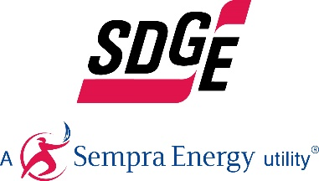
SDG&E BUSINESS CONTENT PACKAGE | NOVEMBER 2020
Here are social posts, articles and photos you’re welcome to use in email communications, websites or newsletters. Thank you for sharing this with your residents, customers & employees. There are several images with each posting. Feel free to mix and match the images or use your own. You can find free images at unsplash.com.
This month’s topics: On-Bill Financing, business rebates, energy webinars, SDG&E’s sustainability strategy
Article 1: HOW MUCH IS YOUR INEFFICIENT EQUIPMENT COSTING YOU?
SDG&E can help you save energy and money on your monthly bill. Consider On-Bill Financing when upgrading your business’s equipment. Energy efficiency upgrades are a great way to lower your energy use, reduce monthly bills and help the environment.

SDG&E provides loans to qualified business candidates to purchase eligible energy-efficient equipment. You pay the loan interest-free through a line item on your monthly utility bill. On-Bill Financing (OBF) works in conjunction with SDG&E’s rebate and incentive programs. OBF offers eligible business customers 0% financing for qualifying upgrades that include:
- LED lighting
- Foodservice equipment
- Refrigeration products
- Laundry systems
- HVAC products
- Water heaters
Find out if On-Bill financing is an option for your new equipment upgrades. Visit SDGE.com/OBF or call SDG&E at 1-800-644-6133 to learn more.

Social posts: HOW MUCH IS YOUR INEFFICIENT EQUIPMENT COSTING YOU?
- In need of a business equipment upgrade? SDG&E offers 0% financing on qualifying energy-efficient equipment. Get details at SDGE.com/OBF. #sdge #energytips4u
- Want an interest-free loan to fund your business’s new energy-efficient equipment? SDG&E can help. Learn more at SDGE.com/OBF. #sdge #energytips4u
- SDG&E’s On-Bill financing program provides 0% interest loans to businesses for the purchase of energy-efficient equipment like LED lighting and water heaters. Find out more at SDGE.com/OBF. #sdge #energytips4u

Images: HOW MUCH IS YOUR INEFFICIENT EQUIPMENT COSTING YOU?

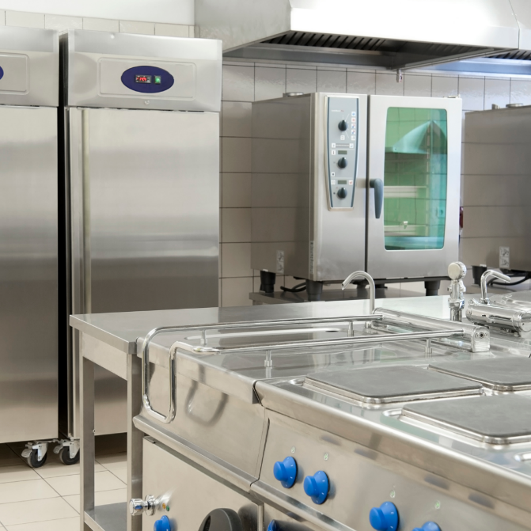

Article 2: SAVE ENERGY WITH A SMART THERMOSTAT FOR YOUR BUSINESS
It can be difficult to reduce your business’s monthly energy bill, but did you know incorporating smart thermostats in your building can help save both energy and money? Smart thermostats allow businesses to have greater control over energy use because temperatures can be controlled remotely. Businesses can run energy-efficient schedules and optimize their system performance, leading to a more predictable monthly bill.

If you’d like to reduce your business’s energy use and costs, why not get a smart thermostat? You can register for SDG&E’s Smart Thermostat Program for businesses and get a $50 rebate check for each thermostat you purchase (limit 4). This program also allows SDG&E to adjust your thermostat when an event day is called so you can be sure you save when demand for energy is at its highest. Find out if you qualify at sdge.com/business-thermostat.

Social posts: SAVE ENERGY WITH A SMART THERMOSTAT FOR YOUR BUSINESS
- Want to reduce your business’s energy use and costs? Get a smart thermostat and take control of your energy use no matter where you are. What’s more, if you register for SDG&E’s Smart Thermostat Program for businesses, you can get a $50 rebate check for every thermostat you purchase (limit 4). Learn more sdge.com/business-thermostat. #sdge #energytips4u
- Did you know that SDG&E has a Smart Thermostat Program for businesses? If you register now, you can get a $50 rebate check for each thermostat (limit 4) you purchase. Find out if you qualify at sdge.com/business-thermostat. #sdge #energytips4u

Images: SAVE ENERGY WITH A SMART THERMOSTAT FOR YOUR BUSINESS

Article 3: NEW SDG&E HVAC REBATES ARE NOW AVAILABLE
Does your business need to upgrade its HVAC? SDG&E offers rebates on many types of energy-efficient equipment for businesses – which can help save energy and lower bills. Now, there are more ways you can save energy and earn rebates on your HVAC unit. Upgrading your HVAC components can help lower your monthly energy bill and save energy.
Newly added rebates include:
- Variable frequency drives – rebates range from $55 - $131 per cap-ton
- Package terminal AC or heat pump – rebates range from $24 - $38 per cap-ton
- Water cooled chillers – rebates ranging from $39 - $148 per cap-ton
Visit sdge.com/NLrebates to see SDG&E’s current product catalog for a full list of their business rebates.
You can also visit sdge.com/BES to schedule a complimentary energy assessment to find out if your business qualifies for no- or low-cost energy efficiency upgrades.
Social posts: NEW SDG&E HVAC REBATES ARE NOW AVAILABLE
- You can track and monitor your business’s energy usage by signing up for SDG&E’s My Account at sdge.com/myaccount. Take advantage of SDG&E’s new HVAC rebates to help your business save energy and money. Learn about business rebates and incentives at sdge.com/EEBR. #sdge #energysavings4u
- SDG&E has new HVAC rebates for businesses to help lower your energy bill. Get details at sdge.com/EEBR. #sdge #energysavings4u
- Check out SDG&E’s current product catalog for a full list of business rebates including new rebates for HVAC at sdge.com/NLrebates. #sdge #energysavings4u
- Visit sdge.com/BES to schedule a complimentary energy assessment to find out if your business qualifies for no- or low-cost energy efficiency upgrades. #sdge #energytips4u
Images: NEW SDG&E HVAC REBATES ARE NOW AVAILABLE
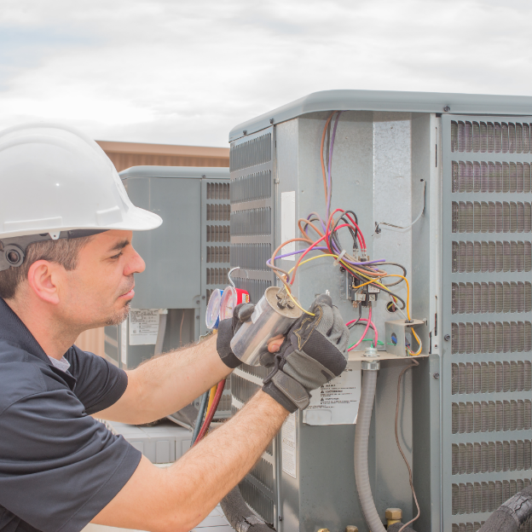
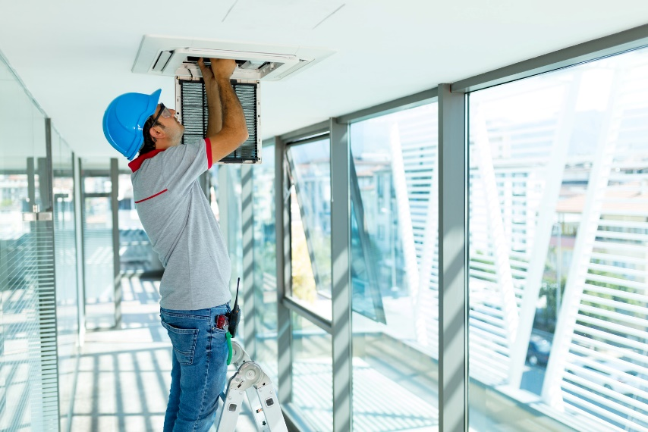

Article 4: SDG&E RELEASES SUSTAINABILITY STRATEGY TO ADVANCE CARBON NEUTRALITY
Amid the growing urgency to address climate change and its impacts, San Diego Gas & Electric released a comprehensive sustainability strategy with aspirational goals in the areas of environmental stewardship, clean transportation, grid modernization, community engagement and company operations to support California’s clean energy ambitions.

The company’s holistic approach to sustainability builds on environmental, social and governance (ESG) principles, as well as its accomplishments to date. Titled “Building a Better Future: Our Commitment to Sustainability” (available at sdge.com/sustainability), the document will serve as a foundation for SDG&E to work toward key sustainability goals in the years and decades to come. Similar to climate action plans developed by local cities, SDG&E aims to update and evolve its “living” sustainability strategy to reflect stakeholder feedback, regulatory policies and technological breakthroughs.

“It’s imperative that we move more quickly to address climate change with strategic investments and partnerships because the stakes are so high if we fail to take collective action now,” said Caroline Winn, SDG&E’s chief executive officer. “As an energy company, we have an important role to play in the fight against climate change by not only doing our part to reduce emissions from our own operations, but to also develop and encourage the use of energy innovations that can make a difference.”

Image: SDG&E RELEASES SUSTAINABILITY STRATEGY TO ADVANCE CARBON NEUTRALITY

Article 5: TAKE ADVANTAGE OF SDG&E’S NO-COST TRAININGS FROM ENERGY EXPERTS
Did you know that SDG&E provides webinars for business owners and trade professionals at no cost? Learn about the latest in green building practices, technology and energy-saving solutions from experts in the industry. Upcoming topics include commercial HVAC, wireless controls for buildings, system testing for energy efficiency and boilers. Certifications and continuing education units are available for many of the classes. Check out the class listing at seminars.sdge.com.

Social posts: TAKE ADVANTAGE OF SDG&E’S NO-COST TRAININGS FROM ENERGY EXPERTS
Did you know SDG&E provides energy education and training webinars at no cost? These webinars are offered at introductory, intermediate and advanced levels. See the webinar list at seminars.sdge.com. #sdge #energytips4u
- Enroll in a no-cost energy topic webinar. Energy education and training can give you the knowledge and skills that customers value. Check out the webinar list at seminars.sdge.com. #sdge #energytips4u
Images: TAKE ADVANTAGE OF SDG&E’S NO-COST TRAININGS FROM ENERGY EXPERTS

