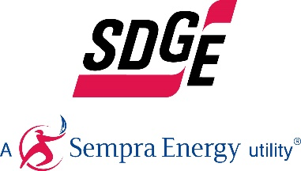
SDG&E BUSINESS CONTENT PACKAGE | JANUARY 2021
Here are social posts, articles and photos you’re welcome to use in email communications, websites or newsletters. Thank you for sharing this with your residents, customers & employees. There are several images with each posting. Feel free to mix and match the images or use your own. You can find free images at unsplash.com.
This month’s topics: Winter energy-saving tips for businesses, heat pump water heaters and energy webinars
Article 1: Winter energy-saving tips FOR BUSINESSES
There are a variety of ways you can reduce energy costs in your business. By assessing the needs of your employees and customers, you’ll be able to make a plan that helps you cut costs where you need it the most.
- Don’t heat what you don’t use. This may seem obvious but it’s easy to oversee. Only heat the rooms and areas of the building which are in use every day. Rooms with low usage should turn down their heat or off until in use. You can also keep temperatures low in hallways as they are not used for more than a couple of minutes at a time.
- Motivate and involve staff. Encourage employees to take part in brainstorming sessions about energy efficiency at work. When employees offer their ideas on how to cut down on energy costs, innovative measures can result.
- Schedule an energy audit for your facility. SDG&E offers complimentary energy assessments to help ensure you are using energy efficiently. Schedule your no-cost appointment here.
- Look out for small drafts that may leak air. Small drafts may result in losing substantial portions of your heating costs. Proper air sealing of the work environment can help eliminate those drafts.
- Keep control of your heating. Keeping your office temperature one degree lower during winters can reduce the energy it uses by up to 10%. Purchasing a smart thermostat will allow you to operate temperatures remotely.
By considering these steps, you may see changes in your energy bill. Don’t underestimate how small energy-efficient changes you make at work can add up to savings. Not only will you be lowering your energy bill, you’ll also be promoting a green environment within your own workplace. For more ideas on how to save energy in your business, visit sdge.com/business.
Social posts: Winter energy-saving tips FOR BUSINESSES
- When you’re in the office, set your thermostat as low as is comfortable. At night or when your business is closed, turn it back around 10 – 15 degrees to save up to 10% a year. Get more tips at sdge.com/winter. #sdge #energytips4u
- The winter season can be a great time to get to all those energy leaks repaired or upgrade your facility to be more energy efficient. Get more tips at sdge.com/winter. #sdge #energytips4u
- Just as a tune-up for your car can improve your gas mileage, an annual tune-up of your HVAC system can improve efficiency and comfort. Get more tips at sdge.com/winter. #sdge #energytips4u
- You can track and monitor your business’s energy usage by signing up for SDG&E’s My Account at sdge.com/myaccount. #sdge #energytips4u
- Find out the best energy pricing plan for your business at sdge.com/steps-selecting-best-pricing-plan. #sdge #energysavings4u

Images: Winter energy-saving tips FOR BUSINESSES
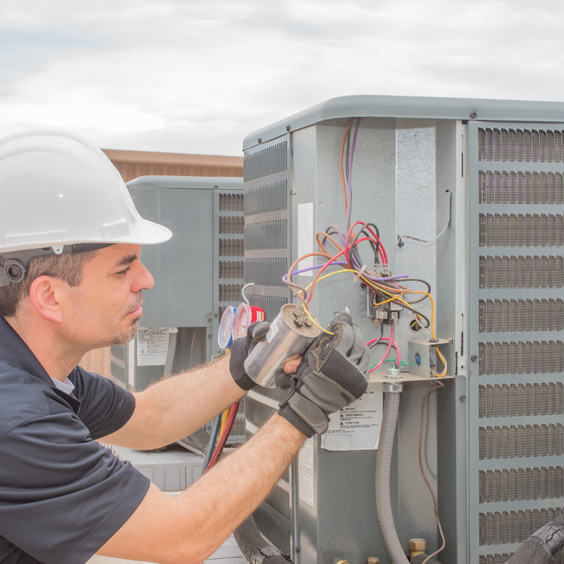
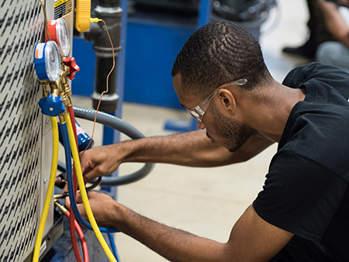
Article 2: WHY HEAT PUMPS ARE A GREAT IDEA FOR YOUR BUSINESS
In California, most greenhouse gas (GHGs) emissions (45%) are from the transportation sector. The next largest source, approximately 24%, comes from buildings that rely on the combustion of natural gas to generate heat. So, to cut GHGs and push towards a zero-emissions future, adopting heat pumps for space and water heating could be a significant step.
Heat pumps don’t rely on combustion to work. Instead, they use electricity and refrigerants to move heat from one area to another; making them more efficient and safer than their gas counterparts. Today’s heat pumps are typically over 100% efficient.
Heat pump space heaters work similarly to heat pump water heaters, moving heat rather than creating it with combustion. Today’s systems are more sophisticated, so it pays to use an experienced contractor. A properly designed and installed heat pump space heater provides steady, even temperatures, with little or no noise at a much higher efficiency than any combustion-based system can.
Energy policy conversation in California includes replacing gas water heaters with heat pump water heaters and replacing gas furnaces with heat pumps for space heating. They’re a perfect solution in regions with small heating loads like most of California. Heat pumps are poised to be the heating solution for buildings and are front and center in efforts to reduce GHG emissions.
Learn about energy-saving programs at sdge.com/businesses/savings-center/rebates-incentives/small-commercial-program. For more information on heat pump water heaters, visit energystar.gov.
Social posts: WHY HEAT PUMPS ARE A GREAT IDEA FOR YOUR BUSINESS
If you’re a small or medium business, you may qualify for customized energy solutions to help reduce costs and save energy. Learn more at sdge.com/small-commercial-program. #sdge #energysavings4u
- Looking for a way to save on energy costs? Think about purchasing a heat pump water heater which also helps reduce greenhouse gas emissions. Get more energy-saving tips at sdge.com/small-commercial-program. #sdge #energysavings4u
- Consider replacing your gas water heater with a more efficient heat pump water heater to save on energy costs. Learn more ways to save energy at sdge.com/small-commercial-program. #sdge #energysavings4u

Images: WHY HEAT PUMPS ARE A GREAT IDEA FOR YOUR BUSINESS
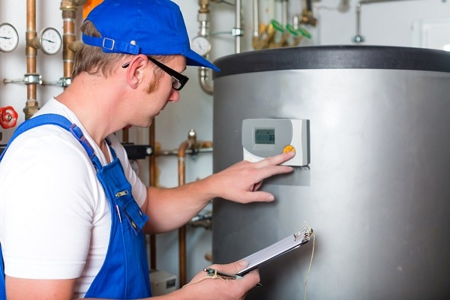
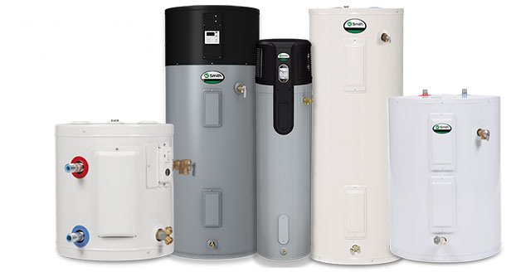

Article 3: TAKE ADVANTAGE OF SDG&E’S NO-COST TRAININGS FROM ENERGY EXPERTS
Did you know that SDG&E provides webinars for business owners and trade professionals, and most are at no cost? You or your employees can learn about the latest in green building practices, technology and energy-saving solutions from experts in the industry. Topics include Title 24 – nonresidential standards for building inspectors, HVAC field performance, NCI airflow testing and diagnostics, and energy and the circular economy. Certifications and continuing education units are available for many of the classes. Check out the class listing at seminars.sdge.com.
Social posts: TAKE ADVANTAGE OF SDG&E’S NO-COST TRAININGS FROM ENERGY EXPERTS
- Did you know SDG&E provides energy education and training webinars at no cost? These webinars are offered at introductory, intermediate and advanced levels. See the webinar list at seminars.sdge.com. #sdge #energytips4u
- Enroll in a no-cost energy topic webinar. Energy education and training can give you and your employees the knowledge and skills that customers value. Check out the webinar list at seminars.sdge.com. #sdge #energytips4u
Images: TAKE ADVANTAGE OF SDG&E’S NO-COST TRAININGS FROM ENERGY EXPERTS

