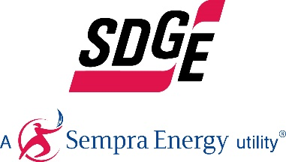
SDG&E BUSINESS CONTENT PACKAGE | APRIL 2021
As a trusted community partner, we thank you in advance for sharing these digital assets with your audiences, including residents, customers, and employees to help amplify our monthly messages. Here are social media posts, articles, and photos you are welcome to use in email communications, websites, or newsletters. There are several images with each posting. Please choose images that fit your audience and feel free to mix and match.

Follow Us
In your social media posts, feel free to tag us on our social media accounts found below and route your audience to our website.

This month’s topics: Energy-saving tips, electric vehicle fleets, energy webinars
Article 1: WHERE IS YOUR BUSINESS WASTING ENERGY?
Heating, ventilation and air conditioning (HVAC) consume approximately 40% of a building’s electricity. In fact, it’s one of the most significant factors in the operating expenses of a business. That’s why it pays to pinpoint HVAC energy waste and reduce it. Here are three common HVAC waste areas and proven ways to help your business become more energy-efficient and control costs.
- Blocked vents require up to 25% more energy to distribute air. Take a close look around your business. Are vents blocked by furniture, paper, tools or equipment? Those blocked vents prevent vital airflow and make your system work harder to heat or cool your business. That’s unnecessary waste and it costs your business every month.
Solution: Clear air distribution is essential to energy efficiency. It’s also important for maintaining a good comfort level for your employees and customers. Carefully assess the area around each vent for proper ventilation. Is air flowing from the vent, circulating freely throughout the room? If there are obstructions that prevent adequate airflow, such as cabinetry or drapes, move them to allow for clear circulation. Don't keep vents closed to save energy; doing this can change how air is distributed and causes an imbalance in the HVAC system's operation. Remember to also check any vents on the floor. It can be more difficult to keep these areas clear of obstructions.
- Up to 80% of energy can be recovered from exhaust air. Exhaust air from inefficient HVAC systems wastes a major opportunity for more efficient heating and cooling. That’s because more energy is required to heat or cool incoming outside air. But there are smart ways to prevent that waste.
Solution: Heat-recovery technology transfers energy from exhaust air to incoming outside air. This greatly reduces the energy that’s required to heat or cool incoming air. As a result, businesses can recover 50% to 80% of energy waste. It’s important to note the percentage of outside air that can be used for efficient ventilation is based on a few factors, including project scope, technology selection and design. A qualified contractor can educate customers on available recovery technologies. For example, an energy recovery ventilator (ERV) can be a suitable solution for maintaining a comfortable temperature, depending on area location and climate. Businesses can turn to their HVAC contractor to decide if an ERV is appropriate. Heat-recovery technologies can include heat exchangers, recuperators, regenerators, passive air pre-heaters and waste heat boilers.
- Advanced controls can reduce energy use by 40%. Ever feel cold when you’re in a big conference room or eating in the cafeteria with just a few other people? That may be because the ventilation system runs at maximum operating power, as if the room was filled. It’s a huge waste of energy.
Solution: Installing advanced control sensors can improve a ventilation system’s operating power for energy efficiency. These controls can count the number of people in a room and then adjust the heat and air conditioning accordingly. When the sensors are integrated into a building’s HVAC system, the advanced controls can reduce energy use by almost 40%.
For more ideas on how to save energy in your business, visit sdge.com/business.

Social posts: WHERE IS YOUR BUSINESS WASTING ENERGY?
- Fifteen percent of energy waste is caused by dirty air filters – which impairs your HVAC system and contributes to wasted energy. Replace air filters (or clean them if they’re reusable), especially during peak heating and cooling seasons. #sdge #EnergyTips4u
- Unsealed ducts contribute to 20% of waste. The ducts that circulate the air throughout your building can be big energy wasters. They may not be sealed properly or insulated well. Hire a contractor to make sure all ducts have duct sealant or metal-backed (foil) tape over the seams and connections. Then, wrap the ducts in insulation. #sdge #EnergyTips4u
- Cut energy use by up to 60% when you switch to open office space. Moving from a closed office environment to an open floor plan helps lower operating costs, increase floor capacity and improve employee comfort. Set controls to shut downlighting and HVAC to individual floor sections when they aren’t occupied. #sdge #EnergyTips4u

Images: WHERE IS YOUR BUSINESS WASTING ENERGY?

Article 2: EARN NEW REVENUE WITH AN EV FLEET
Carbon credits offer a unique earnings opportunity.
While electric vehicles (EVs) can help fleets decrease operating costs, cut emissions and reduce vehicle downtime, the price tag of EVs — and the supporting charging infrastructure — require higher upfront investments.

California’s Low Carbon Fuel Standard (LCFS) Program gives fleets operating EVs an opportunity to make money by generating carbon credits. The program works as a market system where users and producers of clean energy, including EV fleets, can earn credits from reducing their emissions while emitters purchase those credits to offset their carbon footprint.

Fleets that own and operate chargers to support their EVs can generate credits. These revenues can be used to offset EV purchases and maintenance, charging infrastructure purchases and maintenance, electricity costs and administrative fees.

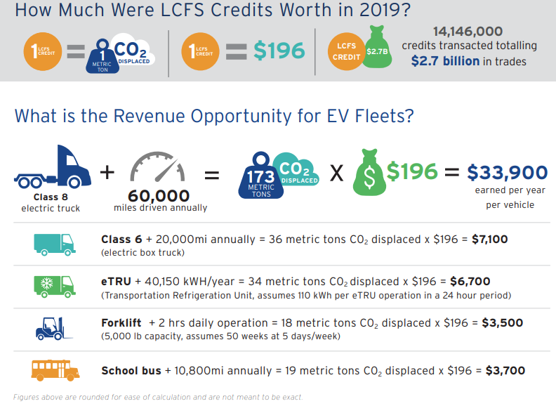

For more information on the program and funding, or to apply, visit sdge.com/EVfleets.

Social Posts: EARN NEW REVENUE WITH AN EV FLEET
- SDG&E’s Power Your Drive for Fleets helps fleet owners and operators reduce operating costs, eliminate emissions and simplify vehicle maintenance by transitioning to electric vehicles. Visit sdge.com/EVfleets for more information. #sdge #EnergyTips4u
- The SDG&E Power Your Drive for Fleets program connects fleets with resources, fleet-friendly charging rates and financial incentives to easily and cost-effectively design and install the charging infrastructure that is needed to power medium- and heavy-duty electric fleets. Visit sdge.com/EVfleets to learn more. #sdge #EnergyTips4u
- California’s Low Carbon Fuel Standard (LCFS) Program gives companies with EV fleets an opportunity to make money by generating carbon credits. Get details on sdge.com/EVfleets. #sdge #EnergyTips4u
- Does your company own its EV fleet? Find out how you can generate credits on sdge.com/EVfleets. #sdge #EnergyTips4u

Images: EARN NEW REVENUE WITH AN EV FLEET
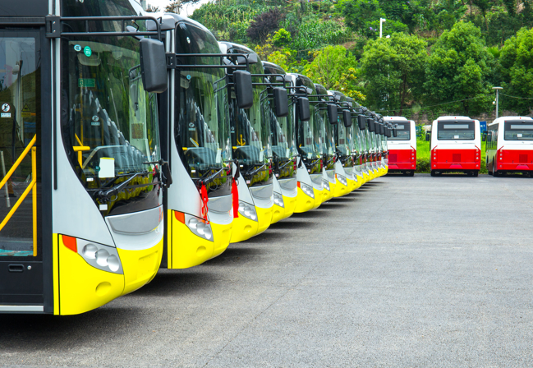

Article 3: TAKE ADVANTAGE OF SDG&E’S NO-COST TRAININGS FROM ENERGY EXPERTS
Did you know that SDG&E provides webinars for business owners and trade professionals, and most are at no cost? You or your employees can learn about the latest in green building practices, technology and energy-saving solutions from experts in the industry. Some of the topics in April include:
- Title 24 – EnergyPro software for residential compliance; Residential standards for building inspectors; Non-residential standards for plan examiners and more
- Photometric lighting solutions
- Energy efficiency and solar for homeowners
- Motor efficiency
- Cash incentives for energy efficiency projects
- Multi-family electrification
- Combination ovens
- Photovoltaic (PV) & energy storage systems (ESS)
- Residential HVAC for new and retrofit construction
- Residential HVAC heat pumps
- Demand control ventilation (DCV) and variable speed fans (non-residential)
- Carbon sequestration to mitigate climate change
- Low-cost hot water system retrofits
- Air sealing and insulating existing homes
Certifications and continuing education units are available for many of the classes. Check out the class listing at seminars.sdge.com.
Social posts: TAKE ADVANTAGE OF SDG&E’S NO-COST TRAININGS FROM ENERGY EXPERTS
- Did you know SDG&E provides energy education and training webinars at no cost? These webinars are offered at introductory, intermediate and advanced levels. See the webinar list at seminars.sdge.com. #sdge #EnergyTips4u
- Learn the latest in green building design, operations, maintenance and technology at no-cost energy webinars led by industry experts. See the webinar list at seminars.sdge.com. #sdge #EnergyTips4u
- Enroll in a no-cost energy topic webinar. Energy education and training can give you and your employees the knowledge and skills that customers value. Check out the webinar list at seminars.sdge.com. #sdge #EnergyTips4u
Images: TAKE ADVANTAGE OF SDG&E’S NO-COST TRAININGS FROM ENERGY EXPERTS

