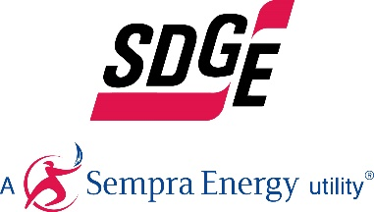
SDG&E BUSINESS CONTENT PACKAGE | MAY 2021
As a trusted community partner, we thank you in advance for sharing these digital assets with your audiences, including residents, customers and employees to help amplify our monthly messages. Here are social media posts, articles and photos you are welcome to use in email communications, websites or newsletters. There are several images with each posting. Please choose images that fit your audience and feel free to mix and match.

Follow Us
In your social media posts, feel free to tag SDG&E’s social media accounts and route your audience to SDG&E’s website at sdge.com. You can find us on Facebook, Instagram, Twitter, YouTube and LinkedIn.

This month’s topics: Customer protections, outdoor safety for businesses, energy-saving tips, free webinars

Article 1: Emergency customer protections are ending
In the beginning of the COVID-19 crisis, SDG&E put emergency customer protections in place to help ease the financial burden many Southern Californians were suddenly feeling. The California Public Utilities Commission (CPUC) has extended the emergency customer protections to June 30, 2021. Normal business operations will resume on July 1, 2021.
- If you have a past due account balance, SDG&E encourages you to set up a flexible payment plan. Credit and collections activities will resume on July 1, 2021. You can set up payment arrangements online on My Account or through the SDG&E mobile app. Visit sdge.com/my-account-2021 for more information.
- From monthly discounts to one-time payment assistance, SDG&E has different programs available to help manage bills. Visit sdge.com/assistance.
- Renters impacted by the COVID-19 pandemic may qualify for rent and utility payment assistance. Call 2-1-1 to learn more.
- If you are currently a CARE or FERA customer, you may also be eligible for debt forgiveness. Visit sdge.com/AMP to find out if you qualify.
- Program recertifications and verifications for CARE, FERA and Medical Baseline will resume on July 1, 2021. SDG&E will notify you via email or mail if additional documentation is needed.
To see how SDG&E can help, visit sdge.com/covid and answer a few easy questions.

If you are an SDG&E business customer, normal credit and collection practices are scheduled to resume July 1, 2021. Avoid disconnection and set up a payment plan and rest easy knowing you’re covered. Visit sdge.com/recovery to learn more.

Article 1 translated: Las protecciones de los clientes de emergencia están terminando
En respuesta a la crisis de COVID-19, en marzo de 2020, SDG&E implementó protecciones de emergencia al cliente para ayudar a aliviar la carga financiera que muchos habitantes del Sur de California estaban sintiendo. La Comisión de Servicios Públicos de California (CPUC) ha extendido las protecciones de emergencia al cliente hasta el 30 de junio de 2021. Las operaciones comerciales normales se reanudarán el 1 de julio de 2021.
- Si tiene un saldo vencido en su cuenta con SDG&E, le recomendamos que establezca un plan de pago flexible. Actividades de crédito y cobro se reanudarán el 1 de julio de 2021. Puede configurar acuerdos de pago en línea a través de My Account y en la aplicación móvil SDG&E. Visita sdge.com/my-account-2021 para obtener más información.
- Desde descuentos mensuales hasta ayuda con pagos únicos, SDG&E tiene diferentes programas disponibles para ayudar a administrar sus facturas de energía. Visite sdge.com/asistencia para ver si califica.
- Inquilinos a quienes la pandemia COVID-19 ha afectado financieramente también pueden calificar para asistencia con la renta y pago de servicios públicos. Llame al 2-1-1 para obtener más información.
- Si actualmente es cliente de CARE o FERA, también puede ser elegible para la condonación de deudas. Visite sdge.com/AMP para averiguar si califica.
- Nuevas certificaciones y verificaciones de programas para CARE, FERA y Medical Baseline se reanudarán el 1 de julio de 2021. Le notificaremos por correo electrónico o postal si se necesita documentación adicional.

Para ver cómo podemos ayudar, visite sdge.com/covid y responda algunas preguntas fáciles.

Si usted es cliente comercial de SDG&E, las prácticas normales de crédito y cobro están programadas para reanudarse el 1 de julio de 2021. Evite la desconexión y configure un plan de pago y sea fácil saber que está cubierto. Visite sdge.com/recovery para obtener más información.

Social post: Emergency customer protections are ending
This year continues to be challenging for many people, and SDG&E wants to help. From payment plans to debt relief, there are various programs to help provide you with immediate financial assistance. Learn more at sdge.com/COVID. #sdge #EnergyTips4u
Este año sigue siendo un desafío para muchas personas, y SDG&E quiere ayudar. Desde planes de pago hasta alivio de deudas, hay varios programas para ayudarle a proporcionarle asistencia financiera inmediata. Obtenga más información en sdge.com/COVID. #sdge #EnergyTips4u
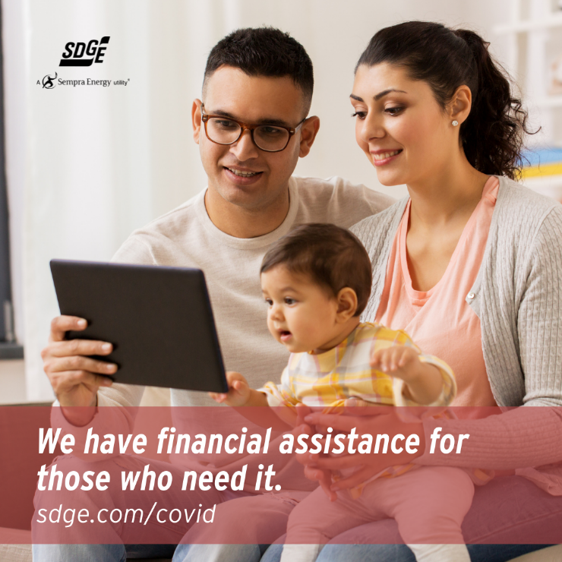

Article 2: SAFETY GUIDELINES FOR OUTDOOR BUSINESS OPERATIONS
Businesses are critical to helping drive economic growth and shaping the future of our region. If your business is operating outdoors, SDG&E recommends these essential safety guidelines so they can continue to provide customers with safe and reliable energy and service.
- Maintain clear access to gas and electric utility equipment to ensure SDG&E crews have quick access in case of emergencies or essential maintenance.
- Keep unobstructed access to all utility infrastructure, including poles, manholes, transformers and curbside gas meters. This will help avoid delays during emergency response.
- Avoid placing outdoor dining chairs, tables, parklets and other items on top of underground facilities or where they block access to poles and other utility infrastructure. Business equipment must be quickly and easily removed if needed for emergency response.
- When your business is open, maintain a 3-foot clearance around utility equipment.
- When your business is closed, ensure an 8-foot clearance is available around utility infrastructure.
For more guidelines to help your business operate safely outdoors, visit sdge.com/outdoor.
Social posts: SAFETY GUIDELINES FOR OUTDOOR BUSINESS OPERATIONS
- When your business is open and operating, keep a 3-foot clearance from SDG&E’s utility equipment. When closed, ensure the clearance is 8 feet. For more business outdoor safety tips, visit sdge.com/outdoor. #sdge #EnergyTips4u
- Keep outdoor heaters away from canopies, tents, trees and other items to prevent fire hazards. For more business outdoor safety tips, visit sdge.com/outdoor.. #sdge #EnergyTips4u
- Is your business operating outside these days? Keep these safety guidelines in mind at sdge.com/outdoor. #sdge #EnergyTips4u
- Always maintain 24-hour access to SDG&E’s utility equipment. Blocking or covering utility infrastructure like manholes, transformers and curbside gas meters can create emergency response delays. For more business outdoor safety tips, visit sdge.com/outdoor. #sdge #EnergyTips4u
Images: SAFETY GUIDELINES FOR OUTDOOR BUSINESS OPERATIONS
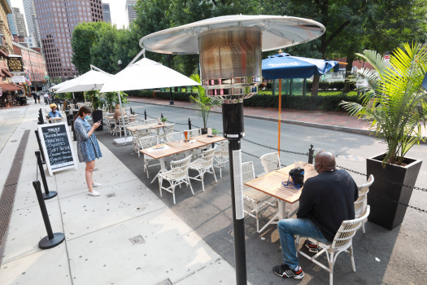
Article 3: Lower energy use in your place of business
Did you know that, according to energystar.gov, the top energy consumers in a typical office are lighting, cooling and computers? Here are some ideas to help you save on your business’s energy use.
Save on cooling:
Cooling (and heating) makes up about 40% of the energy used in commercial buildings. To keep your HVAC system running efficiently, regularly change or clean HVAC filters every month during peak cooling or heating seasons. Dirty filters cost more to use, overwork the equipment and result in lower indoor air quality. Make sure that areas in front of vents are clear of furniture and paper. As much as 25 percent more energy is required to distribute air if your vents are blocked.
Save on lighting:
Use motion detectors to control lighting in frequently unoccupied areas and photocells to turn lights off automatically when enough daylight is detected. Install energy-efficient LEDs and task lighting to illuminate workspaces. Maximize daylight ― sunlight is free! Remove unnecessary lamps in overlit areas.
Save on IT costs:
Turn off office equipment, including monitors and printers, along with lights. Activate sleep settings on your office equipment. Consolidate the number of printers in your office. Use “smart” power strips to reduce the amount of energy used by electronic equipment.
Visit sdge.com/business for more energy-saving tips, pricing plan options and payment arrangements.
Social Posts: Lower energy use in your place of business
- Want to save energy at the office? Turn off lights and electronic equipment, such as monitors and printers, when the office is closed. Activate sleep settings on your office equipment. Consolidate the number of printers in your office. Use “smart” power strips. Visit sdge.com/business for more energy-saving tips. #sdge #EnergyTips4u
- Energy-saving tip at the office: Make sure that areas in front of vents are clear of furniture and paper. As much as 25 percent more energy is required to distribute air if your vents are blocked. Visit sdge.com/business for more energy-saving tips. #sdge #EnergyTips4u
- Looking for ways to reduce your energy use in the office? Use motion detectors to control lighting in frequently unoccupied areas and photocells to turn lights off automatically when enough daylight is detected. Install energy-efficient LEDs and task lighting to illuminate workspaces. Maximize daylight ― sunlight is free! Remove unnecessary lamps in overlit areas. Visit sdge.com/business for more energy-saving tips. #sdge #EnergyTips4u
- The top energy consumers in a typical office are lighting, cooling and computers. Find tips to help you save energy at your workplace at sdge.com/business. #sdge #EnergyTips4u
Images: Lower energy use in your place of business
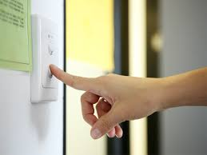
Article 4: TAKE ADVANTAGE OF SDG&E’S NO-COST TRAININGS FROM ENERGY EXPERTS
Did you know that SDG&E provides webinars for business owners and trade professionals, and most are at no cost? You or your employees can learn about the latest in green building practices, technology and energy-saving solutions from experts in the industry. Some of the topics in May include:
- HVAC, A/C, smart thermostats and heat pumps
- Lighting design
- Operating and retrofitting energy efficient data centers
- Building automation dashboards
- Commercial fryers
- Central heat pump water heater systems
- Title 24 – Introduction to modeling, envelope and solar systems
- Carbon sequestration in the landscape series
- Advanced energy management strategies
- HVAC and dehumidification for indoor Ag facilities
Certifications and continuing education units are available for many of the classes. Check out the class listing at seminars.sdge.com.
Social posts: TAKE ADVANTAGE OF SDG&E’S NO-COST TRAININGS FROM ENERGY EXPERTS
- Did you know SDG&E provides energy education and training webinars at no cost? These webinars are offered at introductory, intermediate and advanced levels. See the webinar list at seminars.sdge.com. #sdge #EnergyTips4u
- Learn the latest in green building design, operations, maintenance and technology at no-cost energy webinars led by industry experts. See the webinar list at seminars.sdge.com. #sdge #EnergyTips4u
- Enroll in a no-cost energy topic webinar. Energy education and training can give you and your employees the knowledge and skills that customers value. Check out the webinar list at seminars.sdge.com. #sdge #EnergyTips4u
Images: TAKE ADVANTAGE OF SDG&E’S NO-COST TRAININGS FROM ENERGY EXPERTS

