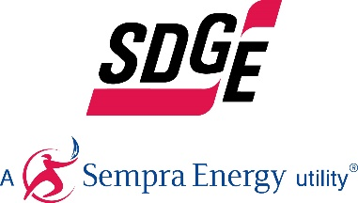
SDG&E BUSINESS CONTENT PACKAGE | JUNE 2021
As a trusted community partner, we thank you in advance for sharing these digital assets with your audiences, including residents, customers and employees to help amplify our monthly messages. Here are social media posts, articles and photos you are welcome to use in email communications, websites or newsletters. There are several images with each posting. Please choose images that fit your audience and feel free to mix and match.

Follow Us
In your social media posts, feel free to tag SDG&E’s social media accounts and route your audience to SDG&E’s website at sdge.com. You can find us on Facebook, Instagram, Twitter, YouTube and LinkedIn.

This month’s topics: Summer energy tips, business pricing plans, electric vehicle fleets, free webinars

Article 1: PREPARE YOUR BUSINESS FOR THE HOT SUMMER
While much has changed over the past year, one thing has not – the promise of hot summer temperatures. Now is the perfect time to set your business up for summer energy savings success. Here are tips to get you started:
- Know the details of your energy pricing plan. Most small businesses are on an Event Day pricing plan which typically offers the lowest annual price due to the potential for an Event Day being called. Pricing during Event Days can reach upwards of 400% during these peak hours, which is why conservation is so important.
- Understand your energy usage. Review your business’ energy usage patterns and history so you can adjust your SDG&E pricing plan if needed. Businesses have had to adjust their operations in many cases so this can be a powerful tool to help you understand your energy usage and whether you are on the best pricing plan.
- Sign up for energy alerts. You can sign up for alerts through SDG&E’s My Account to receive notifications when an Event Day occurs. This way you can prepare in advance for any shifts in operations to conserve energy.
- Take advantage of SDG&E’s business programs. Sign up for a Demand Response (DR) program to help your business save energy and money. DR programs provide incentives to businesses when they can reduce electricity use when the demand is higher. Participating in a DR program contributes to a clean energy future and helps relieve stress on the power grid in your community.
Visit sdge.com/business-summer to learn about energy pricing plans, energy alerts and demand response programs for your business.
Social posts: PREPARE YOUR BUSINESS FOR THE HOT SUMMER
- The summer heat is beginning to rise and your electric bill might follow suit. Make sure your business is prepared by using these tips from SDG&E. Visit sdge.com/business-summer for helpful energy-saving tips. #sdge #EnergyTips4u
- Is your business on the best SDG&E pricing plan? It can make a big difference to your bottom line. Visit sdge.com/business-summer to compare pricing plans. #sdge #EnergyTips4u
- Rising summer temps mean many businesses will be turning on their A/C which can put a strain on the power grid. If your business can reduce its energy use during times of high demand, you could get rewarded when you enroll in a demand response program. Visit sdge.com/business-summer to learn about these plans. #sdge #EnergyTips4u
Images: PREPARE YOUR BUSINESS FOR THE HOT SUMMER
Article 2: INNOVATIVE NEW ELECTRIC VEHICLE-HIGH POWER PLAN OFFERS BILL STABILITY
Businesses, transit agencies and school districts that are considering making a switch to commercial electric vehicles are now able to take advantage of SDG&E’s Power Your Drive for Fleets program. Its innovative pricing plan, the Electric Vehicle-High Power (EV-HP) rate, makes it possible to reap both financial and environmental benefits by powering fleets with electricity. Businesses that sign up for the plan can choose the level of power to subscribe to for their charging needs and pay for it with a fixed monthly subscription fee.
The EV-HP pricing plan also enables businesses to save by charging during times of the day when demand for electricity is low or renewable energy generation is high. Charging during grid-friendly hours ensures that the growing adoption of electric-powered equipment doesn’t strain the grid during peak periods and require costly grid enhancements.
The adoption of the EV-HP rate complements SDG&E’s Power Your Drive for Fleets Program to build charging infrastructure for a minimum of 3,000 plug-in medium-duty and heavy-duty electric vehicles and equipment, including transit buses, school buses, delivery trucks and forklifts. This initiative also supports the electrification of refrigerated semi-truck trailers, which are vital for transporting perishable goods. For more information, visit sdge.com/EVfleets.
Social Posts: INNOVATIVE NEW ELECTRIC VEHICLE-HIGH POWER PLAN OFFERS BILL STABILITY
- Are you thinking about transitioning your business’s fleet to electric vehicles? Several state funding programs can be combined with SDG&E’s funding from its Power Your Drive for Fleets program. Visit sdge.com/EVfleets to learn more. #sdge #EnergyTips4u
- Transit agencies, school districts and fleets located in disadvantaged communities (that are not Fortune 1000 companies) are eligible for rebates of up to 50% off the costs to purchase charging stations for its fleets. Visit sdge.com/EVfleets for more information. #sdge #EnergyTips4u
- SDG&E’s Power Your Drive for Fleets program helps business fleet owners and operators reduce operating costs, eliminate emissions and simplify vehicle maintenance by transitioning to electric vehicles. Visit sdge.com/EVfleets to learn more. #sdge #EnergyTips4u
- Through its Power Your Drive for Fleets program, SDG&E helps install charging infrastructure for medium- and heavy-duty electric vehicles, working with fleets from the initial infrastructure planning stage through to design, construction and ongoing site maintenance. Visit sdge.com/EVfleets for SDG&E’s EV Charging Guidebook. #sdge #EnergyTips4u
Images: INNOVATIVE NEW ELECTRIC VEHICLE-HIGH POWER PLAN OFFERS BILL STABILITY
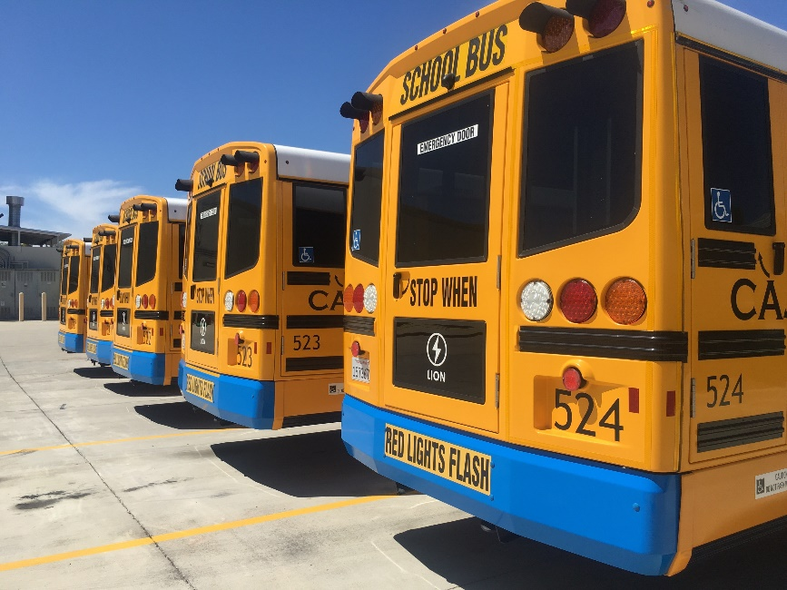
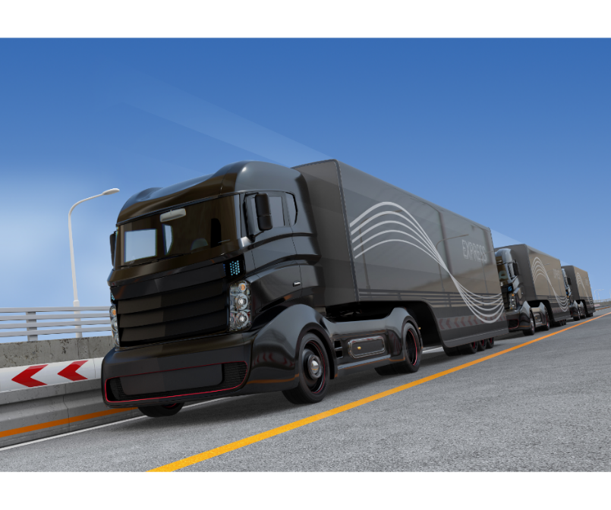
Article 3: TAKE ADVANTAGE OF SDG&E’S NO-COST TRAININGS FROM ENERGY EXPERTS
Did you know that SDG&E provides webinars for business owners and trade professionals, and most are at no cost? You or your employees can learn about the latest in green building practices, technology and energy-saving solutions from industry experts. Some of the topics include HVAC, A/C, smart thermostats, heat pump water heaters, lighting design, commercial kitchen equipment, Net Zero commercial building design and more.
Certifications and continuing education units are available for many of the classes. Check out the class listing at seminars.sdge.com.
Social posts: TAKE ADVANTAGE OF SDG&E’S NO-COST TRAININGS FROM ENERGY EXPERTS
- Did you know SDG&E provides energy education and training webinars at no cost? These webinars are offered at introductory, intermediate and advanced levels. See the webinar list at seminars.sdge.com. #sdge #EnergyTips4u
- Learn the latest in green building design, operations, maintenance and technology at no-cost energy webinars led by industry experts. See the webinar list at seminars.sdge.com. #sdge #EnergyTips4u
- Enroll in a no-cost energy topic webinar. Energy education and training can give you and your employees the knowledge and skills that customers value. Check out the webinar list at seminars.sdge.com. #sdge #EnergyTips4u
Images: TAKE ADVANTAGE OF SDG&E’S NO-COST TRAININGS FROM ENERGY EXPERTS
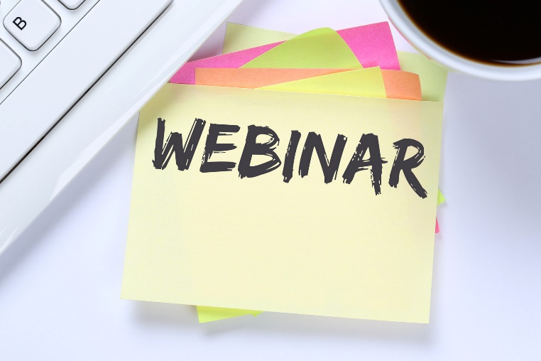

Article 4: SDG&E’S EMERGENCY CUSTOMER PROTECTIONS END JUNE 30
At the beginning of the COVID-19 crisis, SDG&E put emergency customer protections in place to help ease the financial burden many business owners were suddenly feeling. Operating a business throughout the pandemic has been challenging. Shelter-in-place orders have caused many businesses to face financial distress but SDG&E wants to help keep your business up and running.
The California Public Utilities Commission (CPUC) has extended the emergency customer protections to June 30, 2021. Bill collections and disconnection activities for non-payment will resume as part of normal operations on July 1, 2021.
SDG&E can help you avoid a service interruption and take steps towards regaining financial health. Set up a payment plan and rest easy knowing you're covered. Visit sdge.com/recovery for details.
Your business may qualify for city, state or federal assistance. Learn more about the City of San Diego’s Business Relief and Support on their website. Get more information on recovery efforts for businesses in our resources guide.
Social posts: SDG&E’S EMERGENCY CUSTOMER PROTECTIONS END JUNE 30
- Avoid an SDG&E service interruption at your business by setting up a payment plan. Visit sdge.com/recovery for more information or call SDG&E’s Business Care Center at 1-800-336-7343. #sdge #EnergyTips4u
- Your business may qualify for city, state or federal assistance. Learn more about the City of San Diego’s Business Relief and Support on their website.. #sdge #EnergyTips4u
- Is your business on the best SDG&E pricing plan? Compare pricing plans in within SDG&E’s My Account. Learn more about available business resources on sdge.com/recovery. #sdge #EnergyTips4u

Images for these posts can be pulled from this document above.

