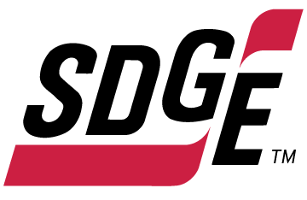
SDG&E BUSINESS CONTENT PACKAGE | JULY 2021
As a trusted community partner, we thank you in advance for sharing these digital assets with your audiences, including residents, customers and employees to help amplify our monthly messages. Here are social media posts, articles and photos you are welcome to use in email communications, websites or newsletters. There are several images with each posting. Please choose images that fit your audience and feel free to mix and match.

Follow Us
You can find us on Facebook, Instagram, Twitter, YouTube and LinkedIn. When sharing these messages in your social posts, feel free to tag SDG&E’s social media accounts and direct your audience to sdge.com.

This month’s topics: Electric safety tips, electric vehicle fleets, free webinars

Article 1: 10 WAYS TO STAY SAFE WHILE WORKING FROM HOME
Many people have transitioned to a work-from-home schedule over the past year. Here are ten electric safety tips to implement:
- Avoid overloading outlets and use a power strip.
- Unplug appliances when you’re not using them to save energy and minimize the risk of shock or fire.
- Regularly inspect electrical cords and extension cords for damage.
- Extension cords should be used only on a temporary basis.
- Never plug a space heater or fan into an extension cord or power strip.
- Never run cords under rugs, carpets, doors or windows.
- Plug in smartly – make sure cords do not become tripping hazards.
- Keep papers and other potential combustibles at least three feet away from space heaters and other heat sources.
- Make sure you use proper wattage for lamps and lighting.
- Make sure your home has smoke alarms. Test them monthly, change batteries annually and replace the alarm every 10 years
For more safety tips, visit sdge.com/safety.

Social posts: 10 WAYS TO STAY SAFE WHILE WORKING FROM HOME
- Home electric safety tip #1. Check all cords, surge protectors and extension cords for frayed casing, exposed wire or broken components. Replace immediately if damaged. For more safety tips, visit sdge.com/safety. #sdge #SDGEAssist
- Home electric safety tip #2. Major appliances, like refrigerators, should be plugged directly into a wall outlet. Don’t use surge protectors, extension cords or power strips. For more safety tips, visit sdge.com/safety. #sdge #SDGEAssist
- Home electric safety tip #3. Extension cords under carpets can overheat. Keep them away from rugs and avoid running over furniture or door thresholds. For more safety tips, visit sdge.com/safety. #sdge #SDGEAssist
- Home electric safety tip #4. Don’t yank or pull on a cord to unplug an appliance, grasp the plug instead. For more safety tips, visit sdge.com/safety. #sdge #SDGEAssist
- Home electric safety tip #5. Unplug appliances before washing, making repairs or when not in use. For more safety tips, visit sdge.com/safety. #sdge #SDGEAssist
Images: 10 WAYS TO STAY SAFE WHILE WORKING FROM HOME

Article 2: TRANSITIONING YOUR FLEET TO Electric vehicleS
Electric fleets are the future and SDG&E wants to help get you there faster. SDG&E’s new 2021 Electric Vehicle Availability Guide provides complete details on the electric medium- and heavy-duty vehicles available today.
Save time and use this resource to easily compare specs from the latest electric vehicles available so you can choose the best fit for your fleet.
Download the Electric Vehicle Availability Guide to see:
- Electric vehicles by weight class (GVWR)
- Current stats on electric vehicle range, base price and payload
- Direct OEM contacts for sales support

You can find the guide at sdge.com/EVFleets at the bottom of the page in the Fleet Resources section.
Social Posts: TRANSITIONING YOUR FLEET TO Electric vehicleS
- Are you thinking about transitioning your business’s fleet to electric vehicles? Several state funding programs can be combined with SDG&E’s funding from its Power Your Drive for Fleets program. Visit sdge.com/EVFleets to learn more. #sdge #SDGEAssist
- Invest in an electric vehicle fleet for your business to avoid the risk of non-compliance with existing and future legislation that place zero-emission requirements on the transportation sector. Learn more at sdge.com/EVFleets. #sdge #SDGEAssist
- SDG&E’s Power Your Drive for Fleets program helps business fleet owners and operators reduce operating costs, eliminate emissions and simplify vehicle maintenance by transitioning to electric vehicles. Visit sdge.com/EVFleets to learn more. #sdge #SDGEAssist
- Through its Power Your Drive for Fleets program, SDG&E helps install charging infrastructure for medium- and heavy-duty electric vehicles, working with fleets from the initial infrastructure planning stage through to design, construction and ongoing site maintenance. Visit sdge.com/EVFleets for SDG&E’s EV Charging Guidebook. #sdge #SDGEAssist
Images: TRANSITIONING YOUR FLEET TO Electric vehicleS
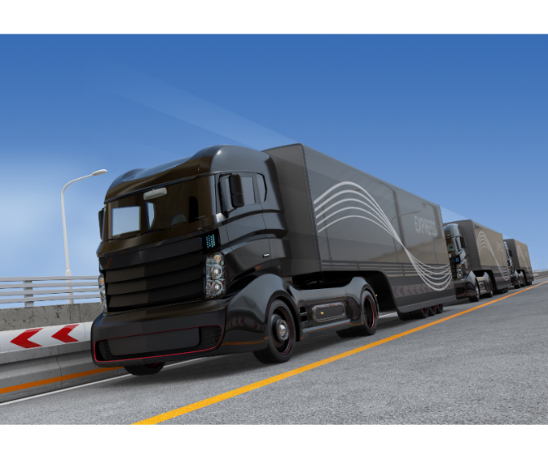

Article 3: TAKE ADVANTAGE OF SDG&E’S NO-COST TRAININGS FROM ENERGY EXPERTS
Did you know that SDG&E provides webinars for business owners and trade professionals, and most are at no cost? You or your employees can learn about the latest in green building practices, technology and energy-saving solutions from industry experts. Some of July’s topics include HVAC and heat pump performance, zero energy homes, Title 24 – Residential Standards for Architects and Designers, green buildings, emergency lighting and power systems and outdoor lighting.
Certifications and continuing education units are available for many of the classes. Check out the class listing at seminars.sdge.com.
Social posts: TAKE ADVANTAGE OF SDG&E’S NO-COST TRAININGS FROM ENERGY EXPERTS
- Did you know SDG&E provides energy education and training webinars at no cost? These webinars are offered at introductory, intermediate and advanced levels. See the webinar list at seminars.sdge.com. #sdge #SDGEAssist
- Learn the latest in green building design, operations, maintenance and technology at no-cost energy webinars led by industry experts. See the webinar list at seminars.sdge.com. #sdge #SDGEAssist
- Enroll in a no-cost energy topic webinar. Energy education and training can give you and your employees the knowledge and skills that customers value. Check out the webinar list at seminars.sdge.com. #sdge #SDGEAssist

Images: TAKE ADVANTAGE OF SDG&E’S NO-COST TRAININGS FROM ENERGY EXPERTS

