Permanent Load Shifting (PLS) Load Impact Ex-Ante Report

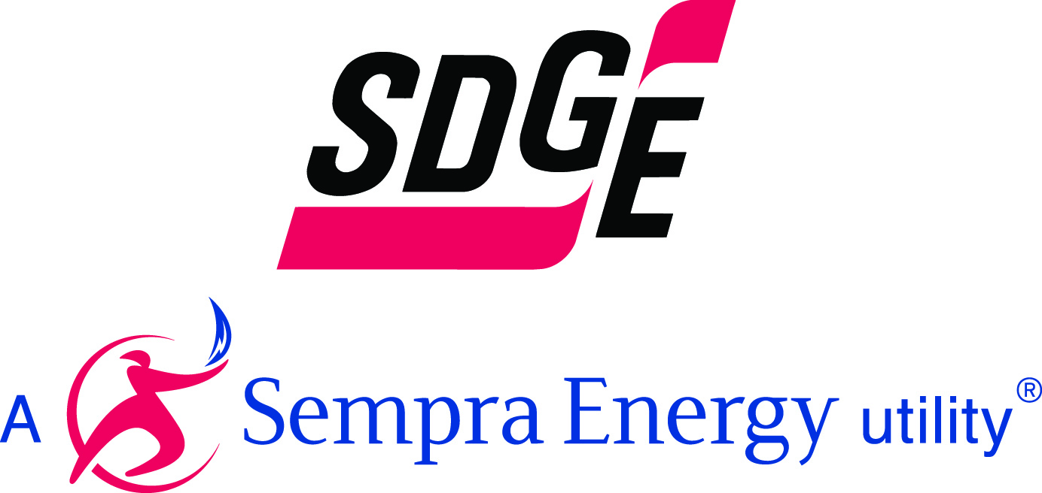

June 1st 2012

PLS Pilot Program Overview
The Permanent Load Shift Program (PLS) is designed as a permanent peak load reduction program. The phrase “permanent load shift” refers to the shifting of energy usage by one or more customers from one-time period-to another on a recurring basis, and for this program, refers to shifting load during the “peak hours” ( 11am-6pm) within the “peak period”(May -October) of the year. The program is not part of the energy efficiency initiative. Although the program is not a demand response program for regulatory purposes it is often included in demand response proceedings.

The PLS program resulted from a 2008 CPUC decision (D.06-11.049) directing the CA IOU’s to seek Permanent Peak Load Reduction in their service territories. SDG&E was authorized to shift up to $4,000,000 of its 2006-2008 DR budget to fund PLS, and to pursue an RFP process to seek proposals. The SDG&E RFP process resulted in two contracts for the PLS program effective through 2011.

Two technology categories were used during the PLS pilot

- Replacement of Electric systems with Gas The overarching purpose of this type of technology is to reduce maximum peak load during the summer by replacing the electric on peak load of the a/c systems with gas cooling systems that are either direct fired or use waste heat to reduce on peak electric load. Gas AC permanent load shifting technology encompasses the installation of gas absorption and gas engine-driven air conditioning systems.

These gas-driven compressors will operate during on-peak periods to replace the operation of electrically driven air-conditioning compressors. Auxiliary loads (cooling water pumps and cooling tower fans) will remain electrically driven.

Another key objective is to begin to condition the market for a wider acceptance of gas cooling technologies. Since Cypress is not an installer of gas cooling equipment they are positioned to cross all market channels and offer an objective source of information on gas cooling technologies for customers.

Refrigerated Zone Control. Refrigerated Zone Control Module technology involves a process called “fly wheeling”. The “fly wheeling” process allows the freezer to operate without mechanical cooling during the on-peak period (using the energy stored in off-peak periods) by utilize the thermal mass of the freezer space.

The Refrigerated Zone Control Module will perform the following functions: Shut off the evaporator fans in the freezer space. Shut off the liquid solenoid in the freezer space, and control the freezer temperature set point during off peak periods when the freezer is cooled by a few additional degrees to establish a sufficient float margin. Potential markets include public cold storage, food processing, agriculture and grocery.
PLS 2012-2014 program overview

For 2012-2014 SDG&E proposed in application a PLS program that will focus on two technology types: Thermal Storage and Non-Thermal Storage. An example of thermal storage is making ice or chilled water at night to provide cooling during the day thereby reducing the on-peak air conditioning load. Non-thermal storage includes chemical batteries that are charged with electricity during the night and discharged during on-peak hours. SDG&E’s proposes providing a standard capacity offer of $500/kW, target contractors who will work with customers to implement the selected technologies and to ensure systems are properly designed, properly built and commissioned and properly operated. The contractors, guided by the results of the E3’s Permanent Load Shifting study, use the capacity based standard offer to provide customers the technology to shift energy use, on an on-going basis, away from weekdays 11 AM to 6 PM. during May 1st through Oct 31st

Decision 12-040-45 approved the PLS program for 2012-2014 but directed SDG&E, SCE and PG&E to standardize their proposed PLs programs and to submit and to file an updated PLS proposal with updated cost-effectiveness tests by August 1st 2012.

PLS pilot High Level Load Impact results

Measurement and evaluation of the PLS pilot was done using engineering measurement and evaluation methods. PLS is a non-event based resource since the load shift is permanent and there are no events called. The non-event based section of the load impact protocols states
“Engineering analysis is another approach that might be suitable for some resource options that
are largely technology driven and that have much more limited behavioral variation than do
pricing resources, for example. Permanent load shifting options such as ice storage and energy
management systems are examples where engineering analysis may be suitable for estimating
load impacts.

Four customers participated in the PLS program. Two converted to chillers powerd by gas and two installed refrigerated zone control technologies According to engineering analysis these customers achieved a load reduction of 2336 kW.

PLS High Level Load Impact Forecast

The PLS program has been approved for the year 2012-2014 and is expected to continue to grow by 1.5 MW per year. Since the program has only been approved for 2012-2014 program enrollment is assumed to be constant for 2015-2022.

August 1 in 2 Peak Day Forecast 1pm-6pm Permanent Load Shifting (MW)
Year | 2012 | 2013 | 2014 | 2015 | 2016 | 2017 | 2018 | 2019 | 2020 | 2021 | 2022
Forecasted Load Reduction | 2.34 | 3.80 | 5.26 | 5.26 | 5.26 | 5.26 | 5.26 | 5.26 | 5.26 | 5.26 | 5.26

