QUESTION 17.1:

- With respect to Anderson’s July 2, 2008 testimony at 7.

  - Please update Figure 1 to include 2007.
  - Please update Figure 1 to include 2008 as best estimated or if this is not feasible, please explain what is currently known about the availability of PNW and California hydroelectric generation for 2008, and any current forecasts of hydroelectric availability for the remainder of 2008, translating this information into a description of likely impact on electric generation demand.

RESPONSE 17.1.1:

See graph below.

RESPONSE 17.1.2:

For year 2008, gas usage from January through September is based on recorded data and gas usage from October through December is based on a forecast. While updating the data for 2007 and 2008, SDG&E/SoCalGas also updated 2006 because one power plant was left out in the original graph.
Figure 1
SoCalGas Electric Generation Throughput versus PNW and California Hydro
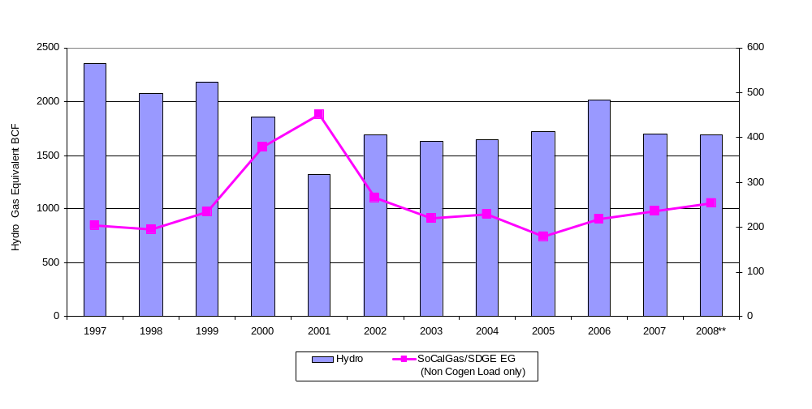

QUESTION 17.2:

- Please provide a copy of SoCalGas’ 2007 Annual Report to the Commission (FERC Form 2).

RESPONSE 17.2:

The SoCalGas FERC Form 2 for 2007 is attached below.

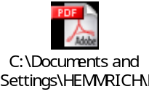

QUESTION 17.3:

- Please send a complete set of workpapers in the form of working Excel spreadsheets with complete formulas and relevant data for the v8-20-2008 LRMC-NCO rate tables that are posted on SoCalGas’ website. The file reference is v8-20-2008 SCG 2009BCAP RD-LRMC NCO.xls.

RESPONSE 17.3 (REVISED):

The workpapers appear on the disc labeled “2007 FERC Form 2 Update” that was sent on October 15 in response to SCGC 16, questions 16.1 and 16.2.

A more recent version of the referenced document that coincides with the October 6, 2008 errata filing is now available on our website: http://www.socalgas.com/regulatory/A0802001.shtml

The excel file is attached.
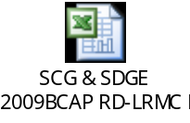

The workpapers for the SoCalGas LRMC NCO rate tables can be found in this version of Allison Smith’s workpapers. The workpapers for the SDG&E LRMC NCO rate tables can be found in Emma Hernandez’s workpapers by going to the “Legend” tab and switching between Rental and NCO.
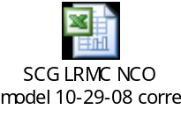

QUESTION 17.4:

- Do the NCO LRMC customer cost values used in SoCalGas’ v8-20-2008 LRMC-NCO cost allocation include or exclude replacement costs?

RESPONSE 17.4:

The customer values include replacement costs for customer-related costs.

A more recent version of the referenced document that coincides with the October 6, 2008 errata filing is now available on our website: http://www.socalgas.com/regulatory/A0802001.shtml

