2013 Load Impact Evaluation of San Diego Gas & Electric Company’s Opt-in Peak Time Rebate Program
Submitted to: San Diego Gas & Electric Co.
Submitted By: Nexant
April 1, 2014

Prepared by:
Stephen George, Senior Vice President
Josh Schellenberg, Managing Consultant
Jeeheh Oh, Project Analyst
Marshall Blundell, Analyst

Table of Contents
1 Executive Summary 1
1.1 Ex Post Evaluation Summary 1
1.2 Ex Ante Evaluation Summary 2
2 Introduction 3
2.1 Evaluation Objectives 3
2.2 Overview of Methods 3
2.3 Current Opt-in PTR Enrollment 4
2.4 Overview of the SCTD Program 4
2.5 Enrollment Forecast 5
2.6 Report Organization 5
3 Ex Post Methods and Validation 6
3.1 Control Group Selection 6
3.2 Estimating Ex Post Load Impacts 8
4 Ex Post Results 10
4.1 Assessment of Customer Fatigue 13
4.2 Comparison of 2012 and 2013 Ex Post Load Impact Estimates 14
5 Ex Ante Methodology and Results 16
5.1 Opt-in PTR Methodology 16
5.2 Estimating Ex Ante Load Impacts for Opt-in PTR 17
5.2.1 Opt-in PTR-only Impact Model 18
5.2.2 Dually-enrolled Impact Model 19
5.2.3 Converting Average Impact to Hourly Impacts 19
5.3 Estimating Ex Ante Load Impacts for SCTD 20
5.4 Ex Ante Load Impact Results 22
5.4.1 Comparison of 2012 and 2013 Ex Ante Estimates 29
5.4.2 Relationship Between Ex Post and Ex Ante Estimates 30
6 Recommendations 32

Executive Summary
This report provides the 2013 ex post and ex ante load impact estimates for San Diego Gas & Electric Company’s (SDG&E) Opt-in Peak Time Rebate (PTR) Program, which is called the Reduce Your UseSM (RYU) program. PTR offers bill credits for reduced energy use between 11 AM and 6 PM on PTR event days. The scope of this evaluation is restricted to residential opt-in PTR customers, which includes customers that will receive a programmable communicating thermostat (PCT) through the Small Customer Technology Deployment (SCTD) program.

Ex Post Evaluation Summary
There was only one PTR event in 2013, which occurred on August 31, 2013. At the time, there were 57,586 customers enrolled in PTR event notification. Table 1-1 shows the average and aggregate opt-in PTR ex post load impact estimates for various customer categories of interest to this evaluation. As measured by the percent load reduction, customers who enrolled in 2013 and customers who received both notification types had the highest performance, with 14.3% and 10.7% load reductions, respectively. There is substantial overlap between these two categories because customers who enrolled in 2013 were more likely to opt in to event notification through both text message and email. In terms of aggregate load reduction, customers with high usage (top half of electricity users) delivered more than 90% of the aggregate load reduction (6.2 MW, relative to 0.4 MW among a similar number of low usage customers). Opt-in PTR customers in the inland climate zone delivered a 7.8% load reduction. In addition to delivering a larger percent reduction than coastal customers (who deliver a 6.4% load reduction), reference loads were higher in the hotter inland areas, which led to an average load impact that was double that of coastal customers.
Table 1-1: Opt-in PTR Ex Post Load Impact Estimates by Customer Category
August 31, 2013 (11 AM to 6 PM)
Customer Category | Number of Customers | Avg. Reference Load (kW) | Avg. Load with DR (kW) | Avg. Load Reduction (kW) | % Load Reduction | Aggregate Load Reduction (MW) | Heat Buildup (Avg. °F,  12 AM to 5 PM)
Climate Zone - Coastal | 32,128 | 1.31 | 1.23 | 0.08 | 6.4% | 2.7 | 79.5
Climate Zone - Inland | 25,458 | 2.00 | 1.85 | 0.16 | 7.8% | 4.0 | 80.6
Usage Level - High | 28,571 | 2.60 | 2.38 | 0.22 | 8.4% | 6.2 | 80.2
Usage Level - Low | 29,015 | 0.65 | 0.63 | 0.01 | 2.1% | 0.4 | 79.8
Enrollment Year - 2012 | 46,404 | 1.62 | 1.53 | 0.09 | 5.5% | 4.1 | 80.0
Enrollment Year - 2013 | 11,182 | 1.60 | 1.37 | 0.23 | 14.3% | 2.5 | 80.0
Notification Type - Email | 33,995 | 1.52 | 1.44 | 0.09 | 5.7% | 2.9 | 80.0
Notification Type - Text | 9,340 | 1.67 | 1.56 | 0.11 | 6.4% | 1.0 | 80.0
Notification Type - Both | 14,251 | 1.81 | 1.61 | 0.19 | 10.7% | 2.7 | 80.0
All Customers | 57,586 | 1.62 | 1.50 | 0.12 | 7.2% | 6.7 | 80.0

Ex Ante Evaluation Summary
Currently, there are roughly 55,000 opt-in PTR customers, but the program is expected to grow to over 73,000 participants by the end of August 2014 (and then remain flat). In addition, the ex ante evaluation assumes that the number of PCTs that are deployed through the SCTD program will grow from basically zero devices to 9,500 devices by the end of summer 2014. By the end of summer 2015, SDG&E projects that there will be a total of 10,500 PCTs deployed through the SCTD program. These PCTs will be activated during future PTR events.
Figure 1-1 summarizes the 2016–2024 opt-in PTR and SCTD aggregate load impact estimates for each monthly system peak day under 1-in-2 and 1-in-10 weather conditions. The opt-in PTR and SCTD programs are expected to be capable of delivering up to 10.6 MW and 7.4 MW, respectively, which occurs during the September monthly peak under 1-in-10 weather conditions. Basically, if the SCTD program delivers the load impacts that are indicated in this forecast, the capacity of opt-in PTR as a whole (including SCTD) will increase by nearly 70% (from 10.6 MW to 18 MW). However, it is important to note that the SCTD impacts should be taken with a higher degree of uncertainty than the opt-in PTR impacts, given that the SCTD program is starting from basically zero participants at this point. While this forecast draws from the best available information, there are a number of factors that could lead to lower than expected impacts from SCTD, such as PCT communication failures or fewer customers enrolling than expected. It will be important for SDG&E to track these metrics as the SCTD program grows.
Figure 1-1: 2016-2024 Opt-in PTR and SCTD Ex Ante Load Impact (MW) Estimates by Month
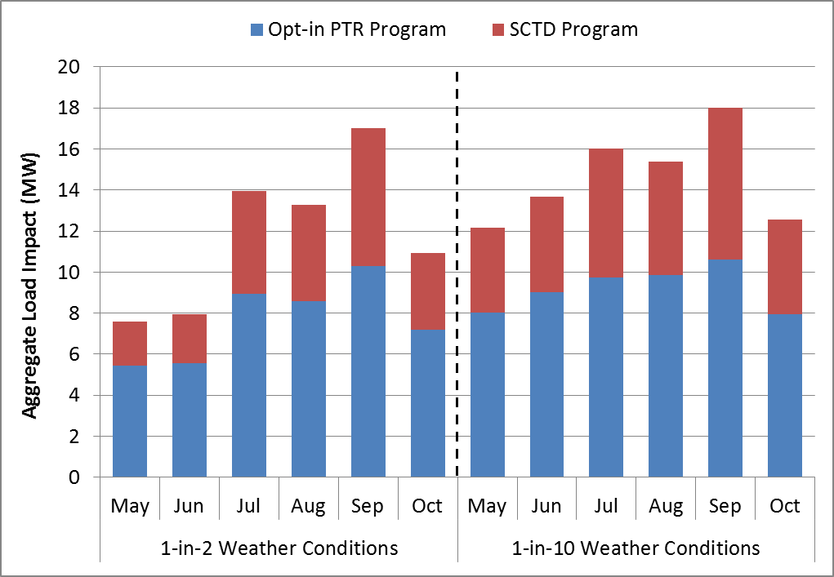

Introduction
This report provides the 2013 ex post and ex ante load impact estimates for San Diego Gas & Electric Company’s (SDG&E) Opt-in Peak Time Rebate (PTR) Program, which is called the Reduce Your UseSM (RYU) program. PTR offers bill credits for reduced energy use between 11 AM and 6 PM on PTR event days. The PTR bill credit is calculated based on event day usage relative to a customer-specific reference level. In 2013, any customer with a working smart meter was eligible for the PTR bill credit. Starting in 2014, only customers who opt in to receive event alerts via text and/or email one day in advance of an event will be eligible for PTR rebates. Therefore, the scope of this evaluation is restricted to residential opt-in PTR customers, which includes customers that will receive a programmable communicating thermostat (PCT) through the Small Customer Technology Deployment (SCTD) program. There was only one PTR event in 2013, which occurred on August 31, 2013. At the time, there were 57,586 customers enrolled in PTR event notification. Currently, there are roughly 55,000 opt-in PTR customers, and the program is expected to grow to over 73,000 participants by the end of August 2014.

Evaluation Objectives
The objectives of this evaluation are to:
- Estimate hourly ex post load reductions on the 2013 PTR event day (aggregate and per-customer level);
- Estimate ex post load reductions by climate zone, usage level, low income status, enrollment year (2012 or 2013), notification type (email, text or both) and dual enrollment in Summer Saver (SDG&E’s air conditioning cycling program);
- Assess customer fatigue in response to PTR events;
- Forecast 2014–2024 opt-in PTR hourly ex ante load impacts for a 1-in-2 and 1-in-10 weather year by month (aggregate and per-customer level); and
Forecast 2014–2024 ex ante load impacts for opt-in PTR customers that will receive a PCT through the SCTD program.

Overview of Methods
To estimate ex post load impacts for opt-in PTR customers, Nexant compared participant load to a matched control group on PTR event days. Customers that have not opted into event alerts (non-alert customers) have been shown in the past to not reduce electricity usage on PTR event days, so these customers are appropriate candidates for selection into the control group in the ex post analysis. Opt-in alert customers were matched to non-alert customers (the control group) based on usage during two event-like days in 2013. Considering that the single 2013 PTR event was on a Saturday, the ex post analysis only used Saturday data. The impact estimates are based on a difference-in-differences comparison of control and treatment group usage during event days and the chosen event-like days.
With only one PTR event in 2013, the ex ante evaluation had to incorporate information from the six PTR events that were called in 2012. Nexant first identified the set of customers that participated in all six PTR events in 2012 and the one PTR event in 2013. Weights were developed so that this set of persistent customers was representative of the current opt-in PTR population. Specifically for this set of customers, the 2012 and 2013 ex post load impacts were re-estimated in order to determine how PTR event load reductions vary as a function of temperature. To estimate the ex ante load impacts, Nexant applied this temperature-load impact relationship to the temperature profiles for each ex ante scenario.

Current Opt-in PTR Enrollment
Table 2-1 provides a summary of opt-in PTR enrollment across various customer categories of interest to this evaluation. All categories are tabulated by enrollment year in order to identify any changes in the customer mix over time. As of the end of 2013, there were 55,365 active opt-in PTR participants, of which 24% enrolled in 2013. In general, 2012 enrollees are similar to 2013 enrollees. Both groups have around 45% of customers in the inland climate zone, roughly 6% dually enrolled in Summer Saver, 20% enrolled in CARE and 34% with average hourly demand more than 1 kW. The only observable difference between the 2012 opt-in PTR enrollees and 2013 enrollees shows up in the distribution of notification types. Participants that enrolled in 2013 were nearly 12% more likely to opt into notification by text message, either by itself or in combination with an email alert. This difference is statistically significant at a less than 1% level.
Table 2-1: Summary of Opt-in PTR Enrollment by Customer Category (As of the End of 2013)
Customer Category | Enrollment Year – 2012 |  | Enrollment Year – 2013 |  | All Opt-in PTR Customers
 | N | % | N | % | N | %
Climate Zone - Coastal | 23,385 | 55.9% | 7,281 | 54.0% | 30,666 | 55.4%
Climate Zone - Inland | 18,485 | 44.1% | 6,214 | 46.0% | 24,699 | 44.6%
Non-Summer Saver | 39,063 | 93.3% | 12,811 | 94.9% | 51,874 | 93.7%
Summer Saver | 2,807 | 6.7% | 684 | 5.1% | 3,491 | 6.3%
Non-CARE | 33,248 | 79.4% | 10,841 | 80.3% | 44,089 | 79.6%
CARE | 8,622 | 20.6% | 2,654 | 19.7% | 11,276 | 20.4%
Avg. kW Less than 1 kW | 27,607 | 65.9% | 8,810 | 65.3% | 36,417 | 65.8%
Avg. kW More than 1 kW | 14,263 | 34.1% | 4,685 | 34.7% | 18,948 | 34.2%
Notification Type – Email Only | 25,851 | 61.7% | 6,723 | 49.8% | 32,574 | 58.8%
Notification Type – Text Only | 6,076 | 14.5% | 2,930 | 21.7% | 9,006 | 16.3%
Notification Type - Both | 9,943 | 23.7% | 3,842 | 28.5% | 13,785 | 24.9%
All Customers | 41,870 | – | 13,495 | – | 55,365 | –

Overview of the SCTD Program
SCTD is a new demand response (DR) program that provides enabling technology to residential customers at no cost in order to automate load reduction on DR event days. SDG&E will use smart meter data to identify, market to, and install load control devices in the homes of residential customers with significant air conditioning load. The automated enabling technologies will provide incremental load reduction during DR events and create a technology platform that will support future dynamic pricing rate adoption for residential and small commercial customers. Potential future end-use loads for the SCTD program include central air conditioning, refrigeration, lighting, pool pumps and electric water heaters. In addition to providing deeper load reductions, the SCTD program is designed to increase the number of vendors capable of these installations and, over time, SDG&E expects that the SCTD program will influence technology solutions that are simple enough for the average home owner or renter to install and utilize during a DR event.
In 2014 and 2015, SDG&E plans to deploy over 10,000 PCTs through the SCTD program. These PCTs will be activated through Wi-Fi and/or zigbee (when possible) communications on PTR event days. Half of SCTD PCTs will feature a 4-degree temperature setback and the other half will have a 50% cycling curtailment strategy. SDG&E plans to curtail load in 4-hour increments on PTR event days. Although SDG&E has the flexibility to curtail load during any 4-hour period between 11 AM and 6 PM, it is expected that most of the time curtailment will occur from 2 to 6 PM. SDG&E plans to market the SCTD program to 190,000 targeted customers with usage patterns that indicate that they have an air conditioner and use it during peak periods.

Enrollment Forecast
SDG&E expects that the opt-in PTR program will continue to grow. By the end of summer 2014, the program is projected to grow to more than 73,000 participants. This does not include customers that will receive a PCT through the SCTD program. The enrollment forecast in the ex ante evaluation assumes that the number of PCTs that are deployed through the SCTD program will grow from basically zero devices to 9,500 devices by the end of summer 2014. By the end of summer 2015, SDG&E projects that there will be a total of 10,500 PCTs deployed through the SCTD program. These PCTs will be activated during future PTR events. For the purposes of this report, these PCT ex ante impacts are provided separately as part of the SCTD program. Therefore, the opt-in PTR ex ante load impact estimates specifically refer to the non-SCTD customers.

Report Organization
The remainder of this report proceeds as follows. Section 3 summarizes the ex post methods and validation process. Section 4 provides the ex post results for all customers and for various segments of the opt-in PTR population. Section 5 focuses on the ex ante evaluation, including the methodology and results. Finally, this report concludes with recommendations for future evaluations.

Ex Post Methods and Validation
Reference loads for the opt-in PTR impact estimates were calculated using a matched control group drawn from the non-alert PTR population – a group that, on average, has not provided load impacts in the past (and did not show response for the 2013 event either). In 2013, given that email alerts were no longer being sent to MyAccount customers who had not proactively requested alerts, a large pool of non-alert customers were available for matching in the control group selection. The control group is designed to ensure that the load on event days is an accurate estimate of what load would have been among opt-in alert customers on the PTR event day had there been no event.
The matched control group method used for this analysis is superior to a within-subjects analysis because there is a large population of non-alert customers to use as a pool for matching and because it eliminates the problem of model misspecification. Any reference load model based on loads observed at non-event times requires the modeler to make assumptions about the relationships between load, time and temperature. If this assumed function does not reflect the true relationships between load, time and temperature, then the model can produce incorrect results. In contrast, the matched control group automatically deals with this problem by assuming that the customers who behave similarly to opt-in PTR customers during non-event periods would also behave similarly during event periods. This eliminates the need to specify load as a function of weather.

Control Group Selection
The control group was selected using a propensity score match to find non-alert customers who had similar load shapes to the opt-in PTR customers. In this procedure, a probit model was used to estimate a score for each customer based on a set of observable variables that are assumed to affect the decision to opt into PTR alerts, such as average daily use and hourly use. A probit model is a regression model designed to estimate probabilities – in this case, the probability that a customer would opt in or enroll. The propensity score can be thought of as a summary variable that includes all the relevant information in the observable variables about whether a customer would opt into PTR alerts. Each customer in the treatment population was matched with a customer in the non-alert population with the closest propensity score.
Figure 3-1 displays the average load shapes of treatment customers for the nine Saturdays with the highest system loads in 2013 as well as the 2013 PTR event day, which is marked with orange squares in the figure. June 29, 2013 and September 7, 2013 were ultimately chosen as the event-like days used in the matching analysis. As shown in Figure 3-1, only those two days have loads remotely close to actual event-day levels.
Figure 3-1: 2013 Event Day and Other High System Load Saturdays

The match was performed within each climate zone and each quintile of overall usage, meaning a treatment customer could only be matched with a customer in the non-alert population within the same climate zone and usage stratum. The five usage quintiles were determined using overall usage levels on the chosen event-like days. The four SDG&E climate zones were aggregated into two climate zones – coastal and inland. Average daily use and average usage for each of the hours between 11 AM and 9 PM on event-like days were used as matching variables in the propensity score model. Additional matches were tested based on different sets of hours as well as other stratifying variables such as Summer Saver enrollment, but these matching specifications were ultimately not chosen because the model validation showed that those variables did not improve accuracy. All matching specifications were validated using out-of-sample testing in which September 7, 2013 was omitted from the match so that control and treatment group usage could be compared for that day. If the two groups have similar usage on event-like days, then it is likely that the control group’s usage is an accurate estimate of event-day reference load. Figure 3-2 shows average hourly usage for both groups on event-like days. Over the event period (11 AM to 6 PM), usage was very similar between the two groups, with a difference of about 0.8%, on average.
Figure 3-2: Validation of Matched Control Group for 2013 PTR Load Impact Estimation
Average Usage on Event-like Days for PTR Customers and Control Group

Estimating Ex Post Load Impacts
After the control groups for opt-in alert customers were matched and validated, load impacts were estimated using a difference-in-differences methodology. Nexant calculated the estimated impacts as the difference in average loads between opt-in PTR and control customers on the August 31 event day, with the slight difference between the two groups on the chosen event-like days removed. This calculation controls for residual differences in load between the groups that are not eliminated through the matching process, thus reducing bias. In the following discussion, this process is framed as an adjustment to control group usage, preserving the reference load framework as well as the ability to integrate results into a format that is compliant with the Load Impact Protocols (i.e., hourly tables with reference loads and load with DR), while still taking advantage of the difference-in-differences methodology.
Figure 3-3 illustrates the adjustment process for the single 2013 PTR event. The solid blue line shows the unadjusted control group usage and the dashed light blue line shows the adjusted control group usage. As Figure 3-3 shows, the adjustment was quite modest and the adjusted control group usage provided a highly plausible reference load from which to estimate PTR load impacts for the event day.
Figure 3-3: Control Group Usage Adjustment for August 31, 2013 PTR Event

Ex Post Results
SDG&E called one PTR event in 2013, on Saturday, August 31. At the time, there were 57,586 customers enrolled in PTR event notification. The ex post load impact estimates for the opt-in PTR customers that received event notification are presented in this section.
Figure 4-1 shows the average load impact per PTR customer in each hour of the event day. During the event hours (11 AM to 6 PM), the average load drop was 0.12 kW per participant. Impacts were the largest during the middle event hours of 1 to 4 PM, with a high of 0.14 kW per participant from 2 to 3 PM. During the first and last hours of the event, impacts were slightly lower, with a reduction of 0.09 kW per participant. Figure 4-2 shows the aggregate load impact for each hour of the event day. The aggregate load drop from 11 AM to 6 PM was 6.6 MW, representing a 7.2% reduction relative to the reference load of 93 MW. After event hours, there was moderate snapback, with an average increase in load of 2.6 MW from 7 PM to midnight.

Figure 4-1: Average Opt-in PTR Ex Post Load Impact (kW) per Participant for August 31, 2013
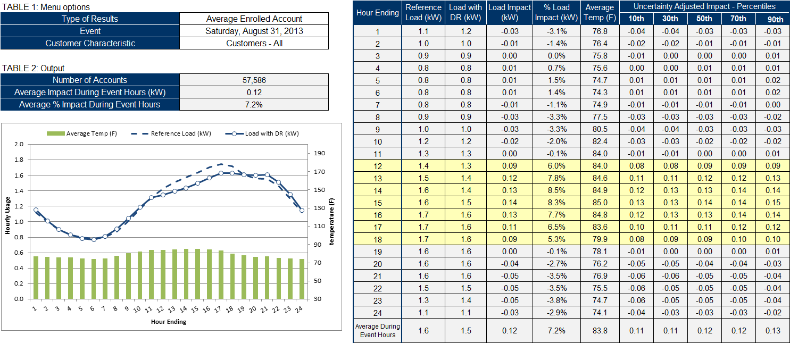

Figure 4-2: Aggregate Opt-in PTR Ex Post Load Impact (MW) for August 31, 2013
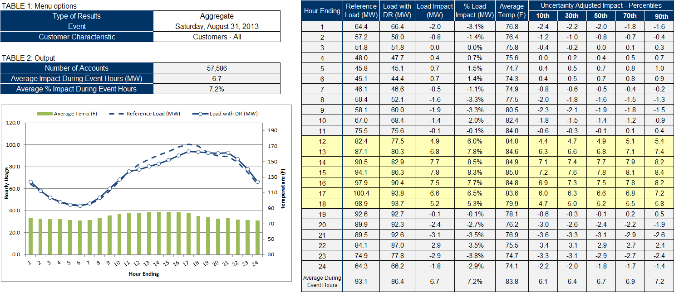

Table 4-1 shows the average and aggregate opt-in PTR ex post load impact estimates for various customer categories of interest to this evaluation. As measured by the percent load reduction, customers who enrolled in 2013, and customers who received both notification types, had the highest performance, with 14.3% and 10.7% load reductions, respectively. There is substantial overlap between these two categories because customers who enrolled in 2013 were more likely to opt in to event notification through both text message and email, as discussed in Section 2. In terms of aggregate load reduction, customers with high usage (top half of electricity users) delivered more than 90% of the aggregate load reduction (6.2 MW, relative to 0.4 MW among a similar number of low usage customers). Opt-in PTR customers in the inland climate zone delivered a 7.8% load reduction. In addition to delivering a larger percent reduction than coastal customers (who deliver a 6.4% load reduction), reference loads were higher in the hotter inland areas, which led to a load impact that was double that of coastal customers. Finally, Summer Saver customers delivered slightly higher impacts than non-Summer Saver customers and CARE customers delivered slightly lower impacts than non-CARE customers.
Table 4-1: Opt-in PTR Ex Post Load Impact Estimates by Customer Category
August 31, 2013 (11 AM to 6 PM)
Customer Category | Number of Customers | Avg. Reference Load (kW) | Avg. Load with DR (kW) | Avg. Load Reduction (kW) | % Load Reduction | Aggregate Load Reduction (MW) | Heat Buildup (Avg. °F,  12 AM to 5 PM)
Climate Zone - Coastal | 32,128 | 1.31 | 1.23 | 0.08 | 6.4% | 2.7 | 79.5
Climate Zone - Inland | 25,458 | 2.00 | 1.85 | 0.16 | 7.8% | 4.0 | 80.6
Non-Summer Saver | 54,149 | 1.59 | 1.47 | 0.11 | 7.2% | 6.2 | 79.9
Summer Saver | 3,437 | 2.07 | 1.93 | 0.14 | 6.9% | 0.5 | 80.5
Non-CARE | 45,382 | 1.67 | 1.54 | 0.12 | 7.3% | 5.5 | 80.0
CARE | 12,204 | 1.43 | 1.34 | 0.09 | 6.6% | 1.2 | 80.0
Usage Level - High | 28,571 | 2.60 | 2.38 | 0.22 | 8.4% | 6.2 | 80.2
Usage Level - Low | 29,015 | 0.65 | 0.63 | 0.01 | 2.1% | 0.4 | 79.8
Enrollment Year - 2012 | 46,404 | 1.62 | 1.53 | 0.09 | 5.5% | 4.1 | 80.0
Enrollment Year - 2013 | 11,182 | 1.60 | 1.37 | 0.23 | 14.3% | 2.5 | 80.0
Notification Type - Email | 33,995 | 1.52 | 1.44 | 0.09 | 5.7% | 2.9 | 80.0
Notification Type - Text | 9,340 | 1.67 | 1.56 | 0.11 | 6.4% | 1.0 | 80.0
Notification Type - Both | 14,251 | 1.81 | 1.61 | 0.19 | 10.7% | 2.7 | 80.0
All Customers | 57,586 | 1.62 | 1.50 | 0.12 | 7.2% | 6.7 | 80.0

Assessment of Customer Fatigue
Only one PTR event was called in 2013, and that event was on a Saturday. To assess customer fatigue, Nexant compared the 2013 event impacts to the impacts of the two 2012 PTR events that also occurred on a Saturday. Only customers that participated in all three events were used in the assessment in order to isolate changes in load reductions over time. The 2012 ex post results were calculated using the same method as the 2013 ex post results. For the 2012 analysis, August 18, 2012 and September 22, 2012 were the event-like days used to match treatment and control customers. With one PTR event in 2013, this comparison is somewhat inconclusive due to a lack of empirical evidence. Nonetheless, it provides a data point to consider as the program continues and more events are called in future years.
Table 4-2 displays key statistics from the three Saturday event days in 2012 and 2013. These results were calculated using the same set of 34,108 customers who experienced all three events. The smallest impacts occurred on the second Saturday event day in 2012. Both the first Saturday event day in 2012 and the only Saturday event day in 2013 returned slightly higher impacts in terms of percent load reduction and aggregate load reduction. However, these three data points cannot be used to definitively say that customer fatigue (after multiple events in 2012) led to the decrease in impacts. For example, 12 AM to 5 PM heat buildup, the average temperature in the first 17 hours of the day, varies from event day to event day and could be a confounding factor. In addition, the second event in 2012 was called in mid-September, which is when many schools are back in session and when demand response events are less likely to occur. Even with these potentially confounding factors, the aggregate load reduction is within a relatively narrow range of 2.5 MW to 2.7 MW, which suggests that this set of customers provides consistent response and is not substantially fatigued from responding to PTR events at this point.
Table 4-2: Results of Customer Fatigue Analysis for Saturday Events in 2012 and 2013
PTR Event Date | Number of Customers | Avg. Reference Load (kW) | Avg. Load with DR (kW) | Avg. Load Reduction (kW) | % Load Reduction | Aggregate Load Reduction (MW) | Heat Buildup (Avg. °F,  12 AM to 5 PM)
8/11/2012 | 34,108 | 1.43 | 1.35 | 0.08 | 5.5% | 2.7 | 76.8
9/15/2012 | 34,108 | 1.77 | 1.69 | 0.07 | 4.2% | 2.5 | 84.4
8/31/2013 | 34,108 | 1.64 | 1.56 | 0.08 | 4.8% | 2.7 | 80.0
Average | 34,108 | 1.61 | 1.54 | 0.08 | 4.8% | 2.6 | 80.4

Comparison of 2012 and 2013 Ex Post Load Impact Estimates
Figure 4-3 provides a comparison of the ex post load impact estimates that were reported in the 2012 opt-in PTR evaluation to those reported in this evaluation. The 2012 PTR evaluation found that opt-in alert customers provided a 0.09 kW load reduction (6.6%) on average across seven event days. For the two Saturday events in 2012, opt-in PTR customers delivered an average load reduction of 0.11 kW (6.7%). The 2013 evaluation found that opt-in PTR customers provided a 0.12 kW load reduction (7.2%) on the August 31 event. However, customers that enrolled in 2012 provided a relatively low reduction of 0.09 kW, which is equal to the average event estimate from the 2012 evaluation, but slightly lower than the average Saturday event in 2012. While it seems most appropriate to compare the Saturday estimates, the two Saturdays in 2012 featured an average event temperature of 89.8 °F, which is significantly higher than temperatures during 2013 event hours (83.8 °F). Therefore, it is not surprising that the Saturday ex post load impact estimates are slightly lower in 2013 for customers that have participated in PTR since 2012. However, after incorporating the relatively high impacts from customers that enrolled in 2013, the August 31 load impact estimate increased by nearly 33% (from 0.09 kW to 0.12 kW). As a result, the 2013 ex post load impact estimates are higher because the 2013 enrollees provided relatively large load impacts, albeit for a single event. It will be important to observe if their performance remains strong in 2014.
Figure 4-3: Comparison of 2012 and 2013 Ex Post Load Impact Estimates
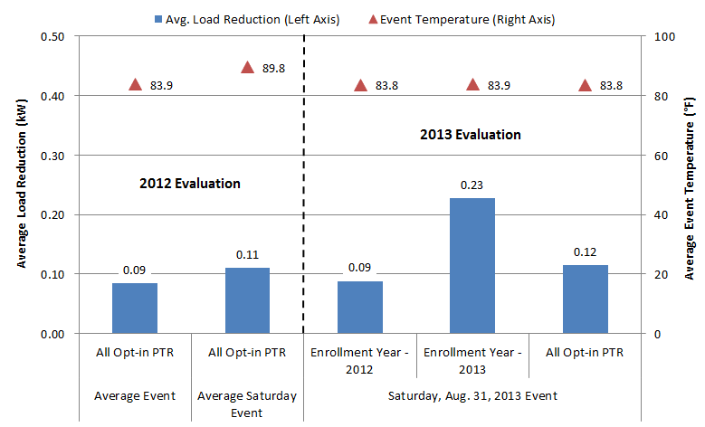

Ex Ante Methodology and Results
This section explains the steps used to predict ex ante load impacts for opt-in PTR and for PCTs that will be deployed through the SCTD program. As discussed in Section 2, these PCTs will be activated during future PTR events. However, for the purposes of this report, the SCTD ex ante impacts are provided separately. Therefore, the opt-in PTR ex ante load impact estimates specifically refer to the non-SCTD customers.
Another important distinction in the ex ante analysis is between opt-in PTR-only customers and dually-enrolled customers, which is determined by dual enrollment in Summer Saver – SDG&E’s air conditioning cycling program. These sets of customers must be divided in the analysis because ex ante load impacts for dually-enrolled customers are attributed to the Summer Saver program in SDG&E’s demand response portfolio. Therefore, the opt-in PTR ex ante load impacts are assumed to be zero for dually-enrolled customers in the portfolio evaluation. Nonetheless, this report focuses on program-specific ex ante load impacts, which shows how dually-enrolled customers will perform when opt-in PTR is called by itself.

Opt-in PTR Methodology
There are a few issues that must be addressed when developing ex ante load impact estimates. First, the weather observed during the event in 2013 is different from the ex ante weather conditions. Second, the population that experienced each event was not constant over the estimating sample since the analysis relies on ex post estimates for two years during which the population changed significantly (with only one event in 2013, the analysis had to draw from the seven events in 2012). The ex ante estimates must reflect the current population mix (or future mix which, in this case, is assumed to be identical to the current population). Finally, even after combining observations from 2012 and 2013, there are only seven events for each climate zone to use for modeling. The modeling procedure outlined here makes the most of the data that exists.
At a high level, the modeling steps consist of the following (each step was performed separately for opt-in PTR-only and for customers dually-enrolled in Summer Saver):
- First, groups of opt-in PTR customers were identified who were representative of the population at the end of 2013 and who experienced all the 2012 and 2013 opt-in PTR events. Propensity score matching was used to find these groups;
- Next, ex post estimates were developed for these customers for 2012 and 2013 using matched control groups of non-alert customers for each year;
- Then an ex ante regression model was developed to explain average ex post impacts from 11 AM to 6 PM as a function of temperatures that day. This model was not estimated separately for each hour; rather, a single average value from 11 AM to 6 PM was used as the dependent variable. The data from both climate zones was pooled. Pooling increases the range of temperatures included in the estimating sample, thus reducing the need to extrapolate outside of the historical conditions to estimate impacts for 1-in-10 year weather conditions, which represent temperatures within many climate zones that are not often experienced during the ex post period. The model was used to predict average impacts from 11 AM to 6 PM for the set of ex ante weather conditions;
- The ex ante impact estimates were then converted to hourly impacts from 11 AM to midnight (including the post-event period) using a scaling factor based on the average ratio between impacts at different hours. The scaling factor was calculated by comparing average impacts from the entire event period to average impacts for each event hour and post-event hour based on ex post results; and
Finally, hourly whole-house reference loads were predicted for each set of ex ante weather conditions based on loads observed in 2013. These reference loads are needed to comply with the load impact protocols, but are not necessary for ex ante load impact estimation, as impacts are estimated directly from ex post impact values. Reference load shapes were estimated by running a simple regression model on 2013 participant load by climate zone. The regression model related hourly usage to temperature, month and day of week.
The steps for estimating load impacts are described in more detail below.

Estimating Ex Ante Load Impacts for Opt-in PTR
Ex ante impact estimates were calculated by making predictions for ex ante weather conditions using a regression model of ex post impacts from 2012 and 2013. With only one event in 2013, the analysis had to draw from the seven events in 2012. Opt-in PTR was a new program for SDG&E in 2012, so no further event data is available outside of these eight events. Therefore, this ex ante evaluation uses as much empirical data as possible. The ex ante weather conditions are the same as those used for the 2012 opt-in PTR evaluation and have been chosen to be representative of 1-in-2 and 1-in-10 monthly peak days and 1-in-2 and 1-in-10 typical event days.
Prior to regression modeling, a sample of customers that experienced all historical opt-in PTR events was developed that had similar observable characteristics to the opt-in PTR population at the end of 2013. The end of 2013 is the most up-to-date snapshot available of the opt-in PTR population and the ex ante load impact estimates are designed to be representative of that population since the customer mix is not expected to change over the forecast horizon. These groups of customers were identified using the same procedure used to identify matched control groups for the ex post evaluation, except that customers were matched based on event-day loads rather than hot non-event day loads since the match was being done among the opt-in PTR population, nearly all of whom have experienced events. This process is conceptually similar to simply reweighting the segment of opt-in PTR participants who have been in the program for two years to look like the population that was present at the end of 2013. These customers were used to estimate a set of ex post estimates for 2012 and 2013 that represent what the current opt-in PTR population would have provided if they had been in the program the whole time.
With only eight events and two climate zones, the analysis started with a simple model specification. The initial model had very low predictive power because there were relatively few data points and because two of those data points were clearly outliers. The two outliers were the event impact estimates for the coastal and inland climate zones on September 15, 2012. The impact estimates for this particular event were unusually low because the event occurred in late summer (nearly a month had passed since the prior event), with unseasonably hot temperatures (maximum temperatures of around 100 °F in both climate zones). Therefore, this outlier was dropped from the analysis for opt-in PTR-only customers. For dually-enrolled customers, the analysis lacked statistical power because there were only 2,300 Summer Saver customers that participated in all opt-in PTR events in 2012 and 2013, relative to nearly 29,000 customers in the opt-in PTR-only group. As a result, the model for dually-enrolled customers had to be adapted from the much larger opt-in PTR-only group, as explained below.

Opt-in PTR-only Impact Model
For opt-in PTR-only customers, the final model specification takes as its dependent variable the ex post impact for each event, averaged over the entire event period. The independent variable is the average temperature from midnight to 5 PM on the event day. The final specification was:
$$Impact=a+b{∙mean17}_{ }+ε$$
Table 5-1: Description of Opt-in PTR Ex Ante Load Regression Variables
Variable | Description
Impact (kW) | Per customer ex post load impact for each event day, averaged over the event period
a | Estimated constant
b | Estimated parameter coefficient
mean17 | Average temperature from 12 AM to 5 PM
Ɛ | The error term, assumed to be a mean zero and uncorrelated with any of the independent variables
It is quite likely that event impacts depend on variables other than this average of recent temperatures, but with limited event impact estimates for modeling and with virtually no other time-varying characteristics to use for modeling, it is not possible to identify these effects sufficiently accurately to be of use in prediction.
Figure 5-1 shows the results of the regression for opt-in PTR-only customers. The blue circles show the 2012 and 2013 ex post load impact estimates for the representative population in each climate zone (excluding the September 15, 2012 outlier). The linear trendline shows the average impacts that were used as a basis for ex ante forecasts. However, the average impact estimate in the ex ante analysis is capped at around 0.14 kW in order to avoid extrapolating into temperature conditions that were not observed in the model. Similarly, the average impact estimate has a lower bound of 0.05 kW for the relatively cool ex ante weather conditions in winter months. An average impact estimate of 0.05 kW is likely to be conservative for any event day, but with the 2012–2013 PTR events only occurring on hot summer days, there wasn’t information on how customers respond in winter months.
Figure 5-1: Ex Post and Ex Ante Impacts versus Mean17 for Opt-in PTR-only Customers
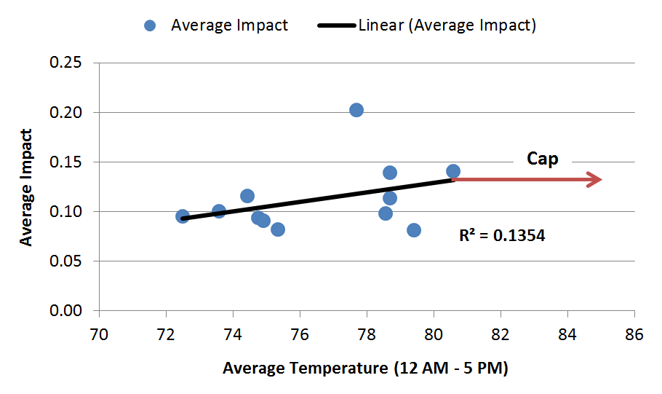

Dually-enrolled Impact Model
As discussed above, the analysis of historical event impacts for customers dually-enrolled in Summer Saver lacked statistical power because there were only 2,300 Summer Saver customers that participated in all opt-in PTR events in 2012 and 2013, relative to nearly 29,000 customers in the opt-in PTR-only group. In addition, three of the eight historical opt-in PTR events overlapped with Summer Saver event days, so those data points could not be used, further restricting statistical power. As a result, the model for dually-enrolled customers was adapted from the much larger opt-in PTR-only group. In the ex post analysis summarized in Section 4, both Summer Saver and non-Summer Saver customers deliver an impact of around 7% for opt-in PTR events. However, all dually-enrolled customers have a central air conditioning system, which is a requirement for participating in Summer Saver. Therefore, dually-enrolled customers have higher usage than opt-in PTR-only customers. As a result, the ex post load impact estimate for dually-enrolled customers was 27% higher than that of opt-in PTR-only customers. This is the most recent information on how dually-enrolled customers perform relative to opt-in PTR-only customers. Event performance in terms of percent impacts is nearly identical, so the ex ante analysis for dually-enrolled customers draws from the opt-in PTR-only model described in Section 5.1.1. However, given that absolute impacts are 27% higher due to higher usage, the opt-in PTR-only model estimates are increased by 27% for dually-enrolled customers in the ex ante analysis.

Converting Average Impact to Hourly Impacts
The next step in estimating load impacts was to translate event-level impact estimates to impacts for each event and post-event hour. First, a ratio of each hour’s impacts to the average impact across the entire event window was calculated. This ratio was calculated using the average ex post impact results for each category of customers. For example, the ratio for the hour from 3 to 4 PM was calculated by taking the average hourly ex post impact from 3 to 4 PM and dividing it by the average ex post impact for the entire event window. Table 5-2 gives an example of this process. The second column of Table 5-2 shows the predicted average event impact across all event hours (i.e., the output from the impact model) using the entire territory on a typical event day in a 1-in-2 weather year as an example. To illustrate, the third column shows the ratio of hourly impact to average whole-event impacts. To calculate the average hourly impact, the average predicted impact was simply multiplied by the category-specific ratio. The only exception to this conversion process is made for post-event hours during winter months. From November through March, impacts are assumed to be zero during post-event hours. The relative magnitude of load shifting to post-event hours is expected to be different during winter months, but without any winter events in 2012 and 2013, the post-event impact is simply assumed to be zero from November through March.
Table 5-2: Example of Converting Average Impact to Hourly Impacts from 11 AM to Midnight
Territory Wide, 1-in-2 Typical Event Day
Hour Ending | Predicted Average Impact (kW)* | Ratio (based on ex post impacts) | Predicted Hourly Impact (kW)
12:00 PM | 0.11 | 0.68 | 0.08
1:00 PM | 0.11 | 0.92 | 0.10
2:00 PM | 0.11 | 1.05 | 0.12
3:00 PM | 0.11 | 1.10 | 0.12
4:00 PM | 0.11 | 1.08 | 0.12
5:00 PM | 0.11 | 1.16 | 0.13
6:00 PM | 0.11 | 1.01 | 0.11
7:00 PM | 0.11 | 0.12 | 0.01
8:00 PM | 0.11 | -0.21 | -0.02
9:00 PM | 0.11 | -0.33 | -0.04
10:00 PM | 0.11 | -0.19 | -0.02
11:00 PM | 0.11 | -0.19 | -0.02
12:00 AM | 0.11 | -0.16 | -0.02
*output from ex ante model; model predicts one average value for all event hours
The implication of this strategy is that the ratio between any two hours of predicted event impacts is constant across nearly all ex ante conditions. While this is an assumption forced on the data, it is roughly accurate. Moreover, the available data do not allow for accurately modeling the nuanced relative differences in the event impacts for different hours that may occur under different conditions. The emphasis is on accurately predicting average event impacts and average impacts for each hour, without additionally trying to estimate whether, for example, impacts at 2 PM tend to be relatively higher than impacts at 3 PM on hot days compared to cooler days.

Estimating Ex Ante Load Impacts for SCTD
In 2014 and 2015, SDG&E plans to deploy over 10,000 PCTs through the SCTD program. These PCTs will be activated through Wi-Fi and/or zigbee (when possible) communications on PTR event days. Half of SCTD PCTs will feature a 4-degree temperature setback and the other half will have a 50% cycling curtailment strategy. SDG&E plans to curtail load in 4-hour increments on PTR event days. Although SDG&E has the flexibility to curtail load during any 4-hour period between 11 AM and 6 PM, it is expected that most of the time curtailment will occur from 2 to 6 PM. Nonetheless, given that the event window is flexible, impacts are estimated for the 5-hour summer resource adequacy window of 1 to 6 PM. Impacts for November through April are assumed to be zero, considering that air conditioning load is expected to be negligible during those months.
SDG&E plans to market the SCTD program to 190,000 targeted customers with usage patterns that indicate that they have an air conditioner and use it during peak periods. To develop the hourly reference loads in the ex ante analysis, Nexant analyzed the 2013 aggregate hourly interval usage data for these 190,000 customers, using a simple regression model that relates hourly usage to temperature, month and day of week (same model that was used to develop reference loads for opt-in PTR customers). At this point, it not known which of the 190,000 customers will enroll, so the aggregate data for all customers that will receive SCTD marketing materials was analyzed. This produced the hourly whole-house reference loads for each set of ex ante weather conditions.
To develop the impact estimates, the ex ante evaluation incorporated information from PG&E’s SmartRate program. While SDG&E does have Summer Saver customers that are dually-enrolled in opt-in PTR, the Summer Saver air conditioners were not activated for PTR events in the past, and SDG&E does not plan to do so in the future (unless the two program event days happen to overlap). SDG&E also has many Summer Saver customers that are not enrolled in opt-in PTR, but the fully automated impacts that those customers provide may not be representative of how an SCTD customer will perform on PTR events. The SmartRate program was most applicable because it has dually-enrolled (SmartAC) customers whose air conditioners are cycled at 50% during SmartRate events. Therefore, this source of information was most relevant to opt-in PTR customers that will have air conditioning usage curtailed during PTR events, as part of the SCTD program.
Given that usage patterns are different in PG&E’s service territory, the SCTD ex ante impact model focused on the percent impacts of dually-enrolled customers during SmartRate events. As such, the model described here is nearly identical to the opt-in PTR-only impact model and to the model described in the 2013 SmartRate load impact evaluation that Nexant conducted for PG&E, except the dependent variable in the model is the percent impact instead of kW impact. Figure 5-2 summarizes the impact model that was used for SCTD customers. The blue line represents the linear relationship between Mean17 (midnight to 5 PM average temperature) and the percent impact on whole house load when SmartAC switches are activated during SmartRate events. That linear model is used to estimate SCTD percent impacts under ex ante weather conditions. The red squares represent the 2013 Summer Saver ex post load impact estimates for customers on 50% cycling, which align relatively closely with the PG&E percent impacts. These Summer Saver estimates do not factor into the SCTD impact model. They are simply meant to provide additional indication of what can be expected from controlling air conditioning loads in San Diego, which further supports that using the SmartRate-SmartAC model is reasonable, considering that the two sources of information closely align.
Figure 5-2: Impact Model for SCTD Customers
(2013 Summer Saver Results are Provided as a Comparison)
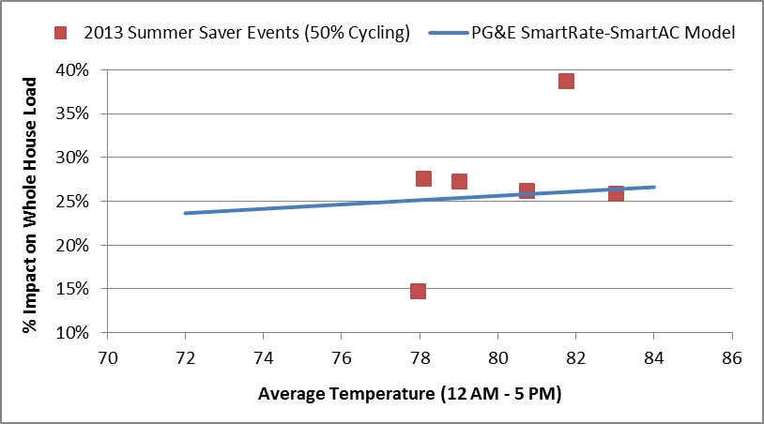
The next step was to multiply the percent impact estimate from the SCTD impact model by the average reference load from 1 to 6 PM. This produced the average impact estimate. As in the opt-in PTR analysis, the ex ante impact estimates were then converted to hourly impacts from 1 PM to midnight (including the post-event period) using a scaling factor based on the average ratio between impacts at different hours. In this case, the ratios were based on the experience of SDG&E’s dually-enrolled customers, considering that both sets of customers have air conditioning.

Ex Ante Load Impact Results
Sections 5.2 and 5.3 summarized the methodology used to develop ex ante impact estimates for the average customer that reflect ex ante weather conditions and event timing. Aggregate ex ante estimates combine these average estimates with projections of program enrollment, developed in a separate effort by SDG&E. SDG&E expects that the opt-in PTR program will continue to grow. By the end of summer 2014, the program is projected to grow to more than 73,000 participants and then remain constant throughout the remainder of the ex ante forecast period. This does not include customers that will receive a PCT through the SCTD program. The number of PCTs that are deployed through the SCTD program is expected to grow from basically zero devices to 9,500 devices by the end of summer 2014. By the end of summer 2015, SDG&E projects that there will be a total of 10,500 PCTs deployed through the SCTD program and then the number will remain constant throughout the remainder of the ex ante forecast period. These PCTs will be activated during future PTR events.
Figures 5-3 and 5-4 show the reference load and estimated load with DR for the average opt-in PTR customer on a typical event day based on 1-in-2 and 1-in-10 weather year conditions for the year 2015. Impacts are reported for 2015 because it is the year in which enrollment growth reaches a steady state. For a 1-in-2 typical event day, the estimated load impact for the average participant is 0.12 kW from 1 to 6 PM. For a 1-in-10 typical event day, the estimated load impact for the average participant is slightly higher, at 0.13 kW. The load impact is around 9% of the reference load under both weather conditions.

Figure 5-3: Opt-in PTR Average Load Impact (kW) per Customer in 2015
for a Typical Event Day Based on 1-in-2 Year Weather Conditions
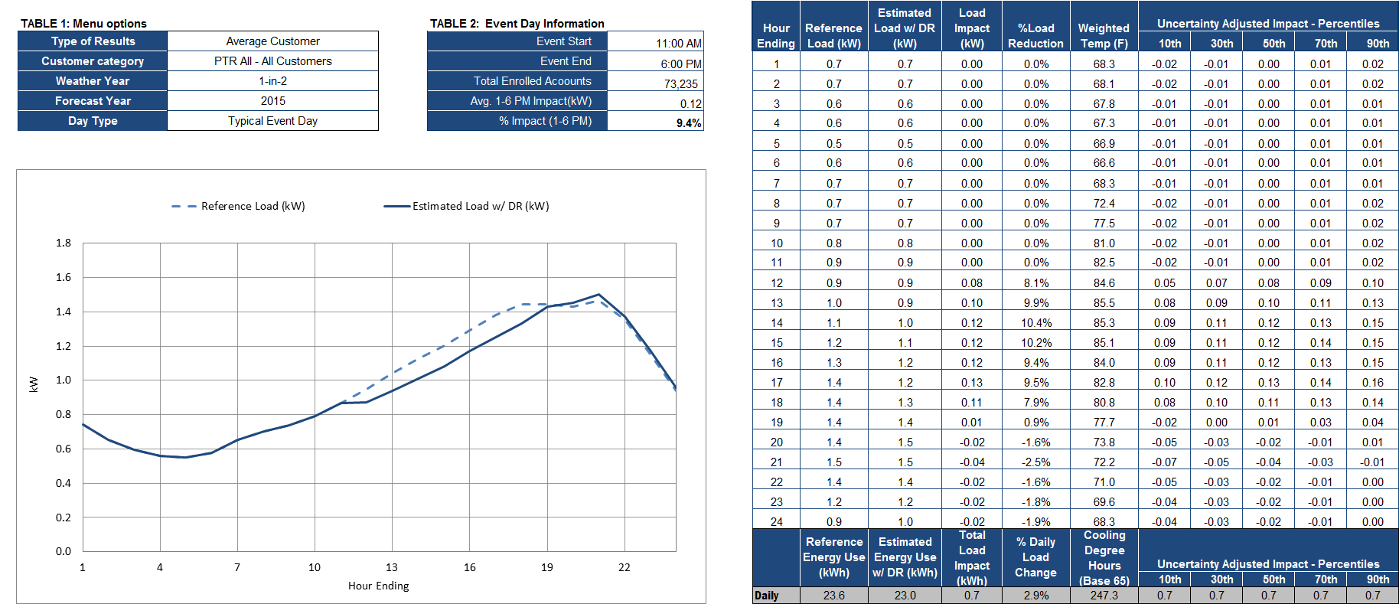
Figure 5-4: Opt-in PTR Average Load Impact (kW) per Customer in 2015
for a Typical Event Day Based on 1-in-10 Year Weather Conditions
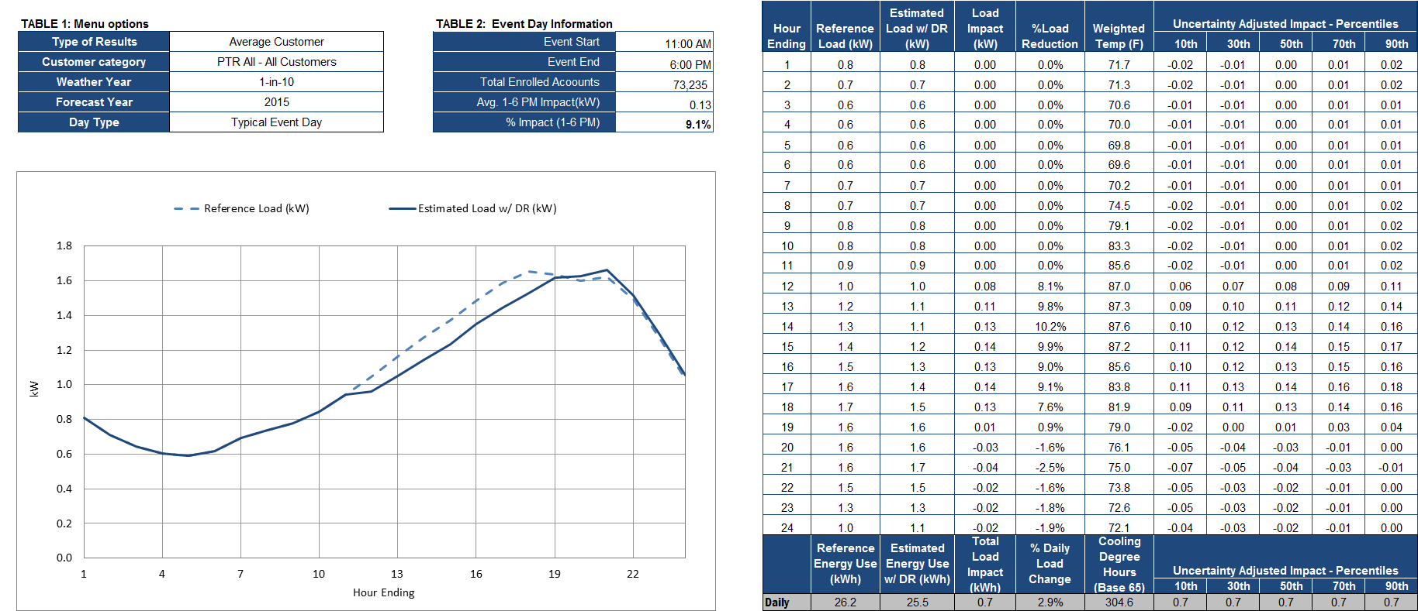
Figures 5-5 and 5-6 provide the same set of results for SCTD customers. These impacts are also reported for 2015 because it is the year in which SCTD enrollment growth reaches a steady state. For a 1-in-2 typical event day, the estimated load impact for the average SCTD participant is 0.45 kW from 1 to 6 PM. For a 1-in-10 typical event day, the estimated load impact for the average participant is 22% higher, at 0.55 kW, which is primarily due to the higher reference load under 1-in-10 conditions. The load impact is around 25% of the reference load under both weather conditions.
The remainder of the hourly ex ante load impact estimates that are required by the protocols for opt-in PTR and SCTD customers, including uncertainty adjusted estimates, can be found in the electronic appendix titled, "SDG&E 2013 Opt-in PTR Ex Ante Load Impact Tables."
Figure 5-5: SCTD Average Load Impact (kW) per Customer in 2015
for a Typical Event Day Based on 1-in-2 Year Weather Conditions
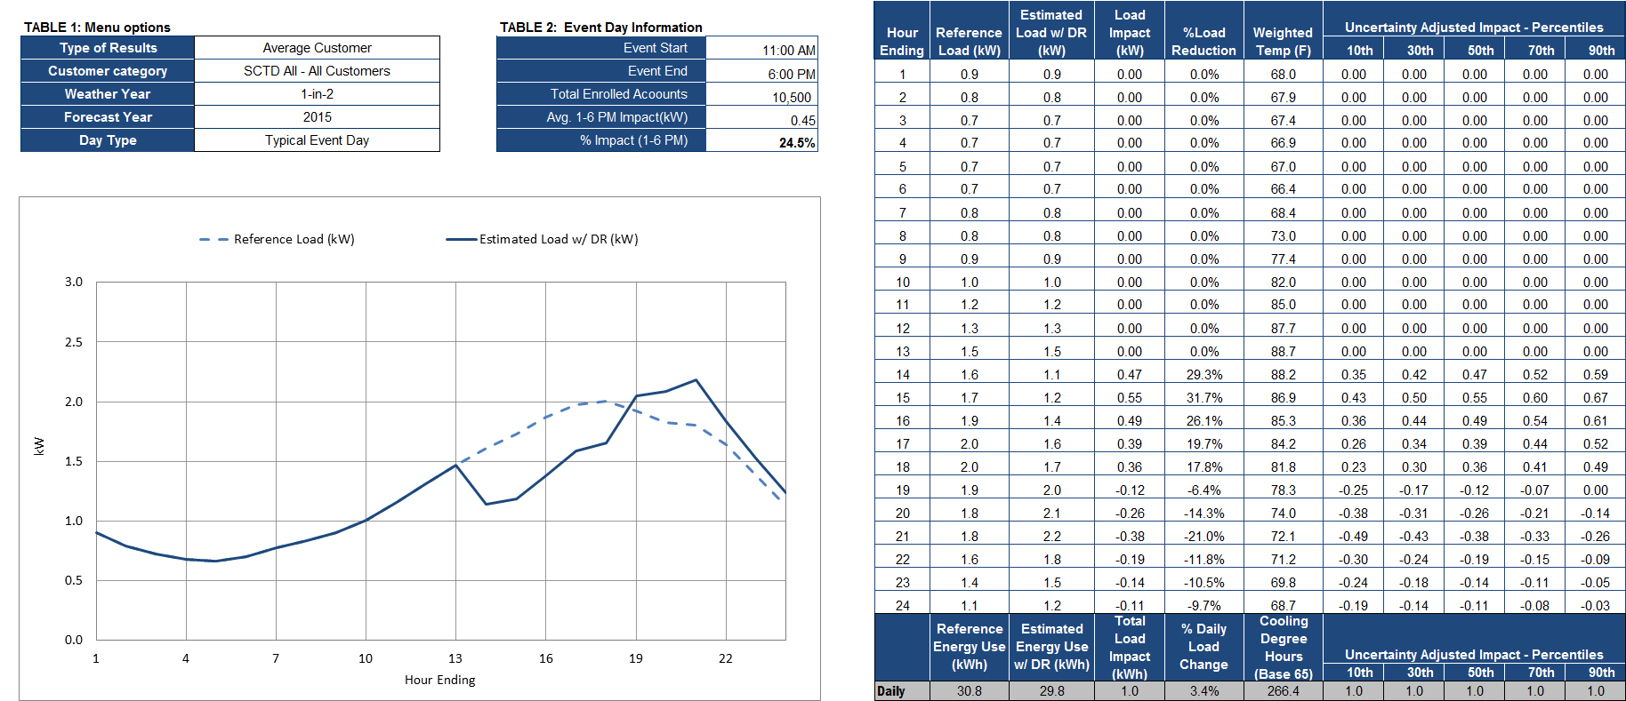
Figure 5-6: SCTD Average Load Impact (kW) per Customer in 2015
for a Typical Event Day Based on 1-in-10 Year Weather Conditions
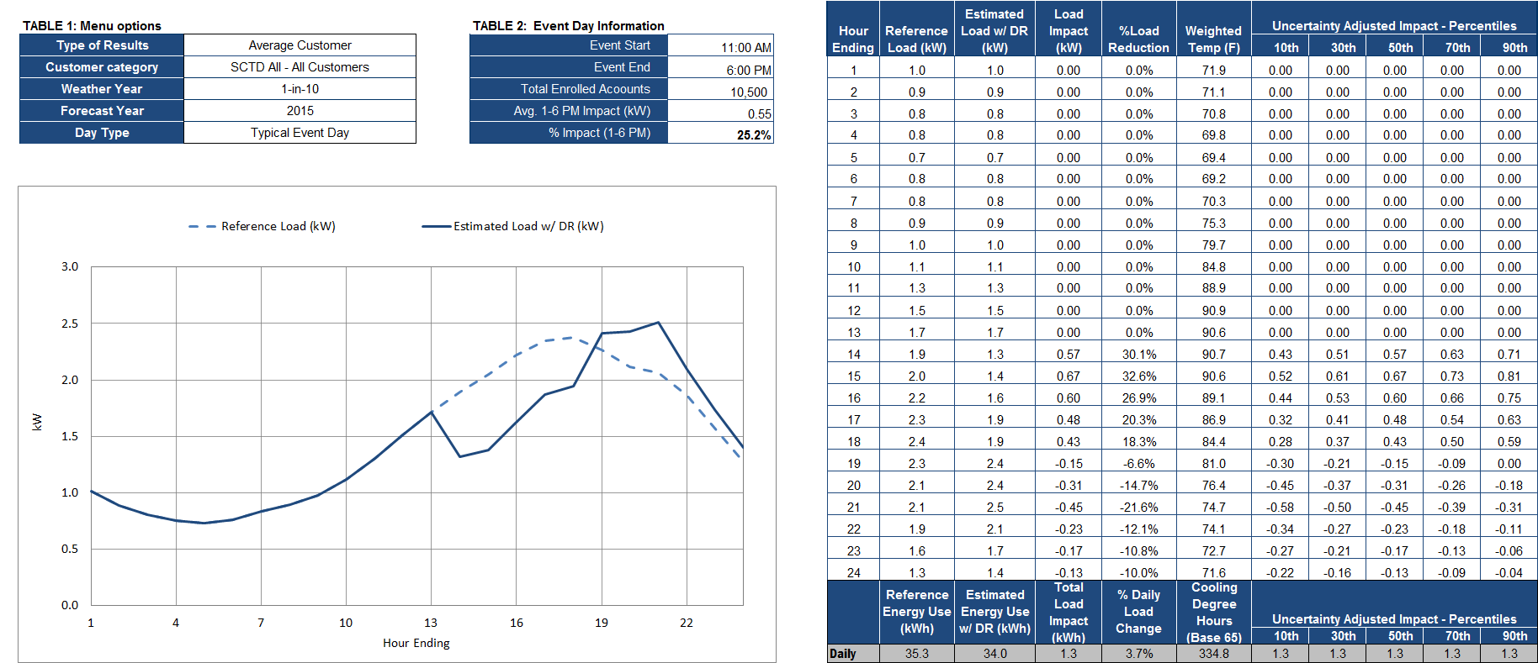

Table 5-3 shows the aggregate on-peak opt-in PTR ex ante load impact estimates for each monthly system peak day by weather year and forecast year. In accordance with the resource adequacy hours, the peak period is defined as 1 to 6 PM from April through October and 4 to 9 PM from November through March. Once enrollment reaches a steady state in the 2015 to 2024 time period, the program is expected to be capable of delivering up to 10.6 MW, which occurs during the September monthly peak under 1-in-10 weather conditions. Table 5-3 also divides these aggregate load impacts between opt-in PTR-only customers and dually-enrolled customers, which shows how much of the resource is allocated to Summer Saver in the portfolio evaluation. For all monthly system peak days under both 1-in-2 and 1-in-10 weather conditions, dually-enrolled customers account for around 9% of aggregate load impacts.
Table 5-3: Opt-in PTR Aggregate On-peak Load Impacts (MW)
for Each Monthly System Peak Day by Weather Year and Forecast Year
Weather Year | Month | Peak Period | Opt-in PTR-only |  | Dually-enrolled Customers |  | Total
 |  |  | 2014 | 2015-2024 | 2014 | 2015-2024 | 2014 | 2015-2024
1-in-2 | Jan | 4-9 PM | 1.1 | 1.5 | 0.1 | 0.1 | 1.2 | 1.6
 | Feb | 4-9 PM | 1.1 | 1.5 | 0.1 | 0.1 | 1.2 | 1.6
 | Mar | 4-9 PM | 1.1 | 1.5 | 0.1 | 0.1 | 1.2 | 1.6
 | Apr | 1-6 PM | 3.2 | 4.3 | 0.3 | 0.4 | 3.5 | 4.7
 | May | 1-6 PM | 3.7 | 4.9 | 0.4 | 0.5 | 4.1 | 5.4
 | Jun | 1-6 PM | 4.2 | 5.1 | 0.4 | 0.5 | 4.6 | 5.6
 | Jul | 1-6 PM | 7.5 | 8.1 | 0.7 | 0.8 | 8.2 | 8.9
 | Aug | 1-6 PM | 7.8 | 7.8 | 0.8 | 0.8 | 8.6 | 8.6
 | Sep | 1-6 PM | 9.4 | 9.4 | 0.9 | 0.9 | 10.3 | 10.3
 | Oct | 1-6 PM | 6.5 | 6.5 | 0.7 | 0.7 | 7.2 | 7.2
 | Nov | 4-9 PM | 2.3 | 2.3 | 0.2 | 0.2 | 2.5 | 2.5
 | Dec | 4-9 PM | 1.5 | 1.5 | 0.1 | 0.1 | 1.6 | 1.6
1-in-10 | Jan | 4-9 PM | 1.1 | 1.5 | 0.1 | 0.1 | 1.2 | 1.6
 | Feb | 4-9 PM | 1.1 | 1.5 | 0.1 | 0.1 | 1.2 | 1.6
 | Mar | 4-9 PM | 1.1 | 1.5 | 0.1 | 0.1 | 1.2 | 1.6
 | Apr | 1-6 PM | 2.8 | 3.7 | 0.3 | 0.3 | 3.0 | 4.0
 | May | 1-6 PM | 5.5 | 7.3 | 0.5 | 0.7 | 6.0 | 8.0
 | Jun | 1-6 PM | 6.8 | 8.2 | 0.7 | 0.8 | 7.5 | 9.0
 | Jul | 1-6 PM | 8.1 | 8.8 | 0.8 | 0.9 | 8.9 | 9.7
 | Aug | 1-6 PM | 9.0 | 9.0 | 0.9 | 0.9 | 9.9 | 9.9
 | Sep | 1-6 PM | 9.7 | 9.7 | 0.9 | 0.9 | 10.6 | 10.6
 | Oct | 1-6 PM | 7.2 | 7.2 | 0.7 | 0.7 | 8.0 | 8.0
 | Nov | 4-9 PM | 1.5 | 1.5 | 0.1 | 0.1 | 1.6 | 1.6
 | Dec | 4-9 PM | 1.5 | 1.5 | 0.1 | 0.1 | 1.6 | 1.6
Table 5-4 shows the aggregate on-peak SCTD ex ante load impact estimates by weather year and forecast year for each system peak day during summer months. As discussed in Section 5.3, SCTD impacts for November through April are assumed to be zero, considering that air conditioning load is expected to be negligible during those months. Once enrollment reaches a steady state of 10,500 customers in the 2016 to 2024 time period, the program is expected to be capable of delivering up to 7.4 MW (0.7 kW per customer), which occurs during the September monthly peak under 1-in-10 weather conditions. If the SCTD program delivers the load impacts that are indicated in this forecast, the capacity of opt-in PTR as a whole (including SCTD) will increase by nearly 70% (from 10.6 MW to 18 MW). However, it is important to note that the SCTD impacts should be taken with a higher degree of uncertainty than the opt-in PTR impacts, given that the program is starting from basically zero participants at this point. While this forecast draws from the best available information, there are a number of factors that could lead to lower than expected impacts from SCTD, such as PCT communication failures or few customers enrolling than expected.
Table 5-4: SCTD Aggregate On-peak Load Impacts (MW)
for Each Monthly System Peak Day by Weather Year and Forecast Year
Weather Year | Month | Peak Period | SCTD Customers
 |  |  | 2014 | 2015 | 2016-2024
1-in-2 | May | 1-6 PM | 0.7 | 2.0 | 2.2
 | Jun | 1-6 PM | 1.4 | 2.2 | 2.4
 | Jul | 1-6 PM | 4.5 | 4.9 | 5.0
 | Aug | 1-6 PM | 4.3 | 4.7 | 4.7
 | Sep | 1-6 PM | 6.1 | 6.7 | 6.7
 | Oct | 1-6 PM | 3.4 | 3.7 | 3.7
1-in-10 | May | 1-6 PM | 1.2 | 3.7 | 4.1
 | Jun | 1-6 PM | 2.8 | 4.3 | 4.6
 | Jul | 1-6 PM | 5.7 | 6.1 | 6.3
 | Aug | 1-6 PM | 5.0 | 5.5 | 5.5
 | Sep | 1-6 PM | 6.7 | 7.4 | 7.4
 | Oct | 1-6 PM | 4.2 | 4.6 | 4.6

Comparison of 2012 and 2013 Ex Ante Estimates
This comparison of 2012 and 2013 ex ante load impact estimates focuses on opt-in PTR customers because SCTD customers were not included in the 2012 evaluation. The opt-in PTR ex ante impacts calculated in 2013 (this year’s evaluation) are significantly higher than the estimates provided in 2012 (last year’s evaluation). Figure 5-7 compares the two forecasts for the August system peak day by weather year in 2014 and 2023. The 2014 and 2023 August opt-in PTR load impacts are equal in this year’s evaluation because opt-in PTR enrollment is assumed to remain flat once it reaches around 73,000 customers as of August 2014. Last year’s enrollment forecast also projected around 73,000 customers as of August 2014, but enrollment was assumed to increase by about 1% per year through 2023, resulting in a proportional percentage increase in aggregate impacts. Nonetheless, the 2013 evaluation produces aggregate load impacts that are 29% to 55% higher for the August system peak day throughout the overlapping forecast period. As in the comparison of 2012 and 2013 ex post load impact estimates described in Section 4.2, this increase is primarily attributed to the relatively high performance of the 2013 opt-in PTR enrollees who comprise 24% of current participants.
Figure 5-7: Comparison of 2012 and 2013 Estimates of Opt-in PTR Aggregate Load Impact (MW) for an August System Peak Day by Weather Year in 2014 and 2023
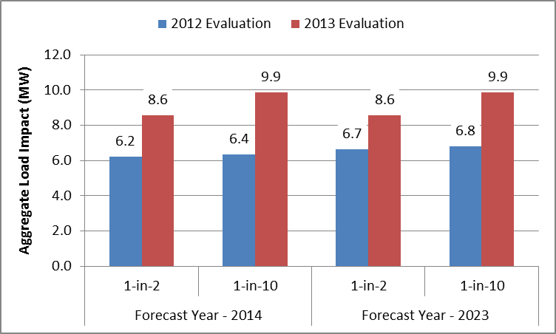

Relationship Between Ex Post and Ex Ante Estimates
Figure 5-8 provides a comparison of the ex post and ex ante estimates from the 2013 evaluation. The 2013 event in the ex post analysis is most comparable to a 1-in-2 August peak day in the ex ante analysis. In addition, considering that the ex ante estimates are summarized in the 1 to 6 PM time period, this comparison focuses on the same time period in the ex post estimates. In general, the per-customer ex post impacts are very similar to the ex ante impacts in magnitude and show similar trends by type of participant (opt-in PTR-only or dually-enrolled). By region, the impacts do not match as closely, but some differences are expected given that regional temperatures for the August 31 event day do not match exactly with temperatures for the 1-in-2 August peak day. The ex ante impacts are aggregated up from the regional level, so even if the average temperature for all participants is similar, underlying variation in regional temperatures can lead to some differences between ex post and ex ante estimates.
Figure 5-8: Comparison of Ex Post and Ex Ante Estimates of
Opt-in PTR Average Load Impact (kW) in August (1 to 6 PM)
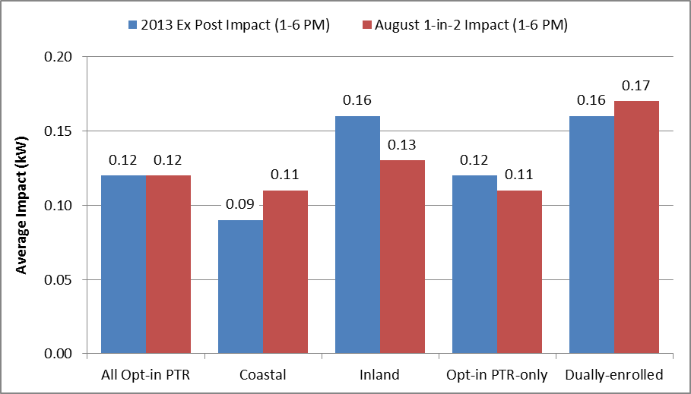

Recommendations
With only one PTR event in 2013, this evaluation was limited by a lack of empirical evidence. In the ex post analysis, the 2013 enrollees showed higher performance for the August 2013 event, but without more PTR events, it is quite uncertain if they will continue to perform well in future opt-in PTR events. With more events, the ex ante evaluation also benefits from having more data points to model what drives opt-in PTR load impacts. Therefore, Nexant recommends that SDG&E calls more PTR events in the future.

Specifically refers to average hourly demand throughout the 10 hottest days in 2013.
For a comparison of results using various research methods, including RCT/RED designs, statistical matching and within-subjects regression analysis, see the interim report on Sacramento Municipal Utility District’s Smart Pricing Options pilot: https://www.smartgrid.gov/sites/default/files/MASTER_SMUD%20CBS%20Interim%20Evaluation_Final_SUBMITTED%20TO%20TAG%2020131023.pdf

