SDG&E RESIDENTIAL CONTENT PACKAGE | MAY 2021
As a trusted community partner, we thank you in advance for sharing these digital assets with your audiences, including residents, customers and employees to help amplify our monthly messages. Here are social media posts, articles and photos you are welcome to use in email communications, websites or newsletters. There are several images with each posting. Please choose images that fit your audience and feel free to mix and match.

Follow Us
In your social media posts, feel free to tag SDG&E’s social media accounts and route your audience to SDG&E’s website at sdge.com. You can find us on Facebook, Instagram, Twitter, YouTube and LinkedIn.

This month’s topics: Customer protections, home energy survey, assistance programs, backup power generator safety and tips

Article 1: Emergency customer protections are ending
In the beginning of the COVID-19 crisis, SDG&E put emergency customer protections in place to help ease the financial burden many Southern Californians were suddenly feeling. The California Public Utilities Commission (CPUC) has extended the emergency customer protections to June 30, 2021. Normal business operations will resume on July 1, 2021.
- If you have a past due account balance, SDG&E encourages you to set up a flexible payment plan. Credit and collections activities will resume on July 1, 2021. You can set up payment arrangements online on My Account or through the SDG&E mobile app. Visit sdge.com/my-account-2021 for more information.
- From monthly discounts to one-time payment assistance, SDG&E has different programs available to help manage bills. Visit sdge.com/assistance.
- Renters impacted by the COVID-19 pandemic may qualify for rent and utility payment assistance. Call 2-1-1 to learn more.
- If you are currently a CARE or FERA customer, you may also be eligible for debt forgiveness. Visit sdge.com/AMP to find out if you qualify.
- Program recertifications and verifications for CARE, FERA and Medical Baseline will resume on July 1, 2021. SDG&E will notify you via email or mail if additional documentation is needed.
To see how SDG&E can help, visit sdge.com/covid and answer a few easy questions.

If you are an SDG&E business customer, normal credit and collection practices are scheduled to resume July 1, 2021. Avoid disconnection and set up a payment plan and rest easy knowing you’re covered. Visit sdge.com/recovery to learn more.

Article 1 translated: Las protecciones de los clientes de emergencia están terminando
En respuesta a la crisis de COVID-19, en marzo de 2020, SDG&E implementó protecciones de emergencia al cliente para ayudar a aliviar la carga financiera que muchos habitantes del Sur de California estaban sintiendo. La Comisión de Servicios Públicos de California (CPUC) ha extendido las protecciones de emergencia al cliente hasta el 30 de junio de 2021. Las operaciones comerciales normales se reanudarán el 1 de julio de 2021.
- Si tiene un saldo vencido en su cuenta con SDG&E, le recomendamos que establezca un plan de pago flexible. Actividades de crédito y cobro se reanudarán el 1 de julio de 2021. Puede configurar acuerdos de pago en línea a través de My Account y en la aplicación móvil SDG&E. Visite sdge.com/my-account-2021 para obtener más información.
- Desde descuentos mensuales hasta ayuda con pagos únicos, SDG&E tiene diferentes programas disponibles para ayudar a administrar sus facturas de energía. Visite sdge.com/asistencia para ver si califica.
- Inquilinos a quienes la pandemia COVID-19 ha afectado financieramente también pueden calificar para asistencia con la renta y pago de servicios públicos. Llame al 2-1-1 para obtener más información.
- Si actualmente es cliente de CARE o FERA, también puede ser elegible para la condonación de deudas. Visite sdge.com/AMP para averiguar si califica.
- Nuevas certificaciones y verificaciones de programas para CARE, FERA y Medical Baseline se reanudarán el 1 de julio de 2021. Le notificaremos por correo electrónico o postal si se necesita documentación adicional.

Para ver cómo podemos ayudar, visite sdge.com/covid y responda algunas preguntas fáciles.

Si usted es cliente comercial de SDG&E, las prácticas normales de crédito y cobro están programadas para reanudarse el 1 de julio de 2021. Evite la desconexión y configure un plan de pago y sea fácil saber que está cubierto. Visite sdge.com/recovery para obtener más información.

Social post: Emergency customer protections are ending
This year continues to be challenging for many people, and SDG&E wants to help. From payment plans to debt relief, there are various programs to help provide you with immediate financial assistance. Learn more at sdge.com/COVID. #sdge #EnergyTips4u
Este año sigue siendo un desafío para muchas personas, y SDG&E quiere ayudar. Desde planes de pago hasta alivio de deudas, hay varios programas para ayudarle a proporcionarle asistencia financiera inmediata. Obtenga más información en sdge.com/COVID. #sdge #EnergyTips4u
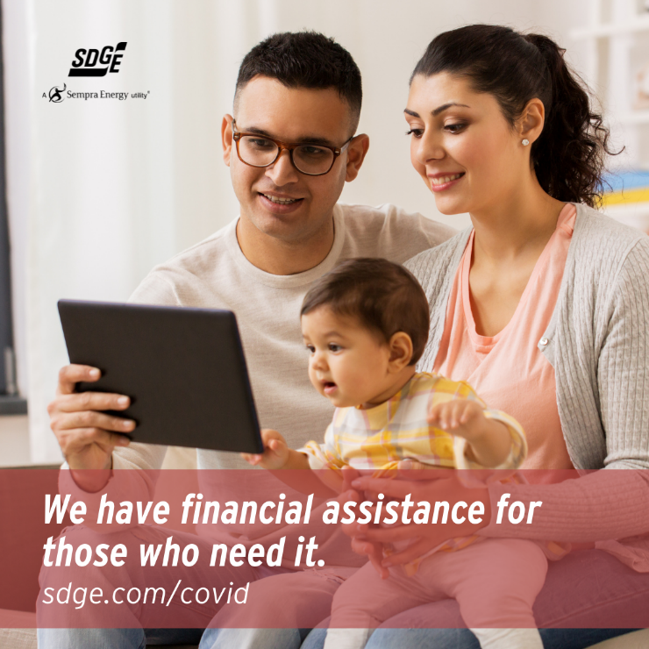

Article 2: TAKE SDG&E’S EASY HOME ENERGY SURVEY TO SAVE MONEY
Did you know a few simple changes here and there can make a difference on your monthly energy bill? If you’d like to see how you could save energy year-round, take SDG&E’s 5-minute online survey to help you identify ways energy inefficiencies in your home could be costing you money.
Taking the survey is easy. All you have to do is identify how you use energy in your home, and you’ll receive an action plan that includes programs, tips or tools that can help you save.
Step 1 – Visit MyAccount.sdge.com and log in with your Username and Password.
Step 2 – Click “Ways to Save” (upper right), select “Ways to Save” in the menu, then click on the link to “Take a home energy survey”. The survey will ask for details about your home, appliances and energy use.
Step 3 – You’ll receive an action plan with energy-saving tips that are personalized for you and your home.
Take the online survey now at sdge.com/survey.

Social posts: TAKE SDG&E’S EASY HOME ENERGY SURVEY TO SAVE MONEY
- Take SDG&E’s quick home energy survey to find ways to save energy. Take the online survey now at sdge.com/survey. #sdge #EnergyTips4u
- Discover simple ways to save energy at home. Take SDG&E’s easy home energy online survey at sdge.com/survey. #sdge #EnergyTips4u
- Find out how you can save energy and money by taking SDG&E’s home energy survey at sdge.com/survey. #sdge #EnergyTips4u

Images: TAKE SDG&E’S EASY HOME ENERGY SURVEY TO SAVE MONEY

Article 3: ASSISTANCE PROGRAMS FOR THOSE IN NEED
If you’ve recently lost your job or need financial assistance, SDG&E can help. You may qualify for savings on your monthly energy bill, even if you’ve never qualified before or are receiving unemployment benefits. Discounts are available through SDG&E’s CARE or FERA programs, based on your current household income.

Applying online is easy. No additional income verification is needed. And if you’re having trouble paying your bill, call SDG&E’s Customer Care Center at 1-800-411-7343 to set up payment arrangements or to find out if you qualify for a reduction in your outstanding balance through the Arrearage Management Payment (AMP) Plan.
Visit sdge.com/assistance to learn more. Help is here for you.

Social posts: ASSISTANCE PROGRAMS FOR THOSE IN NEED
- If you're having trouble paying your energy bill, SDG&E can help you make flexible payment arrangements. Contact SDG&E’s Customer Care Center at 1-800-411-7343 for more information. #sdge #EnergyTips4u
- If you’re behind on your SDG&E bill, you may qualify for financial assistance. Learn more at sdge.com/AMP. #sdge #EnergyTips4u
- Hardship is everywhere right now – the last thing you need is to worry about your energy bill. Get help with your bill at sdge.com/assistance. #sdge #EnergyTips4u
- SDG&E has assistance programs to help you with your monthly bill which can include up to a 30% discount. Find out if you qualify at sdge.com/assistance. #sdge #EnergyTips4u
- Whether you rent or own, you could be eligible to receive no-cost, energy-efficient home improvements that can make your home more comfortable and reduce your energy bill. Find out if you qualify at sdge.com/ESAP. #sdge #EnergyTips4u

Article 3 translated: Programas de asistencia disponibles para aquellos con necesidad
Si recientemente perdió su trabajo o necesita ayuda financiera, SDG&E puede ayudarle. Puede calificar para ahorros en su factura de energía mensual, incluso si no ha calificado antes o está recibiendo beneficios de desempleo. Hay descuentos disponibles a través de las programas CARE o FERA, según los ingresos actuales de su hogar.

Aplicar en línea es fácil. No se necesita verificación de ingresos adicionales.
Y si tiene dificultades para pagar su factura, llame a SDG&E’s Centro de atención al cliente al 1-800-311-7343 para establecer arreglos de pago o para ver si califica para una reducción en su saldo pendiente a través de nuestro plan Arrearage Management Payment (AMP). Visite sdge.com/asistencia para más información. Estamos aquí para ayudar.
Postas sociales: Programas de asistencia disponibles para aquellos con necesidad
- Si tiene problemas para pagar su facture de energía, SDG&E puede ayudarle a realizar arreglos de pago flexibles. Comuníquese con SDG&E’s Centro de Atención al Cliente al 1-800-311-7343 para obtener más información. Estamos aquí para ayudar.
- Si está atrasado en su factura de SDG&E, puede calificar para asistencia financiera. Obtenga más información en sdge.com/AMP. #sdge #EnergyTips4u
- En este momento, las dificultades se encuentran en todas partes - lo último que necesita es preocuparse por su factura de energía. Obtenga ayuda con su factura en sdge.com/asistencia. #sdge #EnergyTips4u
- SDG&E ofrece programas de asistencia para ayudarle con su factura mensual que puede incluir hasta un 30% de descuento. Descubra si califica en sdge.com/asistencia. #sdge #EnergyTips4u
- Ya sea que alquile o sea propietario, podría ser elegible para recibir mejoras de eficiencia energética en su hogar, sin costo, que pueden hacer que su hogar sea más cómodo y reducir su factura de energía. Descubra si califica en sdge.com/ESAP. #sdge #EnergyTips4u

Images: ASSISTANCE PROGRAMS FOR THOSE IN NEED

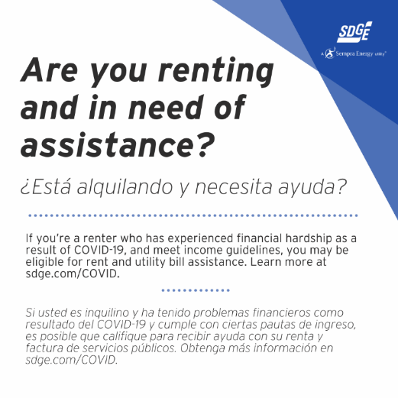
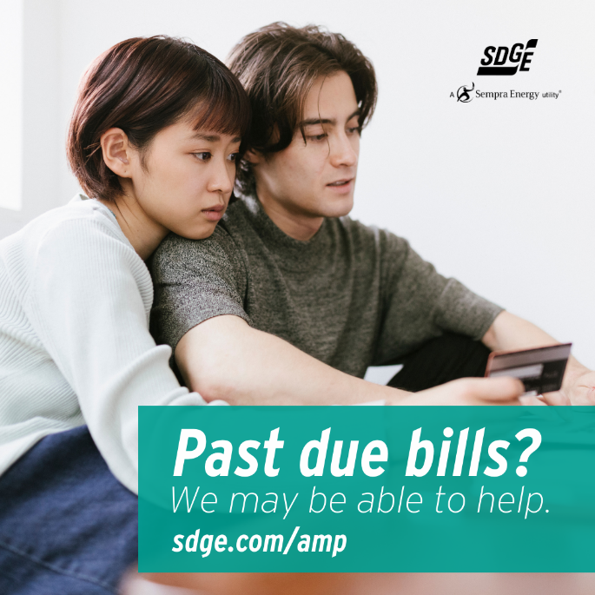

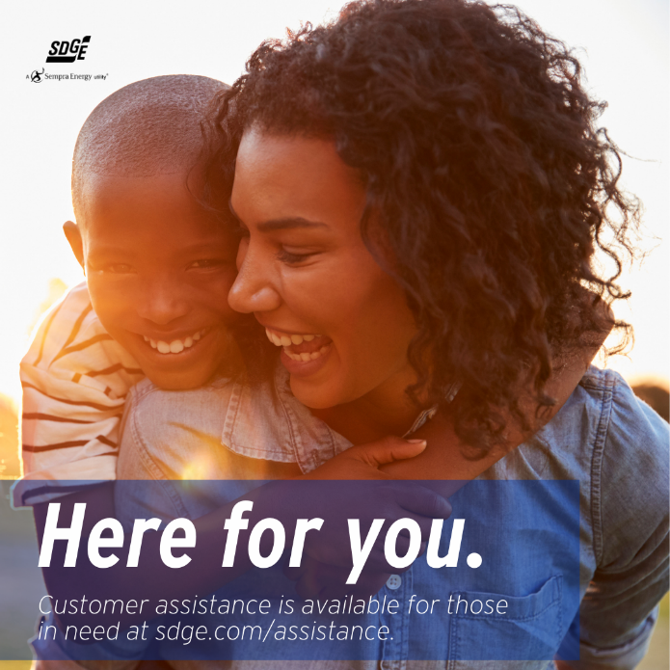

Article 4: CONSIDERING PURCHASING A BACKUP POWER SOURCE?
We all rely on electricity for everyday life. That’s why it’s important to have an emergency plan in place before a power outage occurs. As part of your plan, you may want to consider adding a backup power source like a generator or portable power station.

A backup electric generator can be valuable when the power goes out. Backup electric generators aren’t connected to SDG&E’s power grid. This means that, in the event of an outage, a backup generator can turn the lights back on, keep appliances running and power essential equipment and electronic devices.

There are two types of generators:
- Portable generators provide temporary power for basic needs. They can range in price from a few hundred dollars to more than $1,000. It is very important to determine what size generator you’ll need and how to operate it safely before running it for the first time.
- Permanent standby generators are bigger and better equipped to power larger structures, such as an entire home, if sized properly. When a power outage occurs, they turn on automatically and turn off when power is restored. These generators require professional installation from a licensed electrician.

Find out whether you need one for your home, how to shop for the right generator and how to use it properly to avoid risking you and your family’s safety. Here are a few things to think about before purchasing backup power:

Your Energy Needs — What are the critical appliances you’ll need during an outage? Are you dependent on a medical device or have special heating or cooling needs? Evaluating your energy needs is an important first step in choosing the right generator.
Fuel Preferences — Gasoline, propane, solar with backup storage? There are many factors to consider when choosing the right type of fuel including accessibility, affordability, environmental concerns and the space available for secure generator storage.
Installation Requirements — A permanent standby generator, or rechargeable home battery system should be installed by a qualified professional, such as a licensed contractor.
Always Remember – While a backup power source can be helpful during a power outage, it can also pose safety hazards when not used correctly. If using a fuel-burning generator, be sure it is positioned outside, away from your home and with proper ventilation. Carbon monoxide poisoning can be deadly.

For electric generator safety tips, visit sdge.com/generator.

Social posts: CONSIDERING PURCHASING A BACKUP POWER SOURCE?
- If you’re thinking about buying an electric power generator, there are a few things to think about. Visit sdge.com/generator for tips. #sdge #EnergyTips4u
- Are you in the market for an electric power generator? There are a few things to consider before you buy. Visit sdge.com/generator for more information. #sdge #EnergyTips4u
- Do you have an electric power generator? Get safety tips at sdge.com/generator for more information. #sdge #EnergyTips4u

Images: CONSIDERING PURCHASING A BACKUP POWER SOURCE?

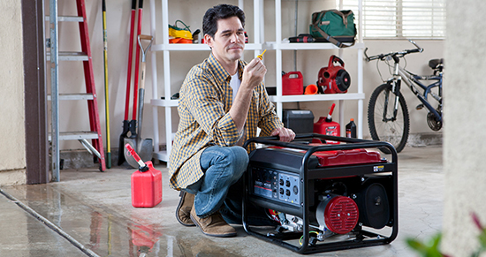

Portable generator:
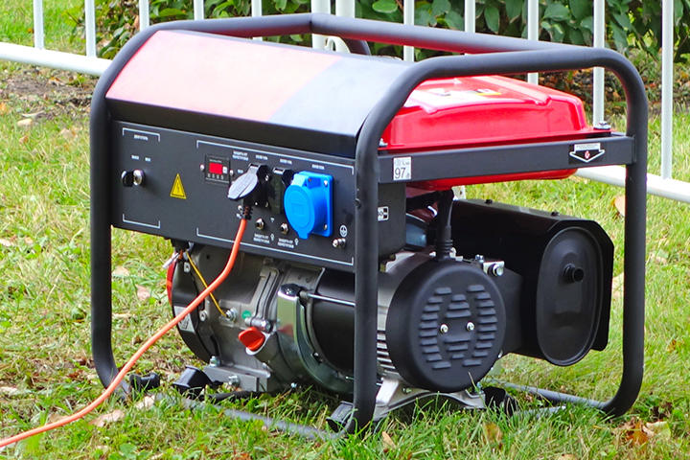

Permanent standby generator: