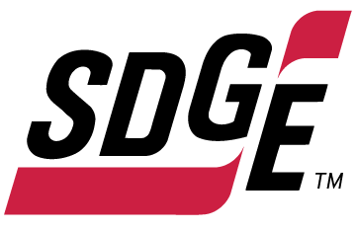

SDG&E RESIDENTIAL CONTENT PACKAGE | AUGUST 2021
As a trusted community partner, we thank you in advance for sharing these digital assets with your audiences, including residents, customers and employees to help amplify our monthly messages. Here are social media posts, articles and photos you are welcome to use in email communications, websites or newsletters. There are several images with each posting. Please choose images that fit your audience and feel free to mix and match.

Follow Us
You can find us on Facebook, Instagram, Twitter, YouTube and LinkedIn. When sharing these messages in your social posts, feel free to tag SDG&E’s social media accounts and direct your audience to sdge.com.

This month’s topics: Summer energy-saving tips, customer assistance programs, wildfire safety tips, DigAlert safety

Article 1: Stay Cool & Save On Energy During Heat Waves (some copy from NewsCenter article)
It’s officially summer – gather your sunscreen, floaties and iced lemonade! Looking for ways to stay cool as a cucumber when the temperatures rise? SDG&E has tips to help keep cool while also saving energy.
Tips to stay cool in high temps
- Escape mid-day summer heat. Visit one of nine Cool Zones open to the public. Find the nearest location at sdge.com/CoolZones. COVID-19 safety measures will be in place.
- Take the heat out of the kitchen. Ovens can raise room temperatures by 10 degrees. Choose no-cook recipes that don’t require the oven like healthy salads, yogurt parfaits and wraps. Plant a vegetable garden for more options or grill outside.
- Use a ceiling or portable fan instead of an air conditioner, when possible.
- Run the A/C early in the morning to cool your home before temperatures rise in the peak hours from 4 p.m. to 9 p.m.
- Close blinds, shades or heat-resistant curtains to block the sun’s heat.
- Block the heat and hot air. Weatherstrip and caulk drafty doors and windows to keep the cold air in and hot air out.
- Open windows at night and early mornings to let the cooler air in.
Tips to save energy and lower your bill
- Run large appliances, such as washers and dryers, before 4 p.m. or after 9 p.m. Energy demand peaks during those hours and so does the cost of electricity.
- Switch off electronic devices such as computers and gaming consoles when not in use. Electronics in standby mode still draw power. Use a power strip to power down devices and appliances at one time.
- Compare your SDG&E pricing plan to other plans. Being on the right energy plan can add up to real savings on energy bills. Visit sdge.com/pricing to review all energy plan options.
- Sign up for Flex Alerts. As temperatures rise and the power grid is strained, the California Independent System Operator may call on Californians to conserve energy and avoid power outages. Visit flexalert.org to learn more.
- Flex alerts are voluntary calls for Californians to conserve electricity when the power grid is strained. Sign up at flexalert.org.
Visit sdge.com/summer for more helpful energy-saving tips.
Social posts: Stay Cool & Save On Energy During Heat Waves
- Instead of the oven, use small appliances like a microwave, toaster oven or instant pot. They use less energy than an oven and won’t add as much heat to your home. Visit sdge.com/summer for more ways to stay cool and save energy. #sdge #SDGEAssist
- Keep your fridge full because it works more efficiently than an empty one. Consider storing bottled water to keep your fridge full. Visit sdge.com/summer for more ways to stay cool and save energy. #sdge #SDGEAssist
- Escape mid-day summer heat. Visit one of nine Cool Zones open to the public. Find the nearest location at sdge.com/CoolZones. Visit sdge.com/summer for more ways to stay cool and save energy. #sdge #SDGEAssist
- Fire up the grill. Take the heat out of the kitchen by cooking outdoors. It’s also a good excuse to get your family or friends outside in the fresh air and away from electronics. Visit sdge.com/summer for more ways to stay cool and save energy. #sdge #SDGEAssist
- Run the A/C early in the morning to cool your home before temperatures rise in the peak hours from 4 p.m. to 9 p.m. Weatherstrip and caulk drafty doors and windows to help keep the cold air in. Visit sdge.com/summer for more ways to stay cool and save energy. #sdge #SDGEAssist

Article 1 translated: Manténgase fresco y ahorre energía durante las olas de calor
¡Llego el verano – agarre su protector solar, flotadores y limonada helada! ¿Está buscando maneras de mantenerse fresco cuando las temperaturas suban? SDG&E tiene consejos para ayudarle a mantenerse fresco y ahorrar energía al mismo tiempo.
Consejos para mantenerse fresco en altas temperaturas
- Escape del calor del mediodía. Visite una de las nueve zonas frescas abiertas al público. Encuentre la ubicación más cercana en sdge.com/Cool-Zone. Se aplicarán medidas de seguridad contra COVID-19.
- Saque el calor de la cocina. Los hornos pueden elevar la temperatura ambiente por 10 grados. Elija recetas que no requieran el horno, como ensaladas, parfaits de yogur y wraps. Plante un huerto para tener más opciones o ase al aire libre.
- Use un ventilador de techo o portátil en lugar de un aire acondicionado, cuando sea posible.
- Encienda el aire acondicionado temprano en la mañana para enfriar su hogar antes de que las temperaturas suban en las horas pico de 4 p.m. a 9 p.m.
- Cierre las persianas, las cortinas o las cortinas resistentes al calor para bloquear el calor del sol.
- Bloquee el calor y el aire caliente. Coloque burletes y selle las puertas y ventanas con corrientes de aire para ayudar a mantener el aire frío adentro y el aire caliente afuera.
- Abra las ventanas por la noche y temprano en la mañana para dejar entrar el aire fresco.
Postas sociales: Consejos para ahorrar energía y reducir su factura
- Use aparatos grandes, como lavadoras y secadoras, antes de las 4 p.m. o después de las 9 p.m. La demanda de energía alcanza su punto máximo durante esas horas y también el costo de la electricidad.
- Apague los dispositivos electrónicos como computadoras y consolas de juego cuando no estén en uso. La electrónica en modo de espera aún consume energía. Use una regleta de enchufe para apagar los dispositivos y electrodomésticos al mismo tiempo.
- Compare su plan tarifario de SDG&E con otros planes. Estar en el plan de energía adecuado puede sumar ahorros reales en sus facturas de energía. Visite sdge.com/pricing para ver todas las opciones de planes de energía.
- Regístrese para recibir Flex Alerts. A medida que las temperaturas aumentan y la red eléctrica se sobrecarga, el Operador Independiente del Sistema de California puede pedir a los californianos que conserven energía para evitar cortes de energía. Visite flexalert.org para inscribirse en #FlexAlerts y para obtener más información.
Visite sdge.com/summer para obtener más consejos para ahorrar energía.
Social posts: Manténgase fresco y ahorre energía durante las olas de calor
- En lugar del horno, use pequeños aparatos como un microondas, un horno tostador o una olla instantánea. Usan menos energía que el horno y no agregarán tanto calor a su hogar. Visite sdge.com/summer para conocer más formas de mantenerse fresco y ahorrar energía. #sdge #SDGEAssist
- Mantener su refrigerador lleno hace que funcione de manera más eficiente que uno vacío. Considere almacenar agua embotellada para mantener su refrigerador lleno. Visite sdge.com/summer para conocer más formas de mantenerse fresco y ahorrar energía. #sdge #SDGEAssist
- Escape del calor del mediodía. Visite una de las nueve zonas frescas abiertas al público. Encuentre la ubicación más cercana en sdge.com/CoolZones. Visite sdge.com/summer para conocer más formas de mantenerse fresco y ahorrar energía. #sdge #SDGEAssist
- Encienda la parrilla. Saque el calor de la cocina cocinando al aire libre. También es una buena excusa para pasar tiempo afuera con la familia y lejos de la electrónica. Visite sdge.com/summer para conocer más formas de mantenerse fresco y ahorrar energía. #sdge #SDGEAssist
- Encienda el aire acondicionado temprano en la mañana para enfriar su hogar antes de que las temperaturas suban en las horas pico de 4 p.m. a 9 p.m. Coloque burletes y selle las puertas y ventanas con corrientes de aire para ayudar a mantener el aire frío adentro. Visite sdge.com/summer para conocer más formas de mantenerse fresco y ahorrar energía. #sdge #SDGEAssist

Images: Stay Cool & Save On Energy During Heat Waves





Article 2: NEED HELP WITH YOUR SDG&E BILL?
You may qualify for a bill discount or home improvements. SDG&E’s assistance programs help lower your monthly energy bill while keeping your home comfortable.
California Alternate Rates for Energy (CARE) Program: Save 30% or more every month on your energy bill. Find out if you qualify at sdge.com/CARE.
Family Electric Rate Assistance (FERA) Program: If you don’t qualify for CARE and your household has 3 or more people, you may qualify for FERA. You could receive an 18% discount on your electric bill. Visit sdge.com/FERA for more information.
Energy Savings Assistance (ESA) Program: You may qualify to receive no-cost, energy-saving improvements for your home, such as new appliances, furnace repair, lighting, insulation and more. Find details at sdge.com/ESAP.
If you’re behind on your SDG&E bill, you may qualify for financial assistance. Learn more at sdge.com/AMP.
Online applications are easy, fast and convenient. To learn more about SDG&E’s assistance programs, visit sdge.com/assistance.
Social posts: NEED HELP WITH YOUR SDG&E BILL?
- If you’re behind on your SDG&E bill, you may qualify for financial assistance. Learn more at sdge.com/AMP. #sdge #SDGEAssist
- Hardship is everywhere right now – the last thing you need is to worry about your energy bill. Get help with your bill at sdge.com/assistance. #sdge #SDGEAssist
- SDG&E provides assistance programs to help you with your monthly bill which can include up to a 30% discount. Find out if you qualify at sdge.com/assistance. #sdge #SDGEAssist
- Whether you rent or own, you could be eligible to receive no-cost, energy-efficient home improvements that can make your home more comfortable and reduce your energy bill. Find out if you qualify at sdge.com/ESAP. #sdge #SDGEAssist

Article 2 translated: ¿Necesita ayuda con su FACTURA de energía?
Usted puede calificar para un descuento en su factura o mejoras en el hogar. Los programas de asistencia de SDG&E ayudan a reducir su factura mensual de energía mientras mantiene su hogar cómodo.
Programa de Tarifas Alternativas de Energía de California (CARE, por sus siglas en inglés): Ahorre un 30% o más cada mes en su factura. Averigüe si califica en sdge.com/CARE.
Programa de Asistencia de Tarifa Eléctrica Familiar (FERA, por sus siglas en inglés): Si no califica para el programa de CARE y su hogar tiene 3 o más personas, puede calificar para FERA. Podría recibir un 18% de descuento en su factura de electricidad. Visite sdge.com/FERA para obtener más información.
Programa de Asistencia para el Ahorro de Energía (ESA, por sus siglas en inglés): Puede calificar para recibir mejoras gratuitas para el ahorro de energía en su hogar, tales como electrodomésticos nuevos, reparación de hornos, iluminación, aislamiento y más. Encuentre los detalles en sdge.com/ESAP.
Las aplicaciones en línea son fáciles, rápidas y convenientes. Para obtener más información, visite sdge.com/asistencia.
Postas sociales: ¿Necesita ayuda con su FACTURA de energía?
- Si está atrasado en su factura de SDG&E, puede calificar para asistencia financiera. Obtenga más información en sdge.com/asistencia. #sdge #SDGEAssist
- En este momento, las dificultades se encuentran en todas partes - lo último que necesita es preocuparse por su factura de energía. Obtenga ayuda con su factura en sdge.com/asistencia. #sdge #SDGEAssist
- SDG&E ofrece programas de asistencia para ayudarle con su factura mensual que puede incluir hasta un 30% de descuento. Descubra si califica en sdge.com/asistencia. #sdge #SDGEAssist
- Ya sea que alquile o sea propietario, podría ser elegible para recibir mejoras de eficiencia energética en su hogar, sin costo, que pueden hacer que su hogar sea más cómodo y reducir su factura de energía. Descubra si califica en sdge.com/ESAP. #sdge #SDGEAssist

Images: NEED HELP WITH YOUR SDG&E BILL?


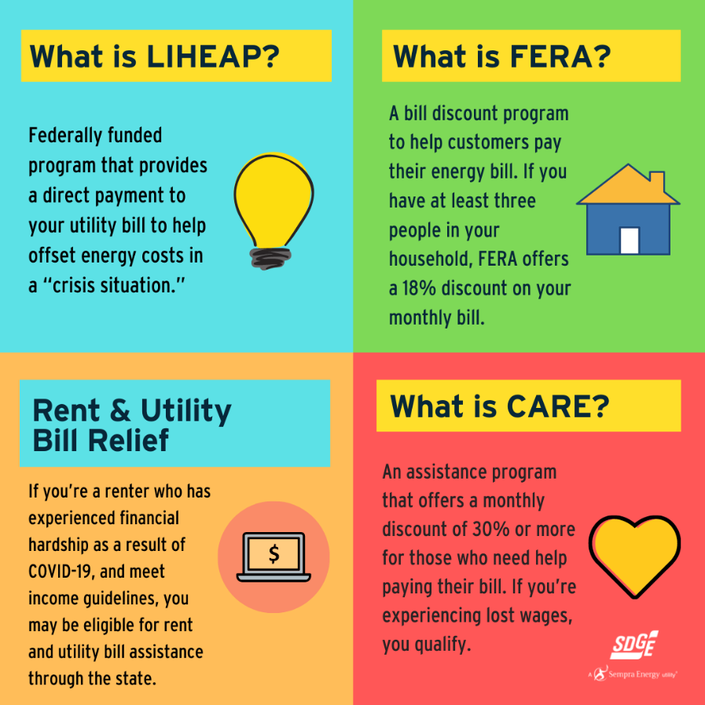
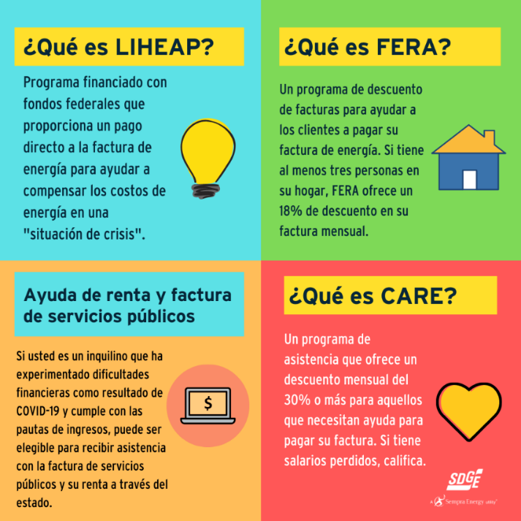

Article 3: reduce the risk of wildfire
Did you know you can reduce wildfire risk by creating zones for the plants and trees around your home? It’s a great way to minimize your home’s exposure to risk because you’re modifying the vegetation space around it that may be able to help resist a wildfire.
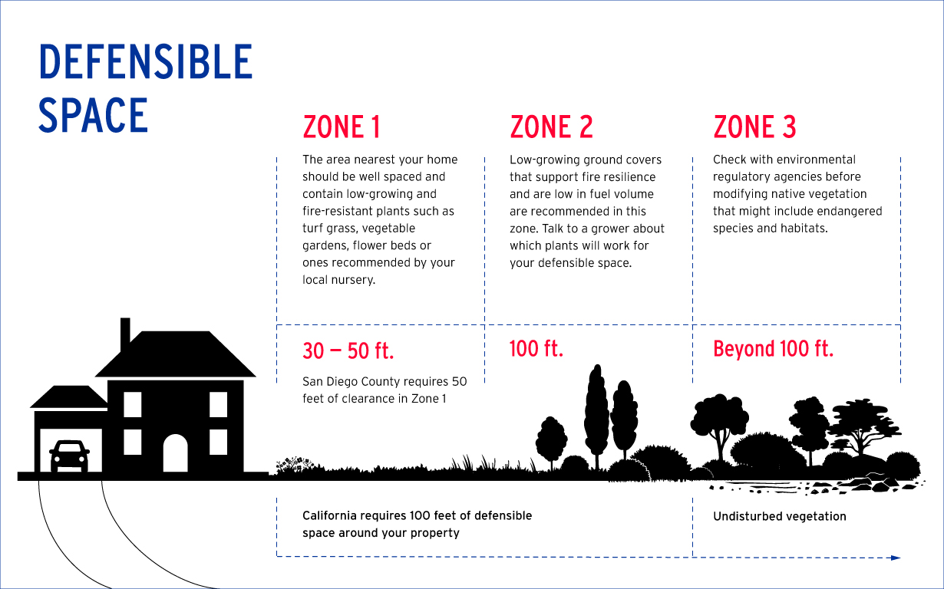
Stay safe. Take action.
Think smart and don’t leave your safety to chance. Follow these steps to prepare now for an emergency later.
- Develop an emergency plan. Identify a place to meet with family, safe routes and shelters, as well as what actions you will take. Discuss and practice the plan with your family, including your children and pets.
- Prepare an emergency kit. Keep essentials on hand. Stock your kit with items you and your family need, including those with a disability, seniors and your pets. Store supplies in easy-to-carry containers such as backpacks or plastic crates. Visit sdge.com/checklists to learn more.
- Help your neighbors. Being a good neighbor takes more than sharing the occasional cup of sugar or hosting a potluck. It’s important to help our neighbors during emergencies, especially those who are vulnerable, elderly or disabled.
Update your SDG&E contact information
Whatever the circumstances, SDG&E will make every effort to communicate with you during emergencies. Go to sdge.com/myaccount to sign in. From the My Account homepage, click on your profile name in the top right-hand corner, then select “My Profile”.
Sign-up for outage notifications
Get notified when there is an outage in your area. Sign into sdge.com/myaccount. From the My Account Home Page, click on your profile name in the top right-hand corner, then select “Notification Settings”.

Social posts: reduce the risk of wildfire
- Be prepared for emergencies like wildfires. Have a checklist and stock up on staples. Learn more at sdge.com/checklists. #sdge #SDGEAssist
- Are you and your family and pets ready in case of an emergency? Visit sdge.com/checklists to learn which items you should have on hand in a pinch. #sdge #SDGEAssist
- Stay safe this wildfire season by updating your contact info. Visit sdge.com/myaccount. #sdge #SDGEAssist
- Help your neighbors during emergencies, especially those who are vulnerable or elderly. Find safety tips at sdge.com/Wildfire-Safety. #sdge #SDGEAssist
- Think smart and don’t leave your safety to chance. Visit sdge.com/Wildfire-Safety for steps to prepare now for an emergency later. #sdge #SDGEAssist
- Does SDG&E have your current contact information in case of a Public Safety Power Shutoff? Visit sdge.com/PSPS for details. #sdge #SDGEAssist
Images: reduce the risk of wildfire

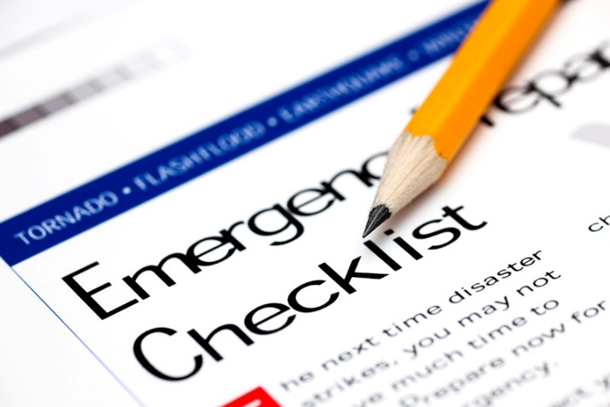
Article 4: Contact DigAlert before your shovel hits the ground
Gas pipelines may be located anywhere, including under streets and sidewalks. You most likely have utility-owned pipelines underground on your property, possibly just inches below the surface.
Excavation, demolition and other forms of digging are a major cause of pipeline damage. It's important to know where they are before you begin any type of digging.
Whether you're planning to build a major development or landscaping your yard, take these steps to protect your safety and the safety of those around you:
- Mark out the proposed excavation with white paint or flags.
- Contact DigAlert at 811 or digalert.org at least two working days before you dig (not including the day of notification). DigAlert will arrange for buried utility-owned lines to be located and marked. This service is free.
- Make sure any contractor you hire contacts DigAlert to have utility-owned lines marked before any digging takes place.
Please be aware that SDG&E does not mark customer-owned gas lines. These typically run from the meter to your gas equipment and/or appliances. You will need to call a qualified professional to mark and maintain your gas lines.
Visit sdge.com/safety for more safety tips.
Social posts: Contact DigAlert before your shovel hits the ground
- Contact DigAlert at 811 or digalert.org at least two working days before you dig (not including the day of notification). DigAlert will arrange for buried utility-owned lines to be located and marked. This service is free. #sdge #SDGEAssist
- Buried utilities can exist just about anywhere on your property so check with DigAlert at least two working days before digging. It’s a free and required. Learn more at digalert.org. #sdge #SDGEAssist
- When should you contact DigAlert? Any time you are digging on your property. Get details at digalert.org. #sdge #SDGEAssist

Images: Contact DigAlert before your shovel hits the ground



