SDG&E RESIDENTIAL CONTENT PACKAGE | JANUARY 2021
Here are social posts, articles and photos you are welcome to use in email communications, websites or newsletters. Thank you for sharing this with your residents, customers & employees. There are several images with each posting. Please choose images that fit your audience and feel free to mix and match.

This month’s topics: Winter energy-saving tips, winter safety tips at home, assistance programs

Article 1: 6 WAYS TO SAVE ENERGY AT HOME THIS WINTER
Lower temperatures and spending more time at home may increase your energy costs. Here are some no-cost and low-cost ideas to help you save energy and money while staying comfortable during the colder winter months.
- Take advantage of heat from the sun: Open curtains on your south-facing windows during the day to allow sunlight to naturally heat your home. Close the curtains at night to reduce the chill you may feel from cold windows.
- Cover drafty windows: Use a heavy-duty, clear plastic sheet on a frame or tape clear plastic film to the inside of your window frames during the cold winter months. Make sure the plastic is sealed tightly to the frame to help reduce infiltration. Install tight-fitting, insulating drapes or shades on windows that feel drafty. Find out about other window treatments and coverings that can improve energy efficiency here.
- Adjust the temperature: When you are asleep or not home, turn your thermostat back 7 to 10 degrees for eight hours and save around 10% a year on your heating bills. A smart or programmable thermostat can make it easy to set back your temperature. If you have a heat pump, maintain a moderate setting or use a programmable thermostat specially designed for use with heat pumps.
- Find and seal leaks: Seal the air leaks around utility cut-throughs for pipes ("plumbing penetrations"), gaps around chimneys and recessed lights in insulated ceilings, and unfinished spaces behind cupboards and closets. Find out how to here. Add caulk or weather-stripping to seal air leaks around leaky doors and windows
- Maintain your heating systems: Schedule service for your heating system. Replace your filter once a month or as needed. Find out how to efficiently maintain furnaces or boilers and heat pumps at energy.gov. Wood or pellet burning appliances are cleaner burning and more efficient. Clean the flue vent regularly and the inside of the appliance with a wire brush periodically to ensure that your home is heated efficiently. Energy.gov also has other maintenance recommendations for wood-and pellet-burning appliances.
- Reduce heat loss from the fireplace: Keep your fireplace damper closed unless a fire is burning. Keeping the damper open is like keeping a window wide open during the winter; it allows warm air to go right up the chimney. When you use the fireplace, reduce heat loss by opening dampers in the bottom of the firebox (if provided) or open the nearest window slightly – around 1 inch – and close doors leading into the room. Find more techniques to improve your fireplace or wood-burning appliance's efficiency and which wood to burn at epa.gov/burnwise.
For more tips on how to save energy this winter, visit sdge.com/winter.

Social posts: 6 WAYS TO SAVE ENERGY AT HOME THIS WINTER
- Keep your fireplace damper closed unless a fire is burning. Keeping the damper open is like keeping a window wide open during the winter; it allows warm air to go right up the chimney. For more winter energy-savings tips sdge.com/winter. #energytips4u #sdge
- When you are asleep or not home, turn your thermostat back 7 to 10 degrees for eight hours and save around 10% a year on your heating and cooling bills. #energytips4u #sdge
- Open curtains on your south-facing windows during the day to allow sunlight to naturally heat your home. For more winter energy-savings tips visit sdge.com/winter. #energytips4u #sdge

Images: 6 WAYS TO SAVE ENERGY AT HOME THIS WINTER

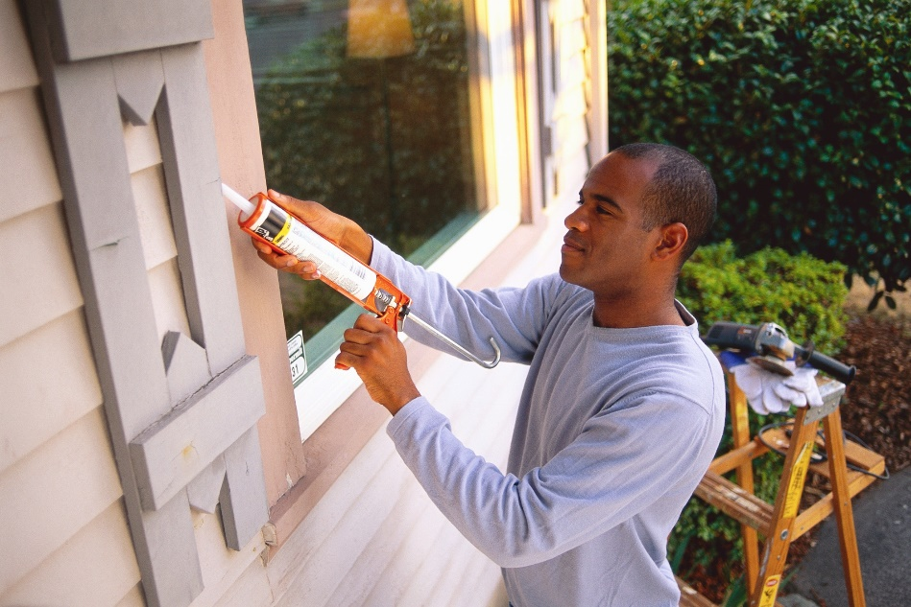

Article 2: WINTER SAFETY TIPS FOR YOUR HOME
Safety should come first every season. Your home depends on electricity, which provides you with power for cooking, hot water, lighting and more. But did you know every year about 51,000 home electric fires occur resulting in nearly 500 deaths? Here are some helpful safety tips for your home.
- Carbon monoxide safety: Keep your family safe from this odorless, colorless gas.
  - Install a battery-operated carbon monoxide detector.
  - Never use your oven to heat your home.
  - Always operate portable generators outdoors.
- Appliance safety tips: Give your appliances the attention they need this winter.
  - Remember to clean or replace your furnace filter.
  - Have a fireplace? Start winter with a clean chimney flue.
  - Clean out dryer lint to lower the chance of a fire.
- Power off: Power down when you’re not around.
  - Turn off lights, computers, TVs and other electronic devices when not in use to reduce risk of fire.
  - Use a smart power strip to make powering off easy.
  - Keep electrical cords away from heat sources and foot traffic and don’t place them under rugs where damage can go unnoticed.
For more tips on using energy safely, visit sdge.com/safety.

Social posts: WINTER SAFETY TIPS FOR YOUR HOME
- Home safety tip #1: Extension cords under carpets can overheat. Keep them away from rugs and avoid running them over furniture or door thresholds. Get more safety tips at sdge.com/safety. #sdge #energytips4u
- Home safety tip #2: Keep electric heaters a safe distance from furniture, blankets, curtains and other objects that could catch fire. Get more safety tips at sdge.com/safety. #sdge #energytips4u
- Home safety tip #3: Major appliances like washers, dryers, refrigerators and water heaters should be plugged directly into the outlet. Don’t use surge protectors, plug strips or extension cords. Get more safety tips at sdge.com/safety. #sdge #energytips4u
- Home safety tip #4: Give your home an electrical checkup: circuits, breakers, switches and outlets. Get more safety tips at sdge.com/safety. #sdge #energytips4u

Images: WINTER SAFETY TIPS FOR YOUR HOME

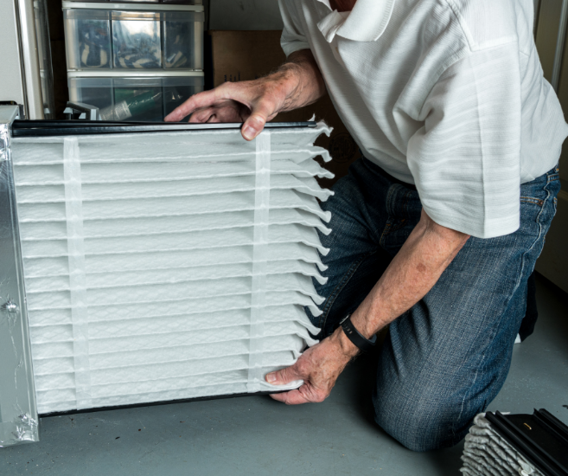
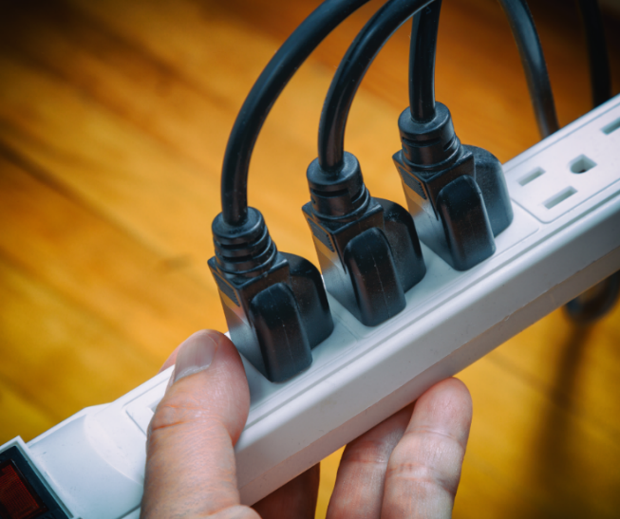

Article 3: DO YOU NEED HELP WITH YOUR ENERGY BILL?
With the coronavirus pandemic causing financial hardships for many individuals and families, you may benefit from one of SDG&E’s assistance programs. You can apply online for these bill discount programs. Many people who previously couldn’t take advantage of these income-based programs may now qualify due to lost wages – even if they’re receiving unemployment benefits. These programs include:

California Alternate Rates for Energy (CARE) Program: Save 30% or more every month on your bill. Find out if you qualify at sdge.com/CARE.

Family Electric Rate Assistance (FERA) Program: If you don’t qualify for CARE and your household has 3 or more people, you may qualify for FERA. You could receive an 18% discount on your electric use. Visit sdge.com/FERA to learn more.

Energy Savings Assistance (ESA) Program: You may qualify to receive free energy-saving improvements for your home, such as new appliances like refrigerators, furnace repair, lighting, insulation and more. Find details at sdge.com/ESAP.

Medical Baseline Allowance Program: If you need to use more energy to operate medical devices due to a qualifying medical condition, you may qualify for a discount on your SDG&E bill. Get more information at sdge.com/medical.

Online applications are easy, fast and convenient. To learn more, visit sdge.com/assistance.

Social posts: DO YOU NEED HELP WITH YOUR ENERGY BILL?
- Hardship is everywhere right now – the last thing you need is to worry about your energy bill. Get help with your bill at sdge.com/assistance. #sdge #energytips4u
- Save 30% or more every month on your energy bill. Find out if you qualify at sdge.com/CARE. #sdge #energytips4u
- If your household has 3 or more people, you may qualify for FERA – an 18% discount on your electric use. Visit sdge.com/FERA to learn more. #sdge #energytips4u
- If you need to use more energy to operate medical devices due to a qualifying medical condition, you may qualify for a discount on your SDG&E bill. Get more information at sdge.com/medical. #sdge #energytips4u
- You may qualify to receive free energy-saving improvements for your home, such as new appliances like refrigerators, furnace repair, lighting, insulation and more. Find details at sdge.com/ESAP. #sdge #energytips4u

Translated article 3: ¿Necesita ayuda con su FACTURA de energía?
Usted puede calificar para un descuento en su factura o mejoras en el hogar. Los programas de asistencia de SDG&E ayudan a reducir su recibo mensual de energía mientras mantiene su hogar cómodo.

Programa de Tarifas Alternativas de Energía de California (CARE, por sus siglas en inglés): Ahorre un 30% o más cada mes en su factura. Averigüe si califica en sdge.com/asistencia.

Programa de Asistencia de Tarifa Eléctrica Familiar (FERA, por sus siglas en inglés): Si no califica para CARE y su hogar tiene 3 o más personas, puede calificar para FERA. Podría recibir un 18% de descuento en su recibo de electricidad. Visite sdge.com/asistencia para obtener más información.

Programa de Asistencia para el Ahorro de Energía (ESA,por sus siglas en inglés): Puede calificar para recibir mejoras gratuitas para el ahorro de energía en su hogar, tales como electrodomésticos nuevos como refrigeradores, reparación de hornos, iluminación, aislamiento y más. Por mas información, visite sdge.com/asistencia.

Programma de Asignación Médica Inicia: Si necesita usar más energía debido a una condición médica calificada, puede calificar para un descuento en su factura de SDG&E. Obtenga más información en sdge.com/asistencia.

Las aplicaciones en línea son fáciles, rápidas y convenientes. Para obtener más información, visite sdge.com/asistencia.

Postas sociales: ¿Necesita ayuda con su recibo de energía?
- Averigüe si su familia califica para electrodomésticos gratuitos para ahorrar energía, iluminación, protección contra la intemperie y más en sdge.com/asistencia. #sdge #energytips4u
- El 30% de descuento en su factura de energía puede ayudarlo bastante. Solicite nuestro programa de alivio de facturas para una oportunidad que le podría ahorrar un 30% o más en sus facturas mensuales de energía. Averigüe si califica en sdge.com/asistencia. #sdge #energytips4u
- Con el programa de Asistencia de Tarifa Eléctrica Familiar (FERA), puede recibir un descuento del 18% en su factura de electricidad. FERA solo está abierto a hogares con tres o más personas. Averigüe si califica en sdge.com/asistencia #sdge #energytips4u

Images: DO YOU NEED HELP WITH YOUR ENERGY BILL?

