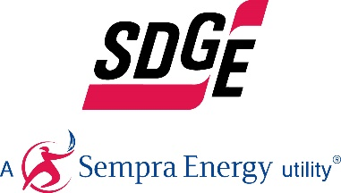

SDG&E RESIDENTIAL CONTENT PACKAGE | OCTOBER 5, 2020
Here are social posts, articles and photos you are welcome to use in email communications, websites or newsletters. Thank you for sharing this with your residents, customers & employees. There are several images with each posting. Please choose images that fit your audience and feel free to mix and match.

This month’s topics: Customer assistance programs, wildfire preparedness and safety, energy-savings tips, public safety power shutoffs

Article 1: DO YOU NEED HELP WITH YOUR ENERGY BILL?
With the coronavirus pandemic causing financial hardships for many individuals and families, you may benefit from one of SDG&E’s assistance programs. You can apply online for these bill discount programs. Many people who previously couldn’t take advantage of these income-based programs may now qualify due to lost wages – even if they’re receiving unemployment benefits. These programs include:

California Alternate Rates for Energy (CARE) Program: Save 30% or more every month on your bill. Find out if you qualify at sdge.com/CARE.

Family Electric Rate Assistance (FERA) Program: If you don’t qualify for CARE and your household has 3 or more people, you may qualify for FERA. You could receive an18% discount on your electric use. Visit sdge.com/FERA to learn more.

Energy Savings Assistance (ESA) Program: You may qualify to receive free energy-saving improvements for your home, such as new appliances like refrigerators, furnace repair, lighting, insulation and more. Find details at sdge.com/ESAP.

Medical Baseline Allowance Program: If you need to use more energy to operate medical devices due to a qualifying medical condition, you may qualify for a discount on your SDG&E bill. Get more information at sdge.com/medical.

Online applications are easy, fast and convenient. To learn more, visit sdge.com/assistance.

Social posts: DO YOU NEED HELP WITH YOUR ENERGY BILL?
- Save 30% or more every month on your energy bill. Find out if you qualify at sdge.com/CARE. #sdge #energytips4u
- If your household has 3 or more people, you may qualify for FERA – an 18% discount on your electric use. Visit sdge.com/FERA to learn more. #sdge #energytips4u
- If you need to use more energy to operate medical devices due to a qualifying medical condition, you may qualify for a discount on your SDG&E bill. Get more information at sdge.com/medical. #sdge #energytips4u
- You may qualify to receive free energy-saving improvements for your home, such as new appliances like refrigerators, furnace repair, lighting, insulation and more. Find details at sdge.com/ESAP. #sdge #energytips4u

Translated article 1: ¿Necesita ayuda con su recibo de energía?
Usted puede calificar para un descuento en su recibo o mejoras en el hogar. Los programas de asistencia de SDG&E ayudan a reducir su recibo mensual de energía mientras mantiene su hogar cómodo.

Programa de Tarifas Alternativas de Energía de California (CARE, por sus siglas en inglés): Ahorre un 30% o más cada mes en su recibo. Averigüe si califica en sdge.com/asistencia.

Programa de Asistencia de Tarifa Eléctrica Familiar (FERA, por sus siglas en inglés): Si no califica para CARE y su hogar tiene 3 o más personas, puede calificar para FERA. Podría recibir un 18% de descuento en su recibo de energía. Visite sdge.com/asistencia para obtener más información.

Programa de Asistencia para el Ahorro de Energía (ESA,por sus siglas en inglés): Puede calificar para recibir mejoras gratuitas para el ahorro de energía en su hogar, tales como electrodomésticos nuevos como refrigeradores, reparación de hornos, iluminación, aislamiento y más. Encuentre los detalles en sdge.com/asistencia.

Programma de Asignación Médica Inicia: Si necesita usar más energía debido a una condición médica calificada, puede calificar para un descuento en su factura de SDG&E. Obtenga más información en sdge.com/asistencia.

Las aplicaciones en línea son fáciles, rápidas y convenientes. Para obtener más información, visite sdge.com/asistencia.

Postas sociales article 1: ¿Necesita ayuda con su recibo de energía?
- Averigüe si su familia califica para electrodomésticos gratuitos para ahorrar energía, iluminación, protección contra la intemperie y más en sdge.com/asistencia. #sdge #energytips4u
- El 30% de descuento en su factura de energía puede ayudarlo bastante. Solicite nuestro programa de alivio de facturas para una oportunidad que le podría ahorrar un 30% o más en sus facturas mensuales de energía. Averigüe si califica en sdge.com/asistencia. #sdge #energytips4u
- Con el programa de Asistencia de Tarifa Eléctrica Familiar (FERA), puede recibir un descuento del 18% en su factura de energía. FERA solo está abierto a hogares con tres o más personas. Averigüe si califica en sdge.com/asistencia #sdge #energytips4u

Images: DO YOU NEED HELP WITH YOUR ENERGY BILL?

Article 2: TIPS TO KEEP COOL AND STAY SAFE DURING HEAT WAVES
With elevated fire conditions and increasing temperatures, please keep safety top of mind when trying to beat the heat. Here are some tips to help you keep cool and conserve energy:
- Use a ceiling or portable fan instead of your air conditioner, health permitting.
- During the hot hours of the day, cover windows to block the sun’s heat. Opening windows in the evening can help your home cool back down.
- Keep track of your energy use and costs with email or text alerts. Visit sdge.com/myaccount to stay on top of your bill, energy use and more by clicking on "alerts and subscriptions."
- Download SDG&E's mobile app for an easier way to track your energy use. Download on the App Store or Google Play.
- Run major appliances, such as your washers and dryers, early in the morning or late at night to avoid peak energy use timeframes.
- Find your nearest “Cool Zone” at sdge.com/coolzones.
- Turn down your water heater by a few degrees. Many water heaters are set higher than the temperature we actually use. Reducing this by a few degrees can reduce your energy costs.
- Use air conditioners safely. Avoid plugging air conditioners into extension cords or power strips. Always keep the area around your air conditioning unit clear of anything that could easily catch fire.
Along with the extreme heat, our region is experiencing elevated fire danger – especially in the backcountry. Everyone is urged to avoid these situations that could spark fires (source – National Fire Protection Association):
- Clear dead leaves and other flammable debris from gutters, eaves, porches and decks. This helps prevent embers from igniting your home.
- Wind-borne embers can get into homes easily through vents, like exterior attic vents and other openings, and burn the home from the inside out. Walk around your house to see what openings you can cover with metal wire mesh no larger than 1/8 inch, or temporarily seal openings.
- Remove flammable materials like firewood stacks, propane tanks and vehicles (anything that can act as a large fuel source) within 30 feet of your home’s foundation and outbuildings, including garages and sheds. If it can catch fire, don’t let it touch your house, deck or porch.
- If you are ordered to evacuate, make sure all windows and doors are closed tightly and seal pet doors. Homes can be destroyed by embers entering these openings.
- Don’t let debris and lawn cuttings linger. Dispose of these items quickly and rake landscaping mulch to reduce fuel for fire.
- Inspect shingles or roof tiles. Replace or repair those that are loose or missing to prevent ember penetration.
For more information on energy safety, efficiency tips and available programs to help with your SDG&E bill, visit sdge.com/summer. For more information on wildfire safety and preparedness, visit sdge.com/wildfire-safety.
Social posts: TIPS TO KEEP COOL AND STAY SAFE DURING HEAT WAVES
- Keep track of your energy use and costs with email or text alerts. Visit sdge.com/myaccount to stay on top of your bill, energy use and more by clicking on "alerts and subscriptions." #sdge #energytips4u
- Remove flammable materials within 30 feet of your home’s foundation and outbuildings, including garages and sheds. If it can catch fire, don’t let it touch your house, deck or porch. #sdge #energytips4u
- To stay informed about SDG&E public safety power shutoffs, download the new app at sdge.com/pspsapp. #sdge #energytips4u
- During extended power outages, SDG&E may open its community resource centers in affected areas. Impacted residents can get fire preparedness materials, ice, water, snacks, car power converters, small solar-powered batteries and radios, and up-to-date outage information. Learn more at sdge.com/resource-centers. #sdge #energytips4u

Images: SDG&E TIPS TO KEEP COOL AND STAY SAFE DURING HEAT WAVES
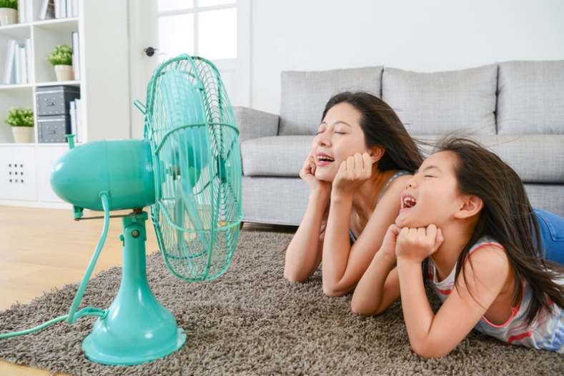
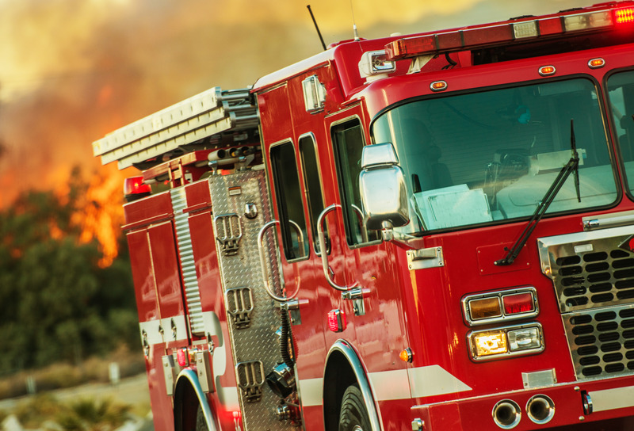

Community Resource Center:

PSPS app:
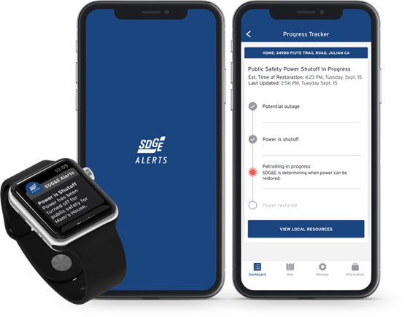

Article 3: ELECTRIC VEHICLE OWNERS: GET THE CREDIT YOU DESERVE
If you like the acceleration of your EV, you’ll love the thrill of an EV credit! If you recently purchased or leased an electric plug-in vehicle, or are thinking about making the switch to clean driving soon, be sure you apply for SDG&E’s special, limited time EV credit by November 30, 2020. Clean driving has many rewards; this special offer is just one of them. Learn more at sdge.com/EVCredit or watch this video. Plus, learn about special SDG&E pricing plans for EV owners at sdge.com/EVPlans.

Social posts: ELECTRIC VEHICLE OWNERS: GET THE CREDIT YOU DESERVE
- If you like saving the earth driving your electric vehicle (EV), you’ll love saving money with an SDG&E EV credit! Get details at sdge.com/EVCredit. #sdge #energytips4u
- If you bought or leased an electric plug-in vehicle between March 1, 2019, and now – you may qualify for SDG&E’s EV Climate Credit. Learn more at sdge.com/EVCredit. #sdge #energytips4u
- Are you an electric vehicle driver or thinking about it? Find out if you qualify for SDG&E’s limited time EV credit. Watch the video at bit.ly/3md3fn2. #sdge #energytips4u
- If you like saving money with your electric vehicle, you’ll love your EV credit from SDG&E! Learn more at sdge.com/EVCredit. #sdge #energytips4u

Images: ELECTRIC VEHICLE OWNERS: GET THE CREDIT YOU DESERVE

