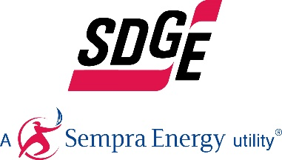

SDG&E RESIDENTIAL CONTENT PACKAGE | NOVEMBER 2020
Here are social posts, articles and photos you are welcome to use in email communications, websites or newsletters. Thank you for sharing this with your residents, customers & employees. There are several images with each posting. Please choose images that fit your audience and feel free to mix and match.

This month’s topics: Public safety power shutoffs, emergency preparedness, customer assistance programs, no-cost home upgrades, SDG&E’s sustainability strategies

Article 1: ARE YOU PREPARED FOR A PUBLIC SAFETY POWER SHUTOFF?
Living in Southern California means living with the possibility of wildfires happening in your community. During dangerous weather conditions, SDG&E might proactively turn off power to lower wildfire risk. This is known as a Public Safety Power Shutoff (PSPS). Even though SDG&E has been working to ensure power shutoffs are smaller in size and duration, it’s still important for our customers to be ready. Here are some tips to prepare in advance for a potential PSPS:
- Consider purchasing a backup power source such as a backup portable generator, permanent standby generator or rechargeable home battery. system that uses solar – learn more at sdge.com/generator
- Update your contact info at sdge.com/notifications so that SDG&E can reach you and notify you of a possible PSPS.
- If you require electricity for a medical device, apply for SDG&E’s Medical Baseline Program at sdge.com/medical – you may qualify for a discount on your SDG&E bill.
- If you have a garage, practice how to open your garage door manually.
- Remember to pack or restock your emergency supply kit – get tips at sdge.com/wildfire-safety.
- Download SDG&E’s new app at sdge.com/pspsapp to track PSPS outages, stay informed about estimated power restoration times and find the nearest open Community Resource Centers.
For more information on what you can do before, during and after a PSPS, visit sdge.com/psps.
Social posts: ARE YOU PREPARED FOR A PUBLIC SAFETY POWER SHUTOFF?
- Update your contact info at sdge.com/notifications so that SDG&E can reach you and notify you of a possible Public Safety Power Shutoff. #sdge #energytips4u
- If you require electricity for a medical device, apply for SDG&E’s Medical Baseline Program at sdge.com/medical – you may qualify for a discount on your SDG&E bill. #sdge #energytips4u
- Living in Southern California means living with the possibility of wildfires happening in your community. Remember to pack or restock your emergency supply kit – get tips at sdge.com/wildfire-safety. #sdge #energytips4u
- Living in Southern California means living with the possibility of wildfires happening in your community, and the potential of a Public Safety Power Shutoff occurring. Consider purchasing a backup power source such as a backup portable generator, permanent standby generator or rechargeable home battery system that uses solar – learn more at sdge.com/generator. #sdge #energytips4u
- To stay informed about SDG&E public safety power shutoffs, download the new app at sdge.com/pspsapp. #sdge #energytips4u

Images: ARE YOU PREPARED FOR A PUBLIC SAFETY POWER SHUTOFF?

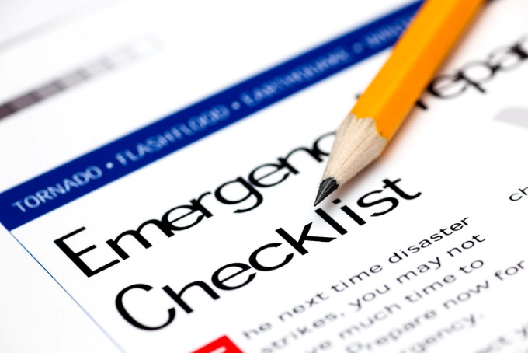

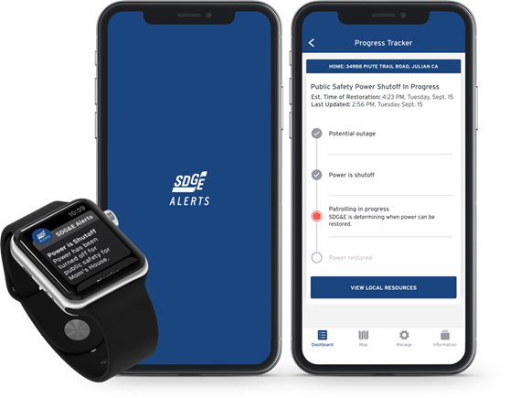

Article 2: DO YOU NEED HELP WITH YOUR ENERGY BILL?
With the coronavirus pandemic causing financial hardships for many individuals and families, you may benefit from one of SDG&E’s assistance programs. You can apply online for these bill discount programs. Many people who previously couldn’t take advantage of these income-based programs may now qualify due to lost wages – even if they’re receiving unemployment benefits. These programs include:

California Alternate Rates for Energy (CARE) Program: Save 30% or more every month on your bill. Find out if you qualify at sdge.com/CARE.

Family Electric Rate Assistance (FERA) Program: If you don’t qualify for CARE and your household has 3 or more people, you may qualify for FERA. You could receive an 18% discount on your electric use. Visit sdge.com/FERA to learn more.

Energy Savings Assistance (ESA) Program: You may qualify to receive free energy-saving improvements for your home, such as new appliances like refrigerators, furnace repair, lighting, insulation and more. Find details at sdge.com/ESAP.

Medical Baseline Allowance Program: If you need to use more energy to operate medical devices due to a qualifying medical condition, you may qualify for a discount on your SDG&E bill. Get more information at sdge.com/medical.

Online applications are easy, fast and convenient. To learn more, visit sdge.com/assistance.

Social posts: DO YOU NEED HELP WITH YOUR ENERGY BILL?
- Hardship is everywhere right now – the last thing you need is to worry about your energy bill. Get help with your bill at sdge.com/assistance. #sdge #energytips4u
- Save 30% or more every month on your energy bill. Find out if you qualify at sdge.com/CARE. #sdge #energytips4u
- If your household has 3 or more people, you may qualify for FERA – an 18% discount on your electric use. Visit sdge.com/FERA to learn more. #sdge #energytips4u
- If you need to use more energy to operate medical devices due to a qualifying medical condition, you may qualify for a discount on your SDG&E bill. Get more information at sdge.com/medical. #sdge #energytips4u
- You may qualify to receive free energy-saving improvements for your home, such as new appliances like refrigerators, furnace repair, lighting, insulation and more. Find details at sdge.com/ESAP. #sdge #energytips4u

Translated article 2: ¿Necesita ayuda con su recibo de energía?
Usted puede calificar para un descuento en su recibo o mejoras en el hogar. Los programas de asistencia de SDG&E ayudan a reducir su recibo mensual de energía mientras mantiene su hogar cómodo.

Programa de Tarifas Alternativas de Energía de California (CARE, por sus siglas en inglés): Ahorre un 30% o más cada mes en su recibo. Averigüe si califica en sdge.com/asistencia.

Programa de Asistencia de Tarifa Eléctrica Familiar (FERA, por sus siglas en inglés): Si no califica para CARE y su hogar tiene 3 o más personas, puede calificar para FERA. Podría recibir un 18% de descuento en su recibo de energía. Visite sdge.com/asistencia para obtener más información.

Programa de Asistencia para el Ahorro de Energía (ESA,por sus siglas en inglés): Puede calificar para recibir mejoras gratuitas para el ahorro de energía en su hogar, tales como electrodomésticos nuevos como refrigeradores, reparación de hornos, iluminación, aislamiento y más. Encuentre los detalles en sdge.com/asistencia.

Programma de Asignación Médica Inicia: Si necesita usar más energía debido a una condición médica calificada, puede calificar para un descuento en su factura de SDG&E. Obtenga más información en sdge.com/asistencia.

Las aplicaciones en línea son fáciles, rápidas y convenientes. Para obtener más información, visite sdge.com/asistencia.

Postas sociales: ¿Necesita ayuda con su recibo de energía?
- Averigüe si su familia califica para electrodomésticos gratuitos para ahorrar energía, iluminación, protección contra la intemperie y más en sdge.com/asistencia. #sdge #energytips4u
- El 30% de descuento en su factura de energía puede ayudarlo bastante. Solicite nuestro programa de alivio de facturas para una oportunidad que le podría ahorrar un 30% o más en sus facturas mensuales de energía. Averigüe si califica en sdge.com/asistencia. #sdge #energytips4u
- Con el programa de Asistencia de Tarifa Eléctrica Familiar (FERA), puede recibir un descuento del 18% en su factura de energía. FERA solo está abierto a hogares con tres o más personas. Averigüe si califica en sdge.com/asistencia #sdge #energytips4u

Images: DO YOU NEED HELP WITH YOUR ENERGY BILL?

Article 3: RECEIVE NO-COST HOME UPGRADES
Right now, due to COVID-19, many San Diegans are having a difficult time. SDG&E offers programs that can help those in need of assistance. Whether you rent or own, you could be eligible to receive no-cost energy-efficient home improvements that can make your home more comfortable and save you money now and for years to come.
Just reach out to SDG&E’s authorized contractor, Synergy, at 888-272-8394 or Sandiego.office@synergycompanies.org. Synergy can help you enroll in the program, contact-free, if you qualify. Once it’s safe, the contractor will come to your home and may provide at no-cost:
- New, energy-efficient lighting
- Repair or replacement of doors
- Replacement of qualified appliances*
- Insulation, weather stripping and caulking
*Existing appliances (refrigerators and washers) must meet age requirements to qualify for replacement. Co-pay may be required for landlords who own appliances and pay tenant utility bill.

Social Posts: RECEIVE no-cost HOME UPGRADES
- Take advantage of no-cost appliance, lighting and other upgrades from SDG&E. Find out if you qualify by calling SDG&E’s authorized contractor, Synergy, at 888-272-8394. #sdge #energytips4u
- Find out if you qualify for no-cost appliances and doors by calling SDG&E’s authorized contractor, Synergy, at 888-272-8394. #sdge #energytips4u
- You may qualify for no-cost insulation, weather stripping, caulking and more. Call SDG&E’s authorized contractor, Synergy, at 888-272-8394 to find out. #sdge #energytips4u

Images: RECEIVE NO-COST HOME UPGRADES

Article 4: SDG&E RELEASES SUSTAINABILITY STRATEGY TO ADVANCE CARBON NEUTRALITY
Amid the growing urgency to address climate change and its impacts, San Diego Gas & Electric released a comprehensive sustainability strategy with aspirational goals in the areas of environmental stewardship, clean transportation, grid modernization, community engagement and company operations to support California’s clean energy ambitions.

The company’s holistic approach to sustainability builds on environmental, social and governance (ESG) principles, as well as its accomplishments to date. Titled “Building a Better Future: Our Commitment to Sustainability” (available at sdge.com/sustainability), the document will serve as a foundation for SDG&E to work toward key sustainability goals in the years and decades to come. Similar to climate action plans developed by local cities, SDG&E aims to update and evolve its “living” sustainability strategy to reflect stakeholder feedback, regulatory policies and technological breakthroughs.

“It’s imperative that we move more quickly to address climate change with strategic investments and partnerships because the stakes are so high if we fail to take collective action now,” said Caroline Winn, SDG&E’s chief executive officer. “As an energy company, we have an important role to play in the fight against climate change by not only doing our part to reduce emissions from our own operations, but to also develop and encourage the use of energy innovations that can make a difference.”

Image: SDG&E RELEASES SUSTAINABILITY STRATEGY TO ADVANCE CARBON NEUTRALITY

