SDG&E RESIDENTIAL CONTENT PACKAGE | APRIL 2021
As a trusted community partner, we thank you in advance for sharing these digital assets with your audiences including residents, customers, and employees to help amplify our monthly messages. Here are social media posts, articles, and photos you are welcome to use in email communications, websites, or newsletters. There are several images with each posting. Please choose images that fit your audience and feel free to mix and match.

Follow Us
In your social media posts, feel free to tag us on our social media accounts found below and route your audience to our website.

This month’s topics: Electric vehicles, assistance programs, tree safety

Article 1: 3 reasons electric vehicles are the perfect choice for you
You might not realize it, but there are lots of reasons an electric vehicle (EV) could be the perfect fit for you. Whether you’re looking for the ideal road trip companion or just looking for something you can rely on day-to-day, there’s an EV that has just what you’re looking for. Here are three reasons to LOVELECTRIC and embrace the EV lifestyle.
- EVs go wherever you want to go.
EVs are more than capable of taking you on your daily drives. Many EVs have ranges of more than 200 miles per charge. Plus, our service territory has over 3,000 public chargers. You can find these at Park & Ride locations, and there will soon be more available at schools, parks and beaches.
- They’re low maintenance.
EVs have significantly lower maintenance costs because they don’t need oil changes, coolant, transmission fluid, belts or other costly engine parts. Estimates show EV drivers can save up to 30% on annual maintenance costs. Check out more savings at sdge.com/ev-compare.
- There are many low-cost options now.
With federal, state and local incentives, the cost to purchase or lease EVs can be much lower. Make sure to check out what’s available at sdge.com/ev-incentives, including the new statewide Clean Fuel Reward that offers up to $1,500 when you purchase or lease a new EV.
Falling in love has never been easier. For more resources and information about why it’s time to love electric vehicles, visit sdge.com/lovelectric.

Social posts: 3 reasons electric vehicles are the perfect choice for you
- Looking for an electric vehicle that’s just your type? There’s an EV for every lifestyle, need and budget. Find your EV type at sdge.com/residential/electric-vehicles/getting-started. #sdge #EnergyTips4u #LOVELECTRIC
- With tax credits, rebates and HOV access, there are many ways electric vehicles can help you save money and time. Find out how you can save at sdge.com/ev-incentives. #sdge #EnergyTips4u #LOVELECTRIC
- SDG&E offers pricing plans for electric drivers that can benefit your entire household. Compare plans at sdge.com/EVplans. #sdge #EnergyTips4u #LOVELECTRIC
- Electric vehicle charging is an easy connection whether you’re home or out and about. Find the nearest EV charging station to you at sdge.com/EV. #sdge #EnergyTips4u #LOVELECTRIC

Images: 3 reasons electric vehicles are the perfect choice for you

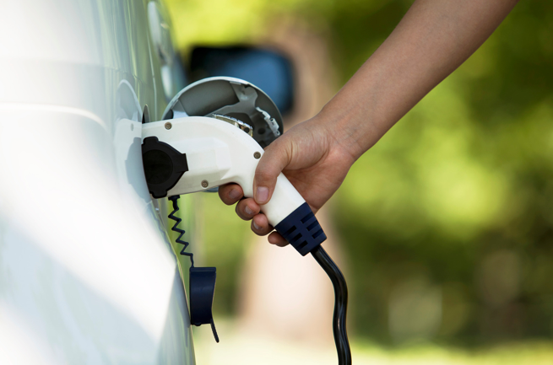
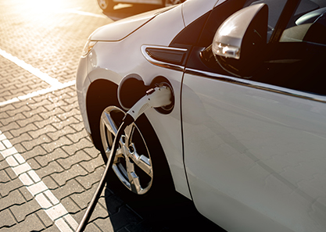

Article 2: NEED HELP WITH YOUR SDG&E BILL?
You may qualify for a bill discount or home improvements. SDG&E’s assistance programs help lower your monthly energy bill while keeping your home comfortable.
California Alternate Rates for Energy (CARE) Program: Save 30% or more every month on your bill. Find out if you qualify at sdge.com/CARE.
Family Electric Rate Assistance (FERA) Program: If you don’t qualify for CARE and your household has 3 or more people, you may qualify for FERA. You could receive an 18% discount on your electric bill. Visit sdge.com/FERA for more information.
Energy Savings Assistance (ESA) Program: You may qualify to receive no-cost, energy-saving improvements for your home, such as new appliances, furnace repair, lighting, insulation and more. Find details at sdge.com/ESAP.
Online applications are easy, fast and convenient. To learn more about SDG&E’s assistance programs, visit sdge.com/assistance.
Social posts: NEED HELP WITH YOUR SDG&E BILL?
- If you’re behind on your SDG&E bill, you may qualify for financial assistance. Learn more at sdge.com/AMP. #sdge #EnergyTips4u
- Hardship is everywhere right now – the last thing you need is to worry about your energy bill. Get help with your bill at sdge.com/assistance. #sdge #EnergyTips4u
- SDG&E provides assistance programs to help you with your monthly bill which can include up to a 30% discount. Find out if you qualify at sdge.com/assistance. #sdge #EnergyTips4u
- Whether you rent or own, you could be eligible to receive no-cost, energy-efficient home improvements that can make your home more comfortable and reduce your energy bill. Find out if you qualify at sdge.com/ESAP. #sdge #EnergyTips4u

Article 2 translated: ¿Necesita ayuda con su recibo de energía?
Usted puede calificar para un descuento en su factura o mejoras en el hogar. Los programas de asistencia de SDG&E ayudan a reducir su factura mensual de energía mientras mantiene su hogar cómodo.
Programa de Tarifas Alternativas de Energía de California (CARE, por sus siglas en inglés): Ahorre un 30% o más cada mes en su factura. Averigüe si califica en sdge.com/CARE.
Programa de Asistencia de Tarifa Eléctrica Familiar (FERA, por sus siglas en inglés): Si no califica para el CARE y su hogar tiene 3 o más personas, puede calificar para FERA. Podría recibir un 18% de descuento en su factura de electricidad. Visite sdge.com/FERA para obtener más información.
Programa de Asistencia para el Ahorro de Energía (ESA, por sus siglas en inglés): Puede calificar para recibir mejoras gratuitas para el ahorro de energía en su hogar, tales como electrodomésticos nuevos, reparación de hornos, iluminación, aislamiento y más. Encuentre los detalles en sdge.com/ESAP.
Las aplicaciones en línea son fáciles, rápidas y convenientes. Para obtener más información, visite sdge.com/asistencia.
Postas sociales: ¿Necesita ayuda con su FACTURA de energía?
- Si está atrasado en su factura de SDG&E, puede calificar para asistencia financiera. Obtenga más información en sdge.com/AMP. #sdge #EnergyTips4u
- En este momento, las dificultades se encuentran en todas partes - lo último que necesita es preocuparse por su factura de energía. Obtenga ayuda con su factura en sdge.com/asistencia. #sdge #EnergyTips4u
- SDG&E ofrece programas de asistencia para ayudarle con su factura mensual que puede incluir hasta un 30% de descuento. Descubra si califica en sdge.com/asistencia. #sdge #EnergyTips4u
- Ya sea que alquile o sea propietario, podría ser elegible para recibir mejoras de eficiencia energética en su hogar, sin costo, que pueden hacer que su hogar sea más cómodo y reducir su factura de energía. Descubra si califica en sdge.com/ESAP. #sdge #EnergyTips4u

Images: NEED HELP WITH YOUR SDG&E BILL?

Article 3: PLANT TREES IN SAFE SPOTS TO HELP PREVENT POWER OUTAGES AND FIRES
With trees, beauty is more than branch deep. Trees help clean the air, prevent erosion and conserve watersheds. They can add shade, greenery, fresh fruit or flowers – even value to your property. However, when branches or roots touch overhead or underground electric equipment, it can cause problems with safety and reliability.
Pair the right tree in the right place. Knowing how trees grow and where to plant them can help prevent electric shock hazards, power outages, and fires.
You’ll find five types of trees that are popular locally and compatible with overhead power lines in SDG&E’s Tree Care for Power Safety brochure at sdge.com/TreeSafety. Browse SDG&E’s tree planting selection guide to learn more about trees you’re considering.
Know what’s below. Before you break ground, contact DigAlert at 811 or DigAlert.org at least two working days in advance. DigAlert’s free service will locate and mark underground utility-owned gas lines so you can avoid dangerous and costly damage.
Never prune trees near electric equipment. It can cause severe shock or death if you touch an electric line or any object that’s in contact with an electric line. State law requires any tree pruning within 10 feet of power lines must be done by a line clearance-qualified arborist.
Report concerns. Call SDG&E at 1-800-411-7343 to request an inspection if you’re concerned about vegetation growing close to a power line or transformer. If a tree poses a hazard, SDG&E will prune it on a priority basis. For regularly scheduled vegetation management work in your area, visit sdge.com/TreeSafety.
Social posts: PLANT TREES IN SAFE SPOTS TO HELP PREVENT POWER OUTAGES AND FIRES
- Are you going to break ground on a new home project? Contact DigAlert at 811 or DigAlert.org at least two working days in advance. DigAlert’s free service will locate and mark underground utility-owned gas lines so you can avoid dangerous and costly damage. #sdge #Energytips4u
- Check out SDG&E’s Tree Care for Power Safety brochure at sdge.com/TreeSafety. You’ll find types of trees that are popular locally and compatible with overhead power lines. These select trees grow no more than 25 feet and require little, if any, pruning. #sdge #EnergyTips4u
- If you’re concerned about vegetation growing too close to a power line or transformer, call SDG&E at 1-800-411-7343 to request an inspection. If it poses a hazard, SDG&E will prune it on a priority basis. Get details at sdge.com/TreeSafety. #sdge #EnergyTips4u
- Before you plant a tree, know where it will grow. You can help prevent power outages and fires by choosing a tree that won’t touch electric lines as it matures. Learn more at sdge.com/TreeSafety. #sdge #EnergyTips4u

Images: PLANT TREES IN SAFE SPOTS TO HELP PREVENT POWER OUTAGES AND FIRES

Social posts: CLIMATE CREDIT
In April 2021, all residential customers with natural gas service will see a $17.86 credit on their bill. Visit our NewsCenter to learn more about the credit, how you’re helping to fight climate change and when the next climate credit is expected to hit your billing statement this year. ow.ly/DdFb50E7DRJ #SDGE #EnergyTips4U

