SDG&E RESIDENTIAL CONTENT PACKAGE | DECEMBER 2020
Here are social posts, articles and photos you are welcome to use in email communications, websites or newsletters. Thank you for sharing this with your residents, customers & employees. There are several images with each posting. Please choose images that fit your audience and feel free to mix and match.

This month’s topics: Holiday lighting safety and energy tips, winter energy-saving tips, assistance programs

Article 1: Keep holiday light decorating safe, ENERGY-efficient, festive and fun
People love lighting up their homes for the holidays – whether it’s inside your home along the fireplace or on your front lawn decorating your trees and bushes. What most people don’t love is the increase in their electricity bill after all the holiday cheer and lights are gone.
Here are some ways to be energy-efficient this holiday season:
- Make smart lighting choices. LED holiday lights are the way to go! They use up to 80% less energy and are brighter and safer since they are much cooler than incandescent lights. They’re easier to install—up to 24 strings of LEDs can be connected end-to-end without overloading a wall socket. They last ten times longer and have no filaments or glass to break.
- Limit energy use. Set timers for lights to automatically turn on when it gets dark and off in the middle of the night. You can save more by keeping light displays on only 8 hours of the evening or less (when you can see them).
- Get reflective. Shiny ornaments, tinsel and mirrors can multiply the effects of your lighting without using more energy. Be sure to keep tinsel away from pets, though. Reflective ornaments and tinsel are just as bright at night, so getting creative with your lighting display can multiply your resources for shine. Don't forget the ribbons, wreaths, garland and reflective menorahs for electricity- free, age-old traditions that bring holiday cheer.

Be sure to stay safe over the holidays. Here are some great tips to keep you and your loved ones safe.
- Limit the connection of light strands. Avoid overloading extension cords and wall sockets by following the manufacturer’s limits for the number of light strings that can be safely connected.
- Hang lighting safely. Make sure that no cords will be pinched by furniture or placed under rugs, furniture or other appliances. If covered, cords can overheat or become frayed, increasing the risk of fire. Replace faulty lights instead of trying to repair them.
- Avoid electric hazards outdoors. Before climbing ladders to string outdoor lights, check for overhead power lines on your roof or attached to your home. Always keep at least 10 feet away from overhead lines. Never place yourself or any object, such as a string of lights, in a position that risks contact with a power line—the result can be fatal.
- Use GFCI outlets. Outdoor electric lights and decorations should be plugged into circuits protected by ground fault circuit interrupters (GFCIs). How do you know if it’s a GFCI? Look for the “test” and “reset” buttons. If circuits are not GFCI-protected, portable outdoor GFCIs can be purchased.
- Check your environment outdoors. Before stringing lights on outdoor trees, make sure tree limbs haven’t grown into or near power lines. Branches, entire trees and even the ground adjacent to a tree can become energized when trees contact power lines.
- Put your tree in a safe location. Keep your holiday tree away from heat sources such as a fireplace or heat vent. The heat will dry out the tree, making it more susceptible to fires caused by heat, flame or sparks.
- Check condition of lights. Inspect light strands for cracked or broken plugs, frayed insulation or bare wires. Worn cords can cause fires, so discard damaged sets of lights.
- Read the labels. Be sure to check each product label to see whether the lights are intended for indoor or outdoor use. Make sure lights have a tag indicating they have been evaluated by a recognized testing laboratory.

For more winter energy-saving and safety tips, visit sdge.com/winter.

Social posts: Keep holiday light decorating safe, ENERGY-efficient, festive and fun
- LED holiday lights are the way to go! They use up to 80% less energy and are brighter, safer, more durable and last longer than traditional light strings. They’re easier to install too – up to 24 strings of LEDs can be connected end-to-end without overloading a wall socket. #sdge #energysavings4u
- Before climbing ladders to string outdoor lights, check for overhead power lines on your roof or attached to your home. Always keep at least 10 feet away from overhead lines. Never place yourself or any object, such as a string of lights, in a position that risks contact with a power line—the result can be fatal. #sdge #energysavings4u
- Set timers for holiday lights to turn on and off automatically. Keep light displays on during the evening and turn them off overnight while you sleep. #sdge #energysavings4u
- Before stringing lights on outdoor trees, make sure tree limbs haven’t grown into or near power lines. Branches, entire trees and even the ground adjacent to a tree can become energized when trees contact power lines. #sdge #energysavings4u
- Get helpful winter energy-saving and safety tips at sdge.com/winter. #sdge #energytips4u

Images: Keep holiday light decorating safe, ENERGY-efficient, festive and fun

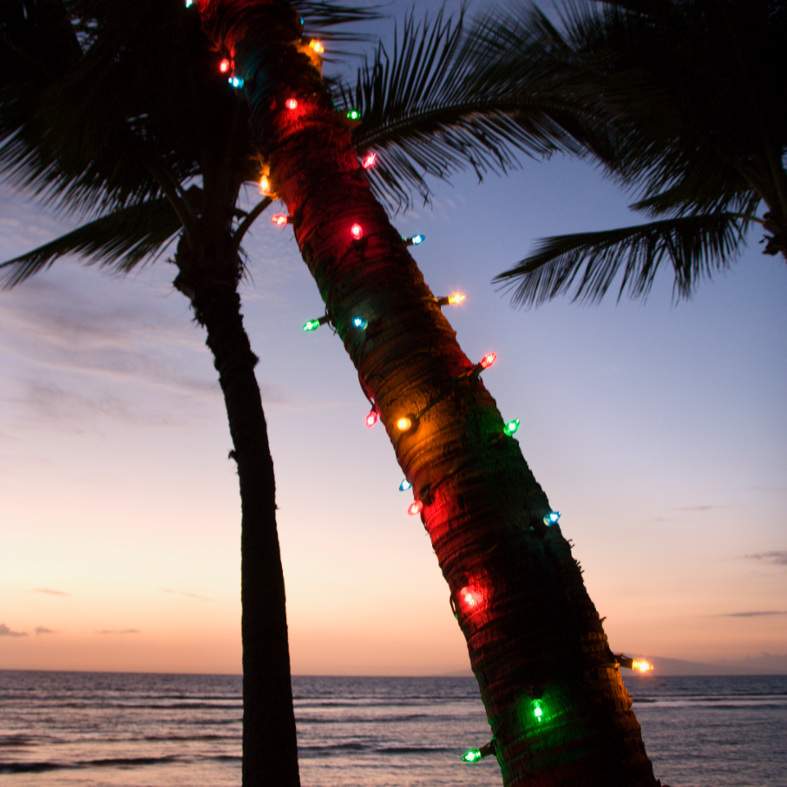
Canva.com

Photo by Jasmin Schuler on Unsplash.com

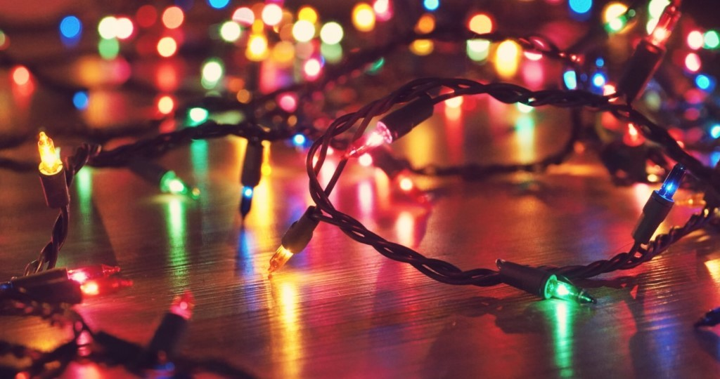
Photo by Thalia Ruiz on Unsplash.com

From Canva.com

Article 2: 10 ENERGY TIPS TO SHAKE THE WINTER’S CHILL
Many of us are spending more time at home so we’re probably using more energy. Here are some no-cost and low-cost energy-saving tips. We know that every little bit helps, especially now.
- Switch your ceiling fan’s blade rotation. Hot air rises so reverse your fan’s blades clockwise to help push the warmth back down to you.
- Use your exhaust fans sparingly. Your bathroom fans and over hoods are overlooked sources of heat loss in the winter because they can pull warmth from your home.
- Weatherize your home by caulking and sealing all seams, cracks and openings to the outside. This can save 10% – 20% on your heating bill.
- Rock your winter wardrobe indoors. Make your home your runway and stay bundled in your winter best. Turn your thermostat down 7° - 10° for 8 hours a day, like when you sleep, and you can save up to 10% on your bill. So, slip on your fuzzy socks and flannel pajamas!
- Let the sunshine in. Take advantage of the world’s best furnace – the sun! Draw your curtains during the day to naturally heat your home.
- Check your home’s insulation. It’s like a winter coat for your house. The heavier it is, the warmer your home will be.
- Reduce heat loss from your fireplace. Keep your fireplace damper closed unless a fire is burning. Keeping the flue open is like keeping a window wide open during the winter – warm air goes right up the chimney.
- Use less hot water (it takes energy to heat up water), wash your clothes in cold water and install low-flow faucets and showerheads.
- Save up to $125 on a smart thermostat. Now through 12/31/20, you can save $75 on the purchase of qualifying smart thermostats. It can be combined with manufacturer rebates for savings up to $125. Learn more at sdge.com/instant.
- Use lids on pots and pans. When you do this, you’re conserving heat which reduces cooking time and saves energy.
For more energy-savings tips, visit sdge.com/winter.
Social posts: 10 ENERGY TIPS TO SHAKE THE WINTER’S CHILL
- Switch your ceiling fan’s blade rotation. Hot air rises so reverse your fan’s blades clockwise to help push the warmth back down to you. For more energy-savings tips, visit sdge.com/winter. #sdge #energytips4u
- Use your exhaust fans sparingly. Your bathroom fans and over hoods are overlooked sources of heat loss in the winter because they can pull warmth from your home. For more energy-savings tips, visit sdge.com/winter. #sdge #energytips4u
- Save up to $125 on a smart thermostat. Now through 12/31/20, you can save $75 on the purchase of qualifying smart thermostats. It can be combined with manufacturer rebates for savings up to $125. Learn more at sdge.com/instant. For more energy-savings tips, visit sdge.com/winter. #sdge #energytips4u
- Let the sunshine in. Take advantage of the world’s best furnace – the sun! Draw your curtains during the day to naturally heat your home. For more energy-savings tips, visit sdge.com/winter. #sdge #energytips4u
- Check your home’s insulation. It’s like a winter coat for your house. The heavier it is, the warmer your home will be. For more energy-savings tips, visit sdge.com/winter. #sdge #energytips4u
- Use less hot water (it takes energy to heat up water), wash your clothes in cold water and install low-flow faucets and showerheads. For more energy-savings tips, visit sdge.com/winter. #sdge #energytips4u

Images: 10 ENERGY TIPS TO SHAKE THE WINTER’S CHILL
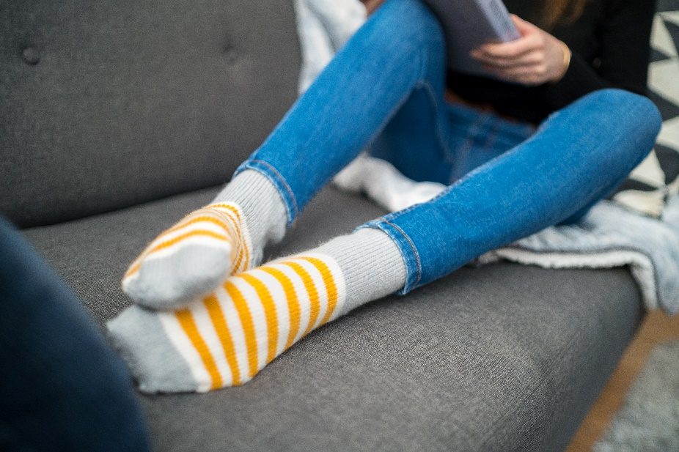
Photo by Les Triconautes on Unsplash.com

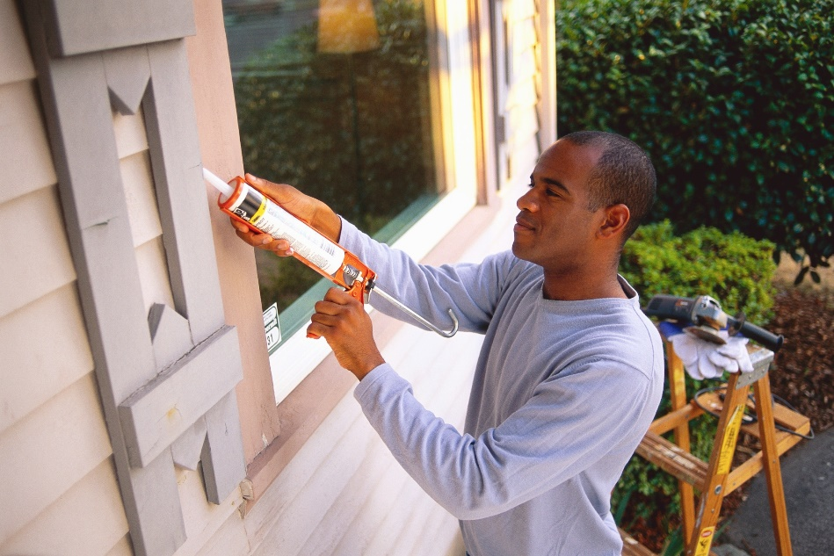

Article 3: DO YOU NEED HELP WITH YOUR ENERGY BILL?
With the coronavirus pandemic causing financial hardships for many individuals and families, you may benefit from one of SDG&E’s assistance programs. You can apply online for these bill discount programs. Many people who previously couldn’t take advantage of these income-based programs may now qualify due to lost wages – even if they’re receiving unemployment benefits. These programs include:

California Alternate Rates for Energy (CARE) Program: Save 30% or more every month on your bill. Find out if you qualify at sdge.com/CARE.

Family Electric Rate Assistance (FERA) Program: If you don’t qualify for CARE and your household has 3 or more people, you may qualify for FERA. You could receive an 18% discount on your electric use. Visit sdge.com/FERA to learn more.

Energy Savings Assistance (ESA) Program: You may qualify to receive free energy-saving improvements for your home, such as new appliances like refrigerators, furnace repair, lighting, insulation and more. Find details at sdge.com/ESAP.

Medical Baseline Allowance Program: If you need to use more energy to operate medical devices due to a qualifying medical condition, you may qualify for a discount on your SDG&E bill. Get more information at sdge.com/medical.

Online applications are easy, fast and convenient. To learn more, visit sdge.com/assistance.

Social posts: DO YOU NEED HELP WITH YOUR ENERGY BILL?
- Hardship is everywhere right now – the last thing you need is to worry about your energy bill. Get help with your bill at sdge.com/assistance. #sdge #energytips4u
- Save 30% or more every month on your energy bill. Find out if you qualify at sdge.com/CARE. #sdge #energytips4u
- If your household has 3 or more people, you may qualify for FERA – an 18% discount on your electric use. Visit sdge.com/FERA to learn more. #sdge #energytips4u
- If you need to use more energy to operate medical devices due to a qualifying medical condition, you may qualify for a discount on your SDG&E bill. Get more information at sdge.com/medical. #sdge #energytips4u
- You may qualify to receive free energy-saving improvements for your home, such as new appliances like refrigerators, furnace repair, lighting, insulation and more. Find details at sdge.com/ESAP. #sdge #energytips4u

Translated article 2: ¿Necesita ayuda con su recibo de energía?
Usted puede calificar para un descuento en su recibo o mejoras en el hogar. Los programas de asistencia de SDG&E ayudan a reducir su recibo mensual de energía mientras mantiene su hogar cómodo.

Programa de Tarifas Alternativas de Energía de California (CARE, por sus siglas en inglés): Ahorre un 30% o más cada mes en su recibo. Averigüe si califica en sdge.com/asistencia.

Programa de Asistencia de Tarifa Eléctrica Familiar (FERA, por sus siglas en inglés): Si no califica para CARE y su hogar tiene 3 o más personas, puede calificar para FERA. Podría recibir un 18% de descuento en su recibo de energía. Visite sdge.com/asistencia para obtener más información.

Programa de Asistencia para el Ahorro de Energía (ESA,por sus siglas en inglés): Puede calificar para recibir mejoras gratuitas para el ahorro de energía en su hogar, tales como electrodomésticos nuevos como refrigeradores, reparación de hornos, iluminación, aislamiento y más. Encuentre los detalles en sdge.com/asistencia.

Programma de Asignación Médica Inicia: Si necesita usar más energía debido a una condición médica calificada, puede calificar para un descuento en su factura de SDG&E. Obtenga más información en sdge.com/asistencia.

Las aplicaciones en línea son fáciles, rápidas y convenientes. Para obtener más información, visite sdge.com/asistencia.

Postas sociales: ¿Necesita ayuda con su recibo de energía?
- Averigüe si su familia califica para electrodomésticos gratuitos para ahorrar energía, iluminación, protección contra la intemperie y más en sdge.com/asistencia. #sdge #energytips4u
- El 30% de descuento en su factura de energía puede ayudarlo bastante. Solicite nuestro programa de alivio de facturas para una oportunidad que le podría ahorrar un 30% o más en sus facturas mensuales de energía. Averigüe si califica en sdge.com/asistencia. #sdge #energytips4u
- Con el programa de Asistencia de Tarifa Eléctrica Familiar (FERA), puede recibir un descuento del 18% en su factura de energía. FERA solo está abierto a hogares con tres o más personas. Averigüe si califica en sdge.com/asistencia #sdge #energytips4u

Images: DO YOU NEED HELP WITH YOUR ENERGY BILL?

