RAM Q&As

- Q: May Respondents list multiple manufacturers on the bid form?

A: Yes, Respondents may list multiple manufacturers on their bid form. However, Respondent should provide sufficient and detailed enough information to evidence that Respondent is using a commercially proven technology and that the project capacity proposed is achievable via the manufacturer models proposed.

- Q: How long between the time in which RAM bids are due and the expected CPUC approval of executed PPAs?

A: RAM bids are due by no later than 12 p.m. Pacific Standard Time (i.e. noon) on December 21, 2012, and the anticipated CPUC approval date of executed RAM PPAs is June 17, 2013. This is approximately six months.

- Q: Would a phased project be accepted?

A: SDG&E’s current pro-forma RAM PPA does not contain the provisions necessary for a phased project. Significant deviations and alterations in the already Commission approved pro-forma RAM PPA may lead to delay or rejection of an executed PPA submitted to the Commission for approval.

- Q: Would two projects utilizing the same interconnection point be eligible if the combined capacity of both projects totaled more than 20 MW?

A: The project size limit the Commission has adopted for the RAM program is 20MW. Breaking up or subdividing larger projects to circumvent the Commission adopted 20 MW project size limit is prohibited. In addition, SDG&E’s current pro-forma RAM PPA does not contain the provisions necessary to address the need for shared facilities in this case. Significant deviations and alterations in the already Commission approved pro-forma RAM PPA may lead to delay or rejection of an executed PPA submitted to the Commission for approval.

- Q: What size project is eligible for the Wholesale Distribution Access Tariff (WDAT) Fast Track Process?

A: Projects must not exceed 2 MW.

- Q: Does the bid form, when asking for “non-reimbursable costs”, intend to include gen-tie costs?

A: Yes. “Non-reimbursable costs” on the bid forms should include non-reimbursable interconnection costs (such as a gen-tie). It is assumed that these gen-tie costs are also factored into a project’s pricing. See also question 11 below.

- Q: What is the deliverability calculation process?
A: See the schematic below.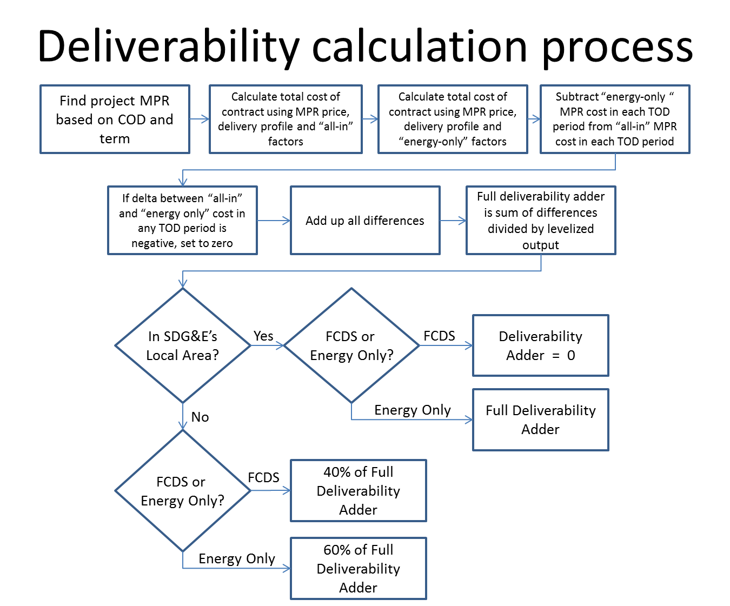
- Q: From a deliverability perspective, would an energy-only project in SDG&E’s service territory be ranked higher (i.e. preferred) than an energy-only project outside SDG&E’s service territory?
A: No, an energy-only project in SDG&E’s service territory would not be ranked higher than an energy-only project outside SDG&E’s service territory. An energy-only project in SDG&E’s service territory would be assessed the full deliverability adder, thereby increasing its Least-Cost-Best-Fit (LCBF) price. An energy-only project NOT in SDG&E’s service territory would only be assessed 60% of the full deliverability adder.
- Q: Does the RAM RFO pertain only to projects built in San Diego County, and what if the proposed project is in the Imperial Irrigation District (IID)?
A: SDG&E cannot restrict a Respondent from proposing a bid, however current RAM rules state that to be eligible for RAM, projects must be located within the service territories of SDG&E, PG&E, or SCE.

- Q: Does a Respondent need to register their company in order to submit a RAM bid?
A: No. A Respondent does not need to register their company to submit a RAM bid. Any party interested in submitting an offer must simply submit the offer via e-mail to: RAMSolicitation@semprautilities.com, and the Subject line of the e-mail should be as follows: Bid Submission for SDG&E’s 2012 Winter RAM RFO. All offers must be emailed no later than 12:00 p.m. (i.e. Noon), Pacific Standard Time, on December 21, 2012 (see the RFO Schedule and website for more details).

- Q: What interconnection costs should and should not be included in a Respondent’s bid price?
A: In short, Respondents should include non-reimbursable interconnection costs in their bid price. For example, non-reimbursable interconnection costs include the interconnection customer’s interconnection facilities such as a gen tie-line. These costs should be captured in Respondent’s Project Description form in Section G “Interconnection” and in the Pricing Form (either row 61 or 62 depending on the pricing form used).
Respondents should NOT include reimbursable interconnection costs in their bid price. Respondent should refer to their interconnection study for specifics, but generally, reimbursable interconnection costs include Reliability Network Upgrades and Deliverability Network Upgrades. SDG&E includes these reimbursable costs in determining the transmission adder that is used to calculate the project’s bid ranking price.

- Q: Does the reference to PST (Pacific Standard Time) in the TODs assume daylight savings time will be factored in?
A: Yes, daylight savings time will be factored in.

- Q: Respondent would like to bid as a Diverse Business Enterprise (DBE). Where should this information be captured in the bid forms?
A: Please check rows 15 and 16 of the pricing forms. Additionally, please utilize Section U “Additional Information” of the Project Description form to provide more information.
- Q: Will a project that bid as an FCDS project be paid the higher FCDS TOD’s if the project is placed on the NQC list via an annual assessment, even if all of the upgrades in the interconnection agreement are not complete and therefore the project has not technically achieved FCDS status? For example, upgrades on X’s system may take only 24 months, while necessary upgrades on Y’s system are scheduled for 84 months. However, because of topology conditions, the project can be deliverable on an annual basis in after 36 months. Would the project be paid the FCDS TOD’s for the period that it could provide RA capacity?

A: SDG&E has not seen an NQC given to a unit until all deliverability upgrades have been built. With that being said, if the project was somehow on the NQC list, SDG&E would pay the FCDS price less the relevant deliverability adder, as the project could not provide RA without the relevant deliverability upgrades built. See also section 4.1(c) of the form RAM PPA as to how payments will be handled when FCDS has not been achieved.

