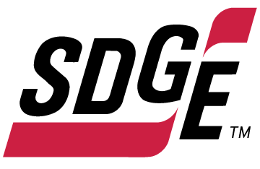

SDG&E RESIDENTIAL AND SMALL BUSINESS CONTENT PACKAGE | OCTOBER 2022
As a trusted community partner, we thank you for sharing our content and digital assets with your audiences – including residents, customers and employees – to help amplify our key messages in your email communications, websites or newsletters.
Best practices for using our content, social media posts and images
- Images
Please choose images that are relevant for your audience and feel free to mix and match what we provide. For alternate images, Unsplash.com and Canva.com offer free images that you can download.
- SDG&E logo
You’re welcome to mention our name but, due to legal requirements, please do not use our logo in any marketing materials that you create. Please only use the SDG&E logo if we provide it to you in this package or it’s publicly available online like a social post or video. You can also retweet our public posts which you’ll find on twitter.com/sdge.
- Videos
We have a library of videos you can share in your communications and social posts when you visit youtube.com/c/SanDiegoGasElectric/videos. If you’d like to sort our videos by topic, visit youtube.com/c/SanDiegoGasElectric. Some videos are in Spanish. Our newest videos discuss the path to net zero, fire hardening and safety, public safety power shutoffs, 811 Dig Alert and more. You’ll see some on TV, too!
This month’s topics: Emergency Preparedness, Medical Baseline Program, Temperature Sensitive Program, free energy-related webinars

Follow us
You can find us on Facebook, Instagram, Twitter, YouTube and LinkedIn. When sharing these digital assets and content, feel free to tag SDG&E’s social media accounts and direct your audience to sdge.com.

Article: PREPARE NOW FOR AN EMERGENCY LATER
Emergencies come in many forms such as wildfires, storms, earthquakes or floods. There’s no better time to prepare for an emergency than right now. Below are some tips and resources to help you plan and stay safe should an emergency happen. Visit sdge.com/emergency for emergency checklists and evacuation plan ideas.

- Develop an emergency plan. Identify a place to meet with family, safe routes and shelters, as well as what actions you will take. Discuss and practice the plan with your family, including your children and pets.
- Prepare an emergency kit for at least three days. Keep essentials on hand like water (one gallon per person per day), a first aid kit, flashlight, canned goods, medicine, clothes and cash. Stock your kit with items you and your family need, including those with a disability, seniors and your pets. Store supplies in easy-to-carry containers such as backpacks or plastic crates. For ideas, download helpful checklists at sdge.com/checklists.
- Help your neighbors. Being a good neighbor takes more than sharing the occasional cup of sugar or hosting a potluck. It’s important to help our neighbors during emergencies, especially those who are vulnerable, elderly or disabled.
- Update your SDG&E contact information. SDG&E will make every effort to communicate with you during emergencies. Go to sdge.com/MyAccount to sign in. From the My Account homepage, click on “Account,” then select “My Profile.” Here, you can make sure your contact information is up to date.
- Sign-up for power outage notifications. Get notified when there is an outage in your area. Sign into sdge.com/MyAccount. From the My Account homepage, click on “Account,” then select “Notification Settings.”
Social posts: PREPARE NOW FOR AN EMERGENCY LATER
- It’s important to be prepared for emergencies like wildfires. Use SDG&E’s checklist and stock up on staples to remain prepared for the unexpected. Learn more at sdge.com/emergency. #sdge #SDGEassist
- Are you, your family and pets ready in case of an emergency? Visit sdge.com/checklists to learn which items you should have on hand in a pinch. #sdge #SDGEassist
- Stay safe this wildfire season by updating your contact info on SDG&E’s website so they can notify you of power outages. Visit sdge.com/MyAccount. #sdge #SDGEassist
- Help your neighbors during emergencies, especially those who are vulnerable or elderly. Find safety tips at sdge.com/Wildfire-Emergency-Preparedness. #sdge #SDGEassist
- Don’t leave your safety to chance. Visit sdge.com/Wildfire-Emergency-Preparedness for steps to prepare now for an emergency later. #sdge #SDGEassist
- Does SDG&E have your current contact information in case of a Public Safety Power Shutoff? Visit sdge.com/PSPS for details. #sdge #SDGEassist
- Stay informed during a Public Safety Power Shutoff event by downloading SDG&E’s Alerts app at sdge.com/notifications. #sdge #SDGEassist

Images: PREPARE NOW FOR AN EMERGENCY LATER

Article: Medical needs? Here’s your prescription for savings.
Certain medical needs may qualify you or someone in your home for savings every month on your gas and electric bill. Apply for the Medical Baseline Allowance program if you need to use more energy due to a qualifying medical condition or to prevent an existing condition from getting worse. Examples include:
A requirement for permanent space heating or cooling due to paraplegia, quadriplegia, hemiplegia, multiple sclerosis, scleroderma, a compromised immune system or a life-threatening illness.
Required use of a life-support device, such as an aerosol tent, apnea monitor, kidney dialysis machine, motorized wheelchair or respirator (devices used for therapy don’t qualify; only medical devices that sustain life or are needed for mobility).
To get a Medical Baseline Allowance application and more information, visit sdge.com/medical. Eligibility requirements include having a physician sign your application to certify the medical need.
Social posts: Medical needs? Here’s your prescription for savings.
- If you or someone in your household has a qualifying medical condition or a need for certain medical devices that require electricity, you may qualify for SDG&E’s Medical Baseline Allowance Program. Apply at sdge.com/medical. #sdge #SDGEassist
- SDG&E’s Medical Baseline Allowance Program provides an additional amount of gas and electricity at the lowest energy rates. Get details at sdge.com/medical. #sdge #SDGEassist
- Anyone who uses certain medical devices or needs space heating or air conditioning because of a medical condition may qualify for SDG&E’s Medical Baseline Allowance Program. Learn more at sdge.com/medical. #sdge #SDGEassist

Article 2 translated: ¿Hay necesidades médicas? Obtenga esta receta para ahorrar.
Ciertas necesidades médicas pueden hacer que usted o alguien que vive en su casa cumpla con los requisitos para ahorrar cada mes en su factura de gas y electricidad. Solicite el programa de Asignación Médica Inicial si necesita consumir más energía debido a una enfermedad que cumpla con las condiciones o para evitar que una condición existente empeore. Por ejemplo:
Requerir calefacción o aire acondicionado ambiental permanente debido a paraplejia, tetraplejia, hemiplejia, esclerosis múltiple, esclerodermia, un sistema inmunitario afectado o una enfermedad potencialmente mortal.
Requerir el uso de un dispositivo de soporte vital, como una tienda de nebulización, monitor de apnea, máquina para diálisis del riñón, silla de ruedas motorizada o respirador (los dispositivos usados para terapia no cumplen con los requisitos; únicamente dispositivos médicos que sustenten la vida o se necesiten para movilidad).
Para obtener un formulario de solicitud para el programa de Asignación Médica Inicial y más información, visite sdge.com/Programa-Medico. Los requisitos para tener derecho a participar incluyen el que un médico firme su solicitud para certificar la necesidad médica.

Postas sociales: ¿Hay necesidades médicas? Obtenga esta receta para ahorrar.
- Si usted o alguien en su hogar tiene una condición médica calificada o una necesidad de ciertos dispositivos médicos, puede calificar para el Programa de Asignación Médica Inicial de SDG&E. Solicite en sdge.com/Programa-Medico. #sdge #SDGEassist
- El Programa de Asignación Médica Inicial de SDG&E proporciona una cantidad adicional de gas y electricidad a las tarifas de energía más bajas. Obtenga detalles en sdge.com/Programa-Medico. #sdge #SDGEassist
- Cualquier persona que use ciertos dispositivos médicos o necesite calefacción o aire acondicionado debido a una afección médica puede calificar para el Programa de Asignación Médica Inicial de SDG&E. Obtenga más información en sdge.com/Programa-Medico. #sdge #SDGEassist

Images: Medical needs? Here’s your prescription for savings.

Article: IS HEAT HARMFUL TO YOUR HEALTH? Request this sdg&e alert!
Get notified about state-directed outages so you can make arrangements to stay cool and connected.
If extreme heat is harmful to the health of anyone living in your home and a moderate indoor temperature is a must, enroll in SDG&E’s Temperature Sensitive Program. This no-cost service provides you with advanced notice of power outages (when possible). An automated phone call will alert you so that you can prepare for a temporary loss of air conditioning.
To sign up for the Temperature Sensitive Program, download the application at sdge.com/TempSensitive. If you participate in SDG&E’s Medical Baseline Program, then you’re already on the call list! Since you already receive the outage notices, you don’t need to enroll in the Temperature Sensitive Program. If you’d like to learn more about SDG&E’s Medical Baseline Program, please visit sdge.com/medical.
Social posts: IS HEAT HARMFUL TO YOUR HEALTH? Request this sdg&e alert!
- If extreme heat is harmful to you or anyone else’s health in your home, and you need a moderate temperature, enroll in SDG&E’s Temperature Sensitive Program at sdge.com/TempSensitive. #sdge #SDGEassist
Images: IS HEAT HARMFUL TO YOUR HEALTH? Request this sdg&e alert!
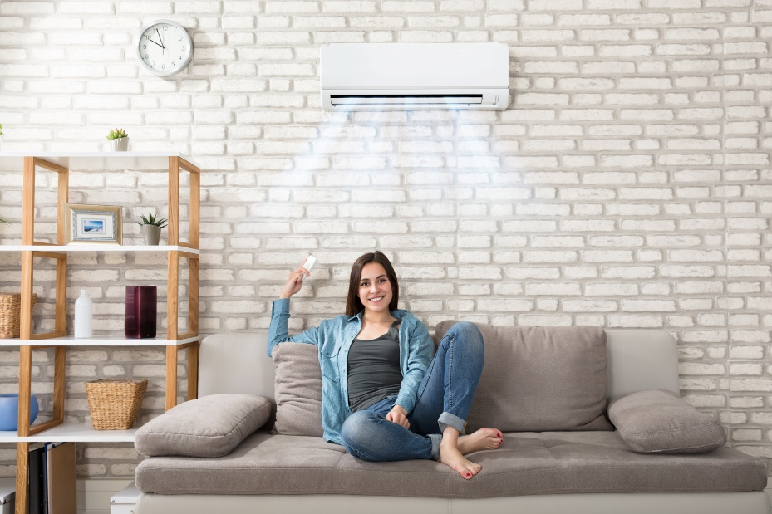
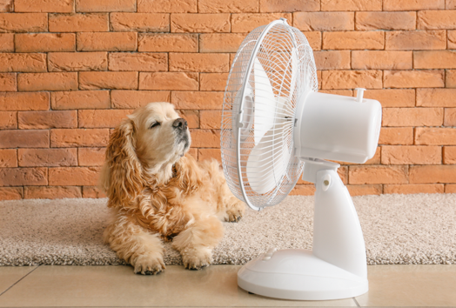

Article AND OR SOCIAL POST: Save 18% on your monthly electric bill with FERA
SDG&E recognizes this is still a challenging time for many customers. Even if you have never qualified for assistance before, you may be eligible now. If you have three or more people in your household and are having a hard time paying your electric bill, you may be eligible for an 18% discount on your electric bill. To apply, visit sdge.com/FERA.

images: Save 18% on your monthly electric bill with FERA
Twitter:
Instagram/Facebook:
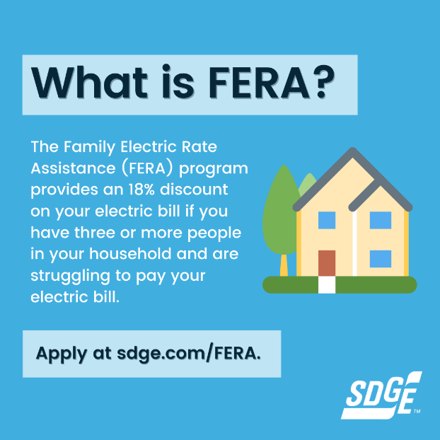
Business Article: PREPARING FOR OUTAGES
Weather often has the biggest impact on the power grid. Rainstorms, windy conditions and heat waves can sometimes result in power outages, so preparing for these weather conditions is important. Because power outages can happen with little to no warning during inclement weather, we’ve put together some helpful tips on how to prepare at sdge.com/Outage-Center.

Check out these ten tips to help keep your business running and employees and customers safe during inclement weather.
- Ensure your contact information is up to date for yourself and your business at sdge.com/MyAccount. Also, sign up for power outage notifications via text or email under “Account” then “Notifications Settings.”
- Create an emergency action plan. There’s no better time to prepare for an emergency than now. Visit sdge.com/emergency to learn more about emergency preparedness ideas for your home and business.
- Prepare your facility or office for severe weather by inspecting the building for drafts, leaks and cracks. Also, regularly check emergency lighting, such as exit signs.
- Create digital copies of important documents like your employee roster and emergency phone numbers. This allows your team to easily reach one another.
- Identify backup charging methods such as portable battery packs for mobile phones and other digital devices. Consider investing in a backup electric generator to keep your business open during power shutoffs. Learn more at sdge.com/generator.
- Build or restock an emergency kit to last at least three days and include flashlights, batteries, a first aid kit, food, water and cash. Recommend your employees create emergency kits to stay safe at home, too. Build your kit with these tips on sdge.com/emergency.
- If your power is out, view outage details and estimated restoration times at sdge.com/Outage-Map.
- It’s critical that you stay away from downed power lines and treat them as if they are energized. Visit sdge.com/safety/Keeping-Safe-Stormy-Weather for tips on how to stay safe during a storm.
- Keep a mobile phone or land line phone at hand. Cordless phones don’t work without electricity.
Social Posts: PREPARing for outages

Use any of the ten tips above and add: “Get more tips at sdge.com/MyBusiness. #sdge #SDGEassist”
Images: PREPARE YOUR BUSINESS FOR stormy CONDITIONS
Twitter:
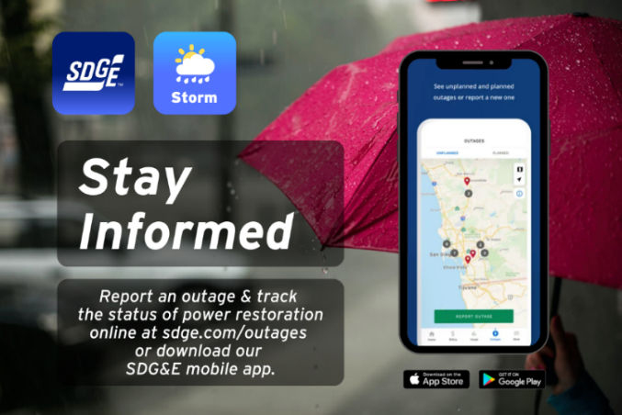
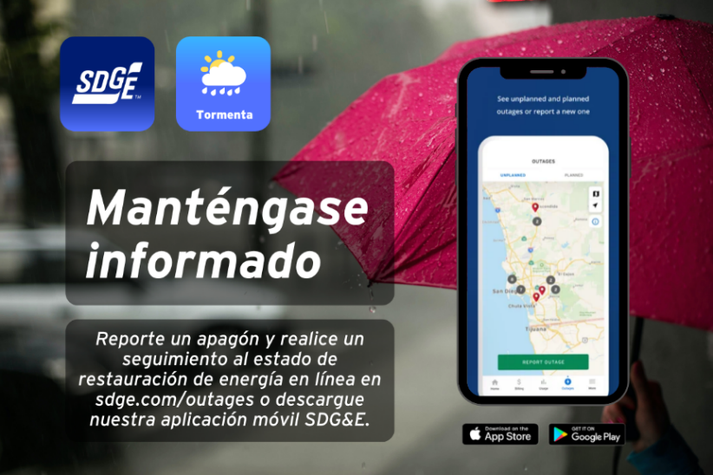

Facebook/Instagram:
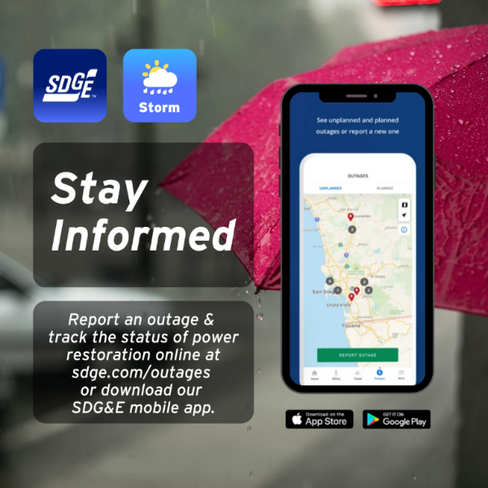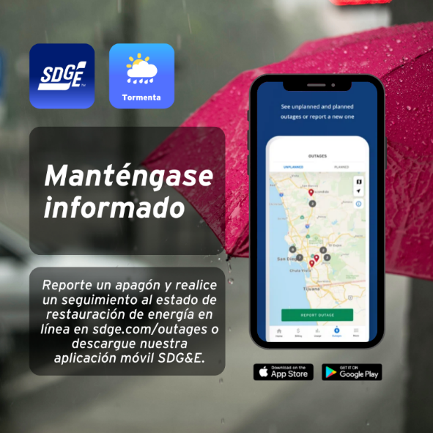

Article: TAKE ADVANTAGE OF NO-COST TRAINING FROM ENERGY EXPERTS
Did you know that SDG&E provides webinars for business owners and trade professionals, so you can learn new skills at your own pace? And most are at no cost. You or your employees can learn about the latest in green building practices, technology and energy-saving solutions from industry experts. Certifications and continuing education units are available for many classes. Check out the class listing at sdge.com/EnergyClasses.
Are you a Trade Professional? Join SDG&E’s Trade Professional Alliance at sdge.com/TradePro.
Some of October’s topics include:
- Decarbonizing the Built Environment
- Green Buildings
- Home Energy Series for Home Pros
- Lighting Fundamentals
- Using Energy Efficiency to Decarbonize Commercial Kitchens
- Designing Commercial Spaces with Modern Ceiling Fans
- Horticulture and Indoor Agricultural Lighting
- Electric Heat Pumps for Water Heating
Social posts: TAKE ADVANTAGE OF NO-COST TRAININGS FROM ENERGY EXPERTS
- Did you know SDG&E provides energy education and training webinars at no cost? These on-demand webinars are offered at introductory, intermediate and advanced levels. See the webinar list at sdge.com/EnergyClasses. #sdge #SDGEAssist
- Learn the latest in green building design, operations, maintenance and technology at no-cost energy webinars led by industry experts. See the on-demand webinar list at sdge.com/EnergyClasses. #sdge #SDGEAssist
- Enroll in a no-cost, on-demand energy topic webinar. Energy education and training can give you and your employees the knowledge and skills that customers value. Check out the webinar list at sdge.com/EnergyClasses. #sdge #SDGEAssist

Images: TAKE ADVANTAGE OF NO-COST TRAININGS FROM ENERGY EXPERTS
Twitter:
Instagram/Facebook:

