

SDG&E® RESIDENTIAL AND SMALL BUSINESS CONTENT PACKAGE | OCTOBER 2023
As a trusted community partner, we thank you for sharing our content and digital assets with your audiences – including residents, customers and employees – to help amplify our key messages in your email communications, websites or newsletters.
Best practices for using our content, social media posts and images
- IMAGES
Choose IMAGES that are relevant for your audience and feel free to mix and match what we provide. For alternate IMAGES, Unsplash.com and Canva.com offer free IMAGES that you can download.
- SDG&E logo
You’re welcome to mention our name but, due to legal requirements, please do not use our logo in any marketing materials that you create. Please only use the SDG&E logo if we provide it to you in this package or it’s publicly available online like a social post or video. You can also retweet our public posts which you’ll find on twitter.com/sdge.
- Videos
We have a library of videos you can share in your communications and SOCIAL POSTS when you visit youtube.com/c/SanDiegoGasElectric/videos. If you’d like to sort our videos by topic, visit youtube.com/c/SanDiegoGasElectric. Some videos are in Spanish. You’ll see some on TV, too!
Follow us
Find us on Facebook, Instagram, Twitter, YouTube and LinkedIn. When sharing our digital assets and content, feel free to tag SDG&E’s social media and direct your audience to sdge.com.

This month’s topics: Gas appliance safety checks, assistance programs, EV Day, energy webinars, mobile app, Cool Zones, California Climate Credit

ARTICLE: SCHEDULE YOUR FREE SDG&E GAS APPLIANCE SAFETY CHECK
As the weather gets cooler, the use of natural gas appliances like water heaters, furnaces and ovens can go up. Schedule a gas appliance check with SDG&E to make sure your appliances are working properly and efficiently to help keep gas bills lower. Getting your appliances inspected is a great way to help prevent carbon monoxide poisoning too.

One of SDG&E’s gas technicians will come to your home or business to inspect your natural gas appliances. There are several complimentary services:
- Light and inspect gas pilot lights. Make sure pilot lights and burner flames are a clear blue.
- Check that gas appliances are operating safely and efficiently and not emitting carbon monoxide.
- Ensure gas furnaces are working properly and inspect the condition of the filter which improves the furnace’s heating ability.

Visit sdge.com/GasCheck for details. You can schedule your appointment at sdge.com/MyAccount or on SDG&E’s mobile app. When in My Account, select “Services,” “Services Overview” then “Gas Appliances Check.” If you’re in the app, select the “More” tab. From “Services,“ select “Gas Appliances Check.”
SOCIAL POSTS: SCHEDULE YOUR FREE SDG&E GAS APPLIANCE SAFETY CHECK
- SDG&E can inspect your gas appliances for safety, make minor adjustments and light heater pilots. Schedule your free SDG&E inspection at sdge.com/MyAccount or in SDG&E’s mobile app. When in My Account, select “Services,” “Services Overview” then “Gas Appliances Check.” If you’re in the app, select the “More” tab, “Services,“ then “Gas Appliances Check.” #sdge #SDGEassist
- Get your gas appliances evaluated to help prevent carbon monoxide poisoning. Schedule your free SDG&E inspection at sdge.com/MyAccount or in SDG&E’s mobile app. When in My Account, select “Services,” “Services Overview” then “Gas Appliances Check.” If you’re in the app, select the “More” tab, “Services,“ then “Gas Appliances Check.” #sdge #SDGEassist
- SDG&E will visit your home and check that your gas appliances are safe. Schedule your free SDG&E inspection at sdge.com/MyAccount or in SDG&E’s mobile app. When in My Account, select “Services,” “Services Overview” then “Gas Appliances Check.” If you’re in the app, select the “More” tab, “Services,“ then “Gas Appliances Check.” #sdge #SDGEassist
IMAGES: SCHEDULE YOUR FREE SDG&E GAS APPLIANCE SAFETY CHECK
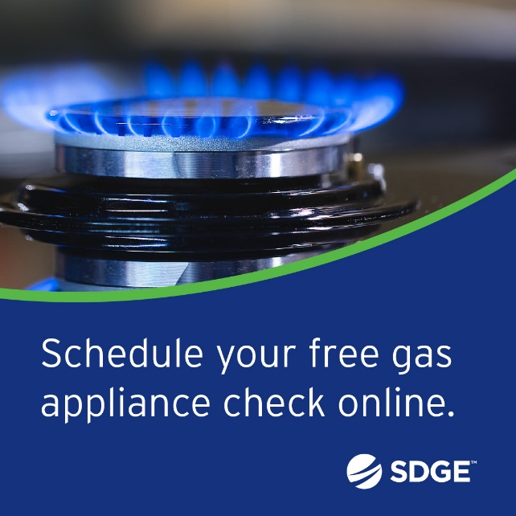
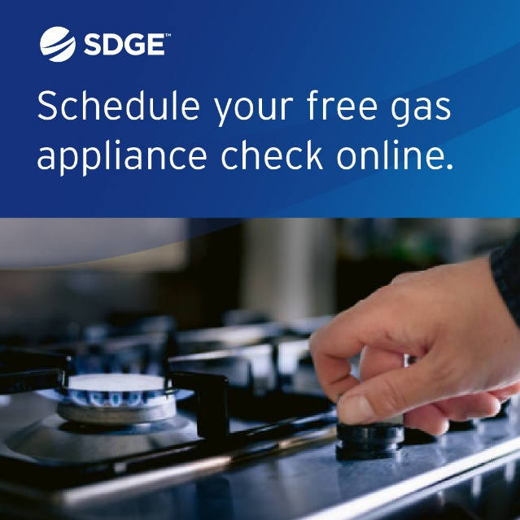
ARTICLE: NEED HELP WITH YOUR ENERGY BILL?

SDG&E recognizes that this can be a challenging time for many customers and may be able to help if you are having trouble paying your bill. You might be eligible for programs and services that can provide immediate financial assistance and help you avoid interruptions in your service. Flexible payment arrangements are also available to help you pay down past due balances. Learn more at sdge.com/Payment-Arrangements.
Check out these energy assistance programs:
- California Alternate Rates for Energy (CARE) Program: Save 30% or more every month on your bill. Find out if you qualify at sdge.com/CARE.
- Family Electric Rate Assistance (FERA) Program: If you don’t qualify for CARE and your household has 3 or more people, you may qualify for FERA. You could receive an 18% discount on your electric bill. Visit sdge.com/FERA to learn more.
- Energy Savings Assistance (ESA) Program: You may qualify to receive free energy-saving improvements for your home, like new appliances, lighting, insulation and more. Find details at sdge.com/ESA.
- Arrearage Management Plan (AMP): If you have outstanding bills and you are a CARE or FERA customer, you may be eligible for debt forgiveness. See if you qualify at sdge.com/AMP.
Even if you made a recent payment or set up a flexible payment plan with SDG&E, there may still be assistance programs available to help you. For a complete list of available offerings, visit sdge.com/assistance.

SOCIAL POSTS: NEED HELP WITH YOUR ENERGY BILL?
- If you’re behind on your energy bill, you may qualify for financial assistance. Learn more at sdge.com/assistance. #sdge #SDGEAssist
- Hardship is everywhere right now – the last thing you need to worry about is your energy bill. Get help with your bill at sdge.com/assistance. #sdge #SDGEAssist
- SDG&E provides assistance programs to help you with your monthly energy bill which can include up to a 30% discount. Find out if you qualify at sdge.com/assistance. #sdge #SDGEAssist
- Whether you rent or own, you could be eligible to receive no-cost, energy-efficient home improvements that can make your home more comfortable and help reduce your energy bill. Find out if you qualify at sdge.com/ESA. #sdge #SDGEAssist

ARTICLE (translated): ¿NECESITA AYUDA CON SU FACTURA DE ENERGÍA?
Usted puede calificar para un descuento en su factura o mejoras en el hogar. Los programas de asistencia de SDG&E ayudan a reducir su factura mensual de energía mientras mantiene su hogar cómodo.
- Programa de Tarifas Alternativas de Energía de California (CARE, por sus siglas en inglés): Ahorre un 30% o más cada mes en su factura. Averigüe si califica en sdge.com/CAREesp.
- Tarifa Eléctrica Familiar (FERA, por sus siglas en inglés): Si no califica para CARE y su hogar tiene 3 o más personas, puede calificar para FERA. Podría recibir un 18% de descuento en su factura de electricidad. Visite sdge.com/FERAesp para obtener más información.
- Programa de Asistencia para el Ahorro de Energía (ESA, por sus siglas en inglés): Puede calificar para recibir mejoras gratuitas para el ahorro de energía en su hogar, tales como electrodomésticos nuevos, iluminación, aislamiento y más. Encuentre los detalles en sdge.com/ESAesp.
- Arrearage Management Plan (AMP): Si tiene facturas pendientes y es participante en el programa de CARE o FERA, puede ser elegible para la condonación de deudas. Averigüe si califica en sdge.com/AMPesp.

Las aplicaciones en línea son fáciles, rápidas y convenientes. Para obtener más información, visite sdge.com/asistencia.

POSTAS SOCIALES: ¿NECESITA AYUDA CON SU FACTURA DE ENERGÍA?
- Si está atrasado en su factura de energía, puede calificar para asistencia financiera. Obtenga más información en sdge.com/asistencia. #sdge #SDGEAssist
- En este momento, las dificultades se encuentran en todas partes - lo último que necesita es preocuparse por su factura de energía. Obtenga ayuda con su factura ensdge.com/asistencia. #sdge #SDGEAssist
- SDG&E ofrece programas de asistencia para ayudarle con su factura mensual que puede incluir hasta un 30% de descuento. Descubra si califica en sdge.com/asistencia. #sdge #SDGEAssist
- Si alquile o es propietario, podría ser elegible para recibir mejoras de eficiencia energética en su hogar, sin costo, que pueden hacer que su hogar sea más cómodo y ayuden reducir su factura de energía. Descubra si califica en sdge.com/ESAesp. #sdge #SDGEAssist

IMAGES: NEED HELP WITH YOUR ENERGY BILL?




ARTICLE: Rev Up Your Curiosity at THE San Diego Electric Vehicle Day EVENT
Are you eager to explore the latest electric vehicle (EV) models and their impressive features? The 11th annual San Diego Electric Vehicle Day event features test drives of the newest EVs, a showcase of electric vehicles, good food and family entertainment. Get ready for an electrifying experience!
This year's event is set to make history as the largest of its kind in the region, offering a lineup of over 50 EVs for test drives and exhibition. The new venue at Snapdragon Stadium provides significantly more space than the previous location ensuring ample room for test drives, vehicle displays and a host of family-friendly activities. Join us for an unforgettable day of EV exploration.
Date and Time: Saturday, October 14th, from 10 a.m. to 3 p.m.
Location: Snapdragon Stadium, 2101 Stadium Way, San Diego, CA 92108
Admission: Free
SOCIAL POSTS: Rev Up Your Curiosity at THE San Diego Electric Vehicle Day EVENT
- Join @SDGE at the 11th annual San Diego EV Day on Oct. 14th! At this free event located at @SnapDragonStadium, you'll be able to test drive the latest EV models, learn about charging options and enjoy a day of family fun. Learn more at sdge.com/EVday. #LOVELECTRIC #sdge #SDGEassist
- Discover the world of electric vehicles at EV Day on Oct. 14th at @SnapDragonStadium. This no-cost event sponsored by @SDGE invites you to drive the latest EV models, chat with local EV owners and learn about EV incentives. Let's drive change together! Learn more at sdge.com/EVday. #LOVELECTRIC #sdge #SDGEassist
- Embrace the power of electric vehicles with @SDGE at @SnapdragonStadium on Oct. 14th! From test drives to eco-friendly vendors, San Diego's EV Day is a free event that has it all. Learn more at sdge.com/EVday. #LOVELECTRIC #sdge #SDGEassist

IMAGES: Rev Up Your Curiosity at THE San Diego Electric Vehicle Day EVENT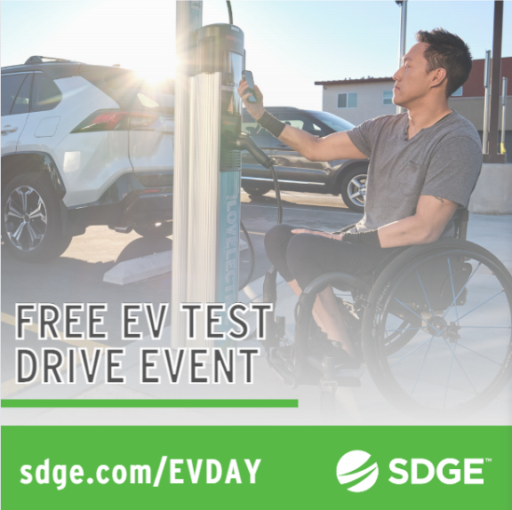
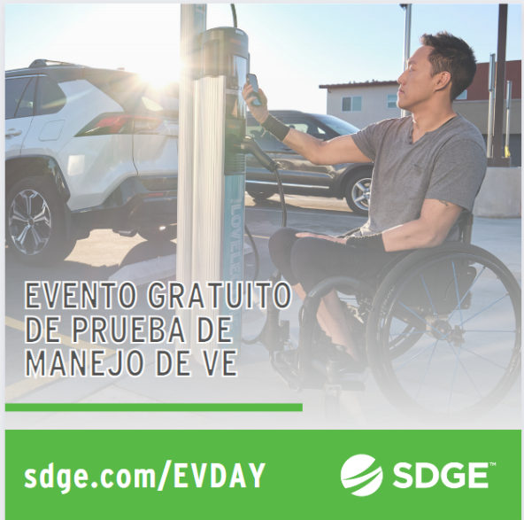

ARTICLE: TAKE ADVANTAGE OF NO-COST TRAINING FROM ENERGY EXPERTS
Did you know that SDG&E provides webinars for business owners and trade professionals, so you can learn new skills at your own pace? And most are at no cost. You or your employees can learn about the latest in green building practices, technology and energy-saving solutions from industry experts. Certifications and continuing education units are available for many classes. Check out the class listing at sdge.com/EnergyClasses.
SOCIAL POSTS: TAKE ADVANTAGE OF NO-COST TRAININGS FROM ENERGY EXPERTS
- Did you know SDG&E provides energy education and training webinars at no cost? These on-demand webinars are offered at introductory, intermediate and advanced levels. See the webinar list at sdge.com/EnergyClasses. #sdge #SDGEassist
- Learn the latest in green building design, operations, maintenance and technology at no-cost energy webinars led by industry experts. See the on-demand webinar list at sdge.com/EnergyClasses. #sdge #SDGEassist
- Enroll in a no-cost, on-demand energy topic webinar. Energy education and training can give you and your employees the knowledge and skills that customers value. Check out the webinar list at sdge.com/EnergyClasses. #sdge #SDGEassist

imageS: TAKE ADVANTAGE OF NO-COST TRAININGS FROM ENERGY EXPERTS


NEW SECTION!
JUST POSTS – Residential
- Do you rent or own a single-family home? Eligible customers may receive free products such as smart thermostats, low-flow showerheads, brushless fan motors, HVAC services like air duct testing and sealing – and more. SDG&E has contracted with Synergy Companies to provide customers with energy efficiency audits from their experts. Customers can request a home visit at SynergyCompanies.com or by calling 1-888-272-8394. Learn more at sdge.com/RES. #sdge #SDGEassist
- Customers who are struggling to pay their SDG&E bill are encouraged to visit sdge.com/assistance to explore all of the resources available to them – bill discounts, debt relief, payment arrangements and no-cost energy efficiency upgrades that can help lower their bill long-term. #sdge #SDGEassist
- Qualifying SDG&E customers can receive rebates toward the purchase of energy-efficient products for the home. Learn more about the Golden State Rebates program at sdge.com/rebates. #sdge #SDGEassist
- The Neighbor-to-Neighbor program provides eligible SDG&E customers with up to $600 to offset their outstanding energy bills. SDG&E customers may apply if they are experiencing serious illness, temporary unemployment, disability or unusual hardship. Learn more at sdge.com/NTN. #sdge #SDGEassist
- To help make your bills a little more predictable, and even out the highs and lows of your seasonal energy bills, enroll in SDG&E’s Level Pay Program. It automatically averages your energy bill every three months so you can budget more easily. Learn more at sdge.com/LPP. #sdge #SDGEassist

Posts promoting October’s CA Climate Credit:
- If you’re a residential SDG&E electric customer, or a residential community choice aggregation customer, you’ll receive a $60.70 Climate Credit on your upcoming bill! For more info, visit bit.ly/46vGUaP. #sdge #SDGEassist
- Look forward to a break on your upcoming electric bill! You’ll receive a $60.70 Climate Credit if you’re an SDG&E residential electric customer or a community choice aggregation customer. For details, visit bit.ly/46vGUaP. #sdge #SDGEassist


Check out our posts about Cool Zones:
- Visit a Cool Zone which is a network of free, air-conditioned facilities across San Diego County like libraries and community centers. If you’re unable to get to a Cool Zone, call 2-1-1 to be connected to a transportation service at no cost. Visiting Cool Zones is also a way to use less energy at home and help reduce your energy costs. Find a Cool Zone near you at sdge.com/Cool-Zones or bit.ly/43EdfKw. #sdge #SDGEassist
- Looking for a place to cool off? Visit a Cool Zone to get respite from the heat. Find a Cool Zone near you at sdge.com/Cool-Zones or bit.ly/43EdfKw. #sdge #SDGEassist


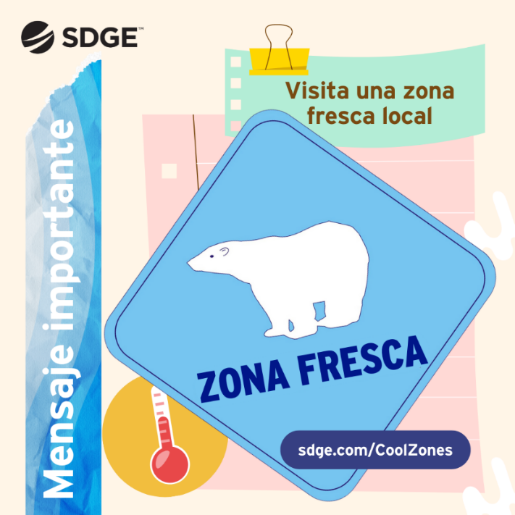

Here are a few posts promoting our mobile app:
- SDG&E's mobile app makes it easy to view and pay your bill, track your energy use and more! You can even schedule service requests like a gas appliance check – just in time for the cooler weather. Download from the App Store or Google Play. Visit sdge.com/MobileApp for more info. #sdge #SDGEassist
- With SDG&E’s mobile app, you can set energy use and cost alerts, pay your bill, track power outages and restoration times, and view your projected bill. Get more info at sdge.com/MobileApp. #sdge #SDGEassist
- Stay informed about your energy use with SDG&E’s mobile app. You can monitor your energy use, access your projected bill, set energy alerts and more. Download from the App Store or Google Play. #sdge #SDGEassist
- SDG&E's mobile app is a convenient way to pay your bill, track your energy use and report outages. Sign in with fingerprint or face recognition. Download from the App Store or Google Play. #sdge #SDGEassist
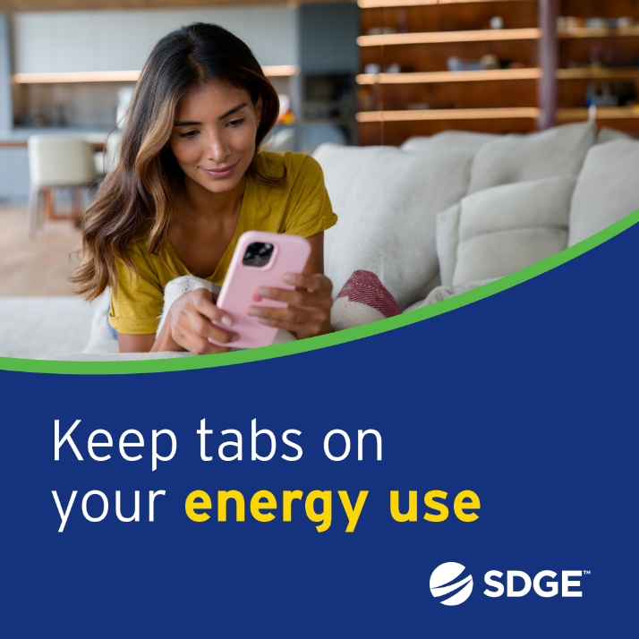


JUST POSTS – Business
- Do you own a small business? Receive energy-efficient upgrades like lighting, water heaters and refrigeration controls when you sign up for a no-cost energy assessment. One of SDG&E’s contractors will come to your business, make recommendations on where to save energy and install new equipment – many items at no cost! For more information, visit sdge.com/BES. #sdge #SDGEassist
- When your business participates in SDG&E’s ELRP program, you can earn financial incentives of $2 per kilowatt-hour when your business reduces energy during a grid emergency. Get more information at sdge.com/ELRP. #sdge #SDGEassist
- Looking for ways to save energy at your business or office? Check out sdge.com/MyBusiness for energy-saving tips. #sdge #SDGEassist
- As the weather transitions to cooler temperatures, it's important to ensure your heating system is working efficiently. Schedule routine maintenance for your HVAC system including cleaning, filter replacement and tuning. A well-maintained system operates more efficiently, reducing energy consumption. Get more energy-saving tips at sdge.com/MyBusiness. #sdge #SDGEassist
- Encourage employees to power down computers, printers, and other electronics at the end of the workday. Many devices continue to draw power in standby mode, which can add up over time. Get more energy-saving tips at sdge.com/MyBusiness. #sdge #SDGEassist





