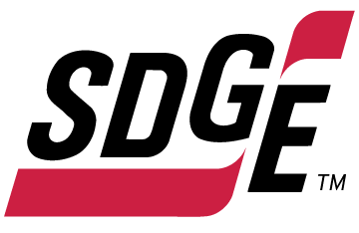

**SDG&E RESIDENTIAL CONTENT PACKAGE | OCTOBER 2021**

As a trusted community partner, we thank you in advance for sharing these digital assets with your audiences, including residents, customers and employees to help amplify our monthly messages. Here are social media posts, articles and photos you are welcome to use in email communications, websites or newsletters. There are several images with each posting. Please choose images that fit your audience and feel free to mix and match.

**Follow Us**

You can find us on [Facebook](https://www.facebook.com/SanDiegoGasandElectric), [Instagram](https://www.instagram.com/sdge), [Twitter](https://twitter.com/SDGE), [YouTube](https://www.youtube.com/sandiegogaselectric) and [LinkedIn](http://linkedin.com/company/sdge). When sharing these messages in your social posts, feel free to tag SDG&E’s social media accounts and direct your audience to sdge.com.

**This month’s topics**: SDG&E microgrids, EV charging, customer assistance programs

**Article 1: MICROGRIDS HELP COMMUNITIES BECOME MORE CLIMATE RESISTANT**

In 2013, SDG&E installed the country’s first utility-scale microgrid. Since then, SDG&E has built four more microgrids to help lessen the impact of public safety power shutoffs, also known as PSPS, for communities located in wildfire-prone regions of San Diego County.

Microgrids are small grids that operate in parallel or independently of the larger electric grid. They have become an important tool to increase community resiliency, allowing the power to flow to critical facilities such as health clinics, schools or defense bases during a PSPS.

One of the newest microgrids is in Cameron Corners, a remote community located in a high fire-threat district in eastern San Diego County. The Cameron Corners microgrid features a state-of-the-art 2,000 kWh flow battery system to store clean energy produced by local solar panels and power the CAL FIRE and central telecommunications switching station in the event of an extended outage or emergency.

*Groundbreaking Technology*

The iron-oxide battery storage is the first of its kind to use ions, salt and water as electrolytes, making the energy storage non-hazardous, non-flammable and fully recyclable.

In addition to the battery, the Cameron Corners microgrid features an 875 kW solar array to generate renewable electricity and an advanced controller to integrated distributed energy resources. Once online, the Cameron Corners Microgrid will support normal grid operations by generating solar power and dispatching clean energy when needed to support grid stability and reliability. Learn more at [**sdgenews.com/article/sdge-microgrids-help-communities-become-more-climate-resilient**](https://www.sdgenews.com/article/sdge-microgrids-help-communities-become-more-climate-resilient).

**Social posts: MICROGRIDS HELP COMMUNITIES BECOME MORE CLIMATE RESISTANT**

1. Four microgrids, built by SDG&E, will help lessen the impact of public safety power shutoffs. Learn more at [**sdgenews.com/article/sdge-microgrids-help-communities-become-more-climate-resilient**](https://www.sdgenews.com/article/sdge-microgrids-help-communities-become-more-climate-resilient). #sdge #SDGEassist
2. Energy resiliency and reliability is a priority for our community. Four microgrids are being developed by SDG&E to help keep customers and critical facilities energized during power outages. Visit [**sdgenews.com/article/sdge-microgrids-help-communities-become-more-climate-resilient**](https://www.sdgenews.com/article/sdge-microgrids-help-communities-become-more-climate-resilient) for more info. #sdge #SDGEassist

**Images: MICROGRIDS HELP COMMUNITIES BECOME MORE CLIMATE RESISTANT**

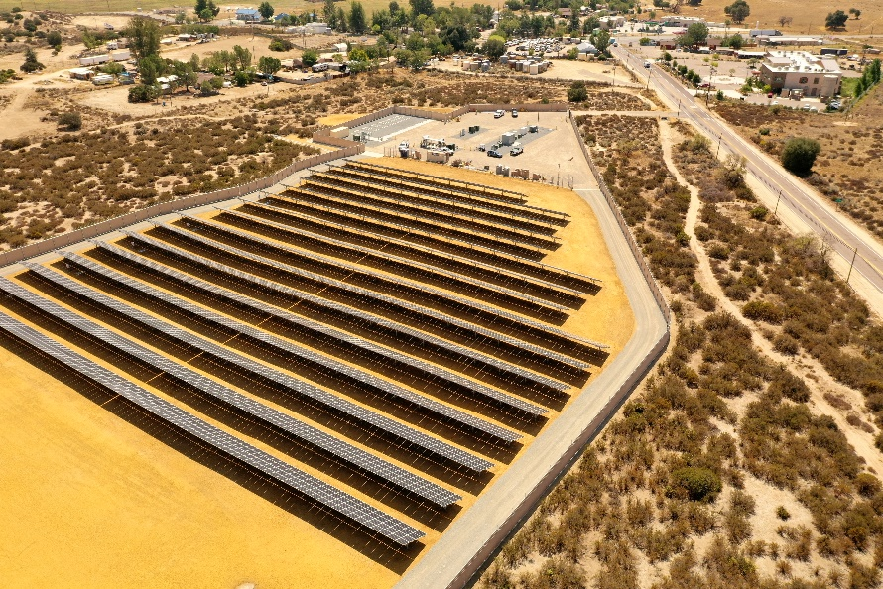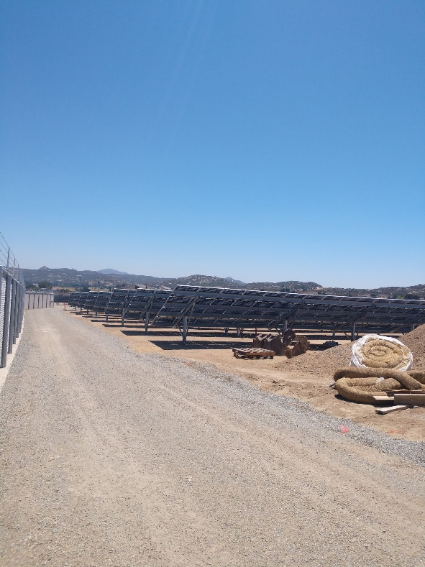

**Article 2: Driving an electric vehicle in san diego has just been made easier** (from sdge.com and NewsCenter article)

SDG&E is installing 336 electric vehicle (EV) chargers at 52 sites to help reduce greenhouse gas emissions (GHGs) and air pollution. These locations include popular community facilities in the region such as parks, beaches and schools to accommodate existing EV drivers and encourage EV adoption. The two types of chargers that will be installed include: Level 2 (208-240 volt) chargers that can provide up to 10-20 miles of range per hour of charging and DC fast chargers (480 volt) that can provide about 50-60 miles per hour of charging.  For more information, visit [**sdge.com/EV-Charging**](https://www.sdge.com/residential/electric-vehicles/power-your-drive/power-your-drive-for-schools-parks-and-beaches)**.**

To support local, regional and state climate and air quality goals, SDG&E has been working aggressively to expand the regional EV charging infrastructure to support zero-emission cars, trucks, buses and more. In the coming years, SDG&E plans to build thousands more chargers regionwide.​​​​​​​

Transportation is the single largest source of greenhouse gas emissions (GHG) in California. It accounts for 41% of all GHG in the state. Transportation is also a significant source of air pollution. Under the Power Your Drive for Schools, Parks and Beaches, SDG&E’s goal is to install 50% of the chargers in underserved communities.

Learn more about SDG&E’s EV program at [**sdge.com/lovelectric**](https://www.sdge.com/residential/lovelectric).

**Social posts: EV CHARGErS being INSTALLED AT SCHOOLS, PARKS AND BEACHES**

1. Regardless of where you live, work and play, electric vehicle chargers are more accessible, so anyone who is interested in making the switch to a plug-in vehicle can do it. Get more information at [**sdge.com/lovelectric**](https://www.sdge.com/residential/lovelectric)**.** #sdge #SDGEassist
2. Driving an electric vehicle is getting easier. SDG&E is installing 336 electric vehicle chargers at 52 sites including parks, beaches and schools. Get details at [**sdge.com/EV-Charging**](https://www.sdge.com/residential/electric-vehicles/power-your-drive/power-your-drive-for-schools-parks-and-beaches)**.** #sdge #SDGEassist
3. Charge your electric vehicle at over 50 new sites! Locations include parks and beaches. Level 2 and DC fast chargers are being installed by SDG&E. Learn more at [**sdge.com/EV-Charging**](https://www.sdge.com/residential/electric-vehicles/power-your-drive/power-your-drive-for-schools-parks-and-beaches)**.** #sdge #SDGEassist

**Images: EV CHARGErS being INSTALLED AT SCHOOLS, PARKS AND BEACHES**

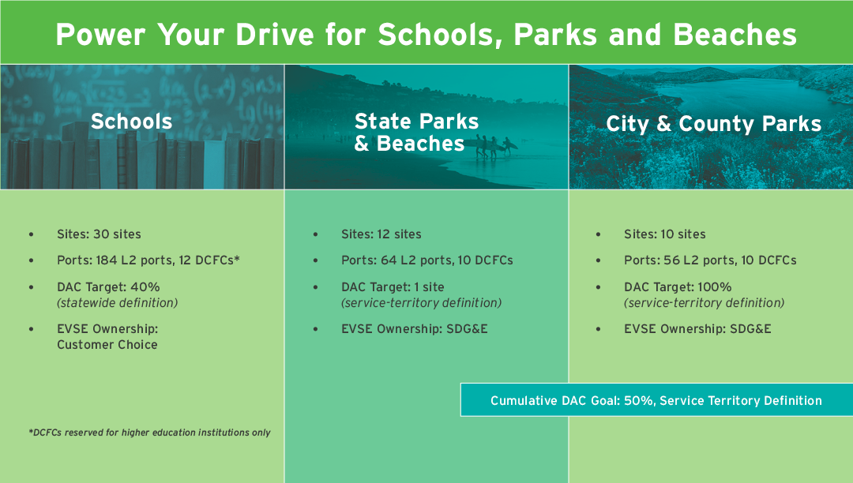

**Article 3: NEED HELP WITH YOUR ENERGY BILL?**

You may qualify for a bill discount or home improvements. SDG&E’s assistance programs can help you lower your energy use and/or monthly energy bill while keeping your home comfortable.

In collaboration with the San Diego Housing Commission, San Diego & Imperial Counties Labor Council, and other community-based organizations, SDG&E helped publicize local, state and federal COVID assistance programs through outreach events and public education materials. $10 million from the Emergency Rent and Utilities Assistance program (ERAP) has gone to help pay off local residents’ outstanding energy bills.

California Alternate Rates for Energy (CARE) Program: Save 30% or more every month on your energy bill. Find out if you qualify at [**sdge.com/CARE**](https://www.sdge.com/residential/pay-bill/get-payment-bill-assistance/assistance-programs).

Family Electric Rate Assistance (FERA) Program: If you don’t qualify for CARE and your household has 3 or more people, you may qualify for FERA. You could receive an 18% discount on your electric bill. Visit [**sdge.com/FERA**](https://www.sdge.com/FERA) for more information.

Energy Savings Assistance (ESA) Program: You may qualify to receive no-cost, energy-saving improvements for your home, such as new appliances, furnace repair, lighting, insulation and more. Find details at [**sdge.com/ESAP**](https://www.sdge.com/residential/pay-bill/get-payment-bill-assistance/assistance-programs/no-cost-energy-efficient-home-improvements).

Online applications are easy, fast and convenient. To learn more about SDG&E’s assistance programs, visit [**sdge.com/assistance**](https://www.sdge.com/residential/pay-bill/get-payment-bill-assistance).

**Social posts: NEED HELP WITH YOUR ENERGY BILL?**

1. If you’re behind on your energy bill, you may qualify for financial assistance. Learn more at [**sdge.com/assistance**](https://www.sdge.com/residential/pay-bill/get-payment-bill-assistance). #sdge #SDGEassist
2. Hardship is everywhere right now – the last thing you need is to worry about your energy bill. Get help with your bill at [**sdge.com/assistance**](https://www.sdge.com/residential/pay-bill/get-payment-bill-assistance). #sdge #SDGEassist
3. SDG&E provides assistance programs to help you with your monthly bill which can include up to a 30% discount. Find out if you qualify at [**sdge.com/assistance**](https://www.sdge.com/residential/pay-bill/get-payment-bill-assistance). #sdge #SDGEassist
4. Whether you rent or own, you could be eligible to receive no-cost, energy-efficient home improvements that can make your home more comfortable and reduce your energy bill. Find out if you qualify at [**sdge.com/ESAP**](https://www.sdge.com/residential/pay-bill/get-payment-bill-assistance/assistance-programs/no-cost-energy-efficient-home-improvements). #sdge #SDGEassist

**Article 3 (translated): ¿Necesita ayuda con su FACTURA de energía?**

Usted puede calificar para un descuento en su factura o mejoras en el hogar. Los programas de asistencia de SDG&E ayudan a reducir su factura mensual de energía mientras mantiene su hogar cómodo.

Programa de Tarifas Alternativas de Energía de California (CARE, por sus siglas en inglés): Ahorre un 30% o más cada mes en su factura. Averigüe si califica en [**sdge.com/CARE**](https://www.sdge.com/programas-de-asistencia-para-tarifas-residenciales).

Programa de Asistencia de Tarifa Eléctrica Familiar (FERA, por sus siglas en inglés): Si no califica para el programa de CARE y su hogar tiene 3 o más personas, puede calificar para FERA. Podría recibir un 18% de descuento en su factura de electricidad. Visite [**sdge.com/FERA**](https://www.sdge.com/programas-de-asistencia-para-tarifas-residenciales) para obtener más información.

Programa de Asistencia para el Ahorro de Energía (ESA, por sus siglas en inglés): Puede calificar para recibir mejoras gratuitas para el ahorro de energía en su hogar, tales como electrodomésticos nuevos, reparación de hornos, iluminación, aislamiento y más. Encuentre los detalles en **sdge.com/ESAP**.

Las aplicaciones en línea son fáciles, rápidas y convenientes. Para obtener más información, visite [**sdge.com/asistencia**](https://www.sdge.com/asistencia-para-clientes-residenciales).

**Postas sociales: ¿Necesita ayuda con su FACTURA de energía?**

1. Si está atrasado en su factura de energía, puede calificar para asistencia financiera. Obtenga más información en [**sdge.com/asistencia**](https://www.sdge.com/asistencia-para-clientes-residenciales). #sdge #SDGEassist
2. En este momento, las dificultades se encuentran en todas partes - lo último que necesita es preocuparse por su factura de energía. Obtenga ayuda con su factura en [**sdge.com/asistencia**](https://www.sdge.com/asistencia-para-clientes-residenciales). #sdge #SDGEassist
3. SDG&E ofrece programas de asistencia para ayudarle con su factura mensual que puede incluir hasta un 30% de descuento. Descubra si califica en [**sdge.com/asistencia**](https://www.sdge.com/asistencia-para-clientes-residenciales). #sdge #SDGEassist
4. Ya sea que alquile o sea propietario, podría ser elegible para recibir mejoras de eficiencia energética en su hogar, sin costo, que pueden hacer que su hogar sea más cómodo y reducir su factura de energía. Descubra si califica en [**sdge.com/ESAP**](https://www.sdge.com/esaespanol). #sdge #SDGEassist

**Images: NEED HELP WITH YOUR SDG&E BILL?**



**211/AFN social posts**

1. During wildfire season, some of us need a little more help. That’s why SDG&E is working with 211 San Diego to help provide additional customer assistance if a Public Safety Power Shutoff is necessary. To get connected to community, health, social and disaster services, call 211 or visit [**211sandiego.org**](https://211sandiego.org/). #sdge #SDGEassist

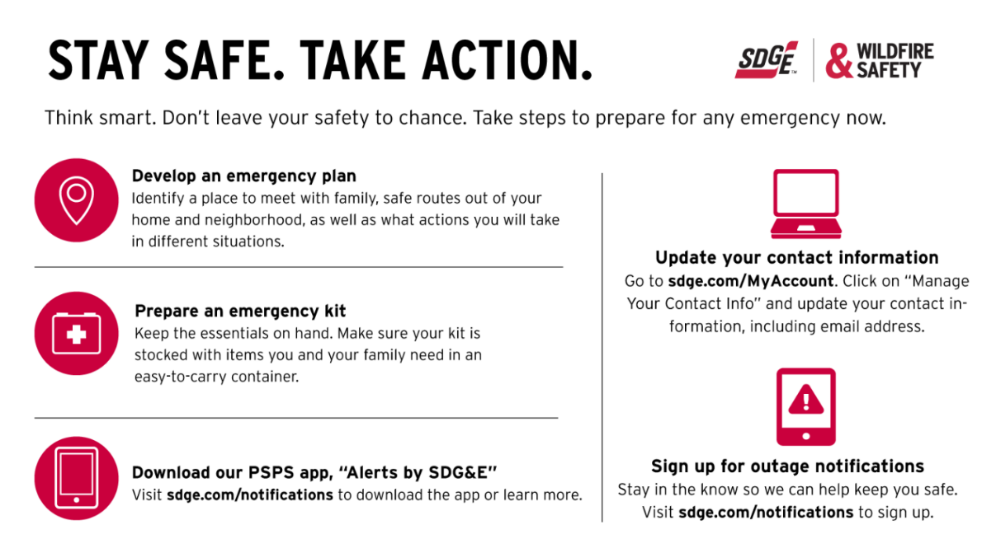

1. SDG&E is committed to making sure that everyone is offered equal opportunity to access their information, resources and services. Visit [**sdge.com/AFN**](https://www.sdge.com/access-and-functional-needs-afn) for information to help prepare for emergencies and find support services during a Public Safety Power Shutoff. #sdge #SDGEassist

