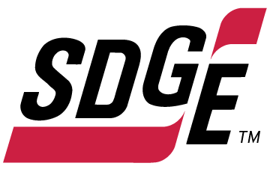

SDG&E RESIDENTIAL AND SMALL BUSINESS CONTENT PACKAGE | NOVEMBER 2022
As a trusted community partner, we thank you for sharing our content and digital assets with your audiences – including residents, customers and employees – to help amplify our key messages in your email communications, websites or newsletters.
Best practices for using our content, social media posts and images
- Images
Please choose images that are relevant for your audience and feel free to mix and match what we provide. For alternate images, Unsplash.com and Canva.com offer free images that you can download.
- SDG&E logo
You’re welcome to mention our name but, due to legal requirements, please do not use our logo in any marketing materials that you create. Please only use the SDG&E logo if we provide it to you in this package or it’s publicly available online like a social post or video. You can also retweet our public posts which you’ll find on twitter.com/sdge.
- Videos
We have a library of videos you can share in your communications and social posts when you visit youtube.com/c/SanDiegoGasElectric/videos. If you’d like to sort our videos by topic, visit youtube.com/c/SanDiegoGasElectric. Some videos are in Spanish. Our newest videos discuss the path to net zero, fire hardening and safety, public safety power shutoffs, 811 Dig Alert and more. You’ll see some on TV, too!
This month’s topics: Emergency Preparedness, Medical Baseline Program, Temperature Sensitive Program, free energy-related webinars

Follow us
You can find us on Facebook, Instagram, Twitter, YouTube and LinkedIn. When sharing these digital assets and content, feel free to tag SDG&E’s social media accounts and direct your audience to sdge.com.

Article: 5 NO-COST TIPS TO SAVE ENERGY AND MONEY
Looking for ways to save on your energy bill? Check out these energy tips that don’t cost you a thing.
- Talk with your family, friends and neighbors to find out how they conserve energy.
This can help you identify additional things you can do in your home to save. You may discover hidden energy costs, figure out how to eliminate them and learn from each other's good habits.
- If you have a second refrigerator, unplug it when it’s not in use. (Save up to $155/year)
An older refrigerator uses nearly twice as much energy as new efficient models. You pay more to run your spare, older appliance than your primary one in the kitchen. If you only need the extra space around the holidays or you're a renter and can't recycle the landlord's refrigerator, simply unplug it when you don't need it.
- Turn your computer off at night or if you won’t use it for two or more hours. (Save up to $65/year)
Turning off your computer at night could save you up to a third of its energy costs, depending on your use and power management settings. It’s good to give your computer a rest, some software updates require computers to shut down and the fan is more likely to wear out on a machine that continually runs. Shutting a computer down also clears its memory so it may run faster the next time you turn it on. Turn off other home office equipment for greater savings. Plugging all devices into a smart power strip makes this easy.
- Unplug electronics when they’re not in use. (Save up to $100/year)
Many electronic devices continue to draw power even when they are turned off. By unplugging devices and chargers when they are not in use, you can avoid paying for this extra energy. Products that waste electricity like this are known as "vampire devices." Examples include televisions, coffee makers, microwaves, cell phone and battery chargers and video game systems. Many vampire devices have rectangular adapter boxes on their plugs. Plug adapters stay warm to the touch even when the connected device is off – a sign that it is a continuous energy user.
- Make it a habit to turn off lights when you leave a room. (Save up to $50/year)
In an average home, lighting accounts for nearly 9% of electricity costs. Turning lights off when you're not in the room is a simple way for you to make a dent in your utility bill. Before you go to sleep, walk through your home and shut off any forgotten lights. To help get into the habit, try leaving eye-catching reminders near your lights and doorways. Encourage family members to turn off their lights as well. This is a great way for young children to do their part to save energy.

Social posts: 5 NO-COST TIPS TO SAVE ENERGY AND MONEY
Select any of the 5 tips above and, at the end, add:
Visit sdge.com/MyEnergy for more energy-saving tips. #sdge #SDGEassist

Images: 5 NO-COST TIPS TO SAVE ENERGY AND MONEY






Article: NEED HELP WITH YOUR ENERGY BILL?
SDG&E recognizes that this can be a challenging time for many customers and may be able to help if you are having trouble paying your bill. You may be eligible for programs and services that can provide immediate financial assistance and help you avoid interruptions in your service. Flexible payment arrangements are available to help you pay down past due balances. Learn more at sdge.com/Payment-Arrangements.

Check out these energy assistance programs:
- California Alternate Rates for Energy (CARE) Program: Save 30% or more every month on your bill. Find out if you qualify at sdge.com/CARE.
- Family Electric Rate Assistance (FERA) Program: If you don’t qualify for CARE and your household has 3 or more people, you may qualify for FERA. You could receive an 18% discount on your electric bill. Visit sdge.com/FERA to learn more.
- Energy Savings Assistance (ESA) Program: You may qualify to receive free energy-saving improvements for your home, such as new appliances, lighting, insulation and more. Find details at sdge.com/ESA.
- Arrearage Management Plan (AMP): If you have outstanding bills and you are a CARE or FERA customer, you may be eligible for debt forgiveness. See if you qualify at sdge.com/AMP.
- Low-income Home Energy Assistance Program (LIHEAP): This program offers up to $1,000 towards your energy bill. This Federal assistance program also provides support for energy-related home improvements. Learn more at sdge.com/LIHEAP.
Even if you made a recent payment or set up a flexible payment plan with SDG&E, there may still be assistance programs available to help you. For a complete list of available offerings, visit sdge.com/assistance.

Social posts: NEED HELP WITH YOUR ENERGY BILL?
- If you’re behind on your energy bill, you may qualify for financial assistance. Learn more at sdge.com/assistance. #sdge #SDGEAssist
- Hardship is everywhere right now – the last thing you need to worry about is your energy bill. Get help with your bill at sdge.com/assistance. #sdge #SDGEAssist
- SDG&E provides assistance programs to help you with your monthly bill which can include up to a 30% discount. Find out if you qualify at sdge.com/assistance. #sdge #SDGEAssist
- Whether you rent or own, you could be eligible to receive no-cost, energy-efficient home improvements that can make your home more comfortable and help reduce your energy bill. Find out if you qualify at sdge.com/ESA. #sdge #SDGEAssist

Article (translated): ¿NECESITA AYUDA CON SU FACTURA DE ENERGÍA?
Usted puede calificar para un descuento en su factura o mejoras en el hogar. Los programas de asistencia de SDG&E ayudan a reducir su factura mensual de energía mientras mantiene su hogar cómodo.
- Programa de Tarifas Alternativas de Energía de California (CARE, por sus siglas en inglés): Ahorre un 30% o más cada mes en su factura. Averigüe si califica en sdge.com/CARE.
- Tarifa Eléctrica Familiar (FERA, por sus siglas en inglés): Si no califica para CARE y su hogar tiene 3 o más personas, puede calificar para FERA. Podría recibir un 18% de descuento en su factura de electricidad. Visite sdge.com/FERA para obtener más información.
- Programa de Asistencia para el Ahorro de Energía (ESA, por sus siglas en inglés): Puede calificar para recibir mejoras gratuitas para el ahorro de energía en su hogar, tales como electrodomésticos nuevos, iluminación, aislamiento y más. Encuentre los detalles en sdge.com/ESAP.
- Arrearage Management Plan (AMP): Si tiene facturas pendientes y es participante en el programa de CARE o FERA, puede ser elegible para la condonación de deudas. Averigüe si califica en sdge.com/AMP.
- Clientes comerciales: Configure un plan de pago flexible, para que pueda estar tranquilo sabiendo que está cubierto. Visite sdge.com/recovery para obtener más información.
Las aplicaciones en línea son fáciles, rápidas y convenientes. Para obtener más información, visite sdge.com/asistencia.

Postas sociales: ¿NECESITA AYUDA CON SU FACTURA DE ENERGÍA?
- Si está atrasado en su factura de energía, puede calificar para asistencia financiera. Obtenga más información en sdge.com/asistencia. #sdge #SDGEAssist
- En este momento, las dificultades se encuentran en todas partes - lo último que necesita es preocuparse por su factura de energía. Obtenga ayuda con su factura en sdge.com/asistencia. #sdge #SDGEAssist
- SDG&E ofrece programas de asistencia para ayudarle con su factura mensual que puede incluir hasta un 30% de descuento. Descubra si califica en sdge.com/asistencia. #sdge #SDGEAssist
- Si alquile o es propietario, podría ser elegible para recibir mejoras de eficiencia energética en su hogar, sin costo, que pueden hacer que su hogar sea más cómodo y ayuden reducir su factura de energía. Descubra si califica en sdge.com/ESA. #sdge #SDGEAssist

Images: NEED HELP WITH YOUR ENERGY BILL?

Twitter:



Instagram/Facebook:
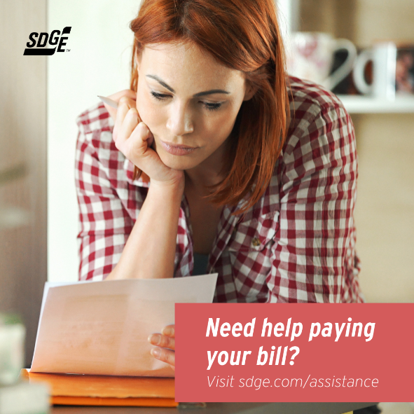


Business Article: 7 WAYS TO REDUCE YOUR BUSINESS’S HEATING BILL
Heating, ventilation and air conditioning (HVAC) uses around 40% of a building’s electricity. In fact, it’s one of the most significant factors in the operating expenses of a business. That’s why it pays to pinpoint HVAC energy waste and reduce it. Here are 7 popular ways to help your business become more energy-efficient and control costs.

Tip #1: Carefully assess the area around each vent for proper ventilation
Is air flowing from the vent circulating freely throughout the room? If there are obstructions that prevent adequate airflow, such as cabinetry or drapes, move them to allow for clear circulation. Don’t keep vents closed to save energy. This can change the way air is distributed and cause an imbalance to the operation of the HVAC system.

Tips #2: Prevent dust and dirt from building up
Replace air filters (or clean them if they’re reusable) monthly, especially during peak heating and cooling seasons. Keeping air filters clean can prevent dust and dirt from building up in the system. When dirt builds up, it can lead to expensive maintenance repairs or the need for a new system.

Tip #3: Check your ducts
Make sure all the ducts that run throughout your building have duct sealant or metal-backed (foil) tape over the seams and connections. You can work with a contractor to wrap the ducts in insulation to keep them from getting hot in the summer or cold in the winter. Contractors can perform verified duct sealing using a special fan to test duct system leakage before and after sealing efforts have been made.

Tip #4: Implement a consistent HVAC maintenance schedule
Not all businesses require the same needs from their HVAC systems. Customized commercial HVAC maintenance plans may be offered by your preferred contractor, which will provide the specific care your system needs to boost performance.
Tips #5: Use heat-recovery technology to transfer energy from exhaust air to incoming outside air
This greatly reduces the energy that’s required to heat or cool incoming air. A qualified contractor can educate customers on available recovery technologies. For example, an energy recovery ventilator (ERV) can be a suitable solution for maintaining comfortable temperature, depending on area location and climate.

Tip #6: Install advanced control sensors to improve a ventilation system’s operating power for energy efficiency
These controls can count the number of people in a room and then adjust the heat and air conditioning accordingly. When the sensors are integrated into a building’s HVAC system, the advanced controls can reduce energy use by almost 40%.

Tip #7: Replace your old, worn-out HVAC
If your HVAC system is more than 10 years old, there’s a good chance you’re spending too much to heat and cool your building. Have a professional contractor give your HVAC system a checkup and see if you should upgrade to high-efficiency ENERGY STAR®-qualified equipment.
For more ideas on how to lower your energy use, visit sdge.com/My-Business.

Social posts: 7 WAYS TO REDUCE YOUR BUSINESS’S HEATING BILL
Use any of the above tips and add:
For more ideas on how to lower your energy use, visit sdge.com/My-Business. #sdge #SDGEassist

Images: 7 WAYS TO REDUCE YOUR BUSINESS’S HEATING BILL
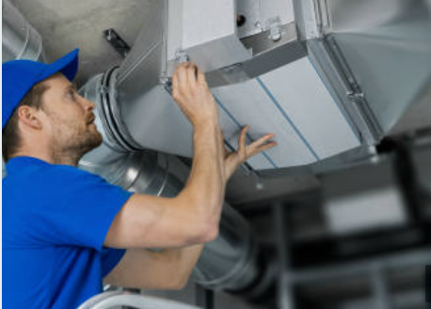
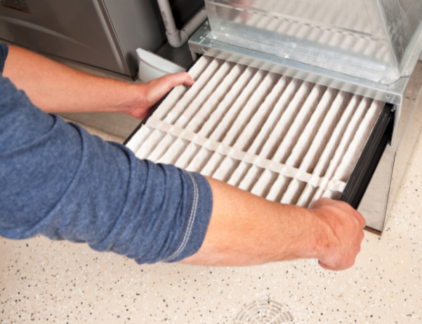


Article: TAKE ADVANTAGE OF NO-COST TRAINING FROM ENERGY EXPERTS
Did you know that SDG&E provides webinars for business owners and trade professionals, so you can learn new skills at your own pace? And most are at no cost. You or your employees can learn about the latest in green building practices, technology and energy-saving solutions from industry experts. Certifications and continuing education units are available for many classes. Check out the class listing at sdge.com/EnergyClasses.
Are you a Trade Professional? Join SDG&E’s Trade Professional Alliance at sdge.com/TradePro.
Some of October’s topics include:
- Decarbonizing the Built Environment
- Green Buildings
- Home Energy Series for Home Pros
- Lighting Fundamentals
- Using Energy Efficiency to Decarbonize Commercial Kitchens
- Designing Commercial Spaces with Modern Ceiling Fans
- Horticulture and Indoor Agricultural Lighting
- Electric Heat Pumps for Water Heating
Social posts: TAKE ADVANTAGE OF NO-COST TRAININGS FROM ENERGY EXPERTS
- Did you know SDG&E provides energy education and training webinars at no cost? These on-demand webinars are offered at introductory, intermediate and advanced levels. See the webinar list at sdge.com/EnergyClasses. #sdge #SDGEAssist
- Learn the latest in green building design, operations, maintenance and technology at no-cost energy webinars led by industry experts. See the on-demand webinar list at sdge.com/EnergyClasses. #sdge #SDGEAssist
- Enroll in a no-cost, on-demand energy topic webinar. Energy education and training can give you and your employees the knowledge and skills that customers value. Check out the webinar list at sdge.com/EnergyClasses. #sdge #SDGEAssist

Images: TAKE ADVANTAGE OF NO-COST TRAININGS FROM ENERGY EXPERTS
Twitter:

Instagram/Facebook:


Social Posts: Gas Appliance Checks

- With cooler weather moving in, now is the time to get your gas furnace inspected to ensure you and your family are safe. Schedule your no-cost SDG&E inspection in My Account. Login to sdge.com/myaccount, select Services, Services Overview and then Gas Appliance Check. #sdge #SDGEassist
- Get your gas appliances tested to help prevent carbon monoxide poisoning. Schedule your no-cost SDG&E inspection in My Account. Login to sdge.com/myaccount, select Services, Services Overview and then Gas Appliance Check. #sdge #SDGEassist
- SDG&E can inspect your gas appliances for safety, make minor adjustments and light heater pilots. Schedule your no-cost SDG&E inspection in My Account. Login to sdge.com/myaccount, select Services, Services Overview and then Gas Appliance Check. #sdge #SDGEassist
- SDG&E will visit your home and check that your gas appliances are safe. Schedule your no-cost SDG&E inspection in My Account. Login to sdge.com/myaccount, select Services, Services Overview and then Gas Appliance Check. #sdge #SDGEassist

