

SDG&E® RESIDENTIAL AND SMALL BUSINESS CONTENT PACKAGE | NOVEMBER 2023
As a trusted community partner, we thank you for sharing our content and digital assets with your audiences – including residents, customers and employees – to help amplify our key messages in your email communications, websites or newsletters.
Best practices for using our content, social media posts and images
- IMAGES
Choose IMAGES that are relevant for your audience and feel free to mix and match what we provide. For alternate IMAGES, Unsplash.com and Canva.com offer free IMAGES that you can download.
- SDG&E logo
You’re welcome to mention our name but, due to legal requirements, please do not use our logo in any marketing materials that you create. Please only use the SDG&E logo if we provide it to you in this package or it’s publicly available online like a social post or video. You can also retweet our public posts which you’ll find on twitter.com/sdge.
- Videos
We have a library of videos you can share in your communications and SOCIAL POSTS when you visit youtube.com/c/SanDiegoGasElectric/videos. If you’d like to sort our videos by topic, visit youtube.com/c/SanDiegoGasElectric. Some videos are in Spanish. You’ll see some on TV, too!
Follow us
Find us on Facebook, Instagram, Twitter, YouTube and LinkedIn. When sharing our digital assets and content, feel free to tag SDG&E’s social media and direct your audience to sdge.com.

This month’s topics: HVAC tips, gas appliance safety checks, assistance programs, energy webinars

ARTICLE: SEALING IN SAVINGS AND COMFORT
When it comes to the efficiency of your heating, ventilation and air conditioning system (HVAC), one of the most overlooked factors is the condition of your ductwork. Failing to properly seal your ducts can lead to a host of problems from wasted energy to reduced comfort levels. Sealing those gaps is one of the cheapest and most effective ways to save your energy dollars.
Finding leaks
Start by locating where air leaks are occurring. It could be any place where two materials meet, such as the foundation walls and the flooring or where there's an opening to the outdoors. Gaps can also occur around exterior doors and cracked caulking around window frames. Another area to check is in the attic — gaps around ceiling fans, recessed light fixtures and electrical outlets.
Fixing leaks
If you find any leaks, sealing them is a simple project you can do yourself with supplies available from your local retailer.
- Windows: Seal windows with exterior caulk. Your best bet is silicone or siliconized caulk.
- Where the window meets the frame, scrape out any existing caulk and make sure the area is clean and dry.
- Cut the tips of the caulk at a 45-degree angle and load it into the caulking gun.
- Run the tips slowly and evenly along the base of the crack.
- Finish by running a wet fingertip along the bead of the caulk to smooth it out.
- Doors: Fix gaps around exterior doors with weatherstripping and a door sweep.
- Measure the top and sides of the door and cut pieces of weatherstripping to fit each.
- Peel back the covering from the adhesive and press the weatherstripping to the inside of the doorstop, ensuring a snug fit.
- Cut the sweep (if needed) to match the width of the door and attach it with adhesive or screws.
- Attic: Ceiling fans, recessed lighting fixtures and electrical outlets in the ceiling below your attic are potential sources of air leakage.
- From the attic, pull back the insulation to find the cutouts and seal them with caulk or expandable foam.
- Check for and seal gaps around plumbing vents, furnace flues and ductwork.
- Seal the attic door or access with weatherstripping.
Learn more about minimizing energy losses in ducts at energy.gov/EnergySaver.
SOCIAL POSTS: SEALING IN SAVINGS AND COMFORT
Use any of the tips in the above article, then add:
For more ways to save energy, visit sdge.com/MyEnergy. #sdge #SDGEassist

IMAGES: SEALING IN SAVINGS AND COMFORT
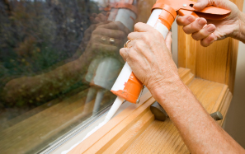


ARTICLE: NEED HELP WITH YOUR ENERGY BILL?

SDG&E recognizes that this can be a challenging time for many people and might be able to help if you are having trouble paying your energy bill. You might be eligible for programs and services that can provide immediate financial assistance and help you avoid interruptions in your service. Flexible payment arrangements are also available to help you pay down past due balances. Learn more at sdge.com/Payment-Arrangements.
Check out these energy assistance programs:
- California Alternate Rates for Energy (CARE) Program: Save 30% or more every month on your bill. Find out if you qualify at sdge.com/CARE.
- Family Electric Rate Assistance (FERA) Program: If you don’t qualify for CARE and your household has 3 or more people, you may qualify for FERA. You could receive an 18% discount on your electric bill. Visit sdge.com/FERA to learn more.
- Energy Savings Assistance (ESA) Program: You may qualify to receive free energy-saving improvements for your home, like new appliances, lighting, insulation and more. Find details at sdge.com/ESA.
- Arrearage Management Plan (AMP): If you have outstanding bills and you are a CARE or FERA customer, you may be eligible for debt forgiveness. See if you qualify at sdge.com/AMP.
Even if you made a recent payment or set up a flexible payment plan with SDG&E, there may still be assistance programs available to help you. For a complete list of available offerings, visit sdge.com/assistance.

SOCIAL POSTS: NEED HELP WITH YOUR ENERGY BILL?
- If you’re behind on your energy bill, you may qualify for financial assistance. Learn more at sdge.com/assistance. #sdge #SDGEAssist
- Hardship is everywhere right now – the last thing you need to worry about is your energy bill. Get help with your bill at sdge.com/assistance. #sdge #SDGEAssist
- SDG&E provides assistance programs to help you with your monthly energy bill which can include up to a 30% discount. Find out if you qualify at sdge.com/assistance. #sdge #SDGEAssist
- Whether you rent or own, you could be eligible to receive no-cost, energy-efficient home improvements that can make your home more comfortable and help reduce your energy bill. Find out if you qualify at sdge.com/ESA. #sdge #SDGEAssist

ARTICLE (translated): ¿NECESITA AYUDA CON SU FACTURA DE ENERGÍA?
Usted puede calificar para un descuento en su factura o mejoras en el hogar. Los programas de asistencia de SDG&E ayudan a reducir su factura mensual de energía mientras mantiene su hogar cómodo.
- Programa de Tarifas Alternativas de Energía de California (CARE, por sus siglas en inglés): Ahorre un 30% o más cada mes en su factura. Averigüe si califica en sdge.com/CAREesp.
- Tarifa Eléctrica Familiar (FERA, por sus siglas en inglés): Si no califica para CARE y su hogar tiene 3 o más personas, puede calificar para FERA. Podría recibir un 18% de descuento en su factura de electricidad. Visite sdge.com/FERAesp para obtener más información.
- Programa de Asistencia para el Ahorro de Energía (ESA, por sus siglas en inglés): Puede calificar para recibir mejoras gratuitas para el ahorro de energía en su hogar, tales como electrodomésticos nuevos, iluminación, aislamiento y más. Encuentre los detalles en sdge.com/ESAesp.
- Arrearage Management Plan (AMP): Si tiene facturas pendientes y es participante en el programa de CARE o FERA, puede ser elegible para la condonación de deudas. Averigüe si califica en sdge.com/AMPesp.

Las aplicaciones en línea son fáciles, rápidas y convenientes. Para obtener más información, visite sdge.com/asistencia.

POSTAS SOCIALES: ¿NECESITA AYUDA CON SU FACTURA DE ENERGÍA?
- Si está atrasado en su factura de energía, puede calificar para asistencia financiera. Obtenga más información en sdge.com/asistencia. #sdge #SDGEAssist
- En este momento, las dificultades se encuentran en todas partes - lo último que necesita es preocuparse por su factura de energía. Obtenga ayuda con su factura ensdge.com/asistencia. #sdge #SDGEAssist
- SDG&E ofrece programas de asistencia para ayudarle con su factura mensual que puede incluir hasta un 30% de descuento. Descubra si califica en sdge.com/asistencia. #sdge #SDGEAssist
- Si alquile o es propietario, podría ser elegible para recibir mejoras de eficiencia energética en su hogar, sin costo, que pueden hacer que su hogar sea más cómodo y ayuden reducir su factura de energía. Descubra si califica en sdge.com/ESAesp. #sdge #SDGEAssist

IMAGES: NEED HELP WITH YOUR ENERGY BILL?





ARTICLE: SCHEDULE YOUR FREE SDG&E GAS APPLIANCE SAFETY CHECK
As the weather gets cooler, the use of natural gas appliances like water heaters, furnaces and ovens can go up. Schedule a gas appliance check with SDG&E to make sure your appliances are working properly and efficiently to help keep gas bills lower. Getting your appliances inspected is a great way to help prevent carbon monoxide poisoning too.

One of SDG&E’s gas technicians will come to your home or business to inspect your natural gas appliances. There are several complimentary services:
- Light and inspect gas pilot lights. Make sure pilot lights and burner flames are a clear blue.
- Check that gas appliances are operating safely and efficiently and not emitting carbon monoxide.
- Ensure gas furnaces are working properly and inspect the condition of the filter which improves the furnace’s heating ability.

Visit sdge.com/GasCheck for details. You can schedule your appointment at sdge.com/MyAccount or on SDG&E’s mobile app. When in My Account, select “Services,” “Services Overview” then “Gas Appliances Check.” If you’re in the app, select the “More” tab. From “Services,“ select “Gas Appliances Check.”
SOCIAL POSTS: SCHEDULE YOUR FREE SDG&E GAS APPLIANCE SAFETY CHECK
- SDG&E can inspect your gas appliances for safety, make minor adjustments and light heater pilots. Schedule your free SDG&E inspection at sdge.com/MyAccount or in SDG&E’s mobile app. When in My Account, select “Services,” “Services Overview” then “Gas Appliances Check.” If you’re in the app, select the “More” tab, “Services,“ then “Gas Appliances Check.” #sdge #SDGEassist
- Get your gas appliances evaluated to help prevent carbon monoxide poisoning. Schedule your free SDG&E inspection at sdge.com/MyAccount or in SDG&E’s mobile app. When in My Account, select “Services,” “Services Overview” then “Gas Appliances Check.” If you’re in the app, select the “More” tab, “Services,“ then “Gas Appliances Check.” #sdge #SDGEassist
- SDG&E will visit your home and check that your gas appliances are safe. Schedule your free SDG&E inspection at sdge.com/MyAccount or in SDG&E’s mobile app. When in My Account, select “Services,” “Services Overview” then “Gas Appliances Check.” If you’re in the app, select the “More” tab, “Services,“ then “Gas Appliances Check.” #sdge #SDGEassist
IMAGES: SCHEDULE YOUR FREE SDG&E GAS APPLIANCE SAFETY CHECK
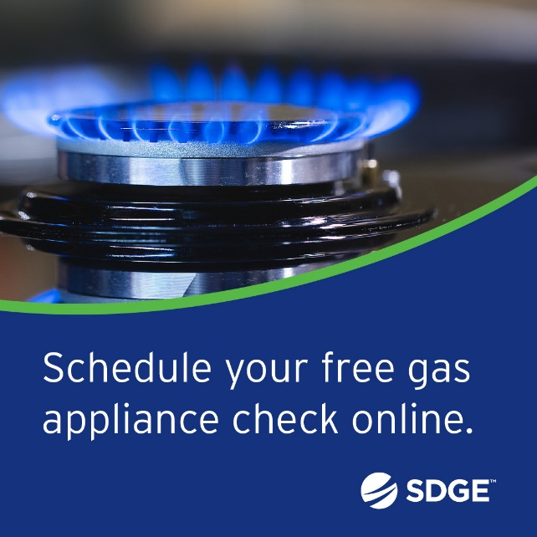
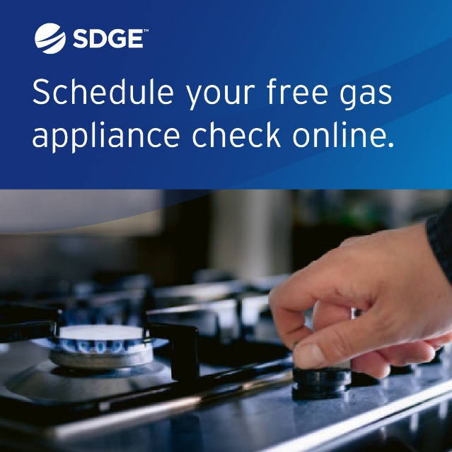

ARTICLE: TAKE ADVANTAGE OF NO-COST TRAINING FROM ENERGY EXPERTS
Did you know that SDG&E provides webinars for business owners and trade professionals, so you can learn new skills at your own pace? And most are at no cost. You or your employees can learn about the latest in green building practices, technology and energy-saving solutions from industry experts. Certifications and continuing education units are available for many classes. Check out the class listing at sdge.com/EnergyClasses.
SOCIAL POSTS: TAKE ADVANTAGE OF NO-COST TRAININGS FROM ENERGY EXPERTS
- Did you know SDG&E provides energy education and training webinars at no cost? These on-demand webinars are offered at introductory, intermediate and advanced levels. See the webinar list at sdge.com/EnergyClasses. #sdge #SDGEassist
- Learn the latest in green building design, operations, maintenance and technology at no-cost energy webinars led by industry experts. See the on-demand webinar list at sdge.com/EnergyClasses. #sdge #SDGEassist
- Enroll in a no-cost, on-demand energy topic webinar. Energy education and training can give you and your employees the knowledge and skills that customers value. Check out the webinar list at sdge.com/EnergyClasses. #sdge #SDGEassist
imageS: TAKE ADVANTAGE OF NO-COST TRAININGS FROM ENERGY EXPERTS


NEW SECTION!
JUST POSTS
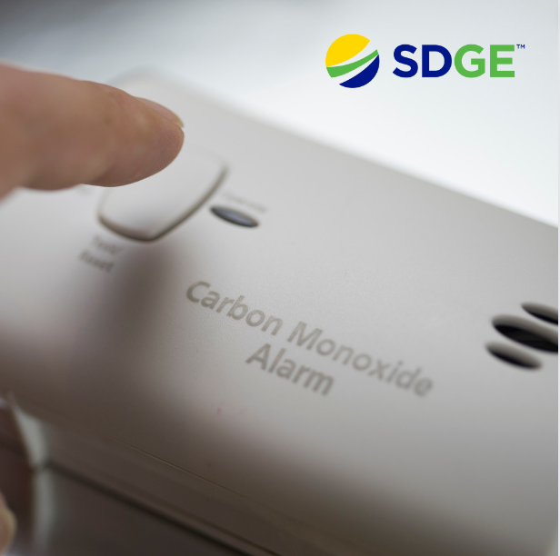
- Place carbon monoxide detectors on each level of your home and near sleeping areas. Test them regularly and replace batteries as needed. For more info, visit sdge.com/CO-Safety. #sdge #SDGEassist
- Are you prepared for an emergency? Make sure you have a disaster supplies kit prepared with basic items your household may need. Learn how to create an emergency kit at ready.gov/kit. #sdge #SDGEassist
- Seal and insulate your ducts. Air ducts are an important part of your home and, if they are poorly sealed or insulated, it’s likely it’s contributing to higher energy bills. For more energy-saving tips, visit sdge.com/MyEnergy. #sdge #SDGEassist
- Do you know how to stay safe during an earthquake? San Diego County is home to a few fault lines so it’s good to be prepared. Get more information at sdgenews.com. #sdge #SDGEassist
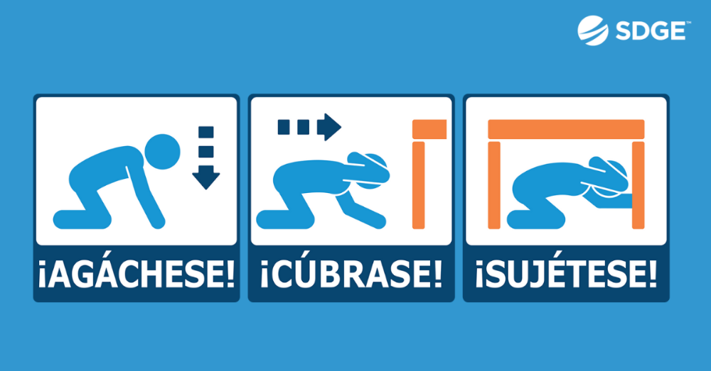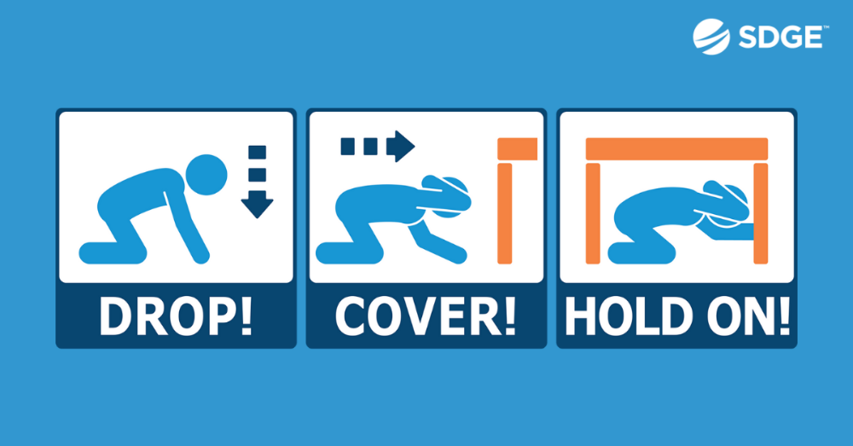
- Do you rent or own a single-family home? Eligible customers may receive free products such as smart thermostats, low-flow showerheads, brushless fan motors, HVAC services like air duct testing and sealing – and more. SDG&E has contracted with Synergy Companies to provide customers with energy efficiency audits from their experts. Customers can request a home visit at SynergyCompanies.com or by calling 1-888-272-8394. Learn more at sdge.com/RES. #sdge #SDGEassist
- The Neighbor-to-Neighbor program provides eligible SDG&E customers with up to $600 to offset their outstanding energy bills. SDG&E customers may apply if they are experiencing serious illness, temporary unemployment, disability or unusual hardship. Learn more at sdge.com/NTN. #sdge #SDGEassist
- Looking for ways to stay warm at home while lowering your energy use? Reverse your ceiling fan direction to clockwise. This will push warm air down, redistributing it throughout the room. For more energy-saving tips, visit sdge.com/MyEnergy. #sdge #SDGEassist

JUST POSTS – Business
- Do you own a small business? Receive energy-efficient upgrades like lighting, water heaters and refrigeration controls when you sign up for a no-cost energy assessment. One of SDG&E’s contractors will come to your business, make recommendations on where to save energy and install new equipment – many items at no cost! For more information, visit sdge.com/BES. #sdge #SDGEassist
- When your business participates in SDG&E’s ELRP program, you can earn financial incentives of $2 per kilowatt-hour when your business reduces energy during a grid emergency. Get more information at elrp.sdge.com. #sdge #SDGEassist
- Looking for ways to save energy at your business or office? Check out sdge.com/MyBusiness for energy-saving tips. #sdge #SDGEassist
- As the weather cools, it's important to ensure your heating system is working efficiently. Schedule routine maintenance for your HVAC system including cleaning, filter replacement and tuning. A well-maintained system operates more efficiently, reducing energy consumption. Get more energy-saving tips at sdge.com/MyBusiness. #sdge #SDGEassist
- Insulate your business’s walls and roof to reduce heat loss. This can lead to significant energy savings. Get more energy-saving tips at sdge.com/MyBusiness. #sdge #SDGEassist
- Install occupancy sensors to automatically turn off lights and HVAC systems in unoccupied areas in your office or building. Get more energy-saving tips at sdge.com/MyBusiness. #sdge #SDGEassist
- Encourage remote work when possible. This can reduce the need for heating the office and can save on energy costs. Get more energy-saving tips at sdge.com/MyBusiness. #sdge #SDGEassist
- Insulate hot water pipes and set the water heater thermostat to a lower temperature. Consider using low-flow faucets and fixtures to reduce hot water usage. Get more energy-saving tips at sdge.com/MyBusiness. #sdge #SDGEassist

