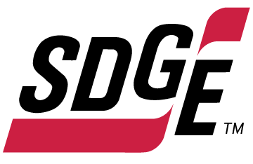

SDG&E RESIDENTIAL CONTENT PACKAGE | NOVEMBER 2021
As a trusted community partner, we thank you in advance for sharing these digital assets with your audiences, including residents, customers and employees to help amplify our monthly messages. Here are social media posts, articles and photos you are welcome to use in email communications, websites or newsletters. There are several images with each posting. Please choose images that fit your audience and feel free to mix and match.

Follow Us
You can find us on Facebook, Instagram, Twitter, YouTube and LinkedIn. When sharing these messages in your social posts, feel free to tag SDG&E’s social media accounts and direct your audience to sdge.com.

This month’s topics: Energy-saving tips at home, customer assistance programs

Article 1: FALL energy savings at home
As the seasons change, so can your energy use. From weather-stripping windows to lowering the temperature on your water heater, these smart and simple tips can help keep your family cozy and your energy costs low. Find ways to save on your energy bill with these timely tips:
- Weather strip and caulk drafty doors and windows to keep the cold at bay. The fall chill can seep in under doors, around windows and even through electrical outlets, baseboards and AC units.
- During mid-day, open window coverings to let in the sun’s heat and close them at night to block the cold.
- Take advantage of SDG&E’s instant instore rebates for up to $500 on new electric heat pump water heaters and gas water heaters. This can save a lot on your water-heating costs every year. Learn more at sdge.com/rebates.
- If the holidays are putting a strain on your budget, SDG&E offers payment plans, bill discounts and assistance programs for those who qualify. Learn more at sdge.com/assistance.
- Switch your ceiling fan’s blade rotation direction to save on your fall heating bill. Hot air rises, so reverse your fan’s blades to a clockwise rotation to help push that warmth back down to you.
- Use your exhaust fans less often. Your bathroom fans and oven hoods are often-overlooked sources of heat loss during the fall season. Use them sparingly and turn them off when not in use to ensure your home’s warmth isn’t being pulled away.
- Lowering the thermostat by 10 to 15 degrees while you sleep at night or are away from home can help save approximately 10% on your heating bills. A smart thermostat can be programmed based on when you are usually home or away and at the temperature you prefer during those times.
- Many people continuously use technology at home for work and entertainment, especially as we spend more time indoors during colder weather. Using the energy saver mode on your devices and appliances can go a long way toward reducing energy use without sacrificing performance.
- Lowering the temperature on your water heater from 140 degrees to 120 degrees can potentially save you up to $400 a year—and you won’t notice the difference.
Visit sdge.com/winter for more energy-saving tips.

Social posts: Fall energy savings at home
- Take advantage of SDG&E’s instant in-store rebates for up to $500 on new electric heat pump water heaters and gas water heaters. This can save a lot on your water-heating costs every year. Learn more at sdge.com/rebates. #sdge #SDGEassist
- If the holidays are putting a strain on your budget, SDG&E offers payment plans, bill discounts and assistance programs for those who qualify. Learn more at sdge.com/assistance. #sdge #SDGEassist
- Everyone knows that ceiling fans are a great way to stay cool in the summer, but did you know they can also help keep you warm in fall? Normally, ceiling fans rotate counterclockwise, pushing air down and producing a slight wind chill effect, allowing you to feel cooler. Most ceiling fans have a reverse switch that will enable them to turn clockwise, producing an updraft and moving the warm air that collects near your ceiling back down. Get more energy-saving tips at sdge.com/winter. #sdge #SDGEassist
- If you’re planning an elaborate holiday light show this season, consider using LED lights because they are more energy efficient than standard incandescent lights. They use 75% less energy than standard bulbs and can last up to 25 times longer. You’ll have to spend a little more upfront, but LEDs are durable and long-lasting. Get more energy-saving tips at sdge.com/winter. #sdge #SDGEassist
- Doors and windows are obvious sources of drafts, but there a few more you may not think of. Cold air can leak into your house through electrical outlets, light fixtures, AC units and gaps in your insulation. A lit fireplace is a great way to warm up in the fall, but it can allow cold air in when not in use. Keep your damper closed whenever you aren’t using your fireplace. If you never use your fireplace, plug and seal the chimney flue. Get more energy-saving tips at sdge.com/winter. #sdge #SDGEassist

Images: Fall energy savings at home

Article 2: take control of your winter energy USE
Winter means shorter days and lower temperatures , which may mean higher energy use and higher energy bills. But that doesn’t mean you can’t save on energy costs. Get started with these timely tips:
- Install ENERGY STAR® certified light bulbs, which use 70 – 90% less energy and last 10 – 25 times longer than incandescent bulbs.
- Use warm water instead of hot water to cut a load of laundry’s energy use in half; using cold water will save even more.
- Check your furnace filter as dirty air filters can increase energy costs.
- Wrap old water heaters with proper insulating jackets and set the temperature to 120° F (or lower). You can also insulate your plumbing to reduce heat loss and raise the water temperature.
- Use the delay start button on your dishwasher and washing machine to run outside of the on-peak hours of 4 p.m. to 9 p.m.
Learn more energy savings tips and available resources at sdge.com/winter.
Social posts: take control of your winter energy use
- Use any of the bullets above and add: Get more energy-saving tips at sdge.com/winter. #sdge #SDGEassist
Images: take control of your winter energy use

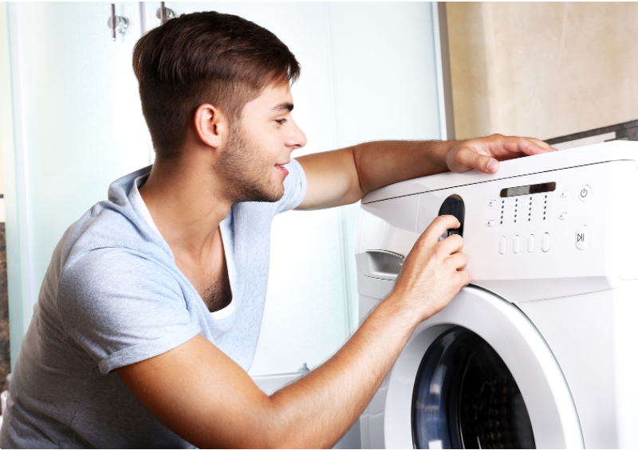
Article 3: NEED HELP WITH YOUR ENERGY BILL?
You may qualify for a bill discount or home improvements. SDG&E’s assistance programs can help you lower your energy use and/or monthly energy bill while keeping your home comfortable.
California Alternate Rates for Energy (CARE) Program: Save 30% or more every month on your energy bill. Find out if you qualify at sdge.com/CARE.
Family Electric Rate Assistance (FERA) Program: If you don’t qualify for CARE and your household has 3 or more people, you may qualify for FERA. You could receive an 18% discount on your electric bill. Visit sdge.com/FERA for more information.
Energy Savings Assistance (ESA) Program: You may qualify to receive no-cost, energy-saving improvements for your home, such as new appliances, furnace repair, lighting, insulation and more. Find details at sdge.com/ESAP.
Online applications are easy, fast and convenient. To learn more about SDG&E’s assistance programs, visit sdge.com/assistance.
Social posts: NEED HELP WITH YOUR ENERGY BILL?
- If you’re behind on your energy bill, you may qualify for financial assistance. Learn more at sdge.com/assistance. #sdge #SDGEassist
- Hardship is everywhere right now – the last thing you need is to worry about your energy bill. Get help with your bill at sdge.com/assistance. #sdge #SDGEassist
- SDG&E provides assistance programs to help you with your monthly bill which can include up to a 30% discount. Find out if you qualify at sdge.com/assistance. #sdge #SDGEassist
- Whether you rent or own, you could be eligible to receive no-cost, energy-efficient home improvements that can make your home more comfortable and reduce your energy bill. Find out if you qualify at sdge.com/ESAP. #sdge #SDGEassist

Article 3 (translated): ¿Necesita ayuda con su FACTURA de energía?
Usted puede calificar para un descuento en su factura o mejoras en el hogar. Los programas de asistencia de SDG&E ayudan a reducir su factura mensual de energía mientras mantiene su hogar cómodo.
Programa de Tarifas Alternativas de Energía de California (CARE, por sus siglas en inglés): Ahorre un 30% o más cada mes en su factura. Averigüe si califica en sdge.com/CARE.
Programa de Asistencia de Tarifa Eléctrica Familiar (FERA, por sus siglas en inglés): Si no califica para el programa de CARE y su hogar tiene 3 o más personas, puede calificar para FERA. Podría recibir un 18% de descuento en su factura de electricidad. Visite sdge.com/FERA para obtener más información.
Programa de Asistencia para el Ahorro de Energía (ESA, por sus siglas en inglés): Puede calificar para recibir mejoras gratuitas para el ahorro de energía en su hogar, tales como electrodomésticos nuevos, reparación de hornos, iluminación, aislamiento y más. Encuentre los detalles en sdge.com/ESAP.
Las aplicaciones en línea son fáciles, rápidas y convenientes. Para obtener más información, visite sdge.com/asistencia.
Postas sociales: ¿Necesita ayuda con su FACTURA de energía?
- Si está atrasado en su factura de energía, puede calificar para asistencia financiera. Obtenga más información en sdge.com/asistencia. #sdge #SDGEassist
- En este momento, las dificultades se encuentran en todas partes - lo último que necesita es preocuparse por su factura de energía. Obtenga ayuda con su factura en sdge.com/asistencia. #sdge #SDGEassist
- SDG&E ofrece programas de asistencia para ayudarle con su factura mensual que puede incluir hasta un 30% de descuento. Descubra si califica en sdge.com/asistencia. #sdge #SDGEassist
- Ya sea que alquile o sea propietario, podría ser elegible para recibir mejoras de eficiencia energética en su hogar, sin costo, que pueden hacer que su hogar sea más cómodo y reducir su factura de energía. Descubra si califica en sdge.com/ESAP. #sdge #SDGEassist
Images: NEED HELP WITH YOUR SDG&E BILL?

