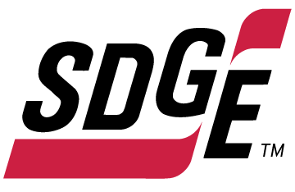
SDG&E BUSINESS CONTENT PACKAGE | NOVEMBER 2021
As a trusted community partner, we thank you in advance for sharing these digital assets with your audiences, including residents, customers and employees to help amplify our monthly messages. Here are social media posts, articles and photos you are welcome to use in email communications, websites or newsletters. There are several images with each posting. Please choose images that fit your audience and feel free to mix and match.

Follow Us
You can find us on Facebook, Instagram, Twitter, YouTube and LinkedIn. When sharing these messages in your social posts, feel free to tag SDG&E’s social media accounts and direct your audience to sdge.com.

This month’s topics: energy-saving tips at work, on-demand energy webinars

Article 1: WINTER Energy-saving tips for small businesses
Did you know that as the season changes and the sun sets earlier in the day, there may be less renewable energy on the grid? This can result in your business relying more on electricity which can lead to changes in your energy bill. If you’d like to stay in control of your energy use, SDG&E has a few timely tips that can help you start saving now.
- Upgrade your lighting. Using LED lighting could help your business save year-round.
- Weatherize your business. Weather strip and caulk drafty doors and windows to keep in the heat when you need it most.
- Use an advanced power strip. Electronics such as smart TVs, laptops or cable boxes use energy even when they are turned off. Using a smart power strip can help cut off power to devices even when they are on standby mode.
- Change air filters regularly. Replacing dirty air filters can increase the airflow throughout your HVAC system, helping it run more efficiently.
- Control your thermostat. Smart thermostats can be adjusted remotely to run energy-efficient schedules. If you join SDG&E’s Smart Thermostat program, you’ll receive $50 per registered thermostat with a max of four thermostats for business and two for your home. Get details on sdge.com/MyBusiness.
It’s always a good idea to prepare. Get ahead of your energy usage and implement energy-savings tips for your business today. Visit sdge.com/MyBusiness for winter energy-saving ideas.
Social Posts: WINTER Energy-saving tips for small businesses
- Save energy all year with a smart thermostat. When you sign up for SDG&E’s Smart Thermostat program, you can get $50 for each (up to 4) registered thermostats in your business. Sign up today and let your thermostat do the energy saving for you. Learn more at sdge.com/Business-Thermostat. #sdge #SDGEassist
- Did you know that as the season changes and the sun sets earlier in the day, there may be less renewable energy on the grid? Avoid surprises on your bill by implementing some energy- saving tips that include weatherizing your business, upgrading your lighting, using smart power strips and more. Visit sdge.com/MyBusiness for more winter energy-savings tips. #sdge #SDGEassist
- With a smart thermostat, you choose when to save. We all know San Diego weather in winter is unpredictable. With a smart thermostat, you can remotely adjust your temperature, allowing you greater control over your business’s energy use. And when you sign up for SDG&E’s Smart Thermostat program, you’ll receive $50 for each thermostat you register (up to 4). Learn more at sdge.com/Business-Thermostat. #sdge #SDGEassist
- Properly placed evergreen trees can act as windbreaks to block cold northwest winter winds. Windbreaks lower the wind chill factor and reduce heating costs. Plant shrubs and bushes about 1 foot from your building. The space acts as an insulator and slows down heat escaping through the walls. Get more winter energy-saving tips at sdge.com/MyBusiness. #sdge #SDGEassist
- Get a tune-up on your heater to ensure your system is operating efficiently. New, clean air filters can improve airflow and heating. SDG&E has instant in-store rebates up to $500 on the purchase of new, qualifying energy-efficient electric heat pump water heaters and gas water heaters. Learn more at sdge.com/rebates. #sdge #SDGEassist
Images: Energy-saving tips for small businesses
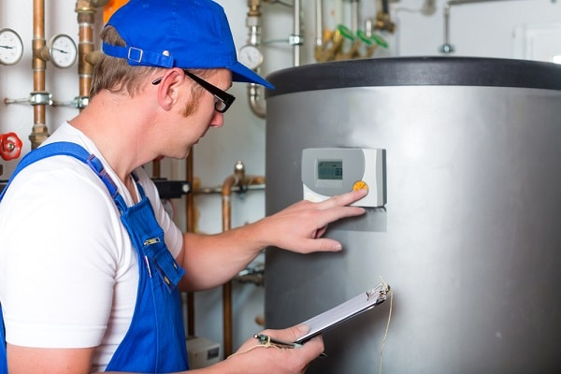

Article 2: IS YOUR BUSINESS WASTING ENERGY?
Heating, ventilation and air conditioning (HVAC) consumes approximately 40% of a building’s electricity. In fact, it’s one of the most significant factors in the operating expenses of a business. That’s why it pays to pinpoint HVAC energy waste and reduce it. Here are 3 common HVAC waste areas and proven ways to help your business become more energy-efficient and control costs.
Blocked vents require up to 25% more energy to distribute air. Take a close look around your business. Are vents blocked by furniture, paper, tools or equipment? Those blocked vents are preventing vital airflow and making your system work harder to heat or cool your business. That’s unnecessary waste and it’s costing your business every month.
Solution: Clear air distribution is essential to contribute to energy efficiency. It’s also important for maintaining a good comfort level for your employees and customers. Carefully assess the area around each vent for proper ventilation. Is air flowing from the vent circulating freely throughout the room? If there are obstructions that prevent adequate airflow, such as cabinetry or drapes, move them to allow for clear circulation. Don’t keep vents closed as an effort to save energy; doing this can change the way air is distributed and cause an imbalance to the operation of the HVAC system. Remember to also check any vents on the floor. It can be more difficult to keep these areas clear of obstructions.
Up to 80% of energy can be recovered from exhaust air. Exhaust air from inefficient HVAC systems wastes a major opportunity for more efficient heating and cooling. That’s because more energy is required to heat or cool incoming outside air. But there are smart ways to prevent that waste.
Solution: Heat-recovery technology transfers energy from exhaust air to incoming outside air. This greatly reduces the energy that’s required to heat or cool incoming air. As a result, businesses can recover 50% to 80% of energy waste. It’s important to note the percentage of outside air that can be used for efficient ventilation is based on a few factors, including project scope, technology selection and design. A qualified contractor can educate customers on available recovery technologies. For example, an energy recovery ventilator (ERV) can be a suitable solution for maintaining comfortable temperature, depending on area location and climate. Businesses can turn to their HVAC contractor to decide if an ERV is appropriate. Heat-recovery technologies can include heat exchangers, recuperators, regenerators, passive air pre-heaters and waste heat boilers.
Advanced controls can reduce energy use by 40%. Ever feel cold when you’re in a big conference room or eating in the cafeteria with just a few other people? That may be because the ventilation system is running at maximum operating power, as if the room was at capacity. It is a huge waste of energy.
Solution: Installing advanced control sensors can improve a ventilation system’s operating power for energy efficiency. These controls can count the number of people in a room and then adjust the heat and air conditioning accordingly. When the sensors are integrated into a building’s HVAC system, the advanced controls can reduce energy use by almost 40%. That could save a typical 500,000-square-foot office building tens of thousands of dollars each year. Such buildings in the U.S. take up more than 4.4 billion square feet.

Social posts: IS YOUR BUSINESS WASTING ENERGY?
- Fifteen percent of energy waste is caused by dirty air filters – which impairs your HVAC system and contributes to wasted energy. Replace air filters (or clean them if they’re reusable), especially during peak heating and cooling seasons. Get more winter energy-saving tips at sdge.com/MyBusiness. #sdge #SDGEassist
- Unsealed ducts contribute to 20% waste. The ducts that circulate the air throughout your building can be big energy wasters. They may not be sealed properly or insulated well. Hire a contractor to make sure all ducts have duct sealant or metal-backed (foil) tape over the seams and connections. Then, wrap the ducts in insulation. Get more winter energy-saving tips at sdge.com/MyBusiness. #sdge #SDGEassist
- Cut energy use by up to 60% when you switch to open office space. Moving from a closed office environment to an open floor plan helps lower operating costs, increase floor capacity and improve employee comfort. Set controls to shut down lighting and HVAC to individual floor sections when they aren’t occupied. Get more winter energy-saving tips at sdge.com/MyBusiness. #sdge #SDGEassist
Images: IS YOUR BUSINESS WASTING ENERGY?
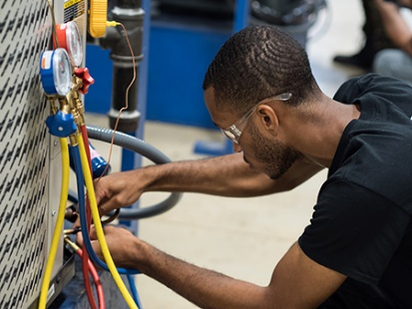
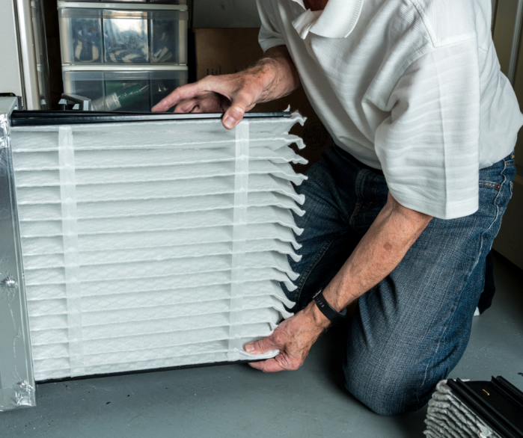
Article 3: TAKE ADVANTAGE OF NO-COST TRAINING FROM ENERGY EXPERTS
Did you know that SDG&E provides webinars for business owners and trade professionals, and most are at no cost? You or your employees can learn about the latest in green building practices, technology and energy-saving solutions from industry experts. Some of November’s topics include:
- Commercial heat pump water heating
- Advanced lighting controls
- Smart building technologies for energy efficiency
- Envelope and solar systems
- Carbon-free homes
- Full-scale induction for commercial kitchens
Certifications and continuing education units are available for many of the classes. Check out the class listing at sdge.com/EIC.
Social posts: TAKE ADVANTAGE OF NO-COST TRAININGS FROM ENERGY EXPERTS
- Did you know SDG&E provides energy education and training webinars at no cost? These on-demand webinars are offered at introductory, intermediate and advanced levels. See the webinar list at sdge.com/EIC. #sdge #SDGEassist
- Learn the latest in green building design, operations, maintenance and technology at no-cost energy webinars led by industry experts. See the on-demand webinar list at sdge.com/EIC. #sdge #SDGEassist
- Enroll in a no-cost, on-demand energy topic webinar. Energy education and training can give you and your employees the knowledge and skills that customers value. Check out the webinar list at sdge.com/EIC. #sdge #SDGEassist
Images: TAKE ADVANTAGE OF NO-COST TRAININGS FROM ENERGY EXPERTS

