2013 Impact Evaluation of SDG&E Non-Alert PTR Population

**CALMAC Study ID SCE0343.02**

*by*

Steven D. Braithwait

Daniel G. Hansen

Marlies Hilbrink

April 1, 2014

**Table of Contents**

abstract 1

Executive Summary 2

Project Objectives 2

Analysis Approach 2

Key Study Findings 2

Conclusions and Recommendations 3

1. introduction and purpose of study 5

2. Description of Resources Covered in the Study 5

2.1 Program Description 5

2.2 PTR Event in 2013 6

2.3 Features of the PTR event 6

3. Study Methodology 13

3.1 Overview 13

3.2 Description of Methods 13

4. Detailed Study Findings 16

4.1 Summary of estimated *ex-post* load impacts 16

4.2 Estimated hourly load impacts 16

4.3 Observations on estimated load impacts 20

5. Conclusions and Recommendations 20

Appendix A. Model Validation 21

**List of Tables**

Table ES–1: Estimated PTR Usage Impacts by Major Customer Group 3

Table 2–1: Characteristics of Non-Alert Population and Sample 6

Table 4–1: Average Event-Hour Loads and Load Impacts – by Climate Zone 16

Table 4–2: Aggregate Hourly Loads and Load Impacts – *Coastal* 17

Table 4–3: Aggregate Hourly Loads and Load Impacts – *Inland* 18

Table A–1: Event-like Days used in the Model Validation Process 21

Table A–2: MPE and MAPE for the Selected Models 21

**List of Figures**

Figure 2–1: Average Customer Loads on High-Temperature Weekend Days – *Coastal* 7

Figure 2–2: Average Customer Loads on High-Temperature Weekend Days – *Inland* 7

Figure 2–3: Average Temperatures on August 31and September 1, 2013 – *Coastal* 9

Figure 2–4: Average Temperatures on August 31and September 1, 2013 – *Inland* 9

Figure 2–5: August 31and Adjusted September 1, 2013 Loads 10

Figure 2–6: Average Event-Window Temperatures vs. kWh – *Coastal* 12

Figure 2–7: Average Event-Window Temperatures vs. kWh – *Inland* 12

Figure 4–1: Aggregate Hourly Loads and Estimated Load Impacts – *Coastal* 19

Figure 4–2: Aggregate Hourly Loads and Estimated Load Impacts – *Inland* 19

Figure A–1: Average of Actual and Predicted Loads across Event-Like Days – *Coastal* 22

Figure A–2: Average of Actual and Predicted Loads across Event-Like Days – *Inland* 23

# abstract

This report documents a load impact evaluation of a portion of San Diego Gas & Electric’s (SDG&E) Peak Time Rebate (PTR) program for Program Year 2013. As background, SDG&E originally planned to call PTR events only on days for which Flex Alerts were issued by the California Independent System Operator (CAISO). Hence, this study was undertaken in concert with an evaluation of the Flex Alert program. Flex Alerts are voluntary calls for consumers to reduce usage on the day of the alert. However, no Flex Alerts were called for Southern California. As a result, SDG&E called one PTR event in the absence of a Flex Alert, on August 31, a Saturday. The objective of this study is to estimate *ex-post* load impacts for the one PTR event, for the non-Alert portion of SDG&E’s residential population, all of whom are eligible for PTR credits. The study also excludes customers who participate in the Summer Saver air conditioner direct load control program, or related technology programs.[1]

The primary overall finding from this study is that that the average non-Alert customer in both climate zones was estimated to have reduced usage by an average of about 3 percent during the PTR event window. This implies aggregate average event-hour load impacts of about 20 MW for the Coastal region and 27 MW for the Inland region, for a total of nearly 48 MW. However, the estimates are subject to a range of uncertainty, based on the variability and lack of precision of the individual hourly estimates (*i.e*., only two of the seven hourly event-window estimates for the Coastal region were statistically significantly different from zero at the 95 percent confidence level, and only three were significant for the Inland region).

The evaluation approach involved first designing and selecting a sample of 20,000 customers from the population of approximately one million SDG&E residential customers who did not receive electronic event notification or participate in the Summer Saver air conditioner cycling program. Regression analysis was then conducted using billing-based interval load data for the average sample customer in the two climate zones of interest—Coastal and Inland. These regressions resulted in estimates of hourly estimated load impacts for both climate zones for the single 2013 PTR event.

# Executive Summary

This report documents a load impact evaluation of a portion of San Diego Gas & Electric’s (SDG&E) Peak Time Rebate (PTR) program for Program Year 2013. SDG&E originally planned to call PTR events only on days for which Flex Alerts were issued by the California Independent System Operator (CAISO). Hence, this study was undertaken in concert with an evaluation of the Flex Alert program. Flex Alerts are voluntary calls for consumers to reduce usage until after 6 p.m. on the day of the alert. However, no Flex Alerts were called for the Southern California region. As a result, SDG&E called one PTR event in the absence of a Flex Alert, on August 31, a Saturday. This study focuses on the population of residential customers who did not request electronic notification of PTR events (i.e., they are classified as “non-Alert”) or participate in the Summer Saver air conditioner cycling program, or related technology programs.[2]

## Project Objectives

The primary objective of this evaluation is to estimate *ex-post* load impacts for the one PTR event, for the non-Alert portion of SDG&E’s residential population, all of whom are eligible for PTR credits, but did not request event notification.

## Analysis Approach

The evaluation approach involved first designing and selecting a sample of 20,000 customers from the population of approximately one million SDG&E residential customers who did not receive electronic event notification or participate in the Summer Saver air conditioner cycling program. We then conducted regression analysis of billing-based interval load data for the average sample customer in the two climate zones of interest—Coastal and Inland. These regressions resulted in estimates of hourly estimated load impacts for both climate zones for the single 2013 PTR event. Results from the estimated equations were then tabulated and summarized.

## Key Study Findings

The primary overall finding from this study is that that the average non-Alert customer in both climate zones was estimated to have reduced usage by an average of about 3 percent during the PTR event window. This implies aggregate load impacts of about 20 MW for the Coastal region and 27 MW for the Inland region, for a total of nearly 48 MW. However, the estimates are subject to a range of uncertainty, based on the variability and lack of precision of the individual hourly estimates (*i.e*., only two of the seven hourly event-window load impact estimates for the Coastal region were statistically significantly different from zero at the 95 percent confidence level, and only three were significant for the Inland region).

Table ES–1 summarizes the average event-hour estimated reference loads and load impacts for the Coastal and Inland climate zones, and overall, for both the average customer and in aggregate. Also shown are indications of the degree of uncertainty surrounding the load impact estimates.

Table ES–1: Estimated PTR Usage Impacts by Major Customer Group

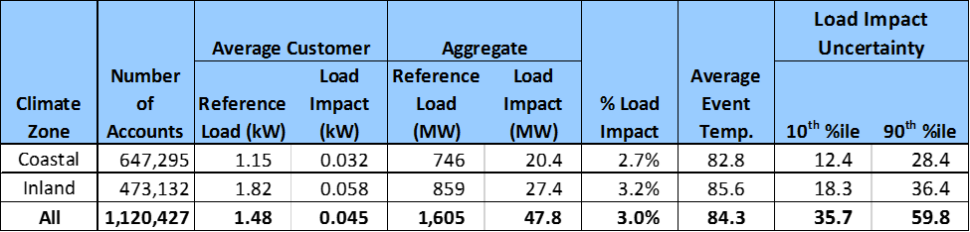

The estimated load impacts for the non-Alert population for the one event in 2013 are qualitatively similar to the estimates for the same population in the 2012 evaluation, in that the estimates are generally not statistically significant (*i.e*., considerable uncertainty surrounds the point estimates of load impacts). However, the nature of the estimates is somewhat different. The 2012 evaluation estimated overall *increases* in energy use during the PTR event window for the average event, though the estimates were not statistically significant. For 2013, we estimate small *reductions* in energy use in each event-hour, where the reductions average approximately 3 percent. A few of the hourly reductions were statistically significant (*i.e*., different from zero with 95 percent confidence), although most were not.

## Conclusions and Recommendations

All three of the SDG&E PTR evaluations (*i.e.*, the 2011 evaluation of the PTR pilot, the 2012 evaluation of the full default PTR program, and the current analysis of non-Alert customers for 2013) have proved challenging due to a combination of factors. These include:

* Small numbers of events that might be considered “comparable” and thus allow characterization of a “typical” event,
* Some weekend events,
* Some events called late in the season (*e.g.*, in October), and
* Very limited numbers of non-event days with weather conditions similar to the event days.

In addition, with the exception of the pilot in 2011, the default nature of PTR has ruled out the availability of a classic control group of customers who are not eligible for PTR credits, but face the same weather conditions as those who are eligible. The availability of control groups removes the need for comparable non-event days to aid in estimating load impacts.[3]

If the program is modified in the future to restrict eligibility for bill credits to only those customers who opt to receive event notification, then non-Alert customers may again serve a useful role as a source of a control group sample for evaluating load impacts for the Alert customers.

# 1. introduction and purpose of study

This report documents a load impact evaluation of a portion of San Diego Gas & Electric’s (SDG&E) Peak Time Rebate (PTR) program for Program Year 2013. SDG&E originally planned to call PTR events only on days for which Flex Alerts were issued by the California Independent System Operator (CAISO). Hence, this study was undertaken in concert with an evaluation of the Flex Alert program. Flex Alerts are voluntary calls for consumers to reduce usage until after 6 p.m. on the day of the alert. However, no Flex Alerts were called for the Southern California region. As a result, SDG&E called one PTR event in the absence of a Flex Alert, on August 31, a Saturday. This study focuses on the population of residential customers who did not request electronic notification of PTR events (*i.e.*, they are classified as “non-Alert”) or participate in the Summer Saver air conditioner cycling program, or related technology programs.[4]

The primary objective of this evaluation is to estimate the *ex-post* load impacts for the non-Alert portion of SDG&E’s residential population, all of whom are eligible for PTR credits, but did not request event notification.

The report is organized as follows. Section 2 describes SDG&E’s PTR program and the event called; Section 3 describes the analysis methods used in the study; Section 4 contains the *ex post* load impact results; Section 5 provides conclusions and recommendations; and Appendix A describes the model validation process.

# 2. Description of Resources Covered in the Study

## 2.1 Program Description

SDG&E’s PTR program is a default program for eligible residential customers who have received a Smart Meter. Customers are encouraged to sign up to receive electronic notification of PTR events. Eligible customers can receive bill credits for usage reductions below a baseline level during the event window from 11 a.m. to 6 p.m. This evaluation focuses on those customers who did not request notification prior to the summer of 2013. Table 2–1 summarizes the characteristics of the target population and the stratified random sample that was drawn from that population. The sample was stratified by climate zone and customer size.[5] The sample consisted of approximately 20,000 customers. The high-usage strata were assigned greater than proportionate sample sizes due to greater variability of usage.

Table 2–1: Characteristics of Non-Alert Population and Sample



## 2.2 PTR Event in 2013

SDG&E called one PTR event in its service area on August 31, a Saturday.

## 2.3 Features of the PTR event

Before turning to the methods used and the study results, we first provide context in the form of background on the weather and customer load conditions on the PTR event day and selected comparable days.

Because the PTR event occurred on a Saturday, and residential loads typically differ in level and pattern on weekends compared to weekdays, we restricted the analysis in this study to weekend days only. Figures 2–1 and 2–2 display average customer loads within each climate zone for a subset of high temperature weekend days. In both figures (*i.e.*, both climate zones), the dashed line represents loads on the August 31 PTR event-day. The most similar alternative load patterns occur on the following day, September 1.[6]

Figure 2–1: Average Customer Loads on High-Temperature Weekend Days – *Coastal*

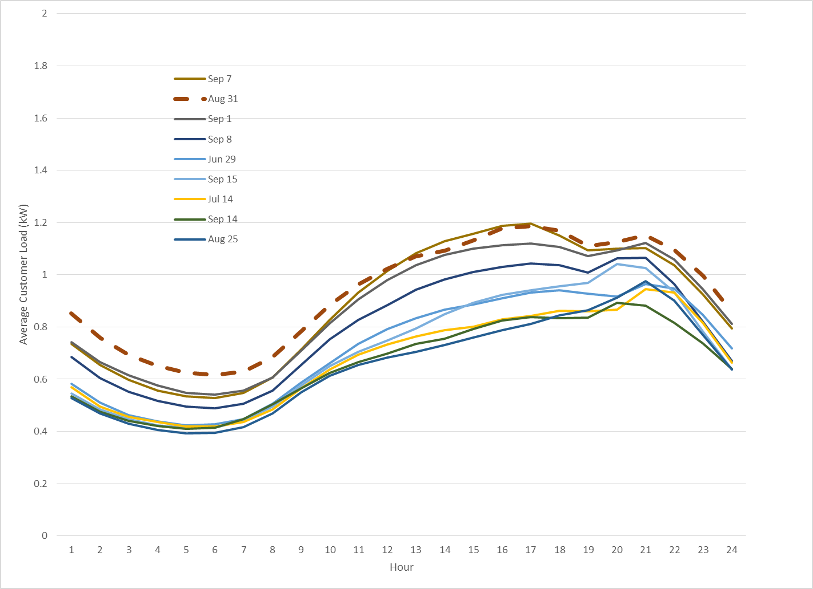

Figure 2–2: Average Customer Loads on High-Temperature Weekend Days – *Inland*

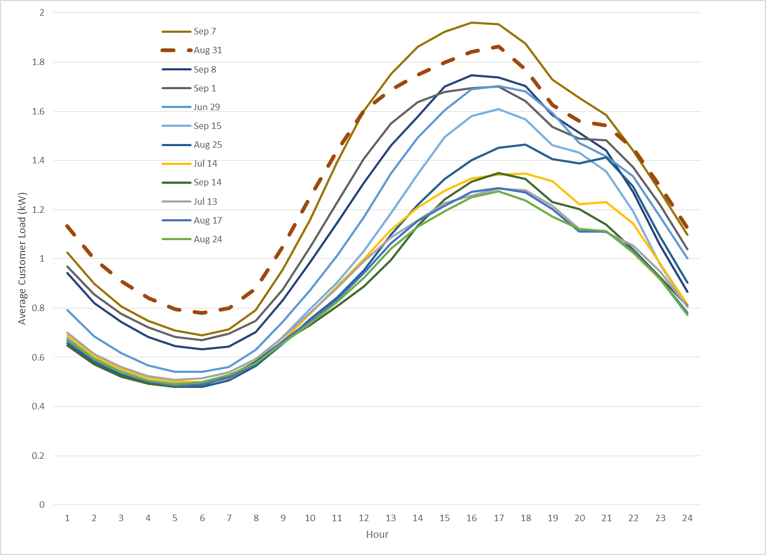

Figures 2–3 and 2–4 show hourly temperature patterns on August 31 and September 1. The temperature profiles look similar to the load profiles for those days, in that morning and evening temperatures were higher on August 31 relative to September 1, but the differences in temperatures narrowed somewhat during the event window.

Figure 2–3: Average Temperatures on August 31and September 1, 2013 – *Coastal*

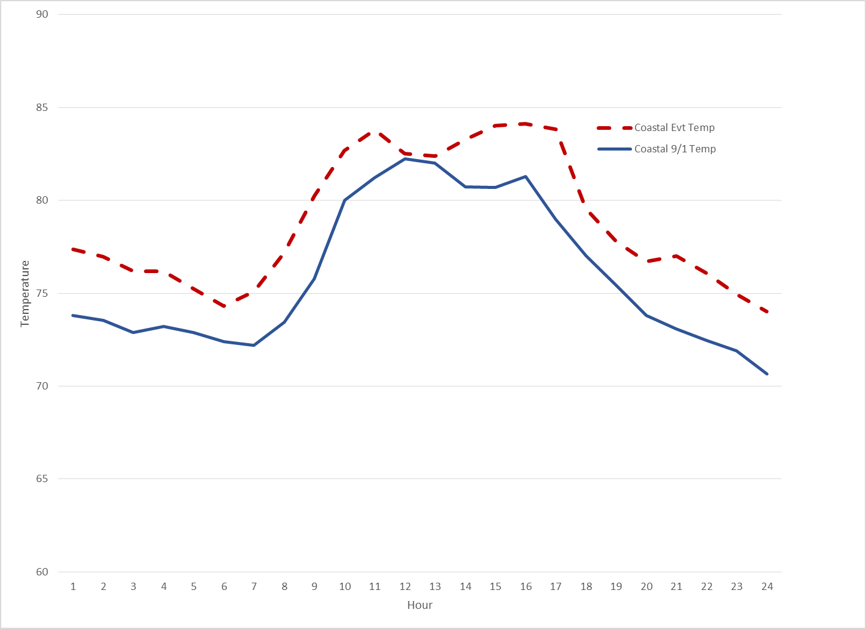

Figure 2–4: Average Temperatures on August 31and September 1, 2013 – *Inland*

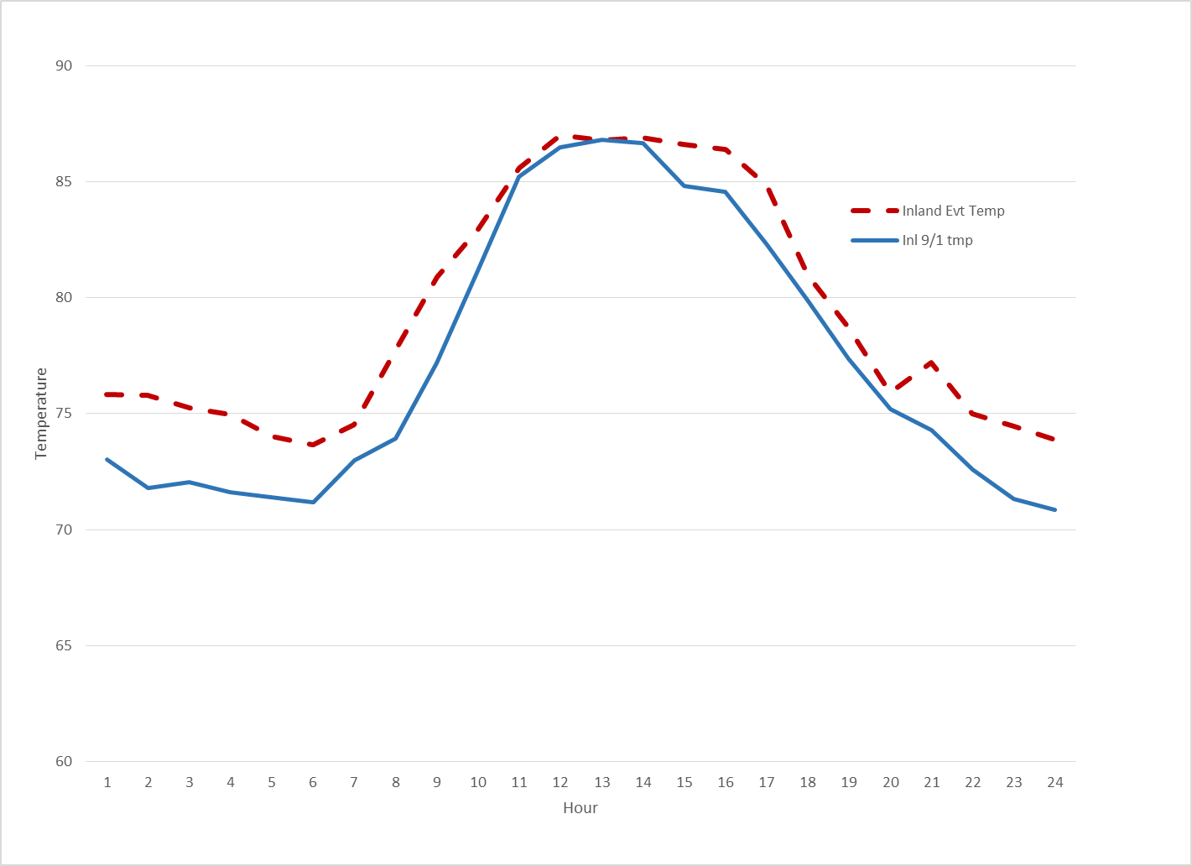

Figure 2–5 compares the event-day loads for the two climate zones to an adjusted load for September 1. The adjustment is similar to a day-of baseline adjustment, in which the September 1 loads are adjusted by the difference between the average load in hours 6 through 10 on the event day and September 1. The two lines at the bottom of the figure show the differences between the adjusted September 1 loads and the event-day loads. These may be interpreted as a crude measure of PTR load impacts for these two customer groups, and appear relatively small and somewhat variable. Formal estimates of the load impacts are provided in Section 4.

Figure 2–5: August 31and Adjusted September 1, 2013 Loads

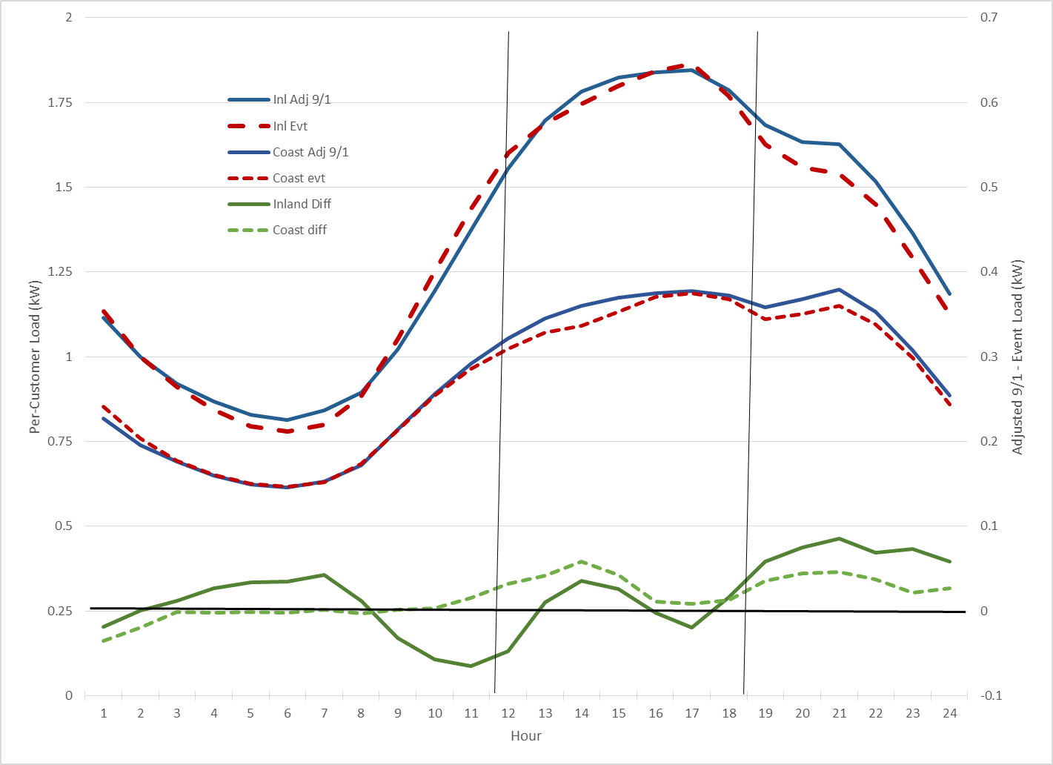

To check the extent to which energy usage during relevant hours on the PTR event-day differed from usage during the same periods on other weekend days, we examine the relationships between average temperature and average hourly usage during the event window (hours ending 12 through 18) on weekend days. These relationships are illustrated in Figures 2–6 and 2–7 for both climate zones, which include a linear trend line. Values for the PTR event-day are indicated by larger red circles. The gray square data points to the lower right represent relatively high temperature days in late September that have unusually low loads. As described in the following section, these late-September days were dropped from the regression analysis.

Both figures show an expected direct relationship between average afternoon temperatures and loads. In both climate zones, loads on the PTR event-day are well above that which would be suggested by a linear relationship between temperature and kWh.[7] The same is true (to a lesser extent) when data points are restricted to only the high-temperature days included in the regression.[8] These results provide additional indications that usage reductions on the PTR event day were likely relatively small. The methods described in the next section formalize the relationships between the loads and factors such as temperature, typical hourly patterns, and day type (*e.g.*, also differentiating Saturdays from Sundays) that are used to control for load changes other that occurrence of the PTR event, and thus allow estimation of PTR load impacts.

Figure 2–6: Average Event-Window Temperatures vs. kWh – *Coastal*

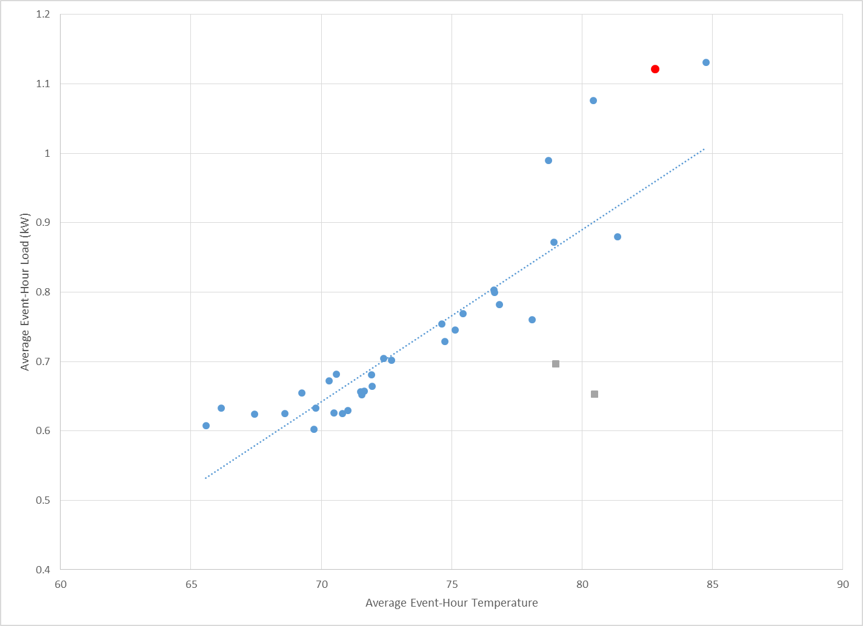

Figure 2–7: Average Event-Window Temperatures vs. kWh – *Inland*

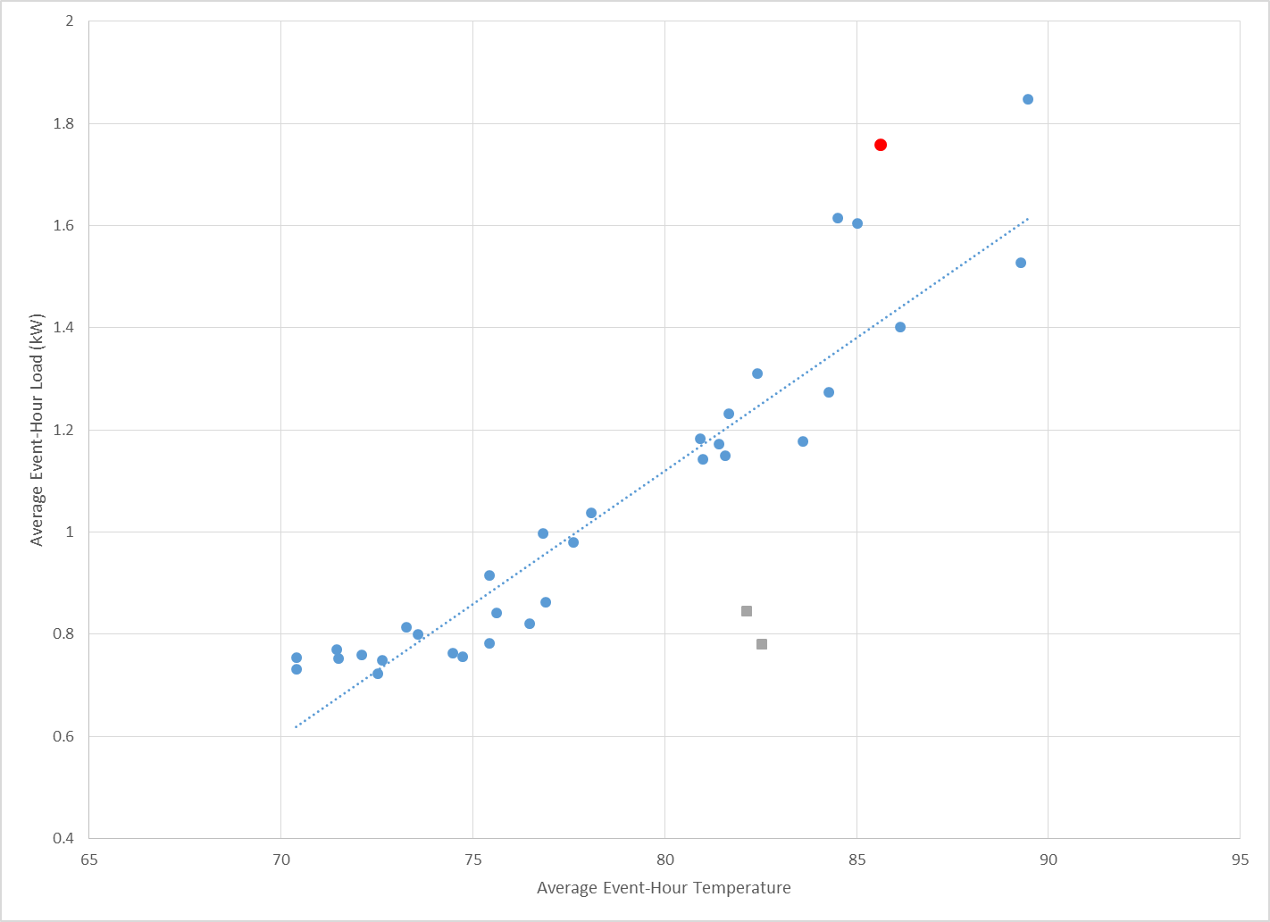

# 3. Study Methodology

## 3.1 Overview

For this evaluation of non-notified residential PTR customers, we designed a sample of the target population of non-alert, non-Summer Saver, and non-technology customers, and conducted regression analysis of billing-based interval load data for the average sample customer in the two climate zones of interest: Coastal and Inland.

## 3.2 Description of Methods

### 3.2.1 Background

This section discusses our sample design and analysis approach for SDG&E’s residential customers who are not covered by the separate SDG&E PTR and Summer Saver evaluation projects.

### 3.2.2 Sample design

We designed a stratified random sample of the target population, with stratification by climate zone and usage category (*e.g.*, low, medium, and high summer average daily usage). SDG&E selected customers at random from the target population of non-alert, non-technology customers within those strata. Hourly load data were then requested for the selected sample customers.

### 3.2.3 Analysis approach

The basic analysis approach involved exploration and testing of traditional methods for estimating load impacts for event-based demand response programs using participants’ own load data for the period in which events were called. That is, we applied regression analysis to hourly load data for June through September 2013 for the selected sample. The analysis controls for factors other than PTR event occurrence that influence customers’ load profiles, including hour of day, day of week, month, and weather, and also includes hourly variables indicating the one event day. The coefficients on the hourly event variables allow direct estimation of hourly PTR load impacts for each customer.

The data used in the analysis were restricted to weekend days from June through September, for which temperatures in hour-ending 15 exceeded the average for those day types.[9] Additionally, we excluded two late-September weekend days which met the hour 15 temperature criterion, but which had uncharacteristically low loads (see gray square data points in Figures 2–5 and 2–6). This low usage could be due to a shift in cooling behavior following a week of relatively mild weather where customers may have turned off air conditioning systems. Weather effects are represented by the three- and 24-hour moving averages of cooling degree hours calculated using a 60-degree threshold.[10]

The model presented below represents the “base” *ex post* load impact model that we have used in previous evaluations to estimate hourly impacts for individual customer accounts, or for a relevant group of customers, for each event day, while controlling for factors such as weather conditions and regular daily and monthly usage patterns (*i.e.*, accounting for differences in load levels across hours of the day, days of the week, and months of the year). We then describe a range of variations that we explored to ensure that we selected the most appropriate model for estimating PTR load impacts.

The base model is shown below, with each term described in the following table.



|  |  |
| --- | --- |
| **Variable Name / Term** | **Variable / Term Description** |
| *Qt* | the hourly usage in time period *t* for a particular customer |
| The various *b*’s | the estimated parameters |
| *hi,t* | an indicator variable for hour *i* |
| *PTRt* | an indicator variable for PTR event days |
| *Wtht* | the weather conditions during hour *t*[11] |
| *Sundayj,t* | indicator variables for Sunday |
| *MONTHi,t* | a series of indicator variables for each month |
| *et* | the error term |

The first term is the component of the equation that allows estimation of *hourly load impacts* (the *bi,Evt* coefficients) for the PTR event day. It does so via the hourly indicator variables *hi,t* interacted with the event variables (indicated by *PTRt*). The remaining terms in the equation are designed to control for weather and other periodic factors (*e.g.*, hours, days, and months) that determine customers’ loads. The interaction of the Sunday day type indicator with the hourly indicators is designed to account for potentially different hourly load profiles on Sundays relative to Saturdays.

#### Tests of alternative specifications

We evaluated alternative versions of this basic model structure that included variations in the representation of weather conditions. Due to the importance of appropriate accounting for weather effects on residential customer loads, we conducted an initial analysis to explore which weather variables and forms of those variables appeared to best explain differences in customers’ daily and hourly usage patterns. In addition, we explored *non-linear* effects of weather on load (*e.g*., customers’ loads may increase more than proportionately at high temperatures, or may reach a saturation point and level off), and the potential importance of lagged weather variables to account for *heat build-up effects* due to consecutive hot days.

These potential enhancements were evaluated by estimating models using average per-customer loads aggregated by climate zone. For each model variant, we estimated the model withholding a set of event-like non-event days. We evaluated the explanatory power of each model using the root mean squared error (RMSE) calculated for the withheld days and for all days in the sample. A “grid search” using this technique allows us to find the model that best explains customer usage on event-like non-event days, and can therefore be expected to produce the most reliable estimates of load impacts.

#### Calculating uncertainty-adjusted load impacts

The Load Impact Protocols require the estimation of uncertainty-adjusted load impacts. In the case of *ex post* load impacts, the parameters that constitute the load impact estimates are not estimated with certainty. Therefore, we base the uncertainty-adjusted load impacts on the variances associated with the estimated load impacts, which measure the degree of statistical confidence in the estimates. Results for the 10th, 30th, 70th, and 90th percentile scenarios are simulated under the assumption that the load impacts are normally distributed with the mean equal to the estimated load impact and the standard deviation equal to the standard error of the estimated load impact.

#### Validity assessment

In the validation assessment in the Appendix, we display graphs of observed loads and simulated loads based on the regression equations for selected non-event days to illustrate the performance of the models in terms of accuracy and potential bias (*e.g.*, do the equations systematically understate load on hot days?). We also report statistics like relative root mean square error and median percent error, which provide formal estimates of the percent differences between observed and simulated loads.

We also conducted additional validation checks on appropriate design of the weather variable(s) included in the regression equations, as noted above. In particular, we explored the effect of different temperature set points for defining cooling degree-day (CDD) or cooling degree-hour (CDH) variables, as well as incorporation of information on prior day weather conditions. The objective of these exercises is to ensure that weather effects are accounted for to the greatest degree possible.

# 4. Detailed Study Findings

This section reports the findings on estimated *ex-post* load impacts from the regression analysis.

## 4.1 Summary of estimated *ex-post* load impacts

Table 4–1 summarizes the average event-hour estimated reference loads and load impacts for the Coastal and Inland climate zones, and all customers combined, for both the average customer and in aggregate. The last two columns report the degree of uncertainty surrounding the estimated load impacts. The 10th and 90th percentile values are based on the standard errors of the estimated load impact coefficients, as described above. The bottom-line result is that the average non-alert customer in both climate zones reduced usage by an estimated average of about 3 percent during the PTR event window. This implies aggregate load impacts of about 20 MW for the Coastal region and 27 MW for the Inland region, for a total of nearly 48 MW. However, the estimates are subject to a range of uncertainty, based on the variability and precision of the individual hourly estimates, as described below.[12]

Table 4–1: Average Event-Hour Loads and Load Impacts – by Climate Zone



## 4.2 Estimated hourly load impacts

Tables 4–2 and 4–3 provide aggregate hourly loads and estimated load impacts for the two climate zones in the format of the Protocol tables. The seven-hour event window of hours-ending 12 through 18 is highlighted. In addition, individual hourly load impact estimates are indicated in bold type in cases where the corresponding regression coefficients were found to be statistically significantly different from zero at the 95 percent confidence level. As indicated, only two of the seven hourly estimates for the Coastal region are statistically significant, as are three of the estimates for the Inland region.

Table 4–2: Aggregate Hourly Loads and Load Impacts – *Coastal*



Table 4–3: Aggregate Hourly Loads and Load Impacts – *Inland*



Figures 4–1 and 4–2 illustrate the observed event-day loads, and estimated reference loads and load impacts in the above tables for the Coastal and Inland climate zones respectively. The event window is indicated by the two vertical lines.

Figure 4–1: Aggregate Hourly Loads and Estimated Load Impacts – *Coastal*

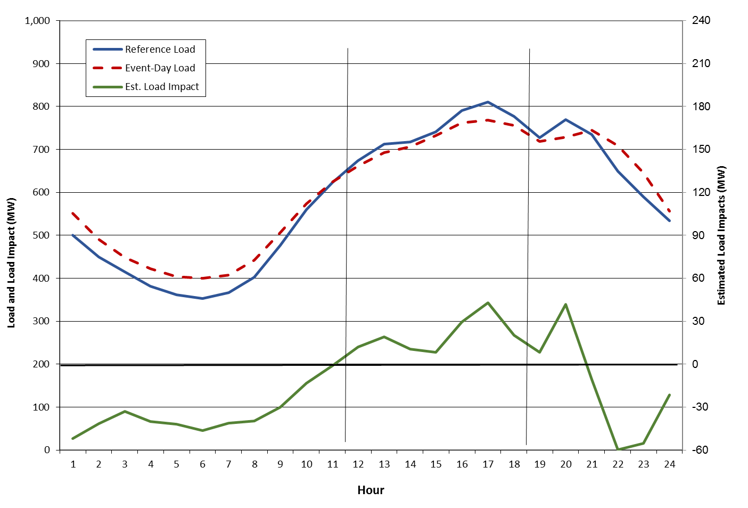

Figure 4–2: Aggregate Hourly Loads and Estimated Load Impacts – *Inland*

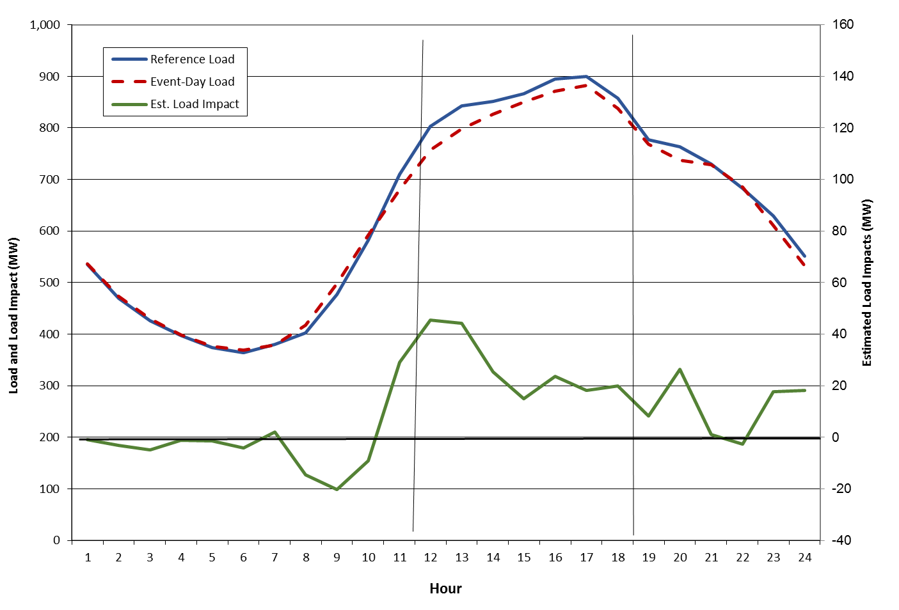

## 4.3 Observations on estimated load impacts

The estimated PTR load impacts for the non-Alert population for the one event in 2013 are qualitatively similar to the estimates for the same population in the 2012 evaluation, in that the estimates are generally not statistically significant (*i.e.*, considerable uncertainty surrounds the point estimates of load impacts). However, the nature of the estimates is somewhat different. The 2012 evaluation estimated overall *increases* in energy use during the PTR event window for the average event, though the estimates were not statistically significant. For 2013, we estimate small *reductions* in energy use in each event-hour, where the reductions average approximately 3 percent. In addition, a few of the hourly reductions were statistically significant (*i.e.*, different from zero with 95 percent confidence), although most were not.

# 5. Conclusions and Recommendations

All three of the SDG&E PTR evaluations (*i.e.*, the 2011 evaluation of the PTR pilot, the 2012 evaluation of the full default PTR program, and the current analysis of non-Alert customers for 2013) have proved challenging due to a combination of factors. These include:

* Small numbers of events that might be considered “comparable” and thus allow characterization of a “typical” event,
* Some weekend events,
* Some events called late in the season (*e.g.*, in October), and
* Very limited numbers of non-event days with weather conditions similar to the event days.

In addition, with the exception of the pilot in 2011, the default nature of PTR has ruled out the availability of a classic control group of customers who are not eligible for PTR credits, but face the same weather conditions as those who are eligible. The availability of control groups removes the need for comparable non-event days to aid in estimating load impacts.[13]

If the program is modified in the future to allow only customers who opt to receive event notification to be eligible for bill credits, then non-Alert customers may again serve a useful role as a source of a control group sample for evaluating load impacts for the Alert customers.

# Appendix A. Model Validation

In an attempt to obtain the most accurate load impact estimates, we tested a variety of econometric model specifications in order to find the best performing model. This process consists of the following steps:

1. Select a set of event-like non-event days.
2. For each tested specification, estimate the model removing one of the event-like days at a time.
3. Use the estimated parameters to predict the load for the withheld day.
4. Summarize the accuracy and bias associated with the predicted loads across all event-like days and tested specifications.

The tests are performed on event-like days (rather than actual event days) because we know the “true” reference loads for those days. The model’s ability to predict the loads on the event-like days should reflect how well it estimates the reference loads on the actual event days, for which we do not know the true reference load.

Table A–1 shows the event-like days selected for the analysis of the PTR event day.

Table A–1: Event-like Days used in the Model Validation Process

|  |
| --- |
| Event-like Days |
| June 29 |
| June 30 |
| September 1 |
| September 7 |
| September 8 |
| September 15 |

The models are evaluated using two criteria: mean percentage error (MPE) is used to assess bias, which is the extent to which the prediction errors tend to be too high or too low. Mean absolute percentage error (MAPE) is used to assess the accuracy of the predictions.

Table A–2 summarizes the MPE and MAPE values for the “winning” specification in each climate zone’s analysis. The models did very well in predicting loads on the event-like non-event days. The model quality is also reflected in the high R-squared values for the models (0.995 for the Coastal model and 0.997 for the Inland model).

Table A–2: MPE and MAPE for the Selected Models

|  |  |  |
| --- | --- | --- |
| Statistic | Coastal | Inland |
| MPE (bias) | -0.2% | -0.0% |
| MAPE (accuracy) | 2.8% | 3.1% |

The selected specification included three- and 24-hour moving averages of cooling degree hours using a 60-degree threshold.

Figures A–1 and A–2 show the average actual and predicted loads across the event-like days, by climate zone, showing how well the models fit the actual hourly loads on the event-like days.

Figure A–1: Average of Actual and Predicted Loads across Event-Like Days – *Coastal*

Figure A–2: Average of Actual and Predicted Loads across Event-Like Days – *Inland*

1. Separate evaluations are being conducted of PTR, focusing on notified, or Alert, customers, as well as the Summer Saver program.
2. Separate evaluations are being conducted of PTR, focusing on notified, or Alert, customers, as well as the Summer Saver program.
3. A follow-on to the official 2012 PTR evaluation tested the use of a sample of the non-Alert population (the same group analyzed in the current study) as a control group for the Alert population of customers, based on the finding of no statistically significant load impacts for the non-Alert customers. The analysis found that including the control groups led to estimated load impacts for the Alert customers that were more reliable and consistent across events than was the case where the estimates were based solely on the Alert customers’ loads on event days and non-event days. However, that approach was not available in this study because the non-Alert population was the focus of the analysis.
4. Separate evaluations are being conducted of PTR, focusing on notified, or Alert, customers, as well as the Summer Saver program.
5. Each customer’s size is determined by Summer Average Daily Usage (SADU).
6. Another day with somewhat higher loads than on the event day is September 7. However, temperature patterns on that day were unusual in that the morning hours were milder than on the event day, but then rose to considerably higher levels during the event window hours than those on the event day.
7. The same is true when using a polynomial trend line.
8. When restricting the data points to only those used in the regression analysis, PTR event-day loads are still slightly above the linear and polynomial trend lines.
9. Weekend days with more mild weather appeared to have a fundamentally different load profile that did not resemble the event-day load profile. Rather than enhance the regression model to properly account for these days, we opted to exclude them. This allowed us to use a simpler model structure and focus the analysis on the days that were most similar the PTR event day.
10. Many weather variables were tested and those used in the model were determined to provide the most accurate prediction of loads. See Appendix A for a description of how weather variables are selected.
11. For example, this could be cooling degree days, which are typically defined as MAX[0, (MaxT + MinT) / 2 – 65], where MaxT is the maximum daily temperature in degrees Fahrenheit, MinT is the minimum daily temperature, and 65 degrees is the reference temperature. In some recent evaluations we have replaced the CDD variable with cooling degree hours (CDH). As described in the text, in this study we propose to explore alternatives to the 65-degree reference temperature, as well as other weather variables. In all cases, customer-specific weather variables are calculated using data for the appropriate climate zone.
12. For example, the uncertainty values for the total estimated load impact value of 48 MW indicate that there is an 80 percent level of certainty that the actual total load impact lies between 36 and 60 MW.
13. A follow-on to the official 2012 PTR evaluation tested the use of a sample of the non-Alert population (the same group analyzed in the current study) as a control group for the Alert population of customers, based on the finding of no statistically significant load impacts for the non-Alert customers. The analysis found that including the control groups led to estimated load impacts for the Alert customers that were more reliable and consistent across events than was the case where the estimates were based solely on the Alert customers’ loads on event days and non-event days. However, that approach was not available in this study because the non-Alert population was the focus of the analysis.