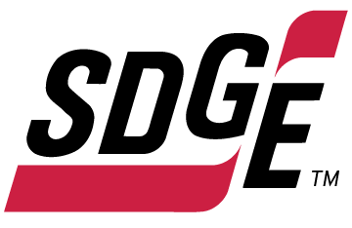

SDG&E RESIDENTIAL AND SMALL BUSINESS CONTENT PACKAGE | MARCH 2022
As a trusted community partner, we thank you in advance for sharing these digital assets with your audiences, including residents, customers and employees to help amplify our monthly messages.
How to use the articles, social posts and images
You are welcome to use these digital assets in your email communications, websites or newsletters. Please choose images below that fit your audience and feel free to mix and match. Two good websites to find additional free images are Unsplash.com and Canva.com. It’s okay to mention our name but, due to legal requirements, please do not use our logo in your marketing materials.
Follow us
You can find us on Facebook, Instagram, Twitter, YouTube and LinkedIn. When sharing these digital assets and copy, feel free to tag SDG&E’s social media accounts and direct your audience to sdge.com.
This month’s topics: energy-saving tips at home and work, customer assistance programs, free energy-related webinars
Residential
Article: 5 WAYS TO LOWER YOUR GAS AND ELECTRIC BILL
Did you know there are simple ways to lower your energy bill? Check out these quick and easy energy-saving tips to help lower your bill while staying warm and comfortable.
- Keep your furnace clean:
Check furnace filters monthly and replace them every 3 – 4 months. A dirty air filter can increase energy costs and cause problems with your equipment.
- Power off:
Turn off lights, computers, TVs, gaming consoles and other electronic devices when not in use. Use a smart power strip to make powering off easier with the push of one button.
- Don’t get burned by hot water:
Lower the thermostat on your water heater to 120 degrees Fahrenheit, if possible. You’ll save on energy and avoid scalding your hands and body.
- Wash with cold water:
Using warm water instead of hot can cut a load’s energy use in half; using cold water will save even more. Bonus – cold water helps your clothes last longer.
- Stop the breeze:
Caulk and weatherstrip around drafty doors and windows. Use a door sweep, door sock or towel at the bottom of doors with a gap.
Visit sdge.com/winter for more savings tips.

Social posts: 5 WAYS TO LOWER YOUR GAS AND ELECTRIC BILL
Use any bullets above and add: For more winter energy-savings tips, visit sdge.com/winter. #sdge #SDGEassist
Images: 5 WAYS TO LOWER YOUR GAS AND ELECTRIC BILL
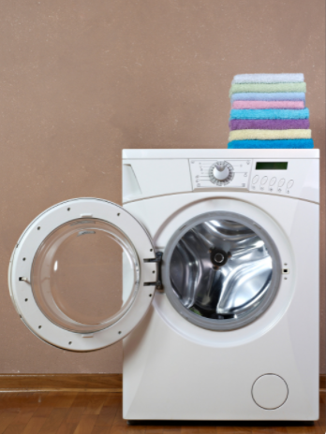

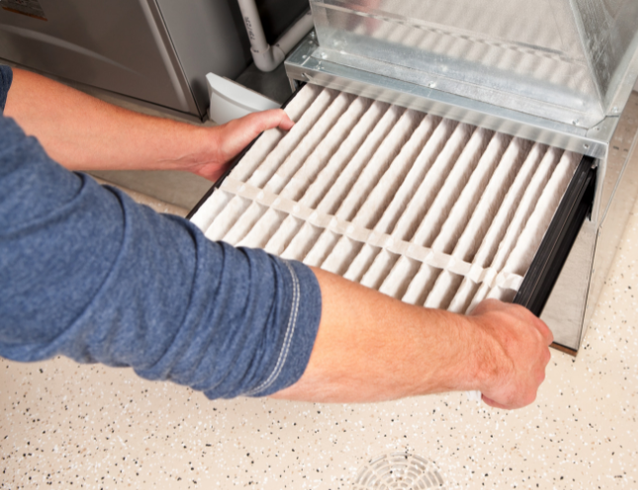

Article: NEED HELP WITH YOUR ENERGY BILL?
SDG&E recognizes that this is still a challenging time for many customers and wants to help. Check out these energy assistance programs.
- California Alternate Rates for Energy (CARE) Program: Save 30% or more every month on your bill. Find out if you qualify at sdge.com/CARE.
- Family Electric Rate Assistance (FERA) Program: If you don’t qualify for CARE and your household has 3 or more people, you may qualify for FERA. You could receive an 18% discount on your electric bill. Visit sdge.com/FERA to learn more.
- Energy Savings Assistance (ESA) Program: You may qualify to receive free energy-saving improvements for your home, such as new appliances, lighting, insulation and more. Find details at sdge.com/ESAP.
- Arrearage Management Plan (AMP): If you have outstanding bills and you are a CARE or FERA customer, you may be eligible for debt forgiveness. See if you qualify at sdge.com/AMP.
- Business customers: Set up a flexible payment plan, so you can rest easy knowing you’re covered. Visit sdge.com/recovery to learn more.
Online assistance program applications are easy, fast and convenient. For more information, visit sdge.com/assistance.

Social posts: NEED HELP WITH YOUR ENERGY BILL?
- If you’re behind on your energy bill, you may qualify for financial assistance. Learn more at sdge.com/assistance. #sdge #SDGEassist
- Hardship is everywhere right now – the last thing you need is to worry about your energy bill. Get help with your bill at sdge.com/assistance. #sdge #SDGEassist
- SDG&E provides assistance programs to help you with your monthly bill which can include up to a 30% discount. Find out if you qualify at sdge.com/assistance. #sdge #SDGEassist
- Whether you rent or own, you could be eligible to receive no-cost, energy-efficient home improvements that can make your home more comfortable and reduce your energy bill. Find out if you qualify at sdge.com/ESAP. #sdge #SDGEassist

Article (translated): ¿NECESITA AYUDA CON SU FACTURA DE ENERGÍA?
Usted puede calificar para un descuento en su factura o mejoras en el hogar. Los programas de asistencia de SDG&E ayudan a reducir su factura mensual de energía mientras mantiene su hogar cómodo.
- Programa de Tarifas Alternativas de Energía de California (CARE, por sus siglas en inglés): Ahorre un 30% o más cada mes en su factura. Averigüe si califica en sdge.com/CARE.
- Tarifa Eléctrica Familiar (FERA, por sus siglas en inglés): Si no califica para CARE y su hogar tiene 3 o más personas, puede calificar para FERA. Podría recibir un 18% de descuento en su factura de electricidad. Visite sdge.com/FERA para obtener más información.
- Programa de Asistencia para el Ahorro de Energía (ESA, por sus siglas en inglés): Puede calificar para recibir mejoras gratuitas para el ahorro de energía en su hogar, tales como electrodomésticos nuevos, iluminación, aislamiento y más. Encuentre los detalles en sdge.com/ESAP.
- Arrearage Management Plan (AMP): Si tiene facturas pendientes y es cliente de CARE o FERA, puede ser elegible para la condonación de deudas. Averigüe si califica en sdge.com/AMP.
- Clientes comerciales: Configure un plan de pago flexible, para que pueda estar tranquilo sabiendo que está cubierto. Visite sdge.com/recovery para obtener más información.
Las aplicaciones en línea son fáciles, rápidas y convenientes. Para obtener más información, visite sdge.com/asistencia.

Postas sociales: ¿NECESITA AYUDA CON SU FACTURA DE ENERGÍA?
- Si está atrasado en su factura de energía, puede calificar para asistencia financiera. Obtenga más información en sdge.com/asistencia. #sdge #SDGEassist
- En este momento, las dificultades se encuentran en todas partes - lo último que necesita es preocuparse por su factura de energía. Obtenga ayuda con su factura en sdge.com/asistencia. #sdge #SDGEassist
- SDG&E ofrece programas de asistencia para ayudarle con su factura mensual que puede incluir hasta un 30% de descuento. Descubra si califica en sdge.com/asistencia. #sdge #SDGEassist
- Ya sea que alquile o sea propietario, podría ser elegible para recibir mejoras de eficiencia energética en su hogar, sin costo, que pueden hacer que su hogar sea más cómodo y reducir su factura de energía. Descubra si califica en sdge.com/ESAP. #sdge #SDGEassist

Images: NEED HELP WITH YOUR SDG&E BILL?

BUSINESS
Article: 10 TIPS TO SAVE ON ENERGY COSTS AT YOUR BUSINESS
Did you know that by implementing a few tips your business can save on its energy use and costs? From regulating your building’s temperature to cleaning air filters regularly, there are smart ways to lower your energy bills. Here are ten tips that can help reduce your costs without having to sacrifice the comfort of your staff or customers:
- Lower the temperature. Your business can keep comfortable without cranking up the heat. Adjust your thermostat by a few degrees to help reduce your energy bill. Don’t completely turn off your heat overnight though – you’ll use more energy to heat up the building again in the morning.
- One of the easiest ways to save money is by controlling your thermostat. Smart thermostats can be adjusted remotely to run energy-efficient schedules. If you join SDG&E’s Smart Thermostat program, you’ll receive $50 per registered thermostat with a max of four thermostats for business and two for your home. Get details on sdge.com/MyBusiness.
- Did you know ceiling fans help in the colder months too? Change the rotation of your fan blades to clockwise, which will pull warm air down and spread it throughout the room.
- Open blinds and sunshades to allow sunlight to heat up the room, especially on south- or west-facing windows. Natural light can warm the space and reduce the need for lighting. When you need to turn on lights, save energy by using energy-efficient LED bulbs.
- In work areas that get little use, like storage and conference rooms, install sensors so lights will automatically go off when employees are working elsewhere.
- Make sure cold air isn’t drifting into your building by checking weather stripping on your doors and caulking on your windows and other areas that outside air can seep inside. This is especially important in older buildings. You can also put clear, inexpensive plastic sheeting on your windows to add more insulation and reduce cold drafts.
- Get a tune-up on your heater to ensure your system is operating efficiently. New, clean air filters can improve airflow and heating.
- Make sure your heating air intake and outlet grilles are not blocked by furniture or other bulky items. Obstructed grilles put more of a burden on the system’s fans to move heated air through an office. Also, check your ductwork for air leaks or any damage to insulation.
- Check your HVAC filters monthly and clean or replace when dirty. Keeping your HVAC system properly maintained can help save on heating costs.
- Check if a door provides good insulation by placing your hand against it from the inside. If it feels cooler than the inside walls, it might be time to install a door that's better insulated.
Visit sdge.com/MyBusiness for more helpful energy-saving tips.
Social posts: 10 TIPS TO SAVE ON ENERGY COSTS AT YOUR BUSINESS
Use any tip #1 – 10 above and add:
Visit sdge.com/MyBusiness for more helpful energy-saving tips. #SDGE #SDGEAssist
Images: 10 TIPS TO SAVE ON ENERGY COSTS AT YOUR BUSINESS
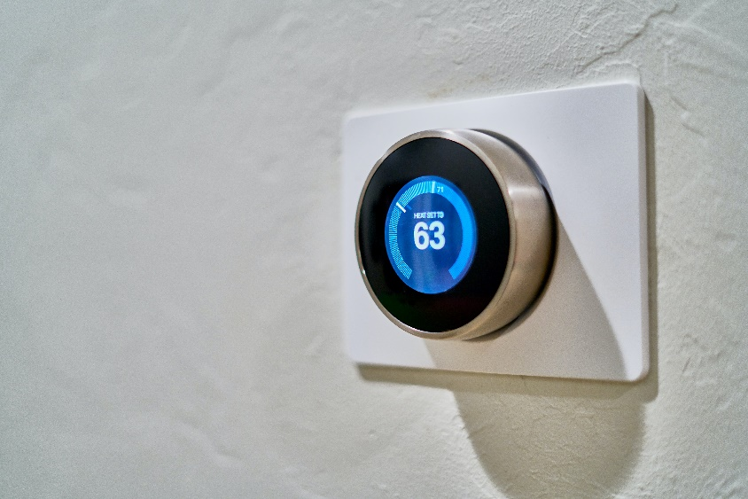
Article: TAKE ADVANTAGE OF NO-COST TRAINING FROM ENERGY EXPERTS
Learn new skills at your own pace. Did you know that SDG&E provides webinars for business owners and trade professionals, and most are at no cost? You or your employees can learn about the latest in green building practices, technology and energy-saving solutions from industry experts. Some of March’s topics include:
- Energy audit skills: tools, data collection techniques and calculations
- HVAC: cooling tower efficiency
- Full scale induction for commercial kitchens: cooktops and woks
- Title 24: residential modeling
- Heat pump water heater retrofit: energy cost estimator
Certifications and continuing education units are available for many of the classes. Check out the class listing at sdge.com/EIC.
Social posts: TAKE ADVANTAGE OF NO-COST TRAININGS FROM ENERGY EXPERTS
- Did you know SDG&E provides energy education and training webinars at no cost? These on-demand webinars are offered at introductory, intermediate and advanced levels. See the webinar list at sdge.com/EIC. #sdge #SDGEassist
- Learn the latest in green building design, operations, maintenance and technology at no-cost energy webinars led by industry experts. See the on-demand webinar list at sdge.com/EIC. #sdge #SDGEassist
- Enroll in a no-cost, on-demand energy topic webinar. Energy education and training can give you and your employees the knowledge and skills that customers value. Check out the webinar list at sdge.com/EIC. #sdge #SDGEassist

Images: TAKE ADVANTAGE OF NO-COST TRAININGS FROM ENERGY EXPERTS

