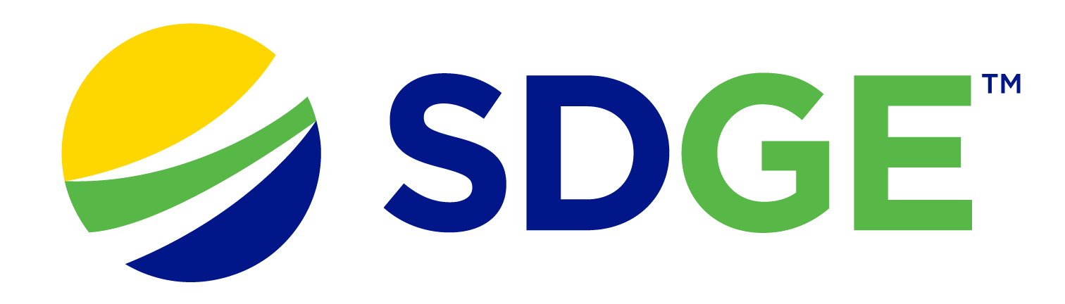

SDG&E® RESIDENTIAL AND SMALL BUSINESS CONTENT PACKAGE | MARCH 2023
As a trusted community partner, we thank you for sharing our content and digital assets with your audiences – including residents, customers and employees – to help amplify our key messages in your email communications, websites or newsletters.
Best practices for using our content, social media posts and images
- Images
Choose images that are relevant for your audience and feel free to mix and match what we provide. For alternate images, Unsplash.com and Canva.com offer free images that you can download.
- SDG&E logo
You’re welcome to mention our name but, due to legal requirements, please do not use our logo in any marketing materials that you create. Please only use the SDG&E logo if we provide it to you in this package or it’s publicly available online like a social post or video. You can also retweet our public posts which you’ll find on twitter.com/sdge.
- Videos
We have a library of videos you can share in your communications and social posts when you visit youtube.com/c/SanDiegoGasElectric/videos. If you’d like to sort our videos by topic, visit youtube.com/c/SanDiegoGasElectric. Some videos are in Spanish. You’ll see some on TV, too!
Follow us
Find us on Facebook, Instagram, Twitter, YouTube and LinkedIn. When sharing our digital assets and content, feel free to tag SDG&E’s social media and direct your audience to sdge.com.

SDG&E provides $16 million to help customers with bill assistance
SDG&E is funding a new $10 million program to support local nonprofit, community-based organizations (CBOs) that provide essential services to vulnerable customers. It’s also increasing funding by $6 million for its Neighbor-to-Neighbor bill assistance program.

Additionally, to help its customers keep their energy costs down, SDG&E launched a new program for renters and owners of single-family homes. The Residential Energy Solutions (RES) program has no income restrictions. Eligible customers receive free products such as smart thermostats, low-flow showerheads, brushless fan motors, HVAC services like air duct testing and sealing – and more. SDG&E has contracted with Synergy Companies. Customers can request a home visit from an energy efficiency expert at synergycompanies.com or by calling (888)-272-8394. Visit sdgenews.com for more information.

SDG&E offers other assistance programs:
- LIHEAP – utility bill help that ranges from a few hundred up to a few thousand dollars
- CARE – customers can save 30% or more off their energy bill
- FERA – customers can receive an 18% discount on their electricity bill
- ESA – no-cost energy-efficiency upgrades to income-qualified customers
- Golden States Rebates program – incentives of $20 - $500 to buy high-efficiency water heaters, smart thermostats or room air conditioners
- Arrearage Management Payment (AMP) Plan – debt forgiveness for past due bills for CARE and FERA customers
To learn more about SDG&E’s bill assistance programs, visit sdge.com/assistance or sdge.com/asistencia.

Social posts: SDG&E provides $16 million to help customers with bill assistance
- Visit sdge.com/assistance to find out if you qualify for SDG&E assistance programs and services including debt forgiveness, monthly discounts and payment arrangements. #sdge #SDGEassist
- The LIHEAP program helps eligible SDG&E customers with overdue bills. Help ranges from a few hundred up to a few thousand dollars. Learn more at sdge.com/LIHEAP. #sdge #SDGEassist
- Eligible SDG&E customers can save 30% or more on their energy bills. For more information, visit sdge.com/CARE. #sdge #SDGEassist
- Eligible SDG&E customers can receive an 18% discount on their electricity bill. Learn more at sdge.com/FERA. #sdge #SDGEassist
- SDG&E provides no-cost energy-efficiency upgrades to income-qualified customers. Get more information at sdge.com/ESA. #sdge #SDGEassist
- Receive incentives up to $500 to buy high-efficiency water heaters, smart thermostats or room air conditioners. Learn more at sdgenews.com. #sdge #SDGEassist
- If you’re an SDG&E CARE or FERA customer, you may be eligible for debt forgiveness for past due bills. Learn more at sdge.com/amp. #sdge #SDGEassist

Images: SDG&E provides $16 million to help customers with bill assistance – see zip file attachment for images

Article: 5 ways SDG&E’s My Account makes it easy to manage your energy bill
SDG&E’s My Account gives you the power to manage your SDG&E bills and account online. Convenient and secure, it’s all at your fingertips. Log in online or download the app today!

- Track your estimated charges and projected bill
- The SDG&E My Account homepage features a visual guide of “How you’re doing so far” with your bill-to-date and projected bill that includes a breakdown of your charges.
- It’s updated daily so you can track your upcoming bill at various times of the month.

- Sign up for Energy Alerts
Alerts are a terrific way to stay current on your energy costs and usage. Simply go to “Account,” then “Notifications Settings” to sign up.
- Weekly alerts: Receive weekly alerts of your projected bill and energy use to date.
- Spending alerts: Manage your budget with alerts when you hit certain dollar amounts. Just enter an amount and you’ll get an alert when your bill is expected to exceed that amount.

- View your bills online
Tired of the paper mess and having to file statements? View your SDG&E bill summary and bill statements online. Plus, you can access your payments and bill history with My Account.

- Pay your bill online
There are several easy and secure ways to pay your SDG&E bill. You can make a payment on sdge.com/MyAccount or on the SDG&E app. If you’d like an even more convenient option, sign up for Auto Pay or Text to Pay.
- Auto Pay: It’s a convenient way to ensure your bill is paid each month on time and gives you peace of mind.
- Text to Pay: Paying by text is super-convenient. You’ll receive a text message with the amount due and you reply to pay.

Get started with these tips by logging in to SDG&E’s My Account at sdge.com/MyAccount. If you’re not enrolled, register today at sdge.com/MyAccount. You can also download the SDG&E app on the App Store or Google Play.

Social posts: 5 ways SDG&E’s My Account makes it easy to manage your energy bill
- Did you know that SDG&E offers a variety of convenient online payment options with My Account? Try one that works for you. Go to sdge.com/Pay-My-Bill. #sdge #SDGEassist
- Make secure payments, manage your bill and get your energy use information with SDG&E’s My Account. Log in or sign up at sdge.com/MyAccount. #sdge #SDGEassist
- Track your projected energy bill and energy use with alerts. Set weekly or spending limit alerts. Visit sdge.com/alerts. #sdge #SDGEassist
- Download SDG&E’s mobile app at sdge.com/app, the App Store or Google Play. You can set energy use and cost alerts, pay your bill, track power outages and restoration times and update your emergency contact information. #sdge #SDGEassist
Images: 5 ways SDG&E’s My Account makes it easy to manage your energy bill
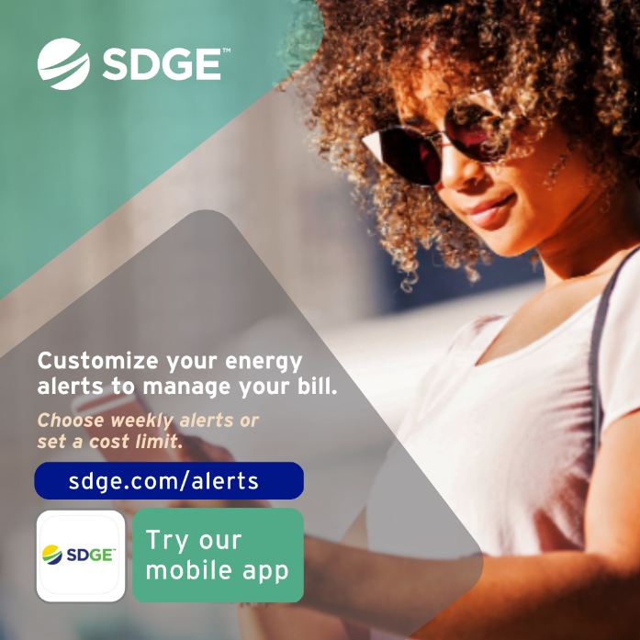

Article: SDG&E’s ACCESSIBLE INFORMATION, RESOURCES & SERVICES
Did you know SDG&E has a variety of resources available to support customers with Access and Functional Needs? Whether you or someone in your household:
- Has a disability
- Uses an electronic medical device for health, safety or independence
- Is blind or has low vision
- Or prefers to receive information in a language other than English, including American Sign Language (ASL)
SDG&E is committed to supporting customers and making sure that everyone is offered equal access to information, resources and services. To learn more, visit sdge.com/AFN. Customers are also encouraged to share their household’s individual needs on SDG&E’s AFN form that can be found at sdge.com/access-and-functional-needs-survey.
Social posts: SDG&E’s ACCESSIBLE INFORMATION, RESOURCES & SERVICES
- SDG&E is committed to supporting their customers with various access and functional needs and making sure that everyone is offered equal access to information, resources and services. Learn more atsdge.com/AFN. #sdge #SDGEassist
- SDG&E is committed to providing all customers with accessible resources and services. To learn more, visit sdge.com/AFN. #sdge #SDGEassist

Article (translated): INFORMACIÓN, RECURSOS Y SERVICIOS ACCESIBLES DE SDG&E
¿Sabía que SDG&E tiene una variedad de recursos disponibles para ayudar a sus clientes con necesidades funcionales y de acceso? Ya sea que usted o alguien en su hogar:
- Tiene una discapacidad
- Utiliza un dispositivo médico electrónico para la salud, la seguridad o la independencia,
- Es ciego o tiene visión baja
- O si prefiere recibir información en español o una idioma que no sea inglés, incluyendo el lenguaje de señas americano (ASL, por sus siglas en inglés)
SDG&E se compromete a apoyar a los clientes y asegurarse de que a todos se les ofrezca el mismo acceso a la información, recursos y servicios. Para obtener más información, visite sdge.com/AFN. También se alienta a los clientes de SDG&E a compartir las necesidades individuales de sus hogares en sdge.com/access-and-functional-needs-survey.

Postas sociales: INFORMACIÓN, RECURSOS Y SERVICIOS ACCESIBLES DE SDG&E
- SDG&E se compromete a apoyar a sus clientes con diversas necesidades funcionales y de acceso y a asegurarse de que a todos se les ofrezca el mismo acceso a la información, los recursos y los servicios. Obtenga más información en sdge.com/AFN. #sdge #SDGEasistencia
- SDG&E se compromete a proporcionar recursos y servicios accesibles a todos los clientes. Para obtener más información, visite sdge.com/AFN. #sdge #SDGEasistencia

Images: SDG&E’s ACCESSIBLE INFORMATION, RESOURCES & SERVICES

Article: WINTER ENERGY-SAVINGS TIPS FOR YOUR BUSINESS
There are a variety of ways to save money when it comes to your business’s energy use. Try these tips to help trim your winter energy bills.
- Adjust your thermostat. When you’re in your office or workplace, set the thermostat as low as is comfortable. At night or when you’re out of the office, turn it back 10 – 15 degrees to save around 10% a year. Invest in a smart thermostat and enroll in SDG&E’s Smart Thermostat Program. You’ll be rewarded $50 for each thermostat you register (up to four thermostats). Get details at sdge.com/Business-Thermostat.
- Tune your HVAC. Just as a tune-up for your car can improve gas mileage, an annual tune-up of your heating and cooling system can improve efficiency and comfort. Schedule a no-cost energy audit at sdge.com/BES. You may also receive installed energy-efficient products at no cost or a discount!
- Keep a consistent HVAC maintenance schedule. Not all businesses have the same needs for their HVAC systems. Talk to your preferred contractor to provide customized care your system needs to boost performance.
- Install advanced control sensors. This improves a ventilation system’s operating power for energy efficiency. These controls count the number of people in a room and adjust the heat and air conditioning accordingly. Advanced controls can reduce energy use by up to 40%.
- Check out the area around each vent for proper ventilation. Make sure there is adequate airflow. Move obstructions like furniture and curtains. Don’t keep vents closed to save energy. It can change the way the air is distributed and cause an imbalance to the operation of your HVAC system.
Get more helpful winter energy-saving and safety tips at sdge.com/MyBusiness.

Social posts: WINTER energy-SAVINGS TIPS FOR YOUR BUSINESS
- Use any of the 5 tips above, then add: For more tips, visit sdge.com/MyBusiness. #sdge #SDGEassist

Images: WINTER ENERGY-SAVINGS TIPS FOR YOUR BUSINESS

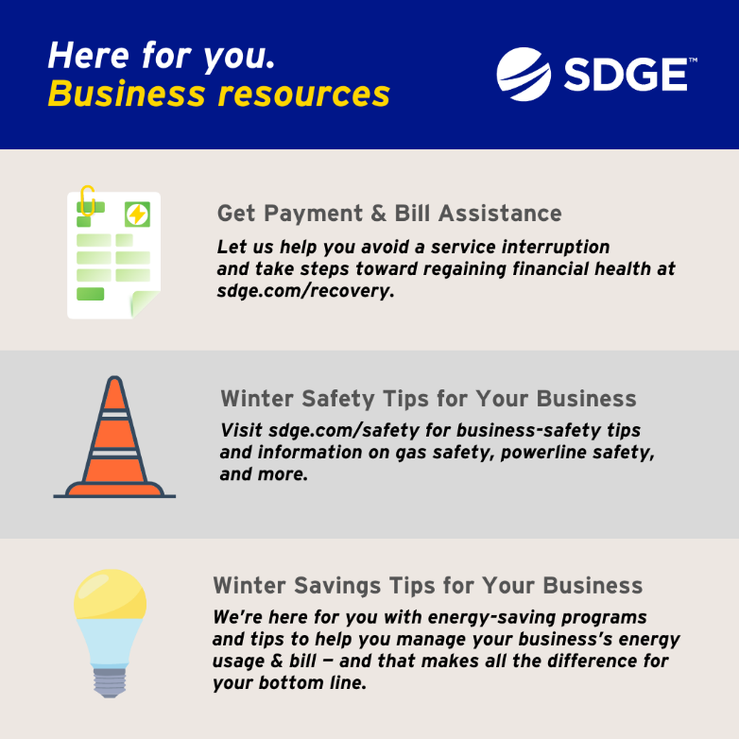
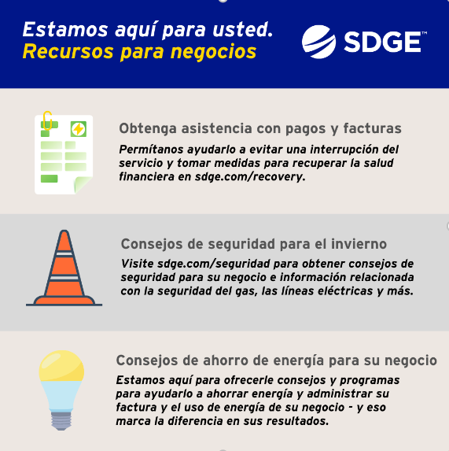
MISC SOCIAL POSTS:
Rebates:
The new Golden State Rebates give qualifying customers rebates toward the purchase of energy-efficient products such as smart thermostats, gas tank water heaters, heat pump water heaters and more. Learn more at sdge.com/rebates. #sdge #SDGEassist

Los nuevos reembolsos de Golden State brindan a los clientes calificados recibir reembolsos para la compra de productos de eficiencia energética, como termostatos inteligentes, calentadores de agua con tanque de gas, calentadores de agua con bomba de calor y más. Obtenga más información en sdge.com/rebates. #sdge #SDGEassist
FERA:
SDG&E recognizes this is still a challenging time for many customers. Even if you have never qualified for assistance before, you may be eligible now. If you have three or more people in your household and are having a hard time paying your electric bill, you may be eligible for an 18% discount on your electric bill. To apply, visit sdge.com/FERA.
Instagram/Facebook:

