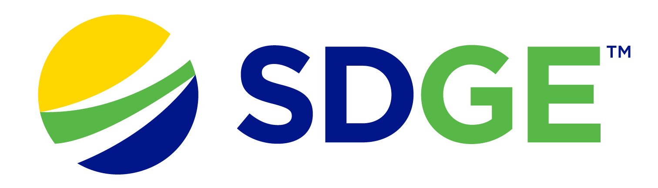

SDG&E® RESIDENTIAL AND SMALL BUSINESS CONTENT PACKAGE | MARCH 2024
As a trusted community partner, we thank you for sharing our content and digital assets with your audiences – including residents, customers and employees – to help amplify our key messages in your email communications, websites or newsletters.
Best practices for using our content, social media posts and images
- IMAGES
Choose IMAGES that are relevant for your audience and feel free to mix and match what we provide. For alternate images, Unsplash.com and Canva.com offer free images that you can download.
- SDG&E logo
You’re welcome to mention our name but, due to legal requirements, please do not use our logo in any marketing materials that you create. Please only use the SDG&E logo if we provide it to you in this package or it’s publicly available online like a social post or video. You can also retweet our public posts which you’ll find on facebook.com/sdge and twitter.com/sdge.
- Videos
We have a library of videos you can share in your communications and SOCIAL POSTS when you visit youtube.com/c/SanDiegoGasElectric/videos. If you’d like to sort our videos by topic, visit youtube.com/c/SanDiegoGasElectric. Some videos are in Spanish. You’ll see some on TV, too!
Follow us
Find us on Facebook, Instagram, Twitter, YouTube and LinkedIn. When sharing our digital assets and content, feel free to tag SDG&E’s social media and direct your audience to sdge.com.

This month’s topics: Auto Pay, paperless billing, AFN, energy-savings tips for residential and business customers, assistance programs, energy webinars

ARTICLE: 5 REASONS YOU SHOULD TRY AUTO PAY
In the age of digital convenience, managing finances has become simpler and more efficient. One such convenience is Auto Pay – a service that automatically deducts payments from your account on predetermined dates. While some may still prefer manual payments, there are compelling reasons why signing up for Auto Pay for your energy bill is a smart choice.
1. Never Miss a Payment
Life can be hectic, and with our busy schedules, it's easy to forget bill due dates. With Auto Pay, you eliminate the risk of missing payments. Auto Pay ensures that your payments are made on time, every time.
2. Save Time and Effort
Manually paying bills can be time-consuming. Auto Pay streamlines this process by automating payments, freeing up your time. Once set up, you can enjoy peace of mind knowing that your bills are being taken care of automatically.
3. Hassle-free Way to Manage Your Budget
Auto Pay can help you stick to your budget. By automatically scheduling payments, you can ensure that essential bills are paid promptly, avoiding the temptation to overspend or delay payments.
4. Secure and Reliable
Concerns about security are natural. Many utilities, like SDG&E, have strong security measures to safeguard your information. With encrypted transactions and authentication protocols, Auto Pay is more secure than mailing a check which can get lost or stolen.
5. Allows Flexibility
You have the flexibility to monitor your transactions and make changes as needed. You can modify or cancel Auto Pay at any time for your energy bill, online with SDG&E’s My Account or on their app. Download SDG&E’s app on The App Store or Google Play.
Learn more at sdge.com/Auto-Pay or enroll in Auto Pay now in My Account. Log in or create an account at sdge.com/MyAccount Consider also enrolling in paperless billing to reduce clutter and lower your environmental impact. Get details at sdge.com/paperless.
SOCIAL POSTS: 5 REASONS YOU SHOULD TRY AUTO PAY
- Short on time? Enroll in SDG&E’s secure Auto Pay to save time and effort. Learn more at sdge.com/Auto-Pay. #sdge #SDGEAssist
- Enjoy the convenience of SDG&E’s Auto Pay with My Account online or on their app. Learn more at sdge.com/Auto-Pay. #sdge #SDGEAssist
- Enroll in SDG&E’s Auto Pay. It is an easy and secure way to make sure your energy bill is paid on time, automatically, each month. Learn more at sdge.com/Auto-Pay. #sdge #SDGEAssist

IMAGES: 5 REASONS YOU SHOULD TRY AUTO PAY

ARTICLE: SDG&E’S ACCESSIBLE INFORMATION, RESOURCES & Services
SDG&E is committed to supporting customers and making sure that everyone is offered equal access to information, resources and services. To learn more, visit sdge.com/AFN. Customers are also encouraged to share their household’s individual needs using the form found at sdge.com/access-and-functional-needs-survey.
Let us know whether you or someone in your household:
- Has a disability;
- Uses an electronic medical device for health, safety or independence;
- Is blind or has low vision;
- Is deaf or hard of hearing; and/or
- Requires the use of assistive technology or durable medical equipment.

Social posts: SDG&E’S ACCESSIBLE INFORMATION, RESOURCES & SERVICES
- SDG&E is committed to supporting their customers with access and functional needs and making sure that everyone is offered equal access to information, resources and services. Learn more at sdge.com/AFN. #sdge #SDGEassist
- SDG&E is committed to providing all customers with accessible resources and services. To learn more, visit sdge.com/AFN. #sdge #SDGEassist

Article (translated): INFORMACIÓN, RECURSOS Y SERVICIOS ACCESIBLES DE SDG&E
SDG&E mantiene su compromiso de apoyar a sus clientes y asegurarse de que a todos se les ofrezca el mismo acceso a la información, recursos y servicios. Para obtener más información, visite sdge.com/AFN. También se anima a los clientes a compartir las necesidades individuales de su hogar usando el formulario en sdge.com/access-and-functional-needs-survey.
Háganos saber si usted o alguien en su hogar:
- Tiene una discapacidad;
- Utiliza un dispositivo médico, electrónico para la salud o seguridad, o para mantener la independencia;
- Es ciego o tiene baja visión;
- Es sordo o tiene dificultades auditivas; y/o
- Requiere el uso de tecnologías de asistencia o equipos médicos duraderos.

Publicaciones para compartir en las redes sociales: INFORMACIÓN, RECURSOS Y SERVICIOS ACCESIBLES DE SDG&E
- SDG&E mantiene su compromiso de apoyar a sus clientes que tienen necesidades funcionales y de acceso y asegurarse de que a todos se les ofrezca el mismo acceso a la información, los recursos y los servicios. Obtenga más información en sdge.com/AFN. #sdge #SDGEasistencia
- SDG&E se compromete a proporcionar recursos y servicios accesibles a todos sus clientes. Para más información, visite sdge.com/AFN. #sdge #SDGEasistencia

Social posts: SDG&E’S ACCESSIBLE INFORMATION, RESOURCES & SERVICES

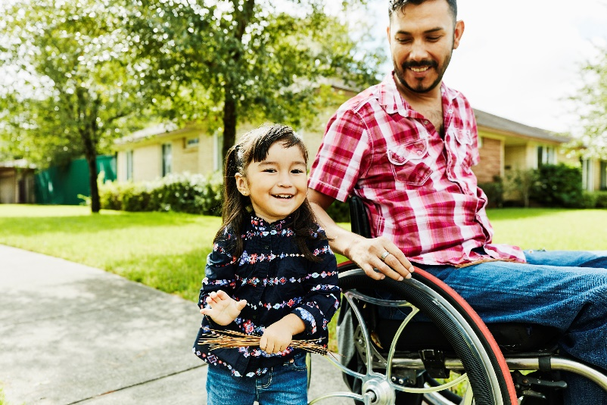

ARTICLE: 5 GREAT REASONS TO CHOOSE PAPERLESS BILLING
Looking for a more convenient way to manage your bills? Enroll in paperless billing! It simplifies the way you manage your energy bill and helps contribute to a greener planet. Here are some key benefits of making the switch to paperless billing.
- Eco-friendly: Going paperless reduces your carbon footprint by cutting down on the amount of pollution caused by making paper, printing and transporting it.
- Convenient: Access your bills and statements online or on an app from anywhere, anytime.
- Saves time: No need to mail your bill, write a check or find a stamp.
- Less clutter: Reduce the mess associated with stacks of paper bills. No more piles of paper to deal with.
- More secure: There is less risk of lost mail or mail fraud. Paper bills sent through traditional mail are susceptible to theft, while digital statements are more secure.
Switch your energy bill to paperless billing at sdge.com/MyAccount or learn more at sdge.com/paperless.
SOCIAL POSTS: 5 GREAT REASONS TO CHOOSE PAPERLESS BILLING
- Why go paperless? It helps the environment. It is good for the planet because it reduces the need for paper. Enroll in paperless billing for your energy bill now at sdge.com/paperless. #SDGE #SDGEassist
- Why go paperless? It is convenient. Your bills and energy use info are available anytime online. Enroll in paperless billing now at sdge.com/paperless. #SDGE #SDGEassist
- Why go paperless? It saves time. No need to mail your energy bill, write a check or find a stamp. Enroll in paperless billing now at sdge.com/paperless. #SDGE #SDGEassist
- Why go paperless? It reduces clutter. No more stacks of paper to deal with. Enroll in paperless billing now at sdge.com/paperless. #SDGE #SDGEassist
- Why go paperless? Your information is safe and secure. Enroll in paperless billing now at sdge.com/paperless. #SDGE #SDGEassist
- Why go paperless? Less paper means less waste. Enroll in paperless billing now at sdge.com/paperless. #SDGE #SDGEassist
IMAGES: 5 GREAT REASONS TO CHOOSE PAPERLESS BILLING

ARTICLE: NEED HELP WITH YOUR ENERGY BILL?

If you are having trouble paying your energy bill, you might be eligible for programs and services that can provide immediate financial assistance and help you avoid interruptions to your service. Flexible payment arrangements are also available to help you pay down past due balances. Learn more at sdge.com/Payment-Arrangements.
Check out these energy assistance programs:
- California Alternate Rates for Energy (CARE) Program: Save 30% or more every month on your bill. Find out if you qualify at sdge.com/CARE.
- Family Electric Rate Assistance (FERA) Program: If you do not qualify for CARE and your household has three or more people, you may qualify for FERA. You could receive an 18% discount on your electric bill. Visit sdge.com/FERA to learn more.
- Energy Savings Assistance (ESA) Program: You may qualify to receive free energy-saving improvements for your home, like new appliances, lighting, insulation and more. Find details at sdge.com/ESA.
- Arrearage Management Plan (AMP): If you have outstanding bills and you are a CARE or FERA customer, you may be eligible for debt forgiveness. See if you qualify at sdge.com/AMP.
Even if you made a recent payment or set up a flexible payment plan with SDG&E, there may still be assistance programs available to help you. For a complete list of available offerings, visit sdge.com/assistance.

SOCIAL POSTS: NEED HELP WITH YOUR ENERGY BILL?
- If you are behind on your energy bill, you may qualify for financial assistance. Learn more at sdge.com/assistance. #sdge #SDGEAssist
- Hardship can hit at any time – when it does, the last thing you need to worry about is your energy bill. Get help with your bill at sdge.com/assistance. #sdge #SDGEAssist
- SDG&E provides assistance programs to help you with your monthly energy bill which can include up to a 30% discount. Find out if you qualify at sdge.com/assistance. #sdge #SDGEAssist
- Whether you rent or own, you could be eligible to receive no-cost, energy-efficient home improvements that can make your home more comfortable and help reduce your energy bill. Find out if you qualify at sdge.com/ESA. #sdge #SDGEAssist

ARTICLE (translated): ¿NECESITA AYUDA CON SU FACTURA DE ENERGÍA?
Usted puede calificar para un descuento en su factura o mejoras en el hogar. Hay programas de asistencia que pueden ayudar a reducir su factura mensual de energía mientras mantiene su hogar cómodo.
- Programa de Tarifas Alternativas de Energía de California (CARE, por sus siglas en inglés): Ahorre un 30% o más cada mes en su factura. Averigüe si califica en sdge.com/CAREesp.
- Tarifa Eléctrica Familiar (FERA, por sus siglas en inglés): Si no califica para CARE y su hogar tiene 3 o más personas, puede calificar para FERA. Podría recibir un 18% de descuento en su factura de electricidad. Visite sdge.com/FERAesp para obtener más información.
- Programa de Asistencia para el Ahorro de Energía (ESA, por sus siglas en inglés): Puede calificar para recibir mejoras gratuitas para el ahorro de energía en su hogar, tales como electrodomésticos nuevos, iluminación, aislamiento y más. Encuentre los detalles en sdge.com/ESAesp.
- Arrearage Management Plan (AMP): Si tiene facturas pendientes y es participante en el programa de CARE o FERA, puede ser elegible para la condonación de deudas. Averigüe si califica en sdge.com/AMPesp.

Las aplicaciones en línea son fáciles, rápidas y convenientes. Para obtener más información, visite sdge.com/asistencia.

Publicaciones para compartir en las redes sociales: ¿NECESITA AYUDA CON SU FACTURA DE ENERGÍA?
- Si está atrasado en su factura de energía, puede calificar para asistencia financiera. Obtenga más información en sdge.com/asistencia. #sdge #SDGEAssist
- Dificultades pueden aparecer en cualquier momento – si aparecen, lo último que necesita es preocuparse por su factura de energía. Obtenga ayuda con su factura en sdge.com/asistencia. #sdge #SDGEAssist
- SDG&E ofrece programas de asistencia para ayudarle con su factura mensual que puede incluir hasta un 30% de descuento. Descubra si califica en sdge.com/asistencia. #sdge #SDGEAssist
- Si alquile o es propietario, podría ser elegible para recibir mejoras de eficiencia energética en su hogar, sin costo, que pueden hacer que su hogar sea más cómodo y ayuden reducir su factura de energía. Descubra si califica en sdge.com/ESAesp. #sdge #SDGEAssist

IMAGES: NEED HELP WITH YOUR ENERGY BILL?

ARTICLE: 10 WAYS YOUR BUSINESS CAN SAVE ON energy COSTS
It is important for businesses to be both eco-friendly and cost-effective. From using energy-efficient technologies to making simple changes in how things are done every day, these tips can guide businesses towards a more planet- and budget-friendly path.
- Implement a paperless office policy to reduce energy usage associated with printing and copying.
- Invest in energy-efficient server equipment and consider cloud-based solutions to reduce the need for physical servers.
- Conduct regular energy audits to identify areas for improvement. Did you know you can track your energy usage in SDG&E’s My Account? Learn more at sdge.com/MyAccount.
- Use natural light whenever possible by keeping windows unobstructed.
- Unplug chargers and other electronics when not in use to prevent phantom energy consumption.
- Use motion-activated lighting in low-traffic areas such as storage rooms or bathrooms.
- Invest in energy-efficient HVAC systems and regularly clean or replace air filters.
- Opt for laptops over desktop computers, as they typically consume less energy.
- Encourage remote work to reduce the need for office energy consumption.
- Set water heaters at lower temperatures and insulate hot water pipes to conserve energy. Check out water heater rebates up to $500 on the purchase of new, qualifying energy-efficient gas water heaters at sdge.com/rebates.

Implementing these energy-saving practices can lower energy costs and contribute to a more sustainable and environmentally friendly workplace. Visit sdge.com/MyBusiness for more helpful energy-saving tips, tools and programs for your business.

SOCIAL POSTS: 10 WAYS YOUR BUSINESS CAN SAVE ON energy COSTS
Use any of the tips above and then add:
Visit sdge.com/MyBusiness for more helpful energy-saving tips. #sdge #SDGEassist

IMAGES: 10 WAYS YOUR BUSINESS CAN SAVE ON ENERGY COSTS

JUST POSTS – Residential
- Air-dry your dishes​. If your dishwasher has an air-dry option, use that instead of heat dry.​ Get more energy-saving tips at sdge.com/MyEnergy. #sdge #SDGEassist
- Use less hot water. The longer you run hot water, the higher your energy use and bills. According to the EPA, running your hot faucet for five minutes uses about as much energy as 22 hours of light from a 60-watt light bulb. Get more energy-saving tips at sdge.com/MyEnergy. #sdge #SDGEassist
- Swap your bath for a shower​ to save. Water heating accounts for about 20% of your home's energy use, the second largest utility expense, according to the Department of Energy. Reducing your hot water use can help you save. Get more energy-saving tips at sdge.com/MyEnergy. #sdge #SDGEassist
- Reduce fireplace heat loss. Keep your damper closed unless a fire is burning. Keeping the damper open is like a wide-open window during the winter; it allows warm air to go right up the chimney. Get more energy-saving tips at sdge.com/MyEnergy. #sdge #SDGEassist
- Don’t get burned by hot water. Lower the thermostat on your water heater to 120F, if possible. You’ll not only save energy; you’ll avoid scalding. Get more energy-saving tips at sdge.com/MyEnergy. #sdge #SDGEassist

JUST POSTS – Business
- Looking for ways to save energy at your business or office? Check out sdge.com/MyBusiness for tips. #sdge #SDGEassist
- Use smart power strips. They can automatically turn off peripheral devices when the main device is turned off. For more energy-saving tips, visit sdge.com/MyBusiness. #sdge #SDGEassist
- Encourage natural ventilation. Open windows and doors to allow fresh air circulation instead of relying solely on HVAC systems. For more energy-saving tips, visit sdge.com/MyBusiness. #sdge #SDGEassist
- Take advantage of energy-efficiency rebates for your business. Check out these current rebates at sdge.com/rebates. For more energy-saving tips, visit sdge.com/MyBusiness. #sdge #SDGEassist
- Go paperless at the office. Reduce paper use to save energy associated with printing and copying. Learn more at sdge.com/paperless. #sdge #SDGEassist

