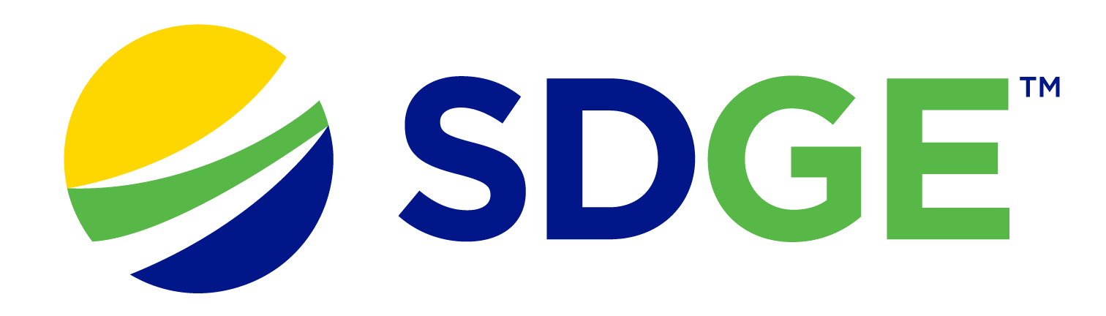

SDG&E® RESIDENTIAL AND SMALL BUSINESS CONTENT PACKAGE | JUNE 2023
As a trusted community partner, we thank you for sharing our content and digital assets with your audiences – including residents, customers and employees – to help amplify our key messages in your email communications, websites or newsletters.
Best practices for using our content, social media posts and images
- IMAGES
Choose IMAGES that are relevant for your audience and feel free to mix and match what we provide. For alternate IMAGES, Unsplash.com and Canva.com offer free IMAGES that you can download.
- SDG&E logo
You’re welcome to mention our name but, due to legal requirements, please do not use our logo in any marketing materials that you create. Please only use the SDG&E logo if we provide it to you in this package or it’s publicly available online like a social post or video. You can also retweet our public posts which you’ll find on twitter.com/sdge.
- Videos
We have a library of videos you can share in your communications and SOCIAL POSTS when you visit youtube.com/c/SanDiegoGasElectric/videos. If you’d like to sort our videos by topic, visit youtube.com/c/SanDiegoGasElectric. Some videos are in Spanish. You’ll see some on TV, too!
Follow us
Find us on Facebook, Instagram, Twitter, YouTube and LinkedIn. When sharing our digital assets and content, feel free to tag SDG&E’s social media and direct your audience to sdge.com.

This month’s topics: Summer energy-saving tips, start/stop/transfer service, customer assistance programs, smart thermostats for businesses, training

ARTICLE: CUT COSTS ON YOUR SUMMER ENERGY BILL
Warmer temps are on their way but it doesn’t have to mean higher energy bills. Use major appliances when energy is less expensive, before 4 pm or after 9 pm, Monday – Sunday. Here are ways to save energy and money while staying cool.
First, let’s talk about appliances. They tend to use a lot of energy and heat up your home at the same time. With that in mind, consider the following:
- Change the way you cook
Turn off the oven and stovetop as much as possible. Relying on microwaves, slow cookers, backyard grills or foods you don’t need to cook (like salads) are great ways to not heat up your food and home at the same time. If you’re going to use your oven, do it sparingly and during the coolest part of the day.
- Change how you wash your clothes
Use cold water to wash your clothes so you don’t have to pay to heat the water. Cold water helps reduce wrinkles and remove stains. Washing in cold also helps your clothes last longer, prolong vibrancy and maintain their shape and size. Always aim for full loads of laundry and consider line drying them.
- Don’t “heat dry” your dishes
When running your dishwasher, turn off the “heat dry” cycle and let dishes air dry instead.
- Use smart plugs for appliances
One of the best smart plug uses is to connect appliances to them. Smart plugs allow you to schedule when your appliances are on or off – even remotely. They also help reduce “vampire draw” because appliances still use energy when they’re off but plugged in.
Beyond appliances, here are other great ways to stay cool and save big:
- Check out SDG&E’s new RES program
Do you rent or own a single-family home? Eligible customers receive free products such as smart thermostats, low-flow showerheads, brushless fan motors, HVAC services like air duct testing and sealing – and more. SDG&E has contracted with Synergy Companies to provide customers with energy efficiency audits from their experts. Customers can request a home visit at SynergyCompanies.com or by calling (888)-272-8394. Learn more at sdge.com/RES.
- Save with Golden State rebates
Receive rebates toward the purchase of energy-efficient products like smart thermostats, heat pump water heaters and room air conditioners. Get details at sdge.com/rebates and for the product list, visit GoldenStateRebates.com.
- Sign up for SDG&E’s Power Saver Rewards
Earn a bill credit of $2 per kilowatt hour when you reduce your energy use when the grid needs it the most. Get details at sdge.com/PowerSaver.
- Use ceiling fans instead of the A/C
Ceiling fans can save up to 25 percent on cooling costs and reduces your home’s temperature up to ten degrees. In warmer temps, fans should be set counter-clockwise for the best cooling effect. Don’t forget to change the direction to clockwise when temps drop in cooler months because the fan pushes heat down.
For more ideas on how to save energy, visit sdge.com/MyEnergy.
SOCIAL POSTS: CUT COSTS ON YOUR SUMMER ENERGY BILL
Use any bullet above and then add: #sdge #SDGEassist

IMAGES: CUT COSTS ON YOUR SUMMER ENERGY BILL

ARTICLE: MOVING? SCHEDULE YOUR SDG&E SERVICE REQUEST ONLINE
Take some stress out of your move when you schedule your SDG&E service request online. Use SDG&E’s My Account to start, transfer or stop your service. It’s easy and only takes a minute. No need to call and no need to wait on the phone. Online scheduling shows you available dates that you can choose. If your plans change, simply update your request online. Cross one more thing off your to-do list! Get more information at sdge.com/move.
SOCIAL POSTS: MOVING? SCHEDULE YOUR SDG&E SERVICE REQUEST ONLINE
- Moving? Make moving easier with online scheduling tools. Visit sdge.com/move to start, transfer or stop your SDG&E service. #sdge #SDGEassist
- Moving made easy. Start, transfer or stop your SDG&E service online. Easy, convenient – no calls, no waiting. Get more information at sdge.com/move. #sdge #SDGEassist

IMAGES: MOVING? SCHEDULE YOUR SDG&E SERVICE REQUEST ONLINE
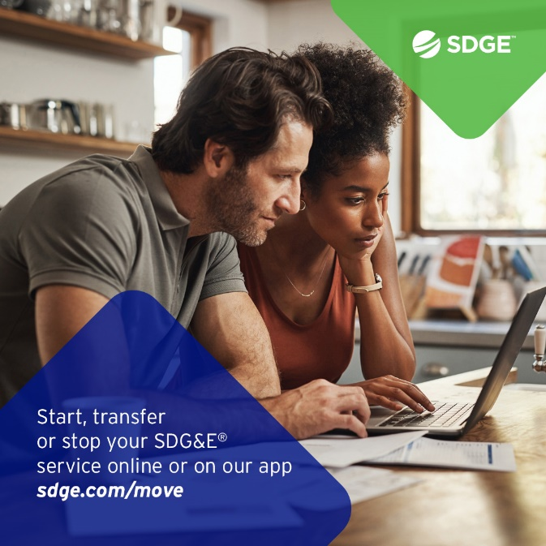

ARTICLE: ENERGY SAVINGS FOR RENTERS AND HOMEOWNERS
To help its customers keep their energy costs down, SDG&E launched a new program for renters and owners of single-family homes. The Residential Energy Solutions (RES) program has no income restrictions. Eligible customers receive no-cost upgrades such as smart thermostats, low-flow showerheads, brushless fan motors, HVAC services like air duct testing and sealing – and more. SDG&E has contracted with Synergy Companies to provide customers with energy efficiency audits from their experts. Customers can request a home visit at sdge.com/RES or by calling (888)272-8394.
SDG&E offers other assistance programs, too:
- Neighbor-to-Neighbor – customers may receive up to $600 toward their past due energy bill
- CARE – customers can save 30% or more off their energy bill
- FERA – customers can receive an 18% discount on their electricity bill
- ESA – no-cost energy-efficiency upgrades to income-qualified customers
- Golden States Rebates program – incentives of $20 – $500 to buy high-efficiency water heaters, smart thermostats or room air conditioners
- Arrearage Management Payment (AMP) Plan – debt forgiveness for past due bills for CARE and FERA customers
To learn more about SDG&E’s bill assistance programs, visit sdge.com/assistance.

SOCIAL POSTS: ENERGY SAVINGS FOR RENTERS AND HOMEOWNERS
- Visit sdge.com/assistance to find out if you qualify for SDG&E assistance programs and services including debt forgiveness, monthly discounts and payment arrangements. #sdge #SDGEassist
- The Neighbor-to-Neighbor program provides qualified customers with up to $600 towards their past due energy bill. Get details at sdge.com/NTN. #sdge #SDGEassist
- Eligible SDG&E customers can save 30% or more on their energy bills. For more information, visit sdge.com/CARE. #sdge #SDGEassist
- Eligible SDG&E customers can receive an 18% discount on their electricity bill. Learn more at sdge.com/FERA. #sdge #SDGEassist
- SDG&E provides no-cost energy-efficiency upgrades to income-qualified customers. Get more information at sdge.com/ESA. #sdge #SDGEassist
- Receive incentives up to $500 to buy high-efficiency water heaters, smart thermostats or room air conditioners. Learn more at sdge.com/rebates. #sdge #SDGEassist
- If you’re an SDG&E CARE or FERA customer, you may be eligible for debt forgiveness for past due bills. Learn more at sdge.com/amp. #sdge #SDGEassist

ARTICLE (TRANSLATED): AHORROS PARA INQUILINOS Y PROPIETARIOS
Para ayudar a sus clientes a mantener bajos sus costos de energía, SDG&E lanzó un nuevo programa para inquilinos y propietarios de viviendas unifamiliares llamado Soluciones de Energía Residencial (Residential Energy Solutions, RES). El programa no tiene restricciones de ingresos. Los clientes que califican para el programa recibirán productos gratuitos como termostatos inteligentes, cabezales de ducha de bajo flujo, motores de ventiladores sin escobillas, servicios para los sistemas HVAC como prueba y sellado de conductos de aire y más. Clientes también pueden solicitar una inspección de su vivienda por parte de un experto en eficiencia energética de Synergy Companies, una empresa que SDG&E ha contratado para administrar el programa. Para pedir una inspección, visite sdge.com/RES o llame al (888) 272-8394.
SDG&E también ofrece los siguientes programas de asistencia:
- Neighbor-to-Neighbor – Clientes pueden recibir hasta $600 en créditos para facturas de energía vencidas
- CARE – Clientes pueden ahorrar un 30% o más en su factura de energía
- FERA – Clientes pueden recibir un 18% de descuento en su factura de electricidad
- ESA – ofrece actualizaciones de eficiencia energética en el hogar sin costo a clientes que califiquen según sus ingresos
- Programa Golden States Rebates – ofrece reembolsos entre $20 y $ 500 para comprar calentadores de agua de alta eficiencia, termostatos inteligentes o acondicionadores de aire para habitaciones
- Plan de Pago de Gestión de Administración de Atrasos (AMP, por sus siglas en inglés) – condonación de deudas por facturas vencidas para los clientes que están inscritos en CARE y FERA
Para obtener más información sobre los programas de asistencia de SDG&E, visite sdge.com/assistance.

POSTAS SOCIALES: AHORROS PARA INQUILINOS Y PROPIETARIOS
- Visite sdge.com/assistance para ver si califica para los programas y servicios de asistencia de SDG&E, incluida la condonación de deudas, descuentos mensuales y arreglos de pago. #sdge #SDGEasistencia
- El programa Neighbor-to-Neighbor ofrece hasta $600 en créditos para facturas vencidas a los clientes de SDG&E que califiquen. Obtenga más detalles en sdge.com/NTN. #sdge #SDGEasistencia
- Los clientes de SDG&E que califiquen pueden ahorrar un 30% o más en sus facturas de energía. Para obtener más información, visite sdge.com/CARE. #sdge #SDGEasistencia
- Los clientes de SDG&E que califiquen pueden recibir un descuento de 18% en sus facturas de electricidad. Obtenga más información en sdge.com/FERA. #sdge #SDGEasistencia
- SDG&E ofrece actualizaciones de eficiencia energética en el hogar sin costo para clientes con ingresos que califican según sus ingresos. Obtenga más información en sdge.com/ESA. #sdge #SDGEasistencia
- Reciba hasta $500 para comprar calentadores de agua de alta eficiencia, termostatos inteligentes o acondicionadores de aire para cuartos. Obtenga más información en sdge.com/rebates. #sdge #SDGEasistencia
- Si es cliente de los programas CARE o FERA de SDG&E, puede ser elegible para la condonación de deudas por facturas vencidas. Obtenga más información en sdge.com/amp. #sdge #SDGEasistencia

IMAGES: ENERGY SAVINGS FOR RENTERS AND HOMEOWNERS

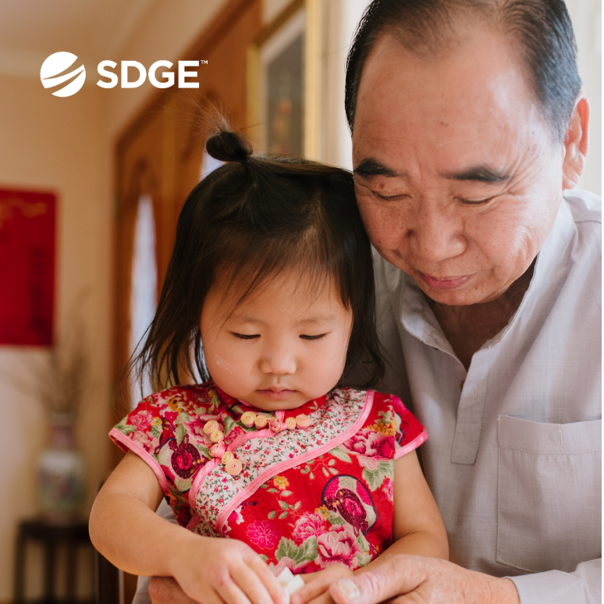

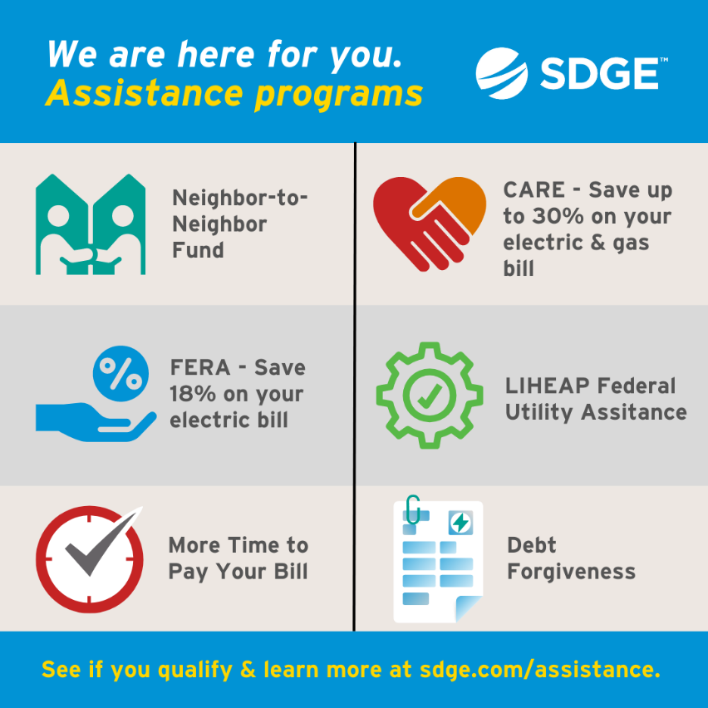

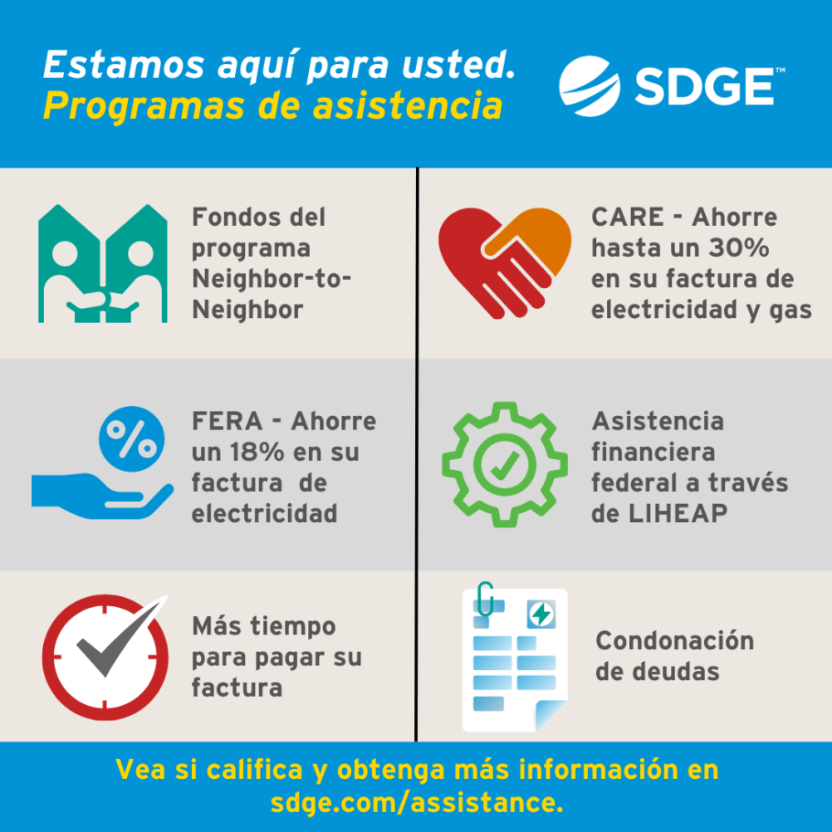
BUSINESS SECTION:
ARTICLE: save energy with sdg&e’s smart thermostat program
With the potential for another summer with higher-than-average temperatures, SDG&E’s Smart Thermostat Program can provide an effective and efficient way to conserve energy and reduce electricity costs for your business. No matter where you are, you can adjust your smart thermostats to run on energy-efficient schedules from your smartphone or other connected devices. As an added incentive, you’ll receive $50 per registered and installed thermostat (up to four thermostats) when you join SDG&E’s Smart Thermostat Program. Learn more about saving energy while contributing to a sustainable energy future at sdge.com/business-thermostat. And for energy-saving tips, visit sdge.com/MyBusiness.
SOCIAL POSTS: save energy with sdg&e’s smart thermostat program
- Using smart thermostats is good business. Control the temperature in your building or office from your smartphone from anywhere at any time. SDG&E’s Smart Thermostat Program can help you get started and rewarded too. Learn more at sdge.com/business-thermostat. #sdge #SDGEassist
- Why be satisfied with business as usual? Save more on your energy bill with less effort by enrolling in SDG&E’s Smart Thermostat Program. Just set it and forget it. Get details at sdge.com/business-thermostat. #sdge #SDGEassist
- Looking for ways to save energy at your business or office? Check out sdge.com/MyBusiness for energy-saving tips. #sdge #SDGEassist

imageS: save energy with sdg&e’s smart thermostat program
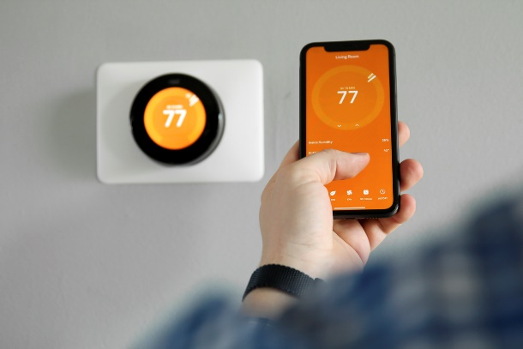
ARTICLE: TAKE ADVANTAGE OF NO-COST TRAINING FROM ENERGY EXPERTS
Did you know that SDG&E provides webinars for business owners and trade professionals, so you can learn new skills at your own pace? And most are at no cost. You or your employees can learn about the latest in green building practices, technology and energy-saving solutions from industry experts. Certifications and continuing education units are available for many classes. Check out the class listing at sdge.com/EnergyClasses.
SOCIAL POSTS: TAKE ADVANTAGE OF NO-COST TRAININGS FROM ENERGY EXPERTS
- Did you know SDG&E provides energy education and training webinars at no cost? These on-demand webinars are offered at introductory, intermediate and advanced levels. See the webinar list at sdge.com/EnergyClasses. #sdge #SDGEassist
- Learn the latest in green building design, operations, maintenance and technology at no-cost energy webinars led by industry experts. See the on-demand webinar list at sdge.com/EnergyClasses. #sdge #SDGEassist
- Enroll in a no-cost, on-demand energy topic webinar. Energy education and training can give you and your employees the knowledge and skills that customers value. Check out the webinar list at sdge.com/EnergyClasses. #sdge #SDGEassist

imageS: TAKE ADVANTAGE OF NO-COST TRAININGS FROM ENERGY EXPERTS
