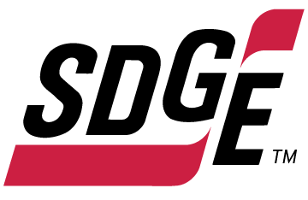

SDG&E RESIDENTIAL AND SMALL BUSINESS CONTENT PACKAGE | JUNE 2022
As a trusted community partner, we thank you for sharing our content and digital assets with your audiences – including residents, customers and employees – to help amplify our key messages in your email communications, websites or newsletters.
Best practices for using our content, social media posts and images
- Images
Please choose images that are relevant for your audience and feel free to mix and match what we provide. For alternate images, Unsplash.com and Canva.com offer free images that you can download.
- SDG&E logo
You’re welcome to mention our name but, due to legal requirements, please do not use our logo in any marketing materials that you create. Please only use the SDG&E logo if we provide it to you in this package or it’s publicly available online like a social post or video. You can also retweet our public posts which you’ll find on twitter.com/sdge.
- Videos
We have a library of videos you can share in your communications and social posts when you visit youtube.com/c/SanDiegoGasElectric/videos. If you’d like to sort our videos by topic, visit youtube.com/c/SanDiegoGasElectric. Some videos are in Spanish. Our newest videos discuss mylar balloon safety, carbon monoxide safety, downed powerlines, 811 Dig Alert and more. You’ll see some on TV too!
This month’s topics: SDG&E bill components, customer assistance programs, business energy-saving tips, free energy-related webinars
Follow us
You can find us on Facebook, Instagram, Twitter, YouTube and LinkedIn. When sharing these digital assets and content, feel free to tag SDG&E’s social media accounts and direct your audience to sdge.com.

Article: EVER WONDER WHAT YOU’RE PAYING FOR IN YOUR SDG&E BILL?
The rising cost of energy is straining a lot of Southern California households. SDG&E hears your concerns and wants you to know what you are paying for. Supplying power to the community includes the cost of energy production, delivering that energy, plus the costs of building and maintaining infrastructure that ensures clean, safe and reliable energy in the future.
Why is SDG&E’s pricing higher than other utilities?
- We use a higher amount of renewable energy to address climate change than other utilities
- We have developed the nation's leading wildfire safety program to keep communities safe
- Technology subsidies required by the state and paid for by customers, such as Net Energy Metering, increases electricity costs for customers without solar by about $260 per year
- Legislative mandates that account for about 24% of electricity rates
- We make improvements to ensure the power grid remains safe and reliable
Your energy bill is impacted by weather, how much energy you use and energy market conditions. What you may not know is that your energy bill is also impacted by regulatory proceedings at the California Public Utilities Commission (CPUC). SDG&E, alongside consumer advocates and other key stakeholders, participates in many CPUC proceedings throughout the year. SDG&E works aggressively to reduce the energy cost burden on its customers while continuing the pursuit of California’s ambitious climate goals.
The price SDG&E pays for electricity and natural gas is the exact same price our customers are charged. There is no markup of any kind and SDG&E makes no profit on energy procurement. There are no quick fixes for lowering the cost of energy but SDG&E provides several programs for those needing payment assistance. Learn more at sdge.com/assistance.
To learn more about SDG&E’s energy pricing, visit sdgeratesinfo.com.
Social posts: EVER WONDER WHAT YOU’RE PAYING FOR IN YOUR SDG&E BILL?
- Do you know what goes into your SDG&E bill? Supplying power includes the cost of energy production, delivering that energy, plus the costs of building and maintaining infrastructure that ensures clean, safe and reliable energy in the future. Learn more about the breakdown of energy pricing at sdgeratesinfo.com. #sdge #SDGEassist
- At the start of every year, SDG&E and other utilities across California are required to update energy pricing to reflect the costs of providing clean, safe and reliable service to customers. Visit sdgeratesinfo.com to find out what your energy bill covers. #sdge #SDGEassist
- The price SDG&E pays for electricity and natural gas is the exact same price its customers are charged. There is no markup on the energy you use and SDG&E makes no profit on energy procurement. Get more information at sdgeratesinfo.com. #sdge #SDGEassist
- San Diego’s usually moderate climate means less energy is consumed. So, while energy pricing has increased, SDG&E’s average monthly residential electric bill is the lowest among California’s major utilities and below the national average. #sdge #SDGEassist

Images: EVER WONDER WHAT YOU’RE PAYING FOR IN YOUR SDG&E BILL?
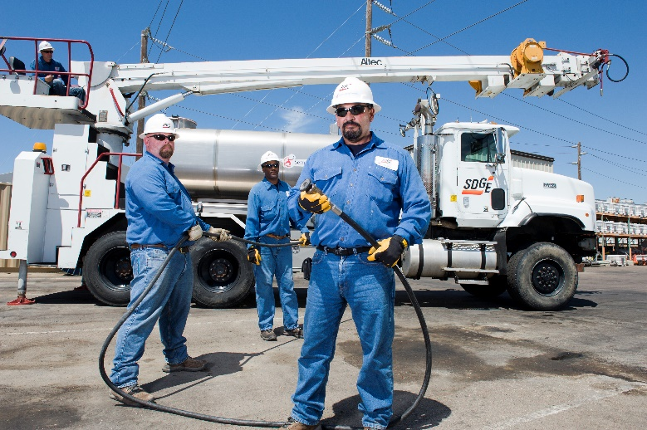
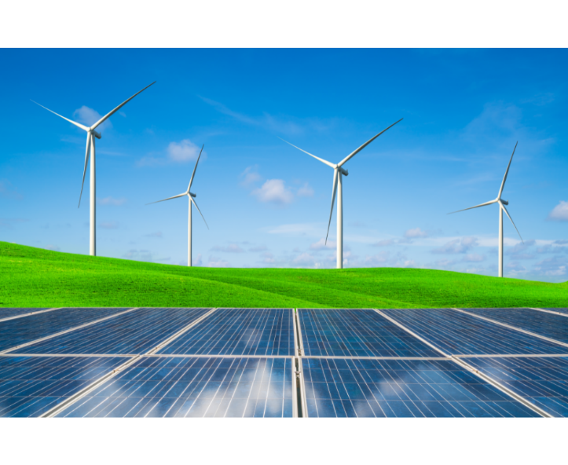

Article: NEED HELP WITH YOUR ENERGY BILL?
SDG&E recognizes that this is still a challenging time for many customers and may be able to help if you are having trouble paying your bill. You may be eligible for programs and services that can provide immediate financial assistance and help you avoid interruptions in your service. Flexible payment arrangements are available to help you pay down past due balances. Learn more at sdge.com/Payment-Arrangements.

Check out these energy assistance programs:
- California Alternate Rates for Energy (CARE) Program: Save 30% or more every month on your bill. Find out if you qualify at sdge.com/CARE.
- Family Electric Rate Assistance (FERA) Program: If you don’t qualify for CARE and your household has 3 or more people, you may qualify for FERA. You could receive an 18% discount on your electric bill. Visit sdge.com/FERA to learn more.
- Energy Savings Assistance (ESA) Program: You may qualify to receive free energy-saving improvements for your home, such as new appliances, lighting, insulation and more. Find details at sdge.com/ESAP.
- Arrearage Management Plan (AMP): If you have outstanding bills and you are a CARE or FERA customer, you may be eligible for debt forgiveness. See if you qualify at sdge.com/AMP.
- Low-income Home Energy Assistance Program (LIHEAP): Offers up to $1,000 towards your energy bill. This Federal assistance program also provides support for energy-related home improvements. Learn more at sdge.com/LIHEAP.

Even if you made a recent payment or set up a flexible payment plan with SDG&E, there may still be assistance programs to help you. For a complete list of available offerings, visit sdge.com/assistance.

Social posts: NEED HELP WITH YOUR ENERGY BILL?
- If you’re behind on your energy bill, you may qualify for financial assistance. Learn more at sdge.com/assistance. #sdge #SDGEassist
- Hardship is everywhere right now – the last thing you need to worry about is your energy bill. Get help with your bill at sdge.com/assistance. #sdge #SDGEassist
- SDG&E provides assistance programs to help you with your monthly bill which can include up to a 30% discount. Find out if you qualify at sdge.com/assistance. #sdge #SDGEassist
- Whether you rent or own, you could be eligible to receive no-cost, energy-efficient home improvements that can make your home more comfortable and reduce your energy bill. Find out if you qualify at sdge.com/ESAP. #sdge #SDGEassist

Article (translated): ¿NECESITA AYUDA CON SU FACTURA DE ENERGÍA?
Usted puede calificar para un descuento en su factura o mejoras en el hogar. Los programas de asistencia de SDG&E ayudan a reducir su factura mensual de energía mientras mantiene su hogar cómodo.
- Programa de Tarifas Alternativas de Energía de California (CARE, por sus siglas en inglés): Ahorre un 30% o más cada mes en su factura. Averigüe si califica en sdge.com/CARE.
- Tarifa Eléctrica Familiar (FERA, por sus siglas en inglés): Si no califica para CARE y su hogar tiene 3 o más personas, puede calificar para FERA. Podría recibir un 18% de descuento en su factura de electricidad. Visite sdge.com/FERA para obtener más información.
- Programa de Asistencia para el Ahorro de Energía (ESA, por sus siglas en inglés): Puede calificar para recibir mejoras gratuitas para el ahorro de energía en su hogar, tales como electrodomésticos nuevos, iluminación, aislamiento y más. Encuentre los detalles en sdge.com/ESAP.
- Arrearage Management Plan (AMP): Si tiene facturas pendientes y es cliente de CARE o FERA, puede ser elegible para la condonación de deudas. Averigüe si califica en sdge.com/AMP.
- Clientes comerciales: Configure un plan de pago flexible, para que pueda estar tranquilo sabiendo que está cubierto. Visite sdge.com/recovery para obtener más información.
Las aplicaciones en línea son fáciles, rápidas y convenientes. Para obtener más información, visite sdge.com/asistencia.

Postas sociales: ¿NECESITA AYUDA CON SU FACTURA DE ENERGÍA?
- Si está atrasado en su factura de energía, puede calificar para asistencia financiera. Obtenga más información en sdge.com/asistencia. #sdge #SDGEassist
- En este momento, las dificultades se encuentran en todas partes - lo último que necesita es preocuparse por su factura de energía. Obtenga ayuda con su factura en sdge.com/asistencia. #sdge #SDGEassist
- SDG&E ofrece programas de asistencia para ayudarle con su factura mensual que puede incluir hasta un 30% de descuento. Descubra si califica en sdge.com/asistencia. #sdge #SDGEassist
- Ya sea que alquile o sea propietario, podría ser elegible para recibir mejoras de eficiencia energética en su hogar, sin costo, que pueden hacer que su hogar sea más cómodo y reducir su factura de energía. Descubra si califica en sdge.com/ESAP. #sdge #SDGEassist

Images: NEED HELP WITH YOUR ENERGY BILL?

Article 3: LOWER ENERGY USE IN YOUR PLACE OF BUSINESS
Did you know that, according to energystar.gov, the top energy consumers in a typical office are lighting, cooling and computers? Here are some ideas to help you save on your business’s energy use.
Save on cooling:
Cooling (and heating) makes up about 40% of the energy used in commercial buildings. To keep your HVAC system running efficiently, regularly change or clean HVAC filters every month during peak cooling or heating seasons. Dirty filters cost more to use, overwork the equipment and result in lower indoor air quality. Make sure that areas in front of vents are clear of furniture and paper. As much as 25 percent more energy is required to distribute air if your vents are blocked.
Save on lighting:
Use motion detectors to control lighting in frequently unoccupied areas and photocells to turn lights off automatically when enough daylight is detected. Install energy-efficient LEDs and task lighting to illuminate workspaces. Maximize daylight ― sunlight is free! Remove unnecessary lamps in overlit areas.
Save on equipment costs:
Turn off office equipment, including monitors and printers, along with lights. Activate sleep settings on your office equipment. Consolidate the number of printers in your office. Use “smart” power strips to reduce the amount of energy used by electronic equipment.

Visit sdge.com/My-Business for more energy-saving tips and information on business pricing plans.

Social Posts: LOWER ENERGY USE IN YOUR PLACE OF BUSINESS
- Want to save energy at the office? Turn off lights and electronic equipment, such as monitors and printers, when the office is closed. Activate sleep settings on your office equipment. Consolidate the number of printers in your office. Use “smart” power strips. Visit sdge.com/My-Business for more energy-saving tips. #sdge #SDGEassist
- Energy-saving tip for the office: Make sure that areas in front of vents are clear of furniture and paper. As much as 25% more energy is required to distribute air if your vents are blocked. Visit sdge.com/My-Business for more energy-saving tips. #sdge #SDGEassist
- Looking for ways to reduce your energy use in the office? Use motion detectors to control lighting in frequently unoccupied areas and photocells to turn lights off automatically when enough daylight is detected. Install energy-efficient LEDs and task lighting to illuminate workspaces. Maximize daylight ― sunlight is free! Remove unnecessary lamps in overlit areas. Visit sdge.com/My-Business for more energy-saving tips. #sdge #SDGEassist
- The top energy consumers in a typical office are lighting, cooling and computers. Find tips to help you save energy at your workplace at sdge.com/My-Business. #sdge #SDGEassist

Images: LOWER ENERGY USE IN YOUR PLACE OF BUSINESS

Article: TAKE ADVANTAGE OF NO-COST TRAINING FROM ENERGY EXPERTS
Did you know that SDG&E provides webinars for business owners and trade professionals, so you can learn new skills at your own pace? And most are at no cost. You or your employees can learn about the latest in green building practices, technology and energy-saving solutions from industry experts. Certifications and continuing education units are available for many classes. Check out the class listing at sdge.com/EnergyClasses.
Some of June’s topics include:
- June 7: Welcome to Facility Management Part 1
- June 7: HVAC Efficient Operation of Motors Part 1
- June 15: Flow Meters – You need to measure water to manage water
- June 16: Light and Health – New data and new standards on the horizon
- Various dates: IHACI Air Distribution Module
- June 28: Advanced CBEEC-Res energy modeling software for residential buildings
- June 30: Best Practices for Industrial and Warehouse Lighting

Social posts: TAKE ADVANTAGE OF NO-COST TRAININGS FROM ENERGY EXPERTS
- Did you know SDG&E provides energy education and training webinars at no cost? These on-demand webinars are offered at introductory, intermediate and advanced levels. See the webinar list at sdge.com/EnergyClasses. #sdge #SDGEassist
- Learn the latest in green building design, operations, maintenance and technology at no-cost energy webinars led by industry experts. See the on-demand webinar list at sdge.com/EnergyClasses. #sdge #SDGEassist
- Enroll in a no-cost, on-demand energy topic webinar. Energy education and training can give you and your employees the knowledge and skills that customers value. Check out the webinar list at sdge.com/EnergyClasses. #sdge #SDGEassist

Images: TAKE ADVANTAGE OF NO-COST TRAININGS FROM ENERGY EXPERTS
