

SDG&E® RESIDENTIAL AND SMALL BUSINESS CONTENT PACKAGE | JULY 2023
As a trusted community partner, we thank you for sharing our content and digital assets with your audiences – including residents, customers and employees – to help amplify our key messages in your email communications, websites or newsletters.
Best practices for using our content, social media posts and images
- IMAGES
Choose IMAGES that are relevant for your audience and feel free to mix and match what we provide. For alternate IMAGES, Unsplash.com and Canva.com offer free IMAGES that you can download.
- SDG&E logo
You’re welcome to mention our name but, due to legal requirements, please do not use our logo in any marketing materials that you create. Please only use the SDG&E logo if we provide it to you in this package or it’s publicly available online like a social post or video. You can also retweet our public posts which you’ll find on twitter.com/sdge.
- Videos
We have a library of videos you can share in your communications and SOCIAL POSTS when you visit youtube.com/c/SanDiegoGasElectric/videos. If you’d like to sort our videos by topic, visit youtube.com/c/SanDiegoGasElectric. Some videos are in Spanish. You’ll see some on TV, too!
Follow us
Find us on Facebook, Instagram, Twitter, YouTube and LinkedIn. When sharing our digital assets and content, feel free to tag SDG&E’s social media and direct your audience to sdge.com.

This month’s topics: Power Saver Rewards, customer assistance programs, start/stop/transfer service, ELRP for businesses, training

ARTICLE: earn a reward FOR Volunteering to CONSERVE ENERGY WITH SDG&E’S POWER SAVER REWARDS PROGRAM (we ran this article in may)
Help make California’s energy grid stronger, safer and more reliable for all Californians this summer – and get a reward for it too! The Power Saver Rewards program pays you for lowering your electricity use when energy is in high demand. When the temperatures rise, it pays to be flexible.
Here is how it works: On sizzling summer days, as more people use energy to stay cool, the electrical grid can become strained due to high demand. When this occurs, the statewide grid operator may call a Flex Alert or other grid emergency. As a result, the Power Saver Rewards program may be activated to help reduce energy use and strain on the grid.
If you are eligible and reduce your energy use during a Power Saver event between the on-peak hours of 4 p.m. – 9 p.m., you could receive a bill credit of $2.00/kWh. And the best part? The more energy you conserve, the more you can save! There are no penalties if you can’t conserve energy during an event, and you can opt-out of the program at any time.
If saving on your monthly energy bill, helping improve grid reliability and contributing to a cleaner environment sound good to you, the Power Saver Rewards program may be the right fit for your home. To learn more about this program, visit sdge.com/PowerSaver or call 1-866- 291-9516.
SOCIAL POSTS: earn a reward WHEN YOU CONSERVE ENERGY WITH SDG&E’S POWER SAVER REWARDS PROGRAM
- Get a reward when you reduce your energy use with Power Saver Rewards! To learn more, visit sdge.com/PowerSaver. #sdge #SDGEassist
- Help make California’s energy grid stronger, safer and more reliable – and get a reward for it too. SDG&E’s Power Saver Rewards program rewards you for lowering your electricity use when energy is most in demand. Visit sdge.com/PowerSaver for details. #sdge #SDGEassist
- Want to save money on your energy bill? Consider participating in the Power Saver Rewards program. Get more information at sdge.com/PowerSaver. #sdge #SDGEassist
- Get rewarded for saving energy, helping the environment and contributing to a stronger grid. Participate in Power Saver Rewards! Learn more about the program at sdge.com/PowerSaver. #sdge #SDGEassist

IMAGES: earn a reward WHEN YOU CONSERVE ENERGY WITH SDG&E’S POWER SAVER REWARDS PROGRAM



ARTICLE: NEED HELP WITH YOUR ENERGY BILL?

SDG&E recognizes that this can be a challenging time for many customers and may be able to help if you are having trouble paying your bill. You might be eligible for programs and services that can provide immediate financial assistance and help you avoid interruptions in your service. Flexible payment arrangements are also available to help you pay down past due balances. Learn more at sdge.com/Payment-Arrangements.
Check out these energy assistance programs:
- California Alternate Rates for Energy (CARE) Program: Save 30% or more every month on your bill. Find out if you qualify at sdge.com/CARE.
- Family Electric Rate Assistance (FERA) Program: If you don’t qualify for CARE and your household has 3 or more people, you may qualify for FERA. You could receive an 18% discount on your electric bill. Visit sdge.com/FERA to learn more.
- Energy Savings Assistance (ESA) Program: You may qualify to receive free energy-saving improvements for your home, like new appliances, lighting, insulation and more. Find details at sdge.com/ESA.
- Arrearage Management Plan (AMP): If you have outstanding bills and you are a CARE or FERA customer, you may be eligible for debt forgiveness. See if you qualify at sdge.com/AMP.
Even if you made a recent payment or set up a flexible payment plan with SDG&E, there may still be assistance programs available to help you. For a complete list of available offerings, visit sdge.com/assistance.

SOCIAL POSTS: NEED HELP WITH YOUR ENERGY BILL?
- If you’re behind on your energy bill, you may qualify for financial assistance. Learn more at sdge.com/assistance. #sdge #SDGEAssist
- Hardship is everywhere right now – the last thing you need to worry about is your energy bill. Get help with your bill at sdge.com/assistance. #sdge #SDGEAssist
- SDG&E provides assistance programs to help you with your monthly bill which can include up to a 30% discount. Find out if you qualify at sdge.com/assistance. #sdge #SDGEAssist
- Whether you rent or own, you could be eligible to receive no-cost, energy-efficient home improvements that can make your home more comfortable and help reduce your energy bill. Find out if you qualify at sdge.com/ESA. #sdge #SDGEAssist

ARTICLE (translated): ¿NECESITA AYUDA CON SU FACTURA DE ENERGÍA?
Usted puede calificar para un descuento en su factura o mejoras en el hogar. Los programas de asistencia de SDG&E ayudan a reducir su factura mensual de energía mientras mantiene su hogar cómodo.
- Programa de Tarifas Alternativas de Energía de California (CARE, por sus siglas en inglés): Ahorre un 30% o más cada mes en su factura. Averigüe si califica en sdge.com/CAREesp.
- Tarifa Eléctrica Familiar (FERA, por sus siglas en inglés): Si no califica para CARE y su hogar tiene 3 o más personas, puede calificar para FERA. Podría recibir un 18% de descuento en su factura de electricidad. Visite sdge.com/FERAesp para obtener más información.
- Programa de Asistencia para el Ahorro de Energía (ESA, por sus siglas en inglés): Puede calificar para recibir mejoras gratuitas para el ahorro de energía en su hogar, tales como electrodomésticos nuevos, iluminación, aislamiento y más. Encuentre los detalles en sdge.com/ESAPesp.
- Arrearage Management Plan (AMP): Si tiene facturas pendientes y es participante en el programa de CARE o FERA, puede ser elegible para la condonación de deudas. Averigüe si califica en sdge.com/AMPesp.

Las aplicaciones en línea son fáciles, rápidas y convenientes. Para obtener más información, visite sdge.com/asistencia.

POSTAS SOCIALES: ¿NECESITA AYUDA CON SU FACTURA DE ENERGÍA?
- Si está atrasado en su factura de energía, puede calificar para asistencia financiera. Obtenga más información en sdge.com/asistencia. #sdge #SDGEAssist
- En este momento, las dificultades se encuentran en todas partes - lo último que necesita es preocuparse por su factura de energía. Obtenga ayuda con su factura en sdge.com/asistencia. #sdge #SDGEAssist
- SDG&E ofrece programas de asistencia para ayudarle con su factura mensual que puede incluir hasta un 30% de descuento. Descubra si califica en sdge.com/asistencia. #sdge #SDGEAssist
- Si alquile o es propietario, podría ser elegible para recibir mejoras de eficiencia energética en su hogar, sin costo, que pueden hacer que su hogar sea más cómodo y ayuden reducir su factura de energía. Descubra si califica en sdge.com/ESAesp. #sdge #SDGEAssist

images: NEED HELP WITH YOUR ENERGY BILL?



ARTICLE: HOME UTILITY BILL DISCOUNTS ARE AVAILABLE
There are programs and services available to help manage your bills.
- Phone bill discount
The California LifeLine Program provides discounted phone services to eligible households. To learn more, visit CaliforniaLifeline.com or call 866-272-0349.
- Home Internet Discount Service
You may be eligible for free or low-cost home internet service through the California Emerging Technology Fund. To learn more, visit InternetForAllNow.org or call 866-519-8655.
- Low Income Water Assistance Program (LIWAP)
The new federal Low Income Household Water Assistance Program (LIHWAP) provides financial assistance to low-income Californians to help manage their residential water utility costs. Since a federal grant provides the funding, you do not have to repay it. Learn more at csd.ca.gov/Pages/LIHWAP.aspx.
With many people struggling to pay their utility bills, SDG&E wants customers to know that this financial assistance is available. However, SDG&E is not responsible for administering these three programs.
SOCIAL POSTS: HOME UTILITY BILL DISCOUNTS ARE AVAILABLE
Use any of the three programs above and add: #sdge #SDGEassist

IMAGES: HOME UTILITY BILL DISCOUNTS ARE AVAILABLE



ARTICLE: MOVING? SCHEDULE YOUR SDG&E SERVICE REQUEST ONLINE
Take a little stress out of your move when you schedule your SDG&E service request online. Use SDG&E’s My Account to start, transfer or stop your service. It’s easy and only takes a minute. No need to call and no need to wait on the phone. Online scheduling shows you available dates that you can choose. If your plans change, simply update your request online. Get more information at sdge.com/move.
SOCIAL POSTS: MOVING? SCHEDULE YOUR SDG&E SERVICE REQUEST ONLINE
- Moving? Make moving easier with online scheduling tools. Visit sdge.com/move to start, transfer or stop your SDG&E service. #sdge #SDGEassist
- Moving made easy. Start, transfer or stop your SDG&E service online. Easy, convenient – no calls, no waiting. Get more information at sdge.com/move. #sdge #SDGEassist

IMAGES: MOVING? SCHEDULE YOUR SDG&E SERVICE REQUEST ONLINE

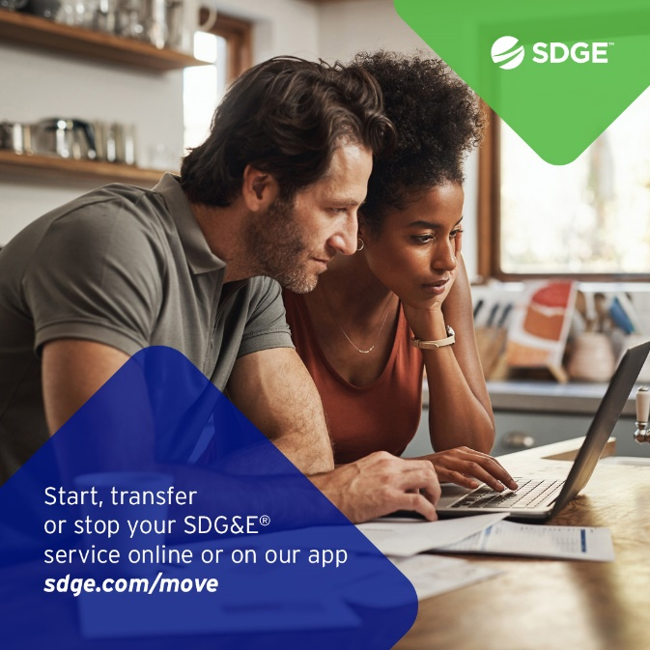

BUSINESS SECTION:
ARTICLE: wOULD YOUR BUSINESS ENJOY LOWER ENERGY BILLS?

Higher summer temperatures can mean higher energy bills and cause an extraordinary strain on the electrical grid. This can lead to a greater risk of grid emergencies and power outages. But it doesn't have to be this way.

During a grid emergency, businesses in SDG&E's service territory can participate in the Emergency Load Reduction Program (ELRP). By joining ELRP, businesses help support the grid when it's facing extra strain and can get a bill credit for their participation. ELRP is a flexible way to get incentives for using less energy.

Participating in ELRP allows qualified businesses to contribute to stabilizing the grid and reduce the risk of issues without worrying about any financial penalties.
To gather more information about ELRP, visit sdge.com/ELRP.

Social posts: wOULD YOUR BUSINESS ENJOY LOWER ENERGY BILLS?
- The Emergency Load Reduction Program is a flexible way your business can get incentives for using less energy. Learn more at sdge.com/ELRP. #sdge #SDGEassist
- When your business participates in SDG&E’s ELRP program, you can earn financial incentives of $2 per kilowatt-hour when your business reduces energy during a grid emergency. Get more information at sdge.com/ELRP. #sdge #SDGEassist

imageS: wOULD YOUR BUSINESS ENJOY LOWER ENERGY BILLS?



ARTICLE: TAKE ADVANTAGE OF NO-COST TRAINING FROM ENERGY EXPERTS
Did you know that SDG&E provides webinars for business owners and trade professionals, so you can learn new skills at your own pace? And most are at no cost. You or your employees can learn about the latest in green building practices, technology and energy-saving solutions from industry experts. Certifications and continuing education units are available for many classes. Check out the class listing at sdge.com/EnergyClasses.

SOCIAL POSTS: TAKE ADVANTAGE OF NO-COST TRAININGS FROM ENERGY EXPERTS
- Did you know SDG&E provides energy education and training webinars at no cost? These on-demand webinars are offered at introductory, intermediate and advanced levels. See the webinar list at sdge.com/EnergyClasses. #sdge #SDGEassist
- Learn the latest in green building design, operations, maintenance and technology at no-cost energy webinars led by industry experts. See the on-demand webinar list at sdge.com/EnergyClasses. #sdge #SDGEassist
- Enroll in a no-cost, on-demand energy topic webinar. Energy education and training can give you and your employees the knowledge and skills that customers value. Check out the webinar list at sdge.com/EnergyClasses. #sdge #SDGEassist

imageS: TAKE ADVANTAGE OF NO-COST TRAININGS FROM ENERGY EXPERTS

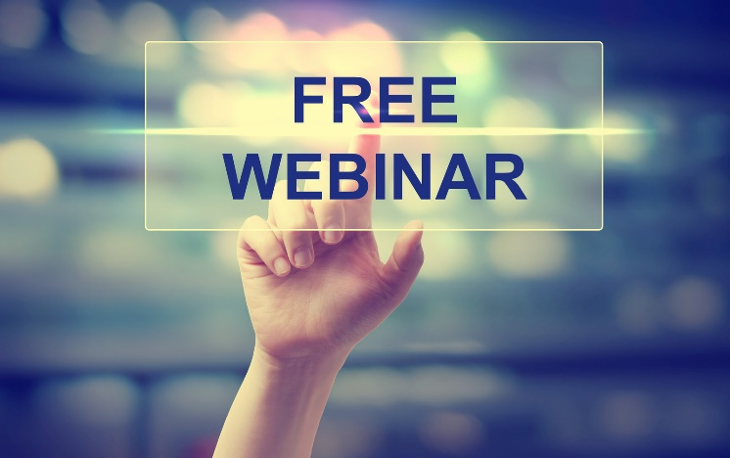
NEW SECTION!
JUST POSTS
- Reduce the temperature in your home when you grill outside instead of using indoor ovens and stoves. Or skip the appliances and make healthy salads or sandwiches. Get more energy-saving tips at sdge.com/MyEnergy. #sdge #SDGEassist
- Turn off ceiling fans when you leave the room. Remember that fans cool people, not rooms, by creating a wind chill effect. Get more energy-saving tips at sdge.com/MyEnergy. #sdge #SDGEassist
- Avoid placing lamps or TV sets near your room air-conditioning thermostat. The thermostat senses heat from these appliances, which can cause the air conditioner to run longer than necessary. Get more energy-saving tips at sdge.com/MyEnergy. #sdge #SDGEassist
- Keep your electronics from sucking up all your summer energy by unplugging your chargers, TV, computer and other small electronics when you’re not using them. Get more energy-saving tips at sdge.com/MyEnergy. #sdge #SDGEassist
- Track your energy costs before you’re billed. My Account gives you the power to manage your energy costs at-a-glance and make sure it meets your budget. Learn more at sdge.com/about-my-account. #sdge #SDGEassist
- Download SDG&E’s mobile app at sdge.com/MobileApp. You can set energy use and cost alerts, pay your bill, track power outages and restoration times and update your emergency contact information. #sdge #SDGEassist
- Flexible payment arrangements are available to help you pay down past due SDG&E bills. Learn more at sdge.com/Payment-Arrangements. #sdge #SDGEassist
- Gas leaks are dangerous. If you suspect a leak, leave the area immediately and call 911. For more info on gas leak signs, visit sdge.com/Gas-Safety. #sdge #SDGEassist
- Looking for ways to save energy at your business or office? Check out sdge.com/MyBusiness for energy-saving tips. #sdge #SDGEassist
- If you qualify for CARE or FERA discounts, or if you live in a disadvantaged community, you may be eligible for solar assistance. Get the details at sdge.com/SolarBillingPlan. #sdge #SDGEassist

